

Disclaimer
The content of these FAQs is provided for information purposes only. The SJU or the Commission cannot be held liablefor any use of the content of this document.
 | SESAR JOINT UNDERTAKING
 | Questions and Answers
 | Call for proposals: H2020-SESAR-2020-1 (VLD2 Open)
 | Edition date: | 03 June 2020
 | Edition: | 01.00
 | Status: | Approved

Document history
Revision | Date | Description
01 | 26/02/2020 | 1st Version
02 | 17/04/2020 | 2nd Version
03 | 11/05/2020 | 3rd Version
04 | 03/06/2020 | 4th Version

Questions & Answers
Q | Topic | SJU Answer
1 | Will you be organising an Information Day and/or Brokerage Event to support potential participants to understand how to engage and build successful teams? | No, the SJU will not organize an Information Day for the call H2020-SESAR-2020-1. However, in the Funding & Tenders Portal, at this link, potential applicants can find a dedicated page to help them finding partners for proposals.
2 | Dear Sir/Madame,  Referring to the VLD2 open call for proposals currently open, we are considering putting forward a proposal under Topic 2 and more specifically on ATM data service provision. We wish to explore a harmonized and coherent approach towards MET service delivery in North Europe by demonstrating a weather hazard and SIGMET service from a central location serving the area of 7 FIRs.  The technical specifications document states that: “The maximum scope of service delivery by ADSPs covers the ATM data services (such as flight data processing) needed to realize the virtual de-fragmentation of European skies and includes the provision of AIS, MET and CNS services.” This does NOT state the minimum, however, and thus my question to SJU would be if a scoping of “MET-only-ADSP” would be considered acceptable? In our opinion this would address the initial concern of multiple providers, add coherence and provide a single point of entry to the airspace users and ATM providers.  Furthermore, is an event envisaged to take place where further information about the call is provided? | Q1. The topic text does not refer to a minimum set of data for scoping the ATM data service provision and therefore the described approach would be considered in scope. However, considering a wider scope of ATM data would be an advantage.  Q2.For the second question, please ref to Q1.
3 | Dear SESAR ,  I am part of company XXX, working on safety aspects of company’s flying taxi project.  We have initiated talks with European research institutes, discussing the possibility to assemble a consortium to answer to SESAR-VLD2-03-2020.  In this process the following additional questions came up:  - What is the expected nature of a SESAR very large scale demonstration? Based on earlier funded VLD projects such as this one https://www.sesarju.eu/news/sesar-u-space-demonstration-gulf-finland-gof-ready-take it seems that actual flight tests and technology demonstrations are expected. Could demonstrations also be run in simulated environments, in particular for demonstrating safe integration of UTM and ATM systems, or safe scalability of strategic de-confliction algorithms at the fleet level?  - It is expected to build upon previous U-Space demonstrated technology?  - Are any exploratory research or industrial research calls nearing publication?  - What are the target TRL levels of technologies to be demonstrated? | As defined in the technical Specifications, Very Large-Scale Demonstrations are primarily designed to help bridge the gap between the development and operational implementation, they are at the border in terms of maturity transition from the Industrial Research & Validation (TRL6) and the industrialisation (TRL7) and to the subsequent implementation. Therefore, the execution of real flights for demonstrating the technology is required, simulation activities wouldn’t be considered as acceptable.  As referred to in the technical specifications page 12, work already done in previous calls will have to be considered, in particular a first U-space “State of the Art” report integrating all SESAR U-Space projects outcomes (available in March 2020).  More information about forthcoming calls, can be found in the Single Programming Document 2020-2022, at the link provided in the Funding and Tenders Portal.
Please note that the Call deadline has been postponed to 16 June 2020
4 | We’re considering the setting up of an interesting proposal with regard to the SJU VLD call with regards to U-space services toward UAM. The question is how rigid is the following requirement:  The VLD will include the following activities:  - Execution of flight demonstrations in accordance with the safety conditions (A significant number of flights is expected to take place with operating methods produced by the project, in coordination with relevant stakeholders, and using one or more eVTOL platform carrying human passengers), the demonstration flights should also include vehicles with full autonomous capabilities;  The VLD we’ve in mind is based on routine urban medical delivery. We do not have, for the time being, partners with the technical capabilities described for human passengers, unless this can be intended as traditional helicopters. What do you think? | As defined in the technical specifications, one of the activities has to address flight demonstrations with platform carrying human passengers. SJU wants to move a step further compared to the delivery of packages such as medical ones.
5 | Many consortia members, especially airlines, would have benefit from an extension of the proposal deadline for the currently open Call for Proposals (VLD2).  This benefit will allow them, and other partners, to achieve a higher quality proposal.  We want to support this motion, and thus question herewith if an extension of the proposal submission deadline can be obtained. | As mentioned here above, the call deadline has been postponed to 16 June 2020.
6 | I’m writing to clarify one of the requirements in the SESAR Open VLD 2 call, in particular with regards to Topic 3: U-space capabilities and services to enable Urban Air Mobility.  1. Do you see any possibility that the requirement that there be an eVTOL platform carrying human passengers be relaxed? We see the possibility of offering an eVTOL of sufficient size for carrying human passengers (+100kg payload), but dedicated to goods transport within the demonstrations. However, human passengers due to certification and liability issues seems extremely difficult to comply with.  2. Also, do you see any possibility that there may be possibly a one month extension granted for submission of the proposal due to the disruptive influence of the Coronovirus situation? | 1. See reply to question n.4  2. See reply to question n.5.
7 | Dear Sir/Madam,  We are writing you in relation to the call H2020-SESAR-2020-1 (TOPIC SESAR-VLD2-03-2020).  We kindly ask you to confirm which is the funding rate for non-profit entities in this call.  According to the information available on the H2020 “Funding & Tender” Portal (Annex D of the Work Programme: https://ec.europa.eu/research/participants/data/ref/h2020/other/wp/2018-2020/annexes/h2020-wp1820-annex-d-ia_en.pdf), the funding rate is “70% (except for non-profit legal entities, where a rate of 100% applies)”.  In spite of that, in the on-line budget template, a 70% rate is displayed for all kind of entities, profit and non-profit.  Thank you in advance for your help. | We can confirm that the funding rate is 70% except for non-profit legal entities, where a rate of 100% applies. The submission forms contains an error which is currently being corrected by the DIGIT development team.  Once the correction goes in production, applicants who have already submitted an application will be invited to re-submit in order to make the correction effective. Applicant who have the application in status ‘draft’ will be invited to save again their data (with no risk of losing previously saved data).
8 | Dear Madam/Sir,  With regards to topic SESAR-VLD2-03-2020, I would like to clarify one aspect on Technical Specification . It states that “Coordination between this VLD and the ongoing ER projects is an essential requirement” (p.11). Can a company submit an idea which is not linked to the previously funded SESAR project? | A company can propose ideas not addressed yet by the previous call. However, as part of the proposal, clear link with previous work shall be identified. The proposal shall complement the previous ER call by conducting flying demonstrations to demonstrate and test development in UAM. As stated in the technical specifications, Coordination between this VLD and the ongoing ER projects is an essential requirement.
9 | I have a query regarding the requirements for VLD projects such as  - how many parties can join in a consortium,  - composition of the consortium,  - whether it is possible for the governmental partners to join the consortium etc. | There is no limit in terms of maximum number of partners joining of consortium. However there is a minimum of 3 partners from 3 different Member States or Associated Countries.  There are no restrictions with regards to the public or private nature of the entities participating.  For more information, please consult the eligibility conditions in the SPD in the Funding & Tenders Portal.
10 | To Whom it may concern,  I am writing regarding the SESAR-VLD2 and SESAR-WAVE calls, are these under the H2020 open calls, or in contrary just restricted to Joint Undertaking Initiative members?  Otherwise, I would appreciate it very much if you could specify those which are open calls under the H2020 framework. | Call H2020-SESAR-2020-1 (VLD2 open) is open to participation of all entities, with respect of the eligibility and admissibility conditions described in Annex B and Annex C of the H2020 Work Programme and in the SJU Single Programming Document 2020-2022.  Call H2020-SESAR-2020-2 (Wave 3) is restricted to SJU members, as specified in the F&T portal.
11 | Dear all,  I would like to download topic description documentation but I can’t find my way in the webportal. Could you please help me with the links to the topic detailed description for the calls here under (VLD2-01-04)  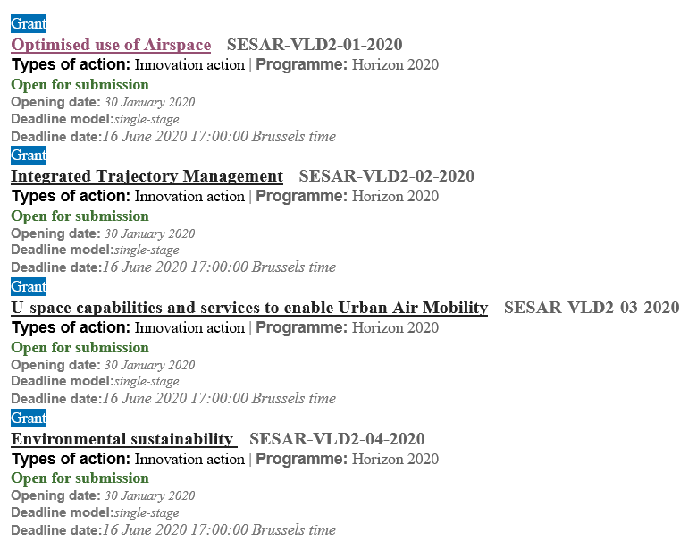  Thank you in advance and stay safe | In order to find the topic description, you have to click on the name of the topic, and then on “show more” under “Topic conditions and documents”, where you will find the link to the Technical specifications, under point 8 “Additional documents”. Please make sure to be familiar with the complete set of documents published in the portal before applying.
12 | We currently prepare project for open VLD and we discuss with partners the WBS structure. I would like to ask you for an advice.  I remember from previous project preparation that was recommended to keep management work package as WP1 however I can not find a reference to it in SJU documents/presentations.  Partners on the project prefer to have management WP as WP4 and keep contractual deliverables under one of it´s sub-work package.  Could you please provide either reference to recommended/ requested WBS structure or provide advice how to handle management WP and it´s deliverables.  We want to avoid rework in GAP phase. | We recommend to have a dedicated WP allocated exclusively to the management of the Grant. Other WPs must focus on the Solutions development. Be the WP management the number 1 or 4 is not an issue.  However, all WPs shall foresee contractual deliverables, either covering management aspects or technical solutions.
13 | I am interesting in applying for the call: U-space capabilities and services to enable Urban Air Mobility, ID: SESAR-VLD2-03-2020  QUESTION: Can I apply for this call if my company is classified as an SME?  I am plan to have 1 industrial and end user partner.  We understand the deadline was extended to 16 June 2020. | As specified in the call documentation, eligibility and admissibility conditions are described in Annex B and Annex C of the H2020 Work Programme and in the SJU Single Programming Document 2020-2022.  Therefore, there are no restrictions to the participation of SMEs.  However, please note that the consortium submitting the proposal must be composed of at least three legal entities. Each of the three must be established in a different EU Member State or Horizon 2020 associated country. All three legal entities must be independent of each other.
Please note that the Call deadline has been postponed to 25 June 2020
14  NEW! | Given the high TRL level the outputs of the demonstrations are to reach, should the consortium include a Business Sustainability task for business models and go-to-market strategies for participating SMEs in the proposal? Or would that be out of scope for this call? | As specified in the “Project Execution Guidance for SESAR 2020 Open VLD 2 Call” available in the call material, the output of the Demonstration activities consist in a Demonstration Report that must cover : the Demonstration Results (detailed analysis of the results per demonstration objective; confidence in results), the conclusions and recommendations (considering the industrialisation, standardisation, deployment) together with Safety, Security and Human Performance Assessment reports. Any other additional elements brought in the Demonstration Report would be welcomed but as these are not mandatory requirements, it would not be considered as an advantage in light of the evaluation.
15  NEW! | We start the process of registration for the VLD2 program. We have seen that there are some eligibility conditions. One of those is the minimum value of the Project, which is 1,5 mln euro.  Considering a smaller value scale of our software program (up to 100 k euro), we would like to clarify this aspect, in order to understand if we are in line with the eligibility conditions of the program or we have to focus/redirect our attention to other SESAR/H2020 projects.  We refer to ”p. 2. Eligibility and admissibility conditions”, Call ID:H2020-SESAR-2020-1 :  2. Eligibility and admissibility conditions: described in Annex B and Annex C of the H2020 Work Programme and in the SJU Single Programming Document 2020-2022.  The awarded projects should be starting to prepare the demonstration activities in Q3-Q4 2020 and shall end by no later than 31 December 2022. Only submitted applications for actions respecting that maximum end date shall be eligible.  Only submitted applications for actions with a total requested EU contribution superior or equal to EUR 1.500.000 and inferior or equal to EUR 4.000.000 shall be eligible. | We confirm that proposals will be eligible only if the related EU requested contribution is superior or equal to EUR 1.500.000 and inferior or equal to EUR 4.000.000.  Proposals with an EU requested contribution not respecting the provision above, will be declared ineligible.

