 | 
 | SESAR 3 Joint Undertaking Communications Guidelines
 | 2022-2027
 | Edition date: | 10 June 2026
 | Edition: | 0.04
 | Status: | Draft
 | Classification: | Public

Abstract
This document sets guidance for members, partners and projects of the SESAR 3 Joint Undertaking (SESAR 3 JU) on how to communicate effectively and consistently to external audiences about their co-funded projects, the Digital European Sky programme, and the SESAR 3 JU partnership.

Authoring & Approval

Author(s) of the document
Name | Position/Title | Date
David Batchelor | Chief External Affairs & Communication | 1 July 2021
Triona Keaveney | Senior Communications and Media Relations Officer | 1 July 2021
Christine Stewart | Communications and Events Officer | 1 July 2021

Reviewed by
Name | Position/Title | Date
Corporate Management Team | n/a | 18 October
Manuela Alfe | Call coordinator | 20 October
Serge Bagieu
Laura Gomez | Data Protection Officer | 15 November 2021

Approved by
Name | Position/Title | Date
Triona Keaveney | Senior Communications and Media Relations Officer

Table of Contents

1 Introduction 5
1.1 Purpose 5
1.2 Communications charter for members 5
1.3 Communications obligations for projects 5
1.4 How to use this document 6
2 SESAR 3 Joint Undertaking and the Digital European Sky programme 7
2.1 Mission 7
2.2 SESAR 3 JU communications objectives and key messages 7
2.3 SESAR 3 JU about text 9
3 Communications principles for member and partners 11
4 Communications guidelines for projects 12
4.1 Definitions 12
4.2 Resources 12
4.3 Communications plan 12
4.4 Scheduling communications activities 13
5 Guidance per channel 15
5.1.1 Branding and acknowledgements 15
5.1.1.1 Members and partners 15
5.1.1.2 Projects 15
In addition, projects are requested to refrain from designing their own logos; instead they can make use of template branding prepared by the SESAR 3 JU. 15
5.1.2 Web presence 16
5.1.3 Social media 17
5.1.4 Publications and newsletters 17
5.1.5 Video and digital content 17
5.1.6 Posters, roll-ups and stickers 18
5.1.7 Media 18
6 Coordination of communication activities 19
6.1 Coordination with the SESAR 3 JU 19
6.2 Coordination between project beneficiaries 19
Appendix A Resources 21
A.1 SESAR JU resources and links 21
A.2 EU Resources 21

List of Figures

Figure 1: audience segmentation 11

Introduction

Purpose
Communications is an important activity for both SESAR 3 JU membership and projects; a fact that is recognised in the legislation creating the SESAR 3 JU, the membership agreement signed by all members, and the model grant agreement for all projects.

Who is this document for

SESAR 3 JU members
This document provides practical guidance on how to communicate effectively to external audiences about their involvement/participation in the SESAR 3 JU and the Digital European Sky research and innovation programme.

SESAR 3 JU project consortia
This document details the rules that all SESAR 3 JU projects must follow when preparing communications material and products (with reference to the relevant articles of the grant agreement). In this respect, it sets out guidance on preparing a communications plan and typical communication activities according to the project lifecycle.

How to use this document
This document is designed to help members, partners and projects communicate effectively and achieve their communications obligations. It sets out:
- Section 2: Mission and objectives – the core messages to be considered as central to all communications activities;
- Section 3: Communications principles for members and partners
- Section 4: Communications guidelines for projects
- Section 5: Checklist per communications channel (members, partners and projects)
- Section 6: Process for coordination with the SESAR 3 JU
Annex A provides a list of useful SESAR 3 JU and EU resources.

SESAR 3 Joint Undertaking and the Digital European Sky programme
This section provides an overview of the mission of the SESAR 3 JU and the related communications objectives and messages.

Mission
To accelerate through research and innovation the delivery of an inclusive, resilient and sustainable Digital European Sky.
Where:
- Accelerate – reducing time to market through focused and agile research and innovation, supporting faster transition to deployment through an extended innovation lifecycle.
- Inclusive – integrates and connects all types of air vehicle and user, including civil and military, manned and unmanned.
- Resilient – enables flexible, scalable, safe and secure air traffic management that can withstand disruptions and enhance cost-efficiency in the aviation system.
- Sustainable – establishes Europe as the most efficient and environmentally-friendly sky to fly in the world.

SESAR 3 JU communications objectives and key messages
To communicate effectively together on the SESAR 3 JU partnership and the Digital European Sky research and innovation programme, the SESAR 3 JU has set out a number of objectives to guide all communications activities over the 2021 – 2028 timeframe. Full details of the SESAR 3 JU communications strategy is available online.
Project beneficiaries are invited to make use of the strategy and the objectives as a basis for the own communications activities in relation to the SESAR 3 JU and the Digital European Sky programme:
- Promote the Digital European Sky vision.
- Promote the role of the SESAR 3 JU partnership in creating added value.
- Promote SESAR research and innovation as an integral part of the EU’s and industry’s efforts to become economically and environmentally sustainable in the long-term.
To ensure maximum consistency, members of the project consortia should aim to include key messages about their project that underpin the following specific messages about the SESAR 3 JU and the Digital European Sky programme.
Objectives | Actions | Target audiences | Messages
Promote the Digital European Sky vision. | Ensure programme coherence - Enable a process to ensure projects promote their objectives and results as part of the overall Digital European Sky programme and in line with Horizon Europe obligations.  Showcase solutions - Illustrate that the Digital European Sky programme is developing solutions that can deliver tangible benefits to aviation, the economy and society. | SESAR 3 JU community | The SESAR 3 JU takes a holistic look at ATM modernisation, ensuring coherency and synergies between solutions with a view to delivering the Digital European Sky.
Promote the role of the SESAR 3 JU partnership in creating added value. | Deliver value for money as a coordinated R&I ecosystem under a partnership - Showcase the role of partnership as a key to ensuring a coherent research and innovation (R&I) programme fulfilling industries’ performance needs. | Policy/decision makers | The SESAR 3 JU as a public-private partnership the most effective and cost-efficient instrument to deliver an integrated and modernised R&I ecosystem for ATM within Horizon Europe. It offers the best means to build consensus and coordinate stakeholders, pooling a critical mass of resources and expertise.
 | Enable global interoperability - Promote SESAR Solutions within the International Civil Aviation Organization (ICAO) and third countries to ensure global interoperability, to facilitate EU exports and to gain competitive edge internationally. | Stakeholders beyond | The SESAR 3 JU cooperates internationally to enhance global harmonisation and promote EU innovation and competitiveness.
 | Promote new talent – Embrace disruptive technologies and unlock change by supporting and encouraging new talent entering the ATM/aviation ecosystem. | Policy/decision makers | The SESAR 3 JU extends the partnership to academia, SMEs and start-ups to consolidate and enrich the R&I network of talent.
Promote SESAR research and innovation as an integral part of the EU’s and industry’s efforts to become economically and environmentally sustainable in the long-term. | Ensure alignment with European policy – Support the delivery of EU initiatives on mobility, digitalisation and sustainability. | Policy/decision makers | The SESAR 3 JU supports the delivery of the Digital European Sky. It is a key element of several EU policy agendas: the sustainable and smart mobility strategy, the European Green Deal, and A Europe fit for the digital age.
Table 1: Project communications lifecycle [2]

SESAR 3 JU about text
SESAR is the technological pillar of the EU’s Single European Sky policy and a key enabler of the European Commission’s Sustainable and Smart Mobility Strategy. SESAR defines, develops and deploys technologies to transform air traffic management in Europe.
The SESAR 3 Joint Undertaking (SESAR 3 JU) is an institutionalised European partnership between private and public sector organisations set up to accelerate through research and innovation the delivery of the Digital European Sky.
It is harnessing developing and accelerating the take-up of the most cutting-edge technological solutions to manage conventional aircraft, drones, air taxis and vehicles flying at higher altitudes. With the Digital European Sky comes the promise of making Europe’s airspace the most efficient and environmentally-friendly sky to fly in the world.
www.sesarju.eu

Communications principles for member and partners
Recognising the added value of coordinated communications, the SESAR 3 JU relies on its members’ support to obtain a critical mass of brand recognition and awareness, and, with that, buy-in for the partnership and the Digital European Sky programme from among its target stakeholders.
In joining the SESAR 3 JU, members commit to support the SESAR 3 JU’s communications objectives and outreach to targeted audiences, as outlined in the SESAR JU communications strategy (2021-2028).
- Provide visibility to the SESAR 3 JU brand and regularly promote participation in the Digital European Sky programme by leveraging their own external corporate communications channels, for example,
  - including the SESAR 3 JU logo and details of their involvement in the programme in relevant communications channels,
  - acting as ambassadors on behalf of the SESAR 3 JU at events/fora or contributing to written/digital communications material.
- Explore and exploit opportunities to support SESAR 3 JU’s outreach efforts in countries and localities where they have a corporate presence, for example, hosting or supporting the organisation of SESAR 3 JU events.
- Promote participation in the SESAR 3 JU across internal communications channels;
- Nominate a representative with communications expertise to join and participate in the SESAR 3 JU Communications Coordination Group;
- Assist the SESAR 3 JU in building a digital media library, contributing stock video footage and photo illustrations for use in SESAR 3 JU communications (respecting relevant copyright conditions).
The same principles can be applied to partners, who wish to promote more broadly their participation in the programme (irrespective of obligations specific to project communications).

Communications guidelines for projects
In line with the grant agreement (Art. 17 and Annex 5), project beneficiaries are obliged to:
- Promote their activities according to a communications plan agreed between the consortia and granting authority (hereafter referred to as the SESAR 3 JU) and follow the specific guidance per communications channel.
- Acknowledge the source of the funding.
- Coordinate all planned activities between consortia members and with the SESAR 3 JU – See section 5.2

Definitions
Before getting started on communications, it is important to note the difference between communications and dissemination - see figure 1 indications. It is important to note that the guidance in this document refers to external communications and not internal communications between project consortia members.
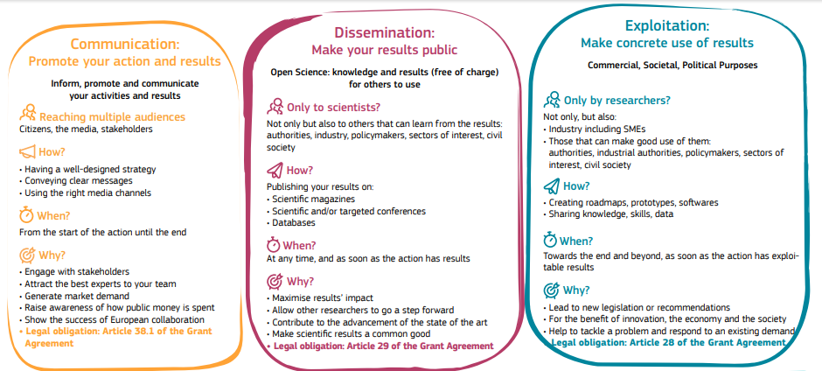
Figure 1: Definitions of Communication, Dissemination and Exploitation [1]

Resources
It is vital that projects ensure that their communications work is allocated sufficient resources (both human and financial) to do a good job. Doing communications well takes time and, for many tasks (e.g. creating videos), can incur costs.
It is also strongly recommended that projects use experienced communications professionals in order to put together and carry out a strong communications strategy and plan with clearly defined goals, audiences, messages and channels.

Communications plan
In order to communicate effectively about their activities and in strong coordination with the SESAR 3 JU, projects are expected to develop and submit to the SESAR 3 JU a communications plan (as a part of broader communications dissemination and exploitation plan - CDE).
Projects are requested to use the template provided by the SESAR 3 JU for the plan, and include the following elements:
- Project “about” text: Refers to a high-level description of the project to be used for communication, dissemination and exploitation purposes during the project life-cycle. The text should be readable by non-experts (max 20 lines).
- Project key messages: Refers to the key messages (max 3) to be used by the consortium, taking into account identified target audiences for communications and dissemination,(E.g. Information sharing is key to developing smart and seamless multimodal solutions for Europe’s citizens.) To attract the attention of media and key decision-maker audiences, projects should:
  - Describe the issue that the project is aiming to address. It is advisable to provide a context to the project, putting into simple terms what existed before the project started;
  - Emphasise the practical, quantified benefits of the project for local communities, as well as for Europe as a whole;
  - Capitalise on the reputation of national partners to engage with national and/or local press;
  - Put forward simple, striking figures and language to illustrate the benefits of the project;
  - Stress the relevance of the project outcomes for future efforts on ATM modernisation, implementation and deployment, specifying solutions to which the project has contributed.
- Keywords: Refers to a list of keywords that can be used to help identify your project. These will be used as metadata on the SESAR 3 JU website and as hashtags on relevant social media messaging.
- Focal point for communications, dissemination and exploitation: Refers to names of focal point(s) for communications, dissemination and exploitation.
- Communications objectives and strategy: outlines the project’s communications objectives and strategy.
- Target audiences: These audiences should be beyond the community in which your project is active, e.g. media, policy-makers, citizens.
- Communication channels: lists the channels to be used; press releases, press/magazine interviews, videos and podcasts, printed and/or online contents (newsletters, leaflets, factsheets, flyers, and brochures), websites and social media are some examples of communication channels/tools.
- Communication key performance indicators (KPIs) and success criteria: refers to the metrics that the project will use to measure the success of its outreach.
- Proposed schedule of activities: provides a timeline for the planned activities, indicated audiences, etc. Projects should consider the project lifecycle when deciding on which activities to schedule when - see Table 2.
See section 5 for further guidance regarding the different channels that will be included in the plan.

Scheduling communications activities
Communications is an activity that should take place throughout the duration of a project. In this respect, projects should consider the entire project lifecycle when scheduling communication activities, identifying the most appropriate timing for familiarising audiences with the project and providing updates. Table 2 indicates what kind of activities are appropriate when and where coordination is critical.
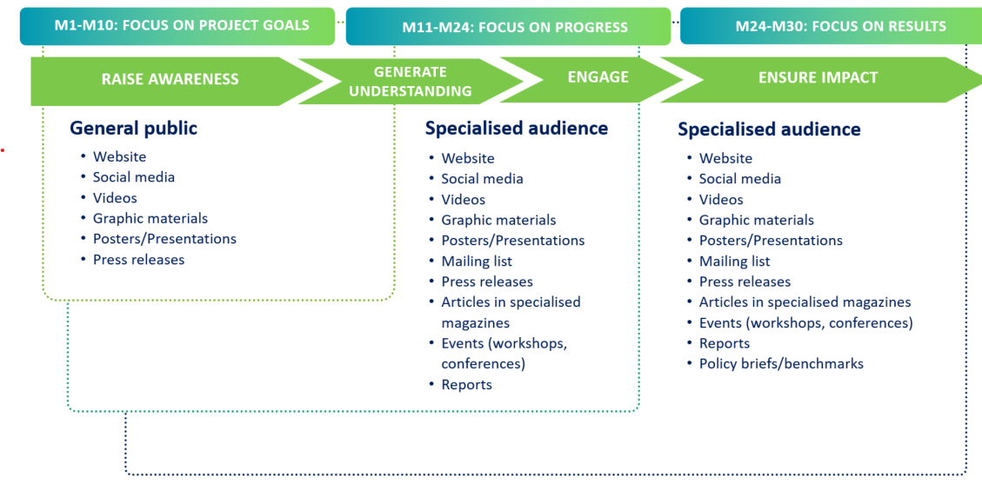
Table 2: Project communications lifecycle [2]
When scheduling activities, projects should also seek to piggyback or benefit from the following:
- Major air transport community events, such as ATM/aviation conferences and air shows represent communication opportunities where projects partner can promote work. Each project should also identify national events that might harness some local interest from key stakeholders and media attention in the project;
- Thematic days or weeks, such as international air traffic controller’s day, women’s day, Green Week, Mobility Week, etc);
- Major policy developments in relation to digitalisation and sustainability.
Projects are expected to enter key communications activities and their milestones into the overall project schedule so that they may be linked to the SESAR 3 JU corporate communications objectives, where applicable. Please see the Project Handbook for more guidance.

Checklist per channel
This section provides a checklist per each main communications channel.
It should be noted that all the costs of the activities described in this section are covered by the project grant/and or by members in-kind contributions.

Branding and acknowledgements

Members and partners
Use the relevant logo in communications material to present participation in the partnership (e.g dedicated webpages, trade stands, banners, posters, etc).  Download: SESAR 3 JU visual charter and “Support by” logo | 
 | 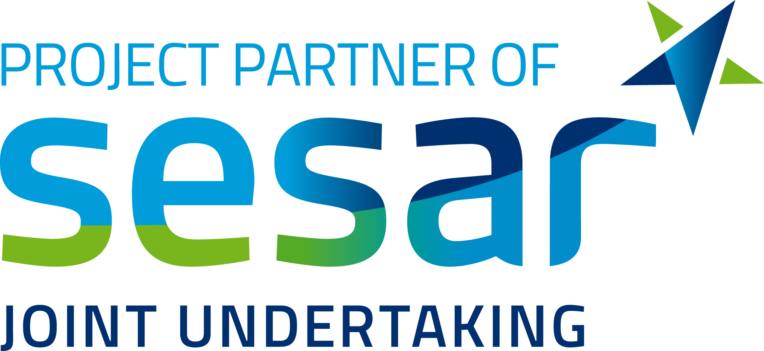
Table 4 Members and partner logos

Projects
The Horizon Europe and Connecting Europe Facility grant agreements have specific provisions regarding the visibility of the EU and SESAR JU logos on project (beneficiary) communication activities (including media relations, conferences, seminars, information material, such as brochures, leaflets, posters, presentations, etc., in electronic form, via traditional or social media, etc.).

In addition, projects are requested to refrain from designing their own logos; instead they can make use of template branding prepared by the SESAR 3 JU.
Acknowledge EU support and display the European flag (emblem) and funding statement  EU emblem (no need for prior approval from the SESAR 3 JU).  Download: https://europa.eu/european-union/about-eu/symbols/flag_en | 
Additional text for Horizon Europe projects
Additional text for Horizon Europe projects | The project has received funding from the SESAR 3 Joint Undertaking under the European Union's  Horizon Europe research and innovation programme under grant  agreement No [yyyyyy]
Use the “Supported/Powered by SESAR Joint Undertaking” logo.  Projects are required to use this logo in all communications material promoting their project activities, in addition to the EU emblem.  This logo should be applied to any prototypes, technical kit, screens, planes involved in SESAR JU projects in addition to the EU emblem. It can also be used when promoting the implementation of  specific solutions.  Download: SESAR 3 JU visual charter and “Support by” logo | 
Apply project branding template  Projects do not need to create their own logos. Logo template is provided by the SESAR 3 JU.  The templates from the SESAR 3 JU use colour scheme denoting the strand of research to which the project belongs within the SESAR JU innovation pipeline.  Project branding should be accompanied by the SESAR JU logo, the EU emblem as per the grant agreement.  Full details of project branding: SESAR 3 JU visual charter and “Support by” logo  Project logos and video intro/outros are available on STELLAR. | 
Branding hierarchy and visibility requirements  The project logo, the SESAR logo and the EU emblem must have clear and prominent visibility in all communication materials.  Project communications must not use the corporate branding, templates or visual identity of a single consortium member.  Where consortium member logos are included, they must appear in a secondary position and reflect the collective nature of the consortium. If logos are displayed, all consortium partners should be represented, rather than highlighting an individual organisation (with exceptions to clusters within consortia).  To ensure consistency, projects should develop dedicated communication templates (e.g. for presentations, reports, news items, social media visuals and press materials) that respect this branding hierarchy. | 
Table 5 Logos/emblems to be used by projects

Web presence

Members and partners
Develop a dedicated space on the website to the SESAR 3 JU containing the following elements:
- SESAR 3 JU logo (see section 5.1.1)
- Generic text about the SESAR 3 JU
- Link to the SESAR 3 JU website
- News/updates about participation in the SESAR 3 JU

Projects
- All EU-funded projects are required to have a web presence.
- Projects may consider developing standalone websites and/or a dedicated space for projects on the SESAR 3 JU website. Plans for standalone websites (e.g. URL, layout, navigation) should be shared with the SESAR 3 JU for approval as part of the CDE plan. Projects should consider using the name of the project and the SESAR in its social media account names, e.g www.burdi-sesar.eu, www.corus-sesar.eu. Projects should consider securing their domain name beyond the project duration to support exploitation obligations and ensure that project deliverables and key information remain accessible after the project ends.
- In addition, the SESAR 3 JU will have a dedicated page on each project. Projects will be provided templates for a number of content types (e.g. events, news, general website text updates), which they will be invited to submit to the SESAR 3 JU for publication on the SESAR 3 JU website and provided guidance on how to customise it and keep it up to date.
- Project beneficiaries should also coordinate with their respective in-house communications teams to develop content relating to the project on their organisation’s websites, ensuring the SESAR 3 JU and EU funding is referenced/displayed.

Events

Members and partners
- Act as ambassadors on behalf of the SESAR 3 JU at events/fora or contributing to written/digital communications material.
- Explore and exploit opportunities to support SESAR 3 JU’s outreach efforts in countries and localities where they have a corporate presence, for example, hosting or supporting the organisation of SESAR 3 JU events.

Projects
- Organise events to promote the work throughout the duration of project – see Table 2, in coordination with the SESAR 3 JU in order to:
  - Ensure consistency of visual branding
  - Maximise promotion
  - Identify SESAR 3 JU/VIP attendance, where appropriate

Social media

Members and partners
Promote the SESAR 3 JU through members/projects’ own social media channels. Specific actions include:
- Follow the SESAR 3 JU on the channels where it has a presence;
- Share and promote SESAR 3 JU posts;
- Post regular updates about involvement in the SESAR 3 JU to coincide with important milestones (e.g. joining the membership, coordinating projects, implementing a SESAR solution, etc)
- Tag or reference the SESAR 3 JU and EU in all relevant posts.

Projects
Promote project activities throughout the duration of the grant and engage directly with multiple audiences to show the benefit of their work. Share project news and stories via social media by:
- Establishing project-level accounts on social media platforms;
  - Projects should consider using the name of the project and the SESAR in its social media account names, e.g BURDI-SESAR, CORUS-SESAR
  - Projects should ensure that EU-SESAR 3 JU funding is referenced in profile bios using the relevant handles e.g. In Twitter, the handles to use are @SESAR_JU @HorizonEU @CINEA
  - Projects should tag or reference the SESAR 3 JU and EU in all posts;
  - In addition to promoting their own content, projects should share SESAR 3 JU’s posts where possible.
- Making use of beneficiaries own accounts on social media platforms;
  - Individual beneficiaries should tag or reference the SESAR 3 JU and EU in all posts, as well as other beneficiaries.
  - In addition to promoting their own content, projects should follow and share SESAR 3 JU’s posts where possible.
- Promoting content through the SESAR 3 JU social media accounts (e.g. @SESAR_JU on Twitter and SESAR Joint Undertaking on LinkedIn).

Publications and newsletters

Members and partners
Develop standalone brochures or a dedicated section on the SESAR 3 JU in annual reports and newsletters.

Projects
Develop printed material and newsletters, ensuring the SESAR 3 JU and EU funding is referenced/displayed.
All: Contribute to SESAR 3 JU publications (e.g. SESAR Solutions Catalogue, results brochures, DigitalSky annual digest, e-news) providing text and illustrative content, where needed.

Video and digital content

Members and partners
Develop video testimonials/animations about participating in the SESAR 3 JU.
Display “Member of/partner of SESAR 3 JU” logos in relevant corporate digital content.

Projects
Develop video and digital content to promote the project’s work, including teasers videos, animations and gifs. This type of material can be repurposed for social media, events and in presentations by project partners.
Ensure to include logos of all participating partners, as well as the SESAR JU and the EU logos (see section 5.1.1).
Read our project's teaser videos guidelines

Posters, roll-ups and stickers
Consider producing the following:

Members and partners
- Roll ups promoting membership/partnership in the SESAR 3 JU to act as backdrops to presentations or events;

Projects
Consider producing the following:
- Posters to illustrate the project’s objectives and core activities for use at events;
- Roll-ups promoting the project partners to act as backdrops to presentations or events;
- Stickers with the SESAR JU and EU emblems to be placed on prototypes, validation hubs, or computers.

Media

Members and partners
Support the SESAR 3 JU in developing targeted media campaigns, identifying journalists, including content in briefings on the partnership with national journalists, supporting press tours.

Projects
Press releases issued on behalf of the project consortium should use project-level branding, including the project logo, SESAR logo and EU emblem with appropriate prominence. They must not be issued under the corporate branding of a single consortium member.
However, individual consortium members may issue their own corporate press releases announcing or highlighting their participation in a SESAR project. In these cases, the communication may use the organisation’s own corporate branding and templates. The project should be clearly identified and acknowledged, including reference to the project name and, where appropriate, the project logo, SESAR Joint Undertaking and EU funding.

This distinction ensures that communications clearly reflect whether the message represents the project consortium as a whole or an individual partner’s communication about its participation.
Projects are encouraged to take a broad approach to media outreach. In addition to trade press (such as industry magazines and inflight magazines), projects should consider media outlets that reach other key audiences, including policy makers and the scientific community. Examples include CORDIS, Euronews, Horizon Magazine, Euractiv and ScienceBusiness.
A practical way to increase visibility is to distribute press materials through press release portals used by journalists, such as AlphaGalileo.
Projects should coordinate media outreach with the SESAR 3 Joint Undertaking, particularly for press launches, major announcements, or opportunities for broader European-level visibility.

Coordination of communication activities
Members and partner are requested to inform the SESAR 3 JU Communications Sector when preparing external communication activities in which the JU is heavily referenced.
Project consortia are also requested to contact the SESAR 3 JU in relation to the activities listed in their communications, dissemination and exploitation plan).
To facilitate the coordination of communication activities, each member and project is asked to:
- Assign a communications lead contact with relevant skills in the field;
- Participate in communication coordination group activities organised by the SESAR 3 JU, such as meetings of the SESAR 3 JU communications coordination group (members only), inter-project coordination meetings, external events, etc – see Section 6.1.

Communications Coordination
Coordination with the SESAR 3 JU is not only necessary but also beneficial for projects:
- Ensures that project communications and outreach milestones are integrated into broader SESAR 3 JU communications scheduling and planning;
- Enables a consistency check of project strategies, key messages, targeted audiences and communications material and an alignment with the SESAR 3 JU’s core objectives;
- Provides communications support of the SESAR 3 JU in promoting project events and conferences;
- Maximises outreach by using SESAR 3 JU communications channels and cooperative arrangements to further cascade relevant content.
Although it may be that one beneficiary takes the lead on communications, it is critical that all project beneficiaries are engaged in decisions and activities relating to external communications.
Beneficiaries should ensure that the communications plan provides the resources that they will need to communicate (Relevant logos, messages, about text, etc).
Beneficiaries should work with linked third parties to ensure the promotion of the project, keeping in mind that:
- All promotion by linked third parties clearly mentions the beneficiary with whom they are collaborating and their role and scope of cooperation within the action.
- Beneficiaries may agree to promote the project on their third parties’ communication channels. Beneficiaries should agree beforehand on text and use of the above emblems/logos to describe the involvement of their linked third parties.
A representative from the SESAR 3 JU communications sector joins project kick-offs and participates in reviews of any deliverables related to communications.

In addition to project communications coordination, members of the SESAR 3 JU can also appoint a point of contact for their organisation to participate in the Communications Coordination Group (CCG). This is group through which the SESAR 3 JU and member representatives coordinate communications activities of the partnership and programme.
The SESAR 3 JU organises one-to-two general meetings per year, as well as ad hoc meetings to address specific communications campaigns or events (e.g. Airspace World).

STELLAR
Why you need to know about STELLAR

All communications points of contacts should be familiar with STELLAR.

Resources
- SESAR JU resources and links
SESAR JU website
SESAR JU logos and visual identity charter
EU emblem and guidance on its use
E-newsletter and subscription
Guidance | Communication-at-a-glance guidelines for SESAR 3 JU-funded projects  Project's teaser videos guidelines  Full communications guidelines on the SESAR 3 JU collaborative platform (STELLAR)  Project presentation template
Social media channels | @SESAR_JU (Twitter), @SESAR Joint Undertaking (LinkedIn), SESARJU (Youtube)  @HorizonEU (Twitter) and @European Commission (LinkedIn)  @cinea_eu (Twitter), cinea - european climate, infrastructure and environment executive agency (LinkedIn)
Social media hashtags | #ATM #DigitalSky #innovation #SESARJU  HorizonEU #MobilityStrategy #Uspace  #HorizonEurope #CEFTransport
Key publications | https://www.sesarju.eu/publications
Videos | SESAR 3 JU animation: https://youtu.be/KWL9DJwMewE  Digital European Sky: https://www.youtube.com/watch?v=chx27ZrlPoM&t=156s

- EU Resources
- Communication, dissemination and exploitation: Why they all matter and what is the difference?
https://ec.europa.eu/research/participants/docs/h2020-funding-guide/imgs/quick-guide_diss-expl_en.pdf
- Communicating EU research and innovation guidance for project participants http://ec.europa.eu/research/participants/data/ref/h2020/other/gm/h2020-guide-comm_en.pdf
- The use of the EU emblem
http://ec.europa.eu/dgs/communication/services/visual_identity/pdf/use-emblem_en.pdf
- EU interinstitutional style guide
http://publications.europa.eu/code/en/en-000100.htm
- Misused English words and Expressions in EU publications
http://ec.europa.eu/translation/english/guidelines/documents/misused_english_terminology_eu_publications_en.pdf
- How to write clearly
http://bookshop.europa.eu/en/how-to-write-clearly-pbHC3010536/
- Social networks of the EU
https://europa.eu/european-union/contact/social-networks_en

SESAR 3 JU Communications Strategy https://www.sesarju.eu/sites/default/files/documents/GB/2022/SESAR%203%20JU%20Communications%20Strategy%20dp.pdf
https://ec.europa.eu/transport/themes/mobilitystrategy_en
https://ec.europa.eu/commission/presscorner/detail/en/fs_19_6714
https://ec.europa.eu/info/strategy/priorities-2019-2024/europe-fit-digital-age_en

