 | SESAR 2020 PJ14.02.06 - TVALR
 | Deliverable ID: | D7.1.030
 | Dissemination Level: | PU
 | Project Acronym: | EECNS
 | Grant: | 734168
 | Call: | [H2020-SESAR-2015-2]
 | Topic: | SESAR.IR-VLD.Wave1-17-2015
 | Consortium Coordinator: | LDO
 | Edition Date: | [10 October 2019]
 | Edition: | [01.00.02]
 | Template Edition: | 02.00.01

INDUSTRIAL RESEARCH



Authoring & Approval
Authors of the document
Name/Beneficiary | Position/Title | Date
Giulio Vivaldi/LDO | T2/T3 Leader and WP7 Solution Manager | 02/10/19
Danila Savian/LDO | Contributor | 17/05/19
Giulio Di Tillio/AIRTEL | T4 Leader | 17/05/19

Reviewers internal to the project
Name/Beneficiary | Position/Title | Date
Nikos Fistas/ECTL | T1 Leader | 08/10/19
Giulio Di Tillio/AIRTEL | T4 Leader | 08/10/19
Victor Flores Gomez/ECTL | Contributor | 08/10/19
Antonio Correas/ECTL-ext | Contributor | 08/10/19
Cecilia Coveri/LDO | Contributor | 08/10/19
Simona Pierattelli/LDO | Contributor | 08/10/19

Approved for submission to the SJU By - Representatives of beneficiaries involved in the project
Name/Beneficiary | Position/Title | Date
Giulio Vivaldi/LDO | T2/T3 Leader and WP7 Solution Manager | 10/10/19
Nikos Fistas/ECTL | T1 Leader | 10/01019
Giulio Di Tillio/AIRTEL | T4 Leader | 10/10/19

Rejected By - Representatives of beneficiaries involved in the project
Name/Beneficiary | Position/Title | Date

Document History
Edition | Date | Status | Author | Justification
00.00.01 | 17/05/19 | Draft | G.Vivaldi | Draft Interim version
00.00.02 | 05/07/19 | Interim | G.Vivaldi | Interim version reviewed by Partners
00.00.03 | 26/07/19 | Final Draft | G.Vivaldi | Final Draft version after Partners review
01.00.00 | 31/07/19 | Final | G.Vivaldi | Final version approved by Partners
01.00.01 | 02/10/19 | Final Draft | G.Vivaldi | Final draft after SJU comments review
01.00.02 | 10/10/19 | Final | G.Vivaldi | Final version approved by Partners
Copyright Statement
© – 2019 – Leonardo Eurocontrol Airtel
All rights reserved. Licensed to the SJU under conditions.
The opinions expressed herein reflect the author’s view only. Under no circumstances shall the SESAR Joint Undertaking be responsible for any use that may be made of the information contained herein.

EECNS
PJ14 EECNS (ESSENTIAL AND EFFICIENT COMMUNICATION NAVIGATION AND SURVEILLANCE INTEGRATED SYSTEM)

This Technical Validation Report is part of a project that has received funding from the SESAR Joint Undertaking under grant agreement No 734168 under European Union’s Horizon 2020 research and innovation programme.


Abstract
This is the Technical Validation Report for Solution PJ14.02.06 (Completion of AeroMACS Development).
Solution PJ14.02.06 builds upon Solution #102 published in the SESAR 1 catalogue. AeroMACS Solution #102 reached TRL6 Maturity Level as Data Link, however in SESAR1 no specific Exercise was executed to integrate AeroMACS Access Network with ATN/OSI and ATN/IPS Networks, neither in Multilink environment, and neither with Digital Voice Systems. This is the scope of PJ14.02.06.
In order to differentiate Solution #102 and PJ14.02. 06 Solutions, a new Enabler (CTE-C02d0) with Maturity Level TRL6 in 2014 has been created and assigned to Solution #102 via CR. In addition, a further CR has been developed to set CTE-C02d TRL6 date in 2019.
This TVALR describes the activities executed within the Solution PJ14.02.06 framework in order to make the Solution reach the planned TRL6 maturity level at the end of Wave 1, specifically through the execution of different Technical Validation exercises. In particular, this document contains a reference to the Technical Validation Plan previously delivered (with the context of the technical validation in terms of R&D needs, technical validation targets, stakeholders’ expectations, objectives and details related to each planned technical validation activities), the detailed Technical Validation Report for the conducted Exercises, the analysis of results and conclusions.
Solution PJ14.02.06 foresees the following Technical Validation Exercises:
- EXE-PJ14.2.6-TRL6-TVALP-001: EXE#01: Technically validate the integration of AeroMACS with ATN/OSI.
- EXE-PJ14.2.6-TRL6-TVALP-002: EXE#02: Technically validate the integration of AeroMACS with ATN/IPS.
- EXE-PJ14.2.6-TRLx-TVALP-003: EXE#03: Technically validate the capability to support digital voice by the AeroMACS Data Link.
- EXE-PJ14.2.6-TRL6-TVALP-004: EXE#04: Technically validate the integration of AeroMACS with Multilink in ATN/OSI environment.
Table of Contents

Abstract 4
1 Executive summary 10
2 Introduction 11
2.1 Purpose of the document 11
2.2 Intended readership 11
2.3 Background 11
2.4 Structure of the document 11
2.5 Glossary of terms 12
2.6 Acronyms and Terminology 13
3 Context of the Technical Validation 16
3.1 SESAR Technological Solution 14.02.06: a summary 16
3.2 Summary of the Technical Validation Plan 17
3.3 Deviations 26
4 SESAR Technological Solution PJ14.02.06 Validation Results 28
4.1 Summary of SESAR Technological Solution PJ14.02.06 Validation Results 28
4.2 Detailed analysis of SESAR Technological Solution Validation Results per Validation objective 31
4.3 Confidence in the Validation Results 51
5 Conclusions and recommendations 53
5.1 Conclusions 53
5.2 Recommendations 53
6 References 55
6.1 Applicable Documents 55
6.2 Reference Documents 57
A.1 Technical Validation Exercise #01 Report 59
A.1.1 Summary of the Technical Validation Exercise #01 Plan 59
A.1.2 Technical Validation Exercise #01 description and scope 59
A.1.3 Summary of Exercise 1 Technical Validation Objectives and success criteria 59
A.1.4 Summary of Technical Validation Exercise #01 Validation scenarios 60
A.1.5 Summary Technical Validation Exercise #01 Assumptions 60
A.2 Deviation from the planned activities 61
A.3 Technical Validation Exercise #01 Validation Results 61
A.3.1 Summary of Technical Validation Exercise #01 Results 61
1. Results on technical feasibility 63
2. Results per KPA 63
A.3.2 Analysis of Exercise 1 Results per Technical Validation objective 63
1. OBJ-14.2.6-TRL6-TVALP-001 Results 63
1. OBJ-14.2.6-TRL6-TVALP-002 Results 63
A.3.3 Unexpected Behaviours/Results 63
A.3.4 Confidence in Results of Validation Exercise 1 63
1. Level of significance/limitations of Technical Validation Exercise Results 63
2. Quality of Technical Validation Exercises Results 64
3. Significance of Technical Validation Exercises Results 64
A.3.5 Conclusions 64
1. Conclusions on technical feasibility 64
2. Conclusions on performance assessments 64
A.3.6 Recommendations 64
Appendix B Technical Validation Exercise #02 Report 65
B.1.1 Summary of the Technical Validation Exercise #02 Plan 65
B.1.2 Technical Validation Exercise #02 description and scope 65
B.1.3 Summary of Exercise #02 Technical Validation Objectives and success criteria 65
B.1.4 Summary of Technical Validation Exercise #02 Validation scenarios 65
B.1.5 Summary Technical Validation Exercise #02 Assumptions 65
B.2 Deviation from the planned activities 66
B.3 Technical Validation Exercise #02 Validation Results 66
B.3.1 Summary of Technical Validation Exercise #02 Results 66
1. Results on technical feasibility 68
2. Results per KPA 68
B.3.2 Analysis of Exercise 2 Results per Technical Validation objective 68
1. OBJ-14.2.6-TRL6-TVALP-003 Results 68
B.3.3 Unexpected Behaviours/Results 68
B.3.4 Confidence in Results of Validation Exercise 2 68
1. Level of significance/limitations of Technical Validation Exercise Results 68
2. Quality of Technical Validation Exercises Results 69
3. Significance of Technical Validation Exercises Results 69
B.3.5 Conclusions 69
1. Conclusions on technical feasibility 69
2. Conclusions on performance assessments 69
B.3.6 Recommendations 69
Appendix C Technical Validation Exercise #03 Report 70
C.1.1 Summary of the Technical Validation Exercise #03 Plan 70
C.1.2 Technical Validation Exercise #03 description and scope 70
C.1.3 Summary of Exercise #03 Technical Validation Objectives and success criteria 70
C.1.4 Summary of Technical Validation Exercise #03 Validation scenarios 70
C.1.5 Summary Technical Validation Exercise #03 Assumptions 70
C.2 Deviation from the planned activities 71
C.3 Technical Validation Exercise #03 Validation Results 71
C.3.1 Summary of Technical Validation Exercise #03 Results 71
1. Results on technical feasibility 72
2. Results per KPA 72
C.3.2 Analysis of Exercise 3 Results per Technical Validation objective 72
1. OBJ-14.2.6-TRL6-TVALP-004 Results 72
C.3.3 Unexpected Behaviours/Results 72
C.3.4 Confidence in Results of Validation Exercise 3 72
1. Level of significance/limitations of Technical Validation Exercise Results 72
2. Quality of Technical Validation Exercises Results 73
3. Significance of Technical Validation Exercises Results 73
C.3.5 Conclusions 73
1. Conclusions on technical feasibility 73
2. Conclusions on performance assessments 73
C.3.6 Recommendations 73
Appendix D Technical Validation Exercise #04 Report 74
D.1.1 Summary of the Technical Validation Exercise #04 Plan 74
D.1.2 Technical Validation Exercise #04 description and scope 74
D.1.3 Summary of Exercise #04 Technical Validation Objectives and success criteria 74
D.1.4 Summary of Technical Validation Exercise #04 Validation scenarios 74
D.1.5 Summary Technical Validation Exercise #02 Assumptions 75
D.2 Deviation from the planned activities 76
D.3 Technical Validation Exercise #02 Validation Results 76
D.3.1 Summary of Technical Validation Exercise #02 Results 76
1. Results on technical feasibility 76
2. Results per KPA 76
D.3.2 Analysis of Exercise 2 Results per Technical Validation objective 77
1. OBJ-14.2.6-TRL6-TVALP-005 Results 77
D.3.3 Unexpected Behaviours/Results 77
D.3.4 Confidence in Results of Validation Exercise 4 77
1. Level of significance/limitations of Technical Validation Exercise Results 77
2. Quality of Technical Validation Exercises Results 77
3. Significance of Technical Validation Exercises Results 77
D.3.5 Conclusions 77
1. Conclusions on technical feasibility 77
2. Conclusions on performance assessments 78
D.3.6 Recommendations 78
Appendix E Safety Assessment Report (SAR) 79
Appendix F Security Assessment Report (SecAR) 80
Appendix G Human Performance Assessment Report (HPAR) 81
Appendix H SESAR Technological Solution(s) Maturity Assessment 82
Appendix I High level Economic Appraisal 83
I.1 Objectives and scope of this Appendix 83
I.2 Problem(s) addressed by the Solution 83
I.3 Stakeholders involvement description 84
I.4 Reference Scenario 85
I.5 Solution Scenario and Benefits 87
I.6 Conclusions 94

List of Tables
Table 1: Glossary of terms 13
Table 2: Acronyms and terminology 15
Table 3: SESAR Technological Solution(s) under Validation 17
Table 4 List of relevant technologies used in the Exercises 18
Table 5 Exercises schedule 18
Table 6: Technical Validation Objective OBJ-14.2.6-TRL6-TVALP-001 19
Table 7: Technical Validation Objective OBJ-14.2.6-TRL6-TVALP-002 21
Table 8: Technical Validation Objective OBJ-14.2.6-TRL6-TVALP-003 22
Table 9: Technical Validation Objective OBJ-14.2.6-TRL6-TVALP-004 23
Table 10: Technical Validation Objective OBJ-14.2.6-TRL6-TVALP-005 24
Table 11: Technical Validation Assumptions overview 25
Table 12: Summary of Technical Validation Exercises Results 31
Table 13: Validation Objectives addressed in Technical Validation Exercise 1 59
Table 14: Technical Validation Assumptions overview 61
Table 15: Technical Validation Results Exercise 1 63
Table 16: Validation Objectives addressed in Technical Validation Exercise 2 65
Table 17: Technical Validation Assumptions overview 66
Table 18: Technical Validation Results Exercise 2 68
Table 19: Validation Objectives addressed in Technical Validation Exercise 3 70
Table 20: Technical Validation Assumptions overview 71
Table 21: Technical Validation Results Exercise 3 72
Table 22: Validation Objectives addressed in Technical Validation Exercise 4 74
Table 23: Technical Validation Assumptions overview 75
Table 24: Technical Validation Results Exercise 4 76
Table 25 – Awards criteria, current scenarios and optimization needs 87
Table 26 Improvements to the current scenario in presence of the proposed technology 89
Table 27: Economic benefits per airport category 92
Table 28: Benefits&Performances: an example of numerical estimation 94

List of Figures
Figure 1: First Scenario: one single Service Provider connected to AeroMACS ASN 32
Figure 2: Second Scenario - two Service Providers connected to AeroMACS ASN in roaming (Visitor/Home) 35
Figure 3: Different aircraft connected to different Service providers (roaming) 36
Figure 4: Distribution of Transaction Times measured in EXE#1 39
Figure 5: Wireshark capture of ADS-C exchange through AeroMACS 40
Figure 6: ATN/OSI over AeroMACS: Protocol Stack description 40
Figure 7: Aircraft ADS-C End-To-End Traffic (EPP) 41
Figure 8: Service Provider connected to AeroMACS ASN in ATN/IPS environment 42
Figure 9: Distribution of Transaction Times measured in EXE#2 44
Figure 10: CPDLC exchange between AIR and GROUND ESs through AeroMACS 44
Figure 11: VoIP over AeroMACS: the validated Scenario 45
Figure 12: SIP/SDP and RTP bursts between VoIP ESs over AeroMACS 47
Figure 13: ATN/OSI Multilink testbed 47

Executive summary
This is the Technical Validation Report for Solution PJ14.02.06 (Completion of AeroMACS Development) . This is intended to provide information to SJU on the executed activities.
successful execution of the different Technical Validation Exercises demonstrated full achievement of TRL6 Maturity Level for CTE-C02d Enabler.
This TVALR describes the activities executed within the Solution PJ14.02.06 framework in order to make the Solution reach the planned TRL6 maturity level at the end of Wave 1, specifically through the execution of different Technical Validation exercises.
The list of Exercises planned in 14.02.06 is reported below:
- Exercise #1 aims to the technical validation of the integration of AeroMACS with ATN/OSI
- Exercise #2 aims to the technical validation of the integration of AeroMACS with ATN/IPS
- Exercise #3 aims to evaluate the integration of Digital Voice as an element of the AeroMACS Communication Infrastructure.
- Exercise #4 is finalized to the technical validation of the integration of AeroMACS with Multilink in ATN/OSI environment; as from the PMP, the integration of AeroMACS with Multilink ATN/IPS will be verified in the framework of PJ14.02.04 Solution, according to the scheduling of PJ14.02.04.
Successful execution of the Technical Validation Exercises demonstrated that the integration of AeroMACS Access Network with the systems indicated in the list above is feasible, and compliant with performance requirements specified in the relevant standards.
For these reasons achieved maturity level for CTE-C02d Enabler at the end of all the technical validation exercises covered in this TVALR is TRL6, and AeroMACS is ready for the deployment phase.

Introduction

Purpose of the document
This document provides the Technical Validation Report for SESAR Technological Solution PJ14.02.06 for TRL6. As recommended by the guidelines, the SESAR Technological Solution PJ.14.02.06 will produce only one Technical Validation Report per TRL6 phase integrating the contributions related to each planned TRL6 validation activity.

Intended readership
The intended readership for this document is:
- PJ14.01.01
- Project members of the technical communications projects (PJ14.02.xx) ,
- Project members of Enhanced Guidance Assistance to Aircraft and Vehicles on the Airport Surface Combined with Routing Pj3a solution 1,
- Project members of SWIM Infrastructures Pj17,
- Involved stakeholders: product management surveillance of ANSPs to be aware of the proposed technical solution
- Pj19 and SJU: to gather information on enabler and consider in future ATC architecture solutions.

Background
The AeroMACS Solution PJ14-02-06 continues the work of the SESAR1 projects P15.02.07 and P9.16, in addition to the PJ12.03.04, that investigated the use of D-TAXI with AeroMACS. Therefore, all the deliverables produced by these SESAR1 Projects are relevant and constitute Background Information, having led AeroMACS Solution #102, published in the SESAR 1 catalogue, to reach TRL6 Maturity Level as Data Link. However, SESAR1 focused on the verification of functions related to the a/g communication over Air Interface, both ground and airborne side, but no specific Exercise was executed to integrate AeroMACS Access Network with ATN/OSI and ATN/IPS Networks, neither in Multilink environment, and neither with Digital Voice Systems. This is the scope of PJ14.02.06.

Structure of the document
This document consists of the following chapters:
- Chapter 1 – Executive Summary: it is intended to provide a summary of the key information and elements contained in the Technical Validation Report in an expanded version of the abstract.
- Chapter 2 – Introduction: it states the purpose of the Technical Validation Report by providing details about the content and a list of intended readerships. This section presents also any previous work that could be relevant to the subject covered by this Technical Validation Report. A summary of the main terms and acronyms used throughout the document is provided as well.
- Chapter 3 – Context of the Technical Validation: it provides a brief description of the overall aim of this Validation Report describing the context in terms of geographical and operational environment, associated Operational Improvement Steps and enablers, R&D needs and validation targets. A picture illustrating the Initial Maturity Level for each of mentioned OIs is provided as well.
- Chapter 4 – PJ14-02-06 Technical Validation Results: it analyses the results of validation exercises at Technological Solution PJ14-02-06 level for TRL6 phase, describing confidence in the Technical Validation results at Solution level.
- Chapter 5 – Conclusions and recommendations
- Chapter 6 – References: it identifies the main documentation that is considered as reference for the Validation Report.
- Appendixes A.1, A.2, A.3, A.4 contain the Technical Validation Exercises Reports

Glossary of terms

Term | Definition | Source of the definition
 | A means by which the terms of an ADS-C agreement will be exchanged between the ground system and the aircraft, via a data link, specifying under what conditions ADS-C reports would be initiated, and what data would be contained in the reports. | EUROCAE ED-120
  Automatic Dependent Surveillance-Contract (ADS-C)
AIR-REPORT | A report from an aircraft in flight prepared in conformity with requirements for position, and operational and/or meteorological reporting. | ICAO Annex 3
Aeronautical Telecommunication Network (ATN) | Can include in its meaning the ATN applications such as CM, CPDLC, and ADS. | EUROCAE ED-110B
ATN end system | ATN end system (ATN ES) The portion of the end system (ES) that implements the application entities as defined in Doc 9705. | EUROCAE ED-110B
Controller Pilot Data Link Communication | Application that allows data link communication between controllers and pilots together with end-to-end protection of message integrity by an application level integrity check that also provides assurance of correct delivery. | EUROCAE ED-110B
Table 1: Glossary of terms

Acronyms and Terminology

Term |  | Definition
AAA | Authentication, Authorization, and Accounting
AAA Server | Computer system performing AAA services (authentication, authorization, accounting)
AAR | Airborne ATN Router
AC-R | Access Router
ADD | Architecture Description Document
ADS-B | Automatic Dependent Surveillance - Broadcast
ADS-C | Automatic Dependent Surveillance - Contract
AGR | Air Ground Router
ASN | Access Service Network
ASN-GW | ASN Gateway
ATM | Air Traffic Management
ATN | Air Traffic Network
B2 | Baseline 2
BIS | Boundary Intermediate System
BS | Base Station
CC | Capability Configuration
CLNP | Connectionless Network Protocol
CM/CPDLC | Context Management/Controller Pilot Data Link Communications
COS | Class Of Service
CPE | Customer Premises Equipment (it refers to both Avionic and Ground Radio equipment, mobile or fixed)
CSN | Connectivity Service Network
DHCP | Dynamic Host Configuration Protocol
EAP-TLS | Extensible Authentication Protocol - Transport Layer Security
EATMA | European ATM Architecture
E-ATMS | European Air Traffic Management System
EPP | Extended Projected Profile
ES | End System
FAA | Federal Aviation Administration
GGR | Ground-Ground Router
HA | Home Agent
IBP | Industrial based Platform
IDRP | Inter Domain Routing Protocol
IER | Information Exchange Requirement
INTEROP | Interoperability Requirements
IP | Internet Protocol
IPS | Internet Protocol Suite
IRS | Interface Requirements Specification
IS | Intermediate System
ISH | Intermediate System Hello
LISP | Location Identifier Separation Protocol
ISRM | Information Services Reference Model
MS | Mobile Station
NAF | NATO Architecture Framework
NAP | Network Access Provider
NAT | Network Address Translation
NSOV | NAF Service Oriented View
NSP | Network Service Provider
NOV | NAF Operational View
NSV | NAF System View
OSI | Open System Interconnection
OSED | Operational Service and Environment Definition
PDU | Protocol Data Unit
PIRM | Programme Information Reference Model
QoS | Quality of Service
RRA | Radio Resource Agent
RRC | Radio Resource Controller
RRM | Radio Resources Management
RTP | Real Time Protocol
SDD | Service Description Document
SDP | Session Description Protocol
SDU | Service Data Unit
SIP | Session Initiation Protocol
SESAR | Single European Sky ATM Research Programme
SJU | SESAR Joint Undertaking (Agency of the European Commission)
SNPA | SubNetwork Point of Attachment
SoaML | Service Oriented Architecture Modelling Language
SPR | Safety and Performance Requirements
SS | Subscriber Station
SUT | System Under Test
SWIM | System Wide Information Model
TRL | Technology Readiness Level
TS | Technical Specification
UDP | User Datagram Protocol
UML | Unified Modelling Language
VoIP | Voice over IP
VRC | Voice Radio Controller
V&V | Validation and Verification
WSDL | Web Services Definition Language
XSD | XML Schema Definition
Table 2: Acronyms and terminology

Context of the Technical Validation
This section provides the general background for the Technical Validation Report, and describes the context for the Technical Validation Report for TRL6 achievement that will be detailed in 4.

SESAR Technological Solution 14.02.06: a summary

SESAR Technological Solution ID | SESAR Technological Solution Description | Master or Contributing  (M or C) | Contribution to the SESAR Technological Solution short description | Enablers ref. (from EATMA)
PJ14.02.06 | Completion of AeroMACS Development | M | Integration and technical validation of AeroMACS data link with ATN services, both at ground and on-board.  At the start of the Solution work, the CTE-C02d Title was “New Airport Datalink technology (AEROMACS) - New wireless technology for the Airport Datalink AEROMACS over ATN/IPS, based on IEEE 802.16 WiMax, as a new standard for airport surface communications (ATS, AOC and APOC) for the Aircraft and Vehicles.” The Enabler Description deals only with ATN/IPS. However, since PJ14.02.06 Solution validates also the integration of AeroMACS with ATN/OSI, then the Enabler Description has been modified accordingly, as indicated in the Enabler Ref. Column. | CTE-C02d - New Airport Datalink technology (AEROMACS)  New wireless technology for the Airport Datalink AEROMACS over ATN/OSI and ATN/IPS, based on IEEE 802.16 WiMax, as a new standard for airport surface communications (ATS, AOC and Airport Authority Communications) for the Aircraft and Vehicles.
Table 3: SESAR Technological Solution(s) under Validation

Summary of the Technical Validation Plan

Validation Plan Purpose
Aim of the Technical Validation Plan is to validate the AeroMACS technology integrated with ATN Services, through a set of exercises, in a realistic operating environment, finalized to reach a pre-operational validation level, i.e. TRL6.
The key activities are the demonstration of ATN services, ATN/OSI and ATN/IPS, over AEROMACS A/G Data Link and the integration of AeroMACS into the multilink environment.

The Plan foresees the execution of four exercises:
- Exercise #1 aims to the technical validation of the integration of AeroMACS with ATN/OSI
- Exercise #2 aims to the technical validation of the integration of AeroMACS with ATN/IPS
- Exercise #3 aims to evaluate the integration of Digital Voice as an element of the AeroMACS Communication Infrastructure.
- Exercise #4 is finalized to the technical validation of the integration of AeroMACS with Multilink in ATN/OSI environment; as from the PMP, the integration of AeroMACS with Multilink ATN/IPS will be verified in the framework of PJ14.02.04 Solution, according to the scheduling of PJ14.02.04.
The table below provides an overview of the technologies that are relevant for the scope of the activities captured in this Validation.

Technology | Provided by | Exercise #1 | Exercise #2 | Exercise #3 | Exercise #4
AeroMACs BS | LDO | X | X | X | X
AeroMACS ASN-GW | LDO | X | X | X | X
AeroMACS AAA-Srv | LDO | X | X | X | X
AeroMACS Mobile Stations | LDO | X | X | X | X
VoIP AM Radios | LDO |  |  | X
VoIP Radio Controller | LDO |  |  | X
NAT Router | LDO |  |  | X
A/G IPS Router | LDO |  | X
Airborne IPS Router | LDO |  | X
VDL2 Link simulator | Airtel-NATMIG |  |  |  | X
ATN OSI Router A/G Router | Airtel-NATMIG | X
A/G Router for VDL2 and AeroMACS | Airtel-NATMIG |  |  |  | X
ATN/IPS GROUND Test Tool | Airtel-NATMIG |  | X
ATN/IPS AIR Test Tool | Airtel-NATMIG |  | X
Ground ATN OSI stack test component | Airtel-NATMIG | X |  |  | X
Airborne ATN OSI test component | Airtel-NATMIG | X |  |  | X
Table 4 List of relevant technologies used in the Exercises

The scheduling for each exercise is summarised in the following table, showing the start and the end of each exercise as extracted by the official GANTT.

Exercise | Title | Start | End
#1 | Technically validate the integration of AeroMACS with ATN/OSI | 19/06/2018 | 06/07/2018
#3 | Technically validate the integration of AeroMACS with Digital Voice | 07/01/2019 | 31/01/2019
#4 | Technically validate the integration of AeroMACS with multilink ATN/OSI environment | 04/02/2019 | 01/03/2019
#2 | Technically validate the integration of AeroMACS with ATN/IPS | 06/05/2019 | 07/06/2019
Table 5 Exercises schedule

Summary of Technical Validation Objectives and success criteria
[OBJ]
Identifier | OBJ-14.2.6-TRL6-TVALP-001
Title | ATN/OSI Technical feasibility
Objective | Ensure and maintain ATN/OSI connectivity to support ATN B2 Services exchanges through AeroMACS Access Network
Category | <Technical Feasibility>
Key Environment Conditions | ATN-B2 Air and Ground end systems or traffic emulators
TRL Phase | TRL6

[OBJ Trace]
Relationship | Linked Element Type | Identifier
<COVERS> | <SESAR Solution> | PJ14-02-06
<COVERS> | <ATMS Requirement> | REQ-14.02-06-TS-IRS-0003
<COVERS> | <ATMS Requirement> | REQ-14.02-06-TS-IRS-0004
<COVERS> | <ATMS Requirement> | REQ-14.02-06-TS-IRS-0005
<COVERS> | <ATMS Requirement> | REQ-14.02-06-TS-IRS-0006
<COVERS> | <ATMS Requirement> | REQ-14.02-06-TS-IRS-0007
<COVERS> | <ATMS Requirement> | REQ-14.02-06-TS-IRS-0008
<COVERS> | <ATMS Requirement> | REQ-14.02-06-TS-IRS-0009
<COVERS> | <ATMS Requirement> | REQ-14.02-06-TS-IRS-0010
<COVERS> | <ATMS Requirement> | REQ-14.02-06-TS-IRS-0012
<COVERS> | <ATMS Requirement> | REQ-14.02-06-TS-IRS-0013
<COVERS> | <ATMS Requirement> | REQ-14.02-06-TS-IRS-0014
<COVERS> | <ATMS Requirement> | REQ-14.02-06-TS-IRS-0001
<COVERS> | <ATMS Requirement> | REQ-14.02-06-TS-IRS-0002

[OBJ Suc]
Identifier | Success Criterion
CRT-14.2.6-TRL6-TVALP-001-001 | Ensure and maintain ATN B2 messages exchange between Airborne and Ground ATN/OSI ESs, through AeroMACS Access Network and one CSP Ground Network.
Table 6: Technical Validation Objective OBJ-14.2.6-TRL6-TVALP-001

[OBJ]
Identifier | OBJ-14.2.6-TRL6-TVALP-002
Title | Two Service Providers connected to AeroMACS ASN in a roaming scenario (Visitor/Home)
Objective | Ensure and maintain ATN/OSI connectivity when one Service Provider is connected to AeroMACS ASN in a roaming scenario through another CSP Network, complying with the long-term performance requirements
Category | <Technical Feasibility>
Key Environment Conditions | ATN-B2 Air and Ground end systems or traffic emulators
TRL Phase | TRL6

[OBJ Trace]
Relationship | Linked Element Type | Identifier
<COVERS> | <SESAR Solution> | PJ14-02-06
<COVERS> | <ATMS Requirement> | REQ-14.02-06-TS-IRS-0003
<COVERS> | <ATMS Requirement> | REQ-14.02-06-TS-IRS-0004
<COVERS> | <ATMS Requirement> | REQ-14.02-06-TS-IRS-0005
<COVERS> | <ATMS Requirement> | REQ-14.02-06-TS-IRS-0006
<COVERS> | <ATMS Requirement> | REQ-14.02-06-TS-IRS-0007
<COVERS> | <ATMS Requirement> | REQ-14.02-06-TS-IRS-0008
<COVERS> | <ATMS Requirement> | REQ-14.02-06-TS-IRS-0009
<COVERS> | <ATMS Requirement> | REQ-14.02-06-TS-IRS-0010
<COVERS> | <ATMS Requirement> | REQ-14.02-06-TS-IRS-0012
<COVERS> | <ATMS Requirement> | REQ-14.02-06-TS-IRS-0014
<COVERS> | <ATMS Requirement> | REQ-14.02-06-TS-IRS-0015
<COVERS> | <ATMS Requirement> | REQ-14.02-06-TS-IRS-0001
<COVERS> | <ATMS Requirement> | REQ-14.02-06-TS-IRS-0002
<COVERS> | <ATMS Requirement> | REQ-14.02-06-TS-IRS-0013

[OBJ Suc]
Identifier | Success Criterion
CRT-14.2.6-TRL6-TVALP-002-001 | Verify that ATN Services messages are properly routed to/from the correct ATN/OSI End System, and meet the following performance requirements, as defined in ED-228A [43] for the most stringent cases for CPDLC (RCP130) and ADS-C (RSP160) services:  • CPDLC:  - Transaction time (RCTPCSP) < 18 s  - Transaction time (RCTPCSP)95% < 10 s  - Availability (ACSP) > 0.9995  • ADS-C:  - Transaction time (RSPCSP) < 12 s  - Transaction time (RSPCSP)95% < 5 s  - Availability (ACSP) > 0.9995
Table 7: Technical Validation Objective OBJ-14.2.6-TRL6-TVALP-002

[OBJ]
Identifier | OBJ-14.2.6-TRL6-TVALP-003
Title | ATN/IPS Technical feasibility
Objective | Ensure and maintain ATN/IPS connectivity to support ATN B2 Services exchanges through AeroMACS Access Network, complying with the long-term performance requirements
Category | <Technical Feasibility>
Key Environment Conditions | ATN-B2 Air and Ground end systems or traffic emulators
TRL Phase | TRL6

[OBJ Trace]
Relationship | Linked Element Type | Identifier
<COVERS> | <SESAR Solution> | PJ14-02-06
<COVERS> | <ATMS Requirement> | REQ-14.02-06-TS-IRS-0015
<COVERS> | <ATMS Requirement> | REQ-14.02-06-TS-IRS-0016
<COVERS> | <ATMS Requirement> | REQ-14.02-06-TS-IRS-0017
<COVERS> | <ATMS Requirement> | REQ-14.02-06-TS-IRS-0018
<COVERS> | <ATMS Requirement> | REQ-14.02-06-TS-IRS-0019
<COVERS> | <ATMS Requirement> | REQ-14.02-06-TS-IRS-0020
<COVERS> | <ATMS Requirement> | REQ-14.02-06-TS-IRS-0021
<COVERS> | <ATMS Requirement> | REQ-14.02-06-TS-IRS-0023
<COVERS> | <ATMS Requirement> | REQ-14.02-06-TS-IRS-0001
<COVERS> | <ATMS Requirement> | REQ-14.02-06-TS-IRS-0002

[OBJ Suc]
Identifier | Success Criterion
CRT-14.2.6-TRL6-TVALP-003-001 | CRT-14.2.6-TRL6-TVALP-003 Verify that ATN messages exchange between Airborne and Ground ATN/IPS ESs is ensured and maintained, through AeroMACS Access Network and one CSP Ground Network, and the related B2 performance requirements defined in ED-228A [43] are met. ED-228A requires the following, for the most stringent cases for CPDLC (RCP130) and ADS-C (RSP160) services:  • CPDLC:  - Transaction time (RCTPCSP) < 18 s  - Transaction time (RCTPCSP)95% < 10 s  - Availability (ACSP) > 0.9995  • ADS-C:  - Transaction time (RSPCSP) < 12 s  - Transaction time (RSPCSP)95% < 5 s  - Availability (ACSP) > 0.9995.
Table 8: Technical Validation Objective OBJ-14.2.6-TRL6-TVALP-003

[OBJ]
Identifier | OBJ-14.2.6-TRL6-TVALP-004
Title | Digital Voice capability
Objective | To demonstrate and validate the capability to support digital voice by the AeroMACS Data Link, for voice being used not as the primary means of communications
Category | <Technical Feasibility>
Key Environment Conditions | VoIP end systems
TRL Phase | TRL6

[OBJ Trace]
Relationship | Linked Element Type | Identifier
<COVERS> | <SESAR Solution> | PJ14-02-06
<COVERS> | <ATMS Requirement> | REQ-14.02-06-TS-IRS-0001
<COVERS> | <ATMS Requirement> | REQ-14.02-06-TS-IRS-0002
<COVERS> | <ATMS Requirement> | REQ-14.02-06-TS-IRS-0011

[OBJ Suc]
Identifier | Success Criterion
CRT-14.2.6-TRL6-TVALP-004-001 | To confirm that AeroMACS is capable to support Digital Voice according to protocol ED-137 B , meeting the following ED-138 performance requirements (see [43]):  • SIP/RTP packet loss lower or equal to 0.5%  • Mean jitter lower or equal to 15 ms
Table 9: Technical Validation Objective OBJ-14.2.6-TRL6-TVALP-004
[OBJ]
Identifier | OBJ-14.2.6-TRL6-TVALP-005
Title | Integration of AeroMACS with Multilink in ATN/OSI environment
Objective | Verify the integration of AeroMACS with Multilink in ATN/OSI environment
Category | <Technical Feasibility>
Key Environment Conditions | ATN-B2 Air and Ground end systems or traffic emulators
TRL Phase | TRL6

[OBJ Trace]
Relationship | Linked Element Type | Identifier
<COVERS> | <SESAR Solution> | PJ14-02-06
<COVERS> | <ATMS Requirement> | REQ-14.02-06-TS-IRS-0003
<COVERS> | <ATMS Requirement> | REQ-14.02-06-TS-IRS-0004
<COVERS> | <ATMS Requirement> | REQ-14.02-06-TS-IRS-0005
<COVERS> | <ATMS Requirement> | REQ-14.02-06-TS-IRS-0006
<COVERS> | <ATMS Requirement> | REQ-14.02-06-TS-IRS-0007
<COVERS> | <ATMS Requirement> | REQ-14.02-06-TS-IRS-0008
<COVERS> | <ATMS Requirement> | REQ-14.02-06-TS-IRS-0009
<COVERS> | <ATMS Requirement> | REQ-14.02-06-TS-IRS-0010
<COVERS> | <ATMS Requirement> | REQ-14.02-06-TS-IRS-0012
<COVERS> | <ATMS Requirement> | REQ-14.02-06-TS-IRS-0013
<COVERS> | <ATMS Requirement> | REQ-14.02-06-TS-IRS-0014
<COVERS> | <ATMS Requirement> | REQ-14.02-06-TS-IRS-0024
<COVERS> | <ATMS Requirement> | REQ-14.02-06-TS-IRS-0025
<COVERS> | <ATMS Requirement> | REQ-14.02-06-TS-IRS-0026
<COVERS> | <ATMS Requirement> | REQ-14.02-06-TS-IRS-0001
<COVERS> | <ATMS Requirement> | REQ-14.02-06-TS-IRS-0002

[OBJ Suc]
Identifier | Success Criterion
CRT-14.2.6-TRL6-TVALP-005-001 | Ensure that ATN B2 exchange is properly executed through AeroMACS when aircraft is on the Airport Surface, and through VDL2 when aircraft is in flight or taking off/landing
Table 10: Technical Validation Objective OBJ-14.2.6-TRL6-TVALP-005

Technical Validation Assumptions

Identifier | Title | Type of Assumption | Description | Justification | Flight Phase | KPA Impacted | Source | Value(s) | Owner | Impact on Assessment
A1 | IP Network | Technical | AeroMACS supports both IPv4 and IPv6. IPv4 will be used in Exercises 01, 03 and 04. IPv6 will be used in Exercise #02 | Irrelevant to the technical validation objectives | N/A | N/A | N/A | N/A | N/A | No impact expected
A2 | IDRP | Technical | IDRP is used over the air/ground link in case of ATN/OSI applications | Compatibility with legacy systems; for further details see TS/IRS, Ch. 4.1.5.2 | N/A | N/A | N/A | N/A | N/A | No impact expected: this protocol is transparent to AeroMACS
A3 | UDP | Technical | UDP Protocol is used over the IP in the link between AGR and Airborne Routers | See detailed justification in TS/IRS, Ch. 4.1.5.2 | N/A | N/A | N/A | N/A | N/A | No impact expected: this protocol is transparent to AeroMACS
Table 11: Technical Validation Assumptions overview

Technical Validation Exercises List
The Plan foresees the execution of four exercises:
- Exercise #1 aims to the technical validation of the integration of AeroMACS with ATN/OSI
- Exercise #2 aims to the technical validation of the integration of AeroMACS with ATN/IPS
- Exercise #3 aims to evaluate the integration of Digital Voice as an element of the AeroMACS Communication Infrastructure.
- Exercise #4 is finalized to the technical validation of the integration of AeroMACS with Multilink in ATN/OSI environment; as from the PMP, the integration of AeroMACS with Multilink ATN/IPS will be verified in the framework of PJ14.02.04 Solution, according to the scheduling of PJ14.02.04;

Deviations

Deviations with respect to the SJU Project Handbook
No significant deviation in the development of the Solution. However, the following change requests have been proposed to be implemented in DS17b, DS18a and DS19:

- DS17b
- CTE-C02d: New Airport Datalink technology (AEROMACS)
  - CR to change IOC date for AeroMACS
    - IOC removed (calculated), V5 is 2016
    - Two CRs to link rationalisation OIs (CNS-0001-B and CNS-0001-C) with AeroMACS enabler (missing links) - Done
- DS19
  - CR 03013: Creation of new POI-0029-COM — ATM High Performance Airport Datalink
    - As a consequence of AI#46, a Performance Operational Improvement was requested and endorsed, for PJ14.02.06.
  - CR 03286: Link CTE-C02d to POI-0029-COM. In this CR, the proposed “TRL6 End" for CTE-C02d is 19th November 2019. This CR is today pending on PJ19 approval.
  - CR 03226/CR 03233: Request to create a new Enabler (CTE-C02d0) with TRL6 end in 2014 for AeroMACS, linked to Solution #102 (SESAR1) and to OI Step CNS-0001-B.
- DS20
  - Finally, CR 03472 was issued (today pending on SJU approval) to again modify Title and Description of PJ14.02.06 Solution, in order to better explain its Scope and differentiate it from Solution #102.
    - Proposed Title: “AeroMACs integrated with ATN, Digital Voice and Multilink”
    - Proposed Description: “The solution consists of the integration of AeroMACs with ATN systems, in both ATN/OSI and ATN/IPS options, with (VoIP) digital voice communication and multilink in ATN/OSI environment (beyond solution #102 in SESAR 1).”

Deviations with respect to the Technical Validation Plan
A deviation respect to the Technical Validation Plan was put in place in EXE01, relatively to Validation Objective OBJ-14.2.6-TRL6-TVALP-002: in particular, an additional test, not initially foreseen in the Plan, was executed with ADS-C Service: Ground ADS-C End System application established an ADS-C Periodic contract with Air End System application , and requested periodic transmission of Extended Project Profile (EPP) messages, each of them containing 120 waypoints, with 1 second periodicity. This led to a throughput of roughly 14 Kbps per aircraft, on the air interface. In addition, the same AeroMACS Base Station was used to decode a real-time video stream from a MS connected with a Video Camera. Hence this test allowed to check the proper system behaviour in presence of a throughput on the air interface that would not be sustainable with current Legacy Data Links. For the complete description and analysis of the Exercise execution, see 4.2.2.

SESAR Technological Solution PJ14.02.06 Validation Results

Summary of SESAR Technological Solution PJ14.02.06 Validation Results

SESAR Technological Solution  Technical Validation Objective ID | SESAR Technological Solution  Technical Validation Objective Title | SESAR Technological Solution  Success Criterion ID | SESAR Technological Solution  Success Criterion | SESAR Technological Solution Validation Results | SESAR Technological Solution  Technical Validation Objective Status
OBJ-14.2.6-TRL6-TVALP-001 | ATN/OSI Technical feasibility | CRT-14.2.6-TRL6-TVALP-001-001 | Ensure and maintain ATN B2 messages exchange between Airborne and Ground ATN/OSI ESs, through AeroMACS Access Network and one CSP Ground Network. | Integration of AeroMACS and ATN/OSI Network was validated with the exchange of CM/CPDLC and ADS-C messages between End Systems |  | OK
OBJ-14.2.6-TRL6-TVALP-002 | Two Service Providers connected to AeroMACS ASN in a roaming scenario (Visitor/Home) | CRT-14.2.6-TRL6-TVALP-002-001 | Verify that ATN Services messages are properly routed to/from the correct ATN/OSI End System, and meet the following performance requirements, as defined in ED-228A [43] for the most stringent cases for CPDLC (RCP130) and ADS-C (RSP160) services:  • CPDLC:  -Transaction time (RCTP_{CSP}) < 18 s  -Transaction time (RCTP_{CSP})95% < 10 s  - Availability (A_{CSP}) > 0.9995  • ADS-C:  -Transaction time (RSP_{CSP}) < 12 s  -Transaction time (RSP_{CSP})95% < 5 s  - Availability (A_{CSP}) > 0.9995 | ATN/OSI connectivity over AeroMACS was ensured and maintained with one Service Provider connected to AeroMACS ASN in a roaming scenario through another CSP Network, complying with the long-term performance requirements |  | OK
OBJ-14.2.6-TRL6-TVALP-003 | ATN/IPS Technical feasibility | CRT-14.2.6-TRL6-TVALP-003-001 | Verify that ATN messages exchange between Airborne and Ground ATN/IPS ESs is ensured and maintained, through AeroMACS Access Network and one CSP Ground Network, and the related B2 performance requirements defined in ED-228A [38] are met.  Note: ED-228A requires the following, for the most stringent cases for CPDLC (RCP130)and ADS-C (RSP160) services:  • CPDLC:  -Transaction time (RCTPCSP) < 18 s  -Transaction time (RCTPCSP)95% < 10 s  - Availability (ACSP) > 0.9995  • ADS-C:  -Transaction time (RSPCSP) < 12 s  -Transaction time (RSPCSP)95% < 5 s  - Availability (ACSP) > 0.9995 | Integration of AeroMACS and ATN/IPS Network was validated with the exchange of CM/CPDLC Service messages between Air and Ground ATN/IPS End Systems, complying with the long-term performance requirements |  | OK
OBJ-14.2.6-TRL6-TVALP-004 | Digital Voice capability | CRT-14.2.6-TRL6-TVALP-004-001 | To confirm that AeroMACS is capable to support Digital Voice according to protocol ED-137 B , meeting the following ED-138 performance requirements:  • SIP/RTP packet loss lower or equal to 0.5%  • Mean jitter lower or equal to 15 ms | AeroMACS capability to support digital voice was demonstrated and validated. |  | OK
OBJ-14.2.6-TRL6-TVALP-005 | Integration of AeroMACS with Multilink in ATN/OSI environment | CRT-14.2.6-TRL6-TVALP-005-001 | Ensure that ATN B2 exchange is properly executed through AeroMACS when aircraft is on the Airport Surface, and through VDL2 when aircraft is in flight or taking off/landing | Integration of AeroMACS and Multilink in ATN/OSI environment was validated with the exchange of CM/CPDLC and ADS-C messages between End Systems |  | OK
Table 12: Summary of Technical Validation Exercises Results

Detailed analysis of SESAR Technological Solution Validation Results per Validation objective

OBJ-14.2.6-TRL6-TVALP-001 Results
A specific Scenario has been developed for OBJ-14.2.6-TRL6-TVALP-001: one single Service Provider has been connected to the AeroMACS Access Service Network.
This scenario has allowed to validate the End-To-End traffic between the Airborne ATN Applications and the Ground ATN Application placed in the CSN domain directly connected to the AeroMACS Access Service Network. This has been done in EXE01.
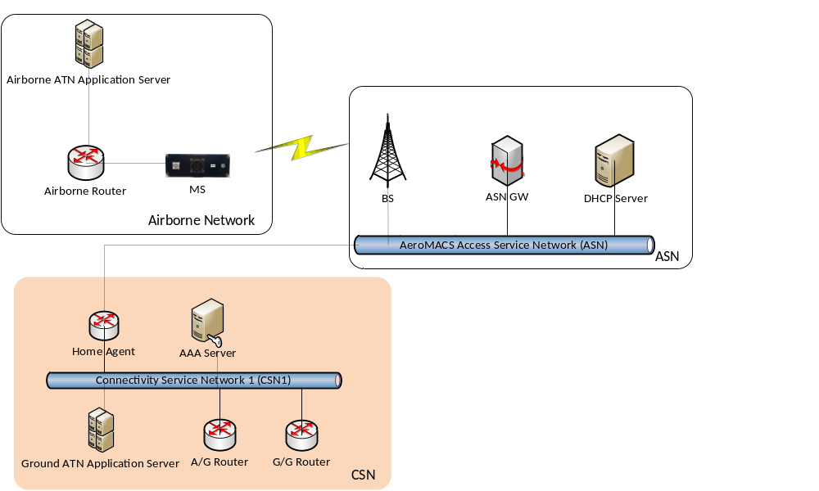
Figure 1: First Scenario: one single Service Provider connected to AeroMACS ASN

In particular, the steps listed below have been successfully executed and verified during the technical validation. No deviation respect to the target described in TVALP ([45]).
Step nr. | Action | Action description (if needed) | PCO  (Point of Control and Observation) | Result
1. | Establish AeroMACS Link |  | Mngt PCs connected to BS and MS | OK
2. | Start all the applications (End System GND, GGR, AGR, Airborne Router, End System AIR) |  | End System GND, GGR, AGR, Airborne Router, End System AIR | OK
3. | Verify that End System GND has an IDRP adjacency with the GGR |  | End System GND and GGR | OK
4. | Verify that AGR has established an IDRP adjacency with the Airborne Router |  | AGR and Airborne Router | OK
5. | Execute CM Logon between End System AIR and End System GND (air initiated CM-Logon Start and ground CM-Logon response) |  | End System AIR and End System GND | OK
6. | Establish a CPDLC session between End System GND and End System AIR (ground initiated)  - From the GND ES, send a CPDLC Start Request  - Verify that a CPDLC Start response is received from the AIR ES |  | GND ES and AIR ES | OK
7. | Start exchange of CPDLC messages between Air and Ground End Systems (e.g. Departure Clearance Request/Standby/Departure Cleared/Wilco):  From the AIR ES, send a Departure Clearance Request (DM125) |  | AIR ES | OK
8. | At the AIR ES, verify that a a Logical ACK (UM227) is received |  | AIR ES | OK
9. | From the GND ES, send a Standby (UM1) |  | GND ES | OK
10. | At the GND ES, verify that a Logical ACK (DM100) is received |  | GND ES | OK
11. | From the AIR ES, send a Wilco (DM0) |  | AIR ES | OK
12. | At the AIR ES, verify that a a Logical ACK (UM227) is received |  | AIR ES | OK
13. | Start establishment of an “ADS-C Periodic Contract” (1s periodicity) between End System GND and End System AIR (ground initiated):  From the GND ES, send an ADS Periodic Contract Request with 1 second periodicity |  | GND ES | OK
14. | At the GND ES, verify that a Logical ACK is received |  | GND ES | OK
15. | At the GND ES, verify that a sequence of ADS-C Periodic Reports is received, with the correct periodicity |  | GND ES and AIR ES | OK
16. | Verify that all the messages exchanged respect the performance requirements indicated in Success Criterion CRT-14.2.6-TRL6-TVALP-002-001 | Use of Wireshark, or tcpdump, or both | GND ES and AIR ES | OK

The proper execution of the above Steps has demonstrated the feasibility for AeroMACS to support any kind of ATN/OSI Service. In particular, the establishment of correct IDRP adjacencies among the various ATN devices involved (AIR End System, Airborne Router, AGR, GGR, Ground End System) demonstrates that all the requirements (identified in the initial TS/IRS) and linked to OBJ-14.2.6-TRL6-TVALP-001 (in the TVALP) have been validated.

In addition, it has been demonstrated that B2 Services in an ATN OSI environment can be easily supported by AeroMACS Data Link. Traced logs evidenced no message lost, and average transaction times measured lower than 58 ms, in any case never higher than 132 ms. If compared with the transaction times required by ED-228A for ATN B2 Services, it is possible to appreciate that AeroMACS System meets the requirement with a margin of some orders of magnitude (see 4.2.2).

OBJ-14.2.6-TRL6-TVALP-002 Results
A Second Scenario has been developed in the same EXE01, in order to represent two Service Providers connected to AeroMACS Access Service Network in a roaming scenario (Visitor/Home)
This scenario has allowed to validate also the End-To-End traffic between the Airborne ATN Applications and the Ground ATN Application placed in the CSN domain not directly connected to the AeroMACS Access Service Network.
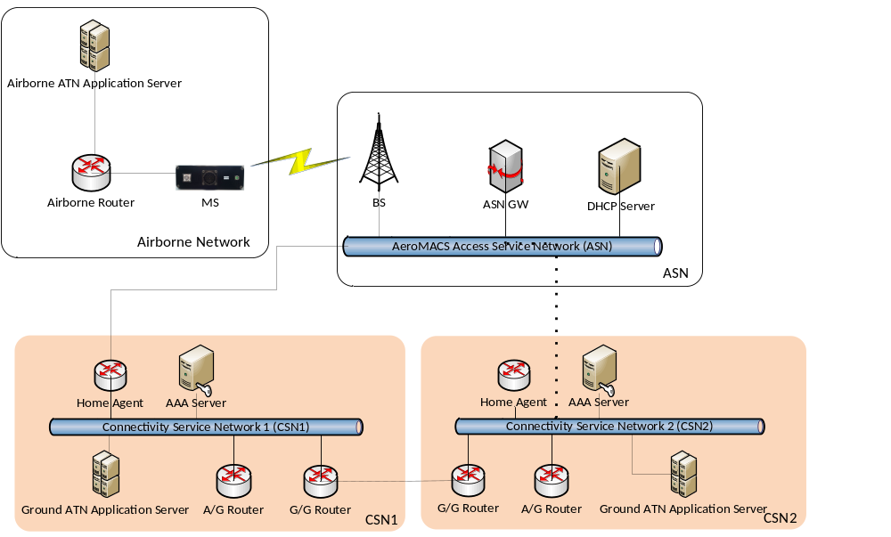
Figure 2: Second Scenario - two Service Providers connected to AeroMACS ASN in roaming (Visitor/Home)

The Technical Validation procedure is the same described for the previous technical Validation Objective, however this time one additional aircraft needs to connect with a Service Provider connected to the AeroMACS Access network by means of roaming through a different Service Provider. See the complete picture in Figure 3.
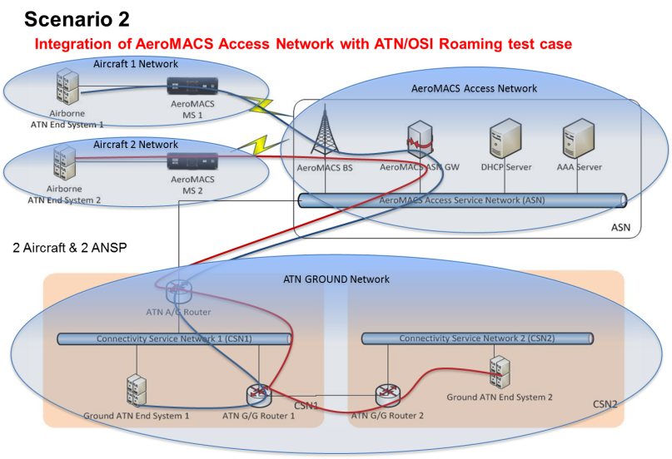
Figure 3: Different aircraft connected to different Service providers (roaming)

In particular, the steps listed below have been successfully executed and verified during the technical validation.
Step nr. | Action | Action description (if needed) | PCO  (Point of Control and Observation) | Results
1. | Establish AeroMACS Link |  | Mngt PCs connected to BS and MS | OK
2. | Start all the applications (End Systems GND, GGRs, AGR, Airborne Router, End Systems AIR) |  | ES GND1, ES GND2, GGR1, GGR2, AGR, Airborne Router, AIR ES1, AIR ES2 | OK
3. | Verify that each End System GND has an adjacency with its GGR |  | ES GND1/GGR1 and ES GND2/GGR2 | OK
4. | Verify that GGR1 and GGR2 have an IDRP adjacency |  | GGR1 and GGR2 | OK
5. | Verify that AGR has established an IDRP adjacency with the Airborne Router |  | AGR and Airborne Router | OK
6. | Execute CM Logon between each End System AIR and each End System GND (air initiated CM-Logon Start and ground CM-Logon response) |  | AIR ES1 and GND ES1; AIR ES2 and GND ES2 | OK
7. | Establish a CPDLC session between each End System GND and each End System AIR (ground initiated)  - From each GND ES, send a CPDLC Start Request  - Verify that a CPDLC Start response is received from the correct AIR ES |  | AIR ES1 vs. GND ES1; AIR ES2 vs. GND ES2 | OK
8. | For both the CPDLC sessions established, start exchanging CPDLC messages between Air and Ground End Systems (e.g. Departure Clearance Request/Standby/Departure Cleared/Wilco):  From each AIR ES, send a Departure Clearance Request (DM125) |  | AIR ES1, AIR ES2 | OK
9. | At each AIR ES, verify that a a Logical ACK (UM227) is received |  | AIR ES1, AIR ES2 | OK
10. | From each GND ES, send a Standby (UM1) |  | GND ES1, GND ES2 | OK
11. | At each GND ES, verify that a Logical ACK (DM100) is received |  | GND ES1, GND ES2 | OK
12. | From each AIR ES, send a Wilco (DM0) |  | AIR ES1, AIR ES2 | OK
13. | At each AIR ES, verify that a a Logical ACK (UM227) is received |  | AIR ES1, AIR ES2 | OK
14. | For each couple of End Systems (AIR ES1 vs. GND ES1, AIR ES2 vs. GND ES2), start establishment of an “ADS-C Periodic Contract” (1s periodicity) between End System GND and End System AIR (ground initiated):  From each GND ES, send an ADS Periodic Contract Request with 1 second periodicity |  | AIR ES1 vs. GND ES1; AIR ES2 vs. GND ES2 | OK
15. | At each GND ES, verify that a Logical ACK is received |  | GND ES1, GND ES2 | OK
16. | At each GND ES, verify that a sequence of ADS-C Periodic Reports is received, with the correct periodicity |  | GND ES1, GND ES2 | OK
17. | Verify that all the messages exchanged respect the performance requirements indicated in Success Criterion CRT-14.2.6-TRL6-TVALP-002-001 | Use of Wireshark, or tcpdump, or other log | GND ES1 and AIR ES1, GND ES2 and AIR ES2 | OK; see A.3.12

Also in this case, the proper execution of the above Steps has demonstrated the feasibility for AeroMACS to support any kind of ATN OSI Service also in a roaming scenario. Again, the establishment of correct IDRP adjacencies among the various ATN devices involved (AIR End System, Airborne Router, AGR, GGR, Ground End System) demonstrates that all the requirements (identified in the initial TS/IRS) and linked to OBJ-14.2.6-TRL6-TVALP-002 (in the TVALP) have been validated.
In addition, it has been demonstrated that B2 Services in an ATN OSI environment can be easily supported by AeroMACS Data Link. Traced logs evidenced no message lost, and average transaction time measured below 58 ms, in any case never higher than 132 ms (see Figure 4 for details). If compared with the transaction times required by ED-228A for ATN B2 Services, it is possible to appreciate that AeroMACS System meets the requirement with a margin some orders of magnitude (see CRT-14.2.6-TRL6-TVALP-002-001). This gives a very good confidence in results of EXE01, even if all devices and networks composing the Technical validation Platform were contained in a Laboratory and not in a real Airport.
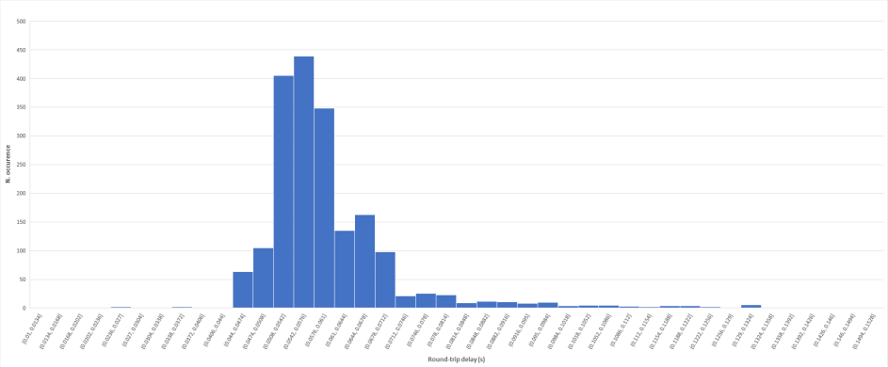
Figure 4: Distribution of Transaction Times measured in EXE#1
Figure 7 represents a Wireshark capture of an ADS-C exchange between Air and Ground ATN End Systems through the AeroMACS Datalink. The log has been taken at the Air ATN End System, and it is useful to measure the Transaction Times between any message transmitted by the Air ATN End System and the related Logical Acknowledge received from the counterpart (Ground ATN End System).
Note 1: In the picture IP Address 192.168.0.6 is the Airborne Router IP Address. However, in this Exercise, Airborne Router and Air ATN End System are co-located. So Transaction Times visible in this picture are identical to Transaction Times between Air and Ground End Systems.
Note 2: In the picture IP Address 192.168.30.67 is the AGR IP Address. However the Logical Acknowledge is actually sent by the Ground ATN End System, even if its IP Address is not visible in this log taken at the Air End System. This is due to the fact that the UDP communication is between the Airborne Router and the AGR (Traffic Interface as defined in the TS/IRS). Details of Protocol Stack layers at the various devices involved are in the communication chain are described in Figure 6.
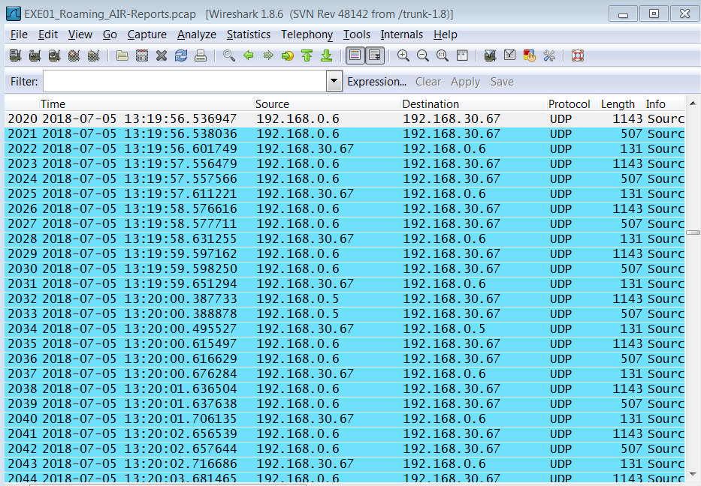
Figure 5: Wireshark capture of ADS-C exchange through AeroMACS

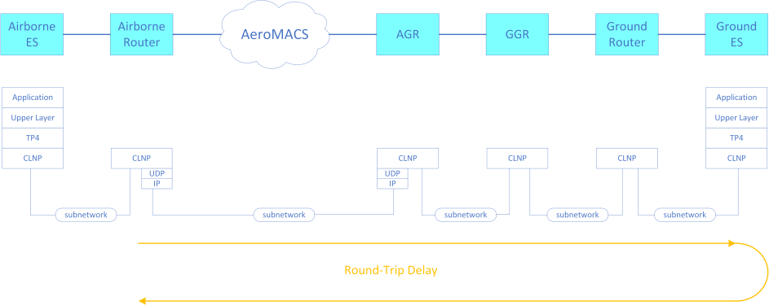
Figure 6: ATN/OSI over AeroMACS: Protocol Stack description

Finally, an additional test, not initially foreseen in the Plan, was executed with ADS-C Service: Ground ADS-C ES application established an ADS-C Periodic contract with Air ES application , and requested periodic transmission of Extended Project Profile (EPP) messages, each of them containing 120 waypoints, with 1 second periodicity. This led to a throughput of roughly 14 Kbps per aircraft, on the air interface. In addition, the same AeroMACS Base Station was used to decode a real-time video stream from a MS connected with a Video Camera. Hence this test allowed to check the proper system behaviour in presence of a throughput on the air interface that would not be sustainable with current Legacy Data Links.

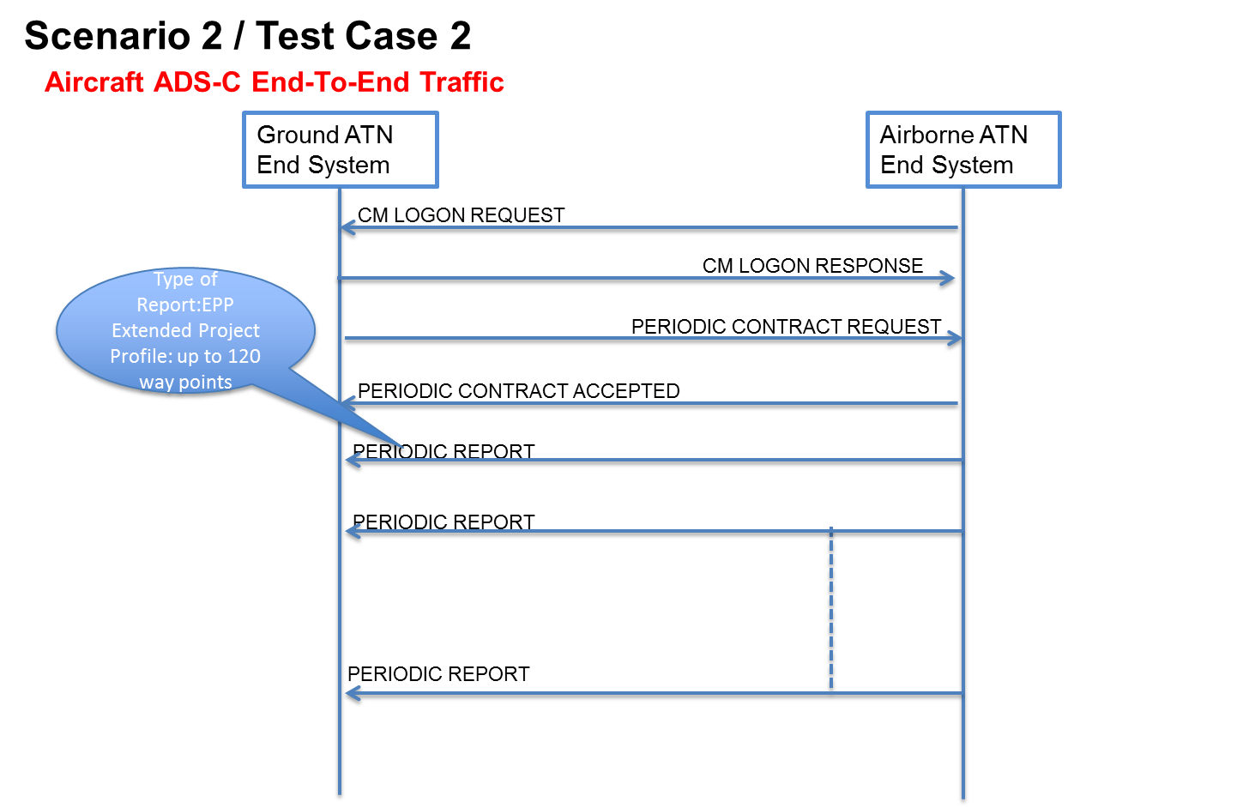
Figure 7: Aircraft ADS-C End-To-End Traffic (EPP)

OBJ-14.2.6-TRL6-TVALP-003 Results
For OBJ-14.2.6-TRL6-TVALP-003 the Scenario is basically the same Scenario described in 4.2.1 with the difference that in this case all the devices are IPS devices.
Scope of the scenario is to validate the End-To-End traffic between the Airborne ATN/IPS Application and the Ground ATN/IPS Application placed in the CSN domain directly connected to the AeroMACS Access Service Network.

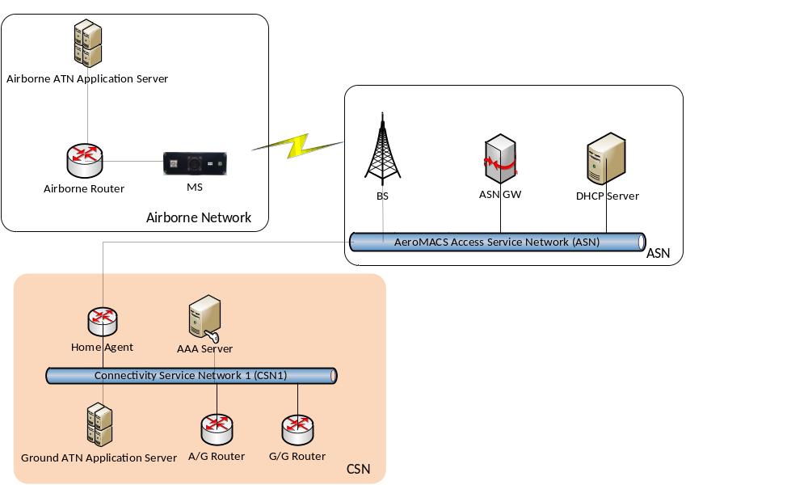
Figure 8: Service Provider connected to AeroMACS ASN in ATN/IPS environment
In particular, the steps listed below have been successfully executed and verified during the technical validation. No deviation respect to the target described in TVALP ([45]).
Step nr. | Action | Action description (if needed) | PCO  (Point of Control and Observation) | Result
1. | Establish AeroMACS Link |  | Mngt PCs connected to BS and MS | OK
2. | Start all the applications (End System GND, GGR, AGR, Airborne Router, End System AIR) |  | End System GND, GGR, AGR, Airborne Router, End System AIR | OK
3. | Verify that End System GND has an adjacency with the GGR |  | End System GND and GGR | OK
4. | Verify that AGR has established an adjacency with the Airborne Router |  | AGR and Airborne Router | OK
5. | Execute CM Logon between End System AIR and End System GND (air initiated CM-Logon Start and ground CM-Logon response) |  | End System AIR and End System GND | OK
6. | Establish a CPDLC session between End System GND and End System AIR (ground initiated)  - From the GND ES, send a CPDLC Start Request  - Verify that a CPDLC Start response is received from the AIR ES |  | GND ES and AIR ES | OK
7. | Start exchange of CPDLC messages between Air and Ground End Systems (e.g. repetition of DM99 and UM183 and related Logical ACK messages):  From the AIR ES, send a DM99 message |  | AIR ES | OK
8. | At the AIR ES, verify that a a Logical ACK (UM227) is received |  | AIR ES | OK
9. | From the GND ES, send a UM183 message |  | GND ES | OK
10. | At the GND ES, verify that a Logical ACK (DM100) is received |  | GND ES | OK
11. | Verify that all the messages exchanged respect the performance requirements indicated in Success Criterion CRT-14.2.6-TRL6-TVALP-003-001 | Use of Wireshark, or tcpdump, or both | GND ES and AIR ES | OK

The proper execution of the above Steps has demonstrated the feasibility for AeroMACS to support any kind of ATN IPS Service.
In addition, it has been demonstrated that B2 Services in an ATN IPS environment can be easily supported by AeroMACS Data Link. Traced logs evidenced no message lost, and average transaction times lower than 46 ms, in any case never higher than 138 ms (see for details). If compared with the transaction times required by ED-228A for ATN B2 Services, it is possible to appreciate a difference of some orders of magnitude (see CRT-14.2.6-TRL6-TVALP-003-001). This gives a very good confidence in results of EXE02, even if all devices and networks composing the Technical validation Platform were contained in a Laboratory and not in a real Airport.
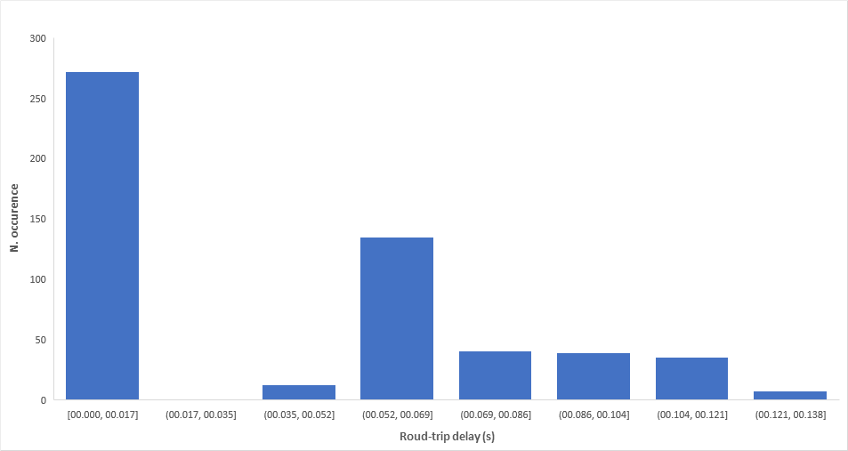
Figure 9: Distribution of Transaction Times measured in EXE#2
Figure 10 represents a Wireshark capture of a CPDLC exchange between Air and Ground ATN End Systems through the AeroMACS Datalink. The log has been taken at the Ground ATN End System, and it is useful to measure the Transaction Times between any message transmitted by the Ground ATN End System (ipv6.src.addr=fc00:2222::1) and the related Logical Acknowledge received from the counterpart (Air ATN End System, ipv6.src.addr=fc00:1111::1).
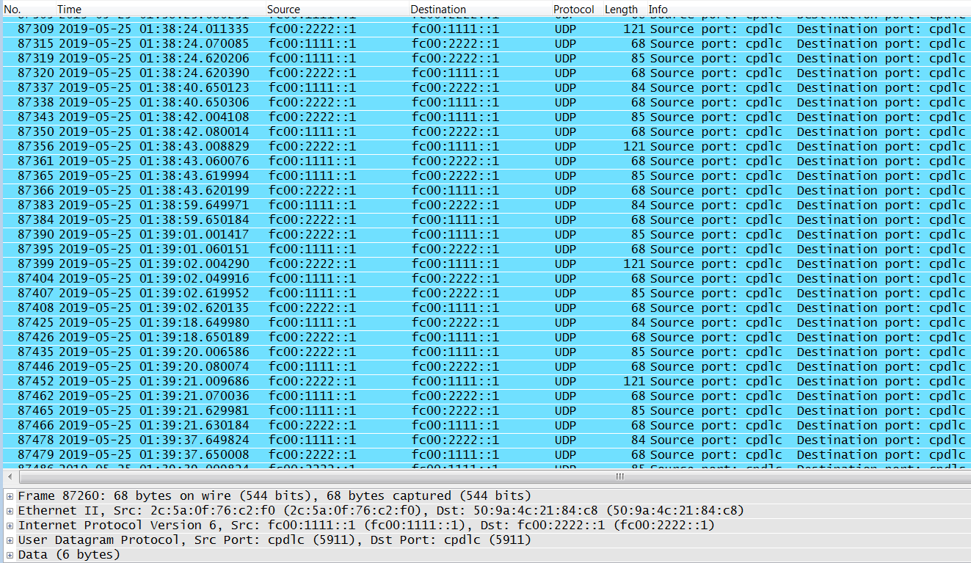
Figure 10: CPDLC exchange between AIR and GROUND ESs through AeroMACS

OBJ-14.2.6-TRL6-TVALP-004 Results
For OBJ-14.2.6-TRL6-TVALP-004 the Scenario is described in Figure 11. IP addresses of the various devices are indicated in the picture. Scope of the scenario is to technically validate the SIP/RTP traffic between the VoIP End Systems.
In particular, in this Scenario a VoIP Radio Controller was connected to the AeroMACS Ground Access Network, while a VOIP VHF Radio was connected Via IP interface to the AeroMACS Mobile Station, modulating and transmitting the received VoIP packets to another VoIP AM Radio.
Both the VoIP Radio Controller (VRC) and VoIP VHF Radio were provided with headphones and microphones. It was also possible to configure the VRC to send a single tone at a configurable frequency (e.g. 2 KHz), in order to better appreciate the received audio quality at the reception side.

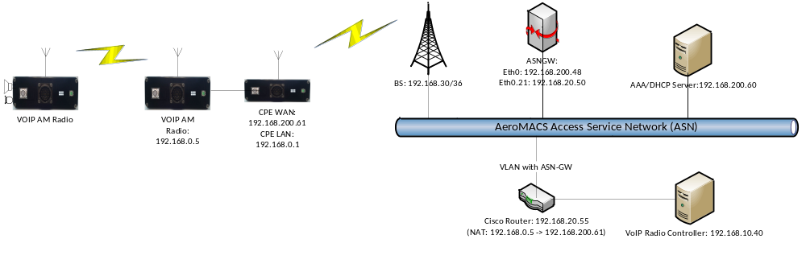
Figure 11: VoIP over AeroMACS: the validated Scenario

In particular, the following steps were executed and verified during the technical validation.
Step nr. | Action | Action description (if needed) | PCO  (Point of Control and Observation) | Result
1. | Establish AeroMACS Link |  | Mngt PCs connected to BS and MS | OK
2. | Switch on all the VoIP devices (VRC, AM VoIP Radios) |  | VRC, AM VoIP Radios | OK
3. | From the VRC, establish a SIP session with remote VoIP AM Radio#1 (over the AeroMACS Link) |  | VRC | OK
4. | From the VRC, activate PTT to the remote VoIP AM Radio#1, and talk in the VRC microphone |  | VRC | OK
5. | Verify that the audio is received by VoIP AM Radio#1, transmitted on the air interface (AM) to VoIP AM Radio#2, received by VoIP AM Radio#2 and properly reproduced by its loudspeaker |  | VOIP Radios TX/RX LEDs, VoIP AM Radio#2 loudspeaker | OK
6. | From the VRC, activate an audio tone at a frequency of 2 KHz, and send it to VoIP AM Radio#1 (over the AeroMACS Link) via PTT, for at least 90 seconds |  | VRC | OK
7. | Verify that the audio is received by VoIP AM Radio#1, transmitted on the air interface (AM) to VoIP AM Radio#2, received by VoIP AM Radio#2 and properly reproduced by its loudspeaker |  | VOIP Radios TX/RX LEDs; VoIP AM Radio#2 loudspeaker | OK
8. | On Ground Switch#2, capture and save the received SIP/RTP stream with appropriate tool (e.g. Wireshark) | Use of Wireshark | Mgmt PC connected to Ground Switch#2 | OK
9. | With Wireshark, execute a Stream Analysis on the RTP packet stream captured at step #7, and verify that, accordingly to CRT-14.2.6-TRL6-TVALP-004-001:  - RTP Packet Loss is lower or equal to 0.5%  - Mean jitter is lower or equal to 15 ms | Use of Wireshark | Mgmt PC connected to Ground Switch#2 | OK

During the test, the proper sequence of SIP/SDP messages between the VoIP VRC and the VoIP VHF Radio through AeroMACS Datalink was checked with Wireshark, connected to Ground Switch #2 between VOIP VHF Radio and AeroMACS CPE. This is shown in Figure 11. Voice transmitted by VRC was reproduced by the receiving VoIP VHF Radio loudspeaker with good quality. The same test was repeated after having configured the VRC to transmit a single tone at a fixed frequency. Using Wireshark tool, RTP Packet Loss and Mean jitter was measured on RTP packets in some tests with different durations and different frequency tones. The measured RTP Packet Loss was always much lower than 0,05% (mean RTP Packet loss lower than 0,001%). Mean jitter measured was lower than 10 ms.
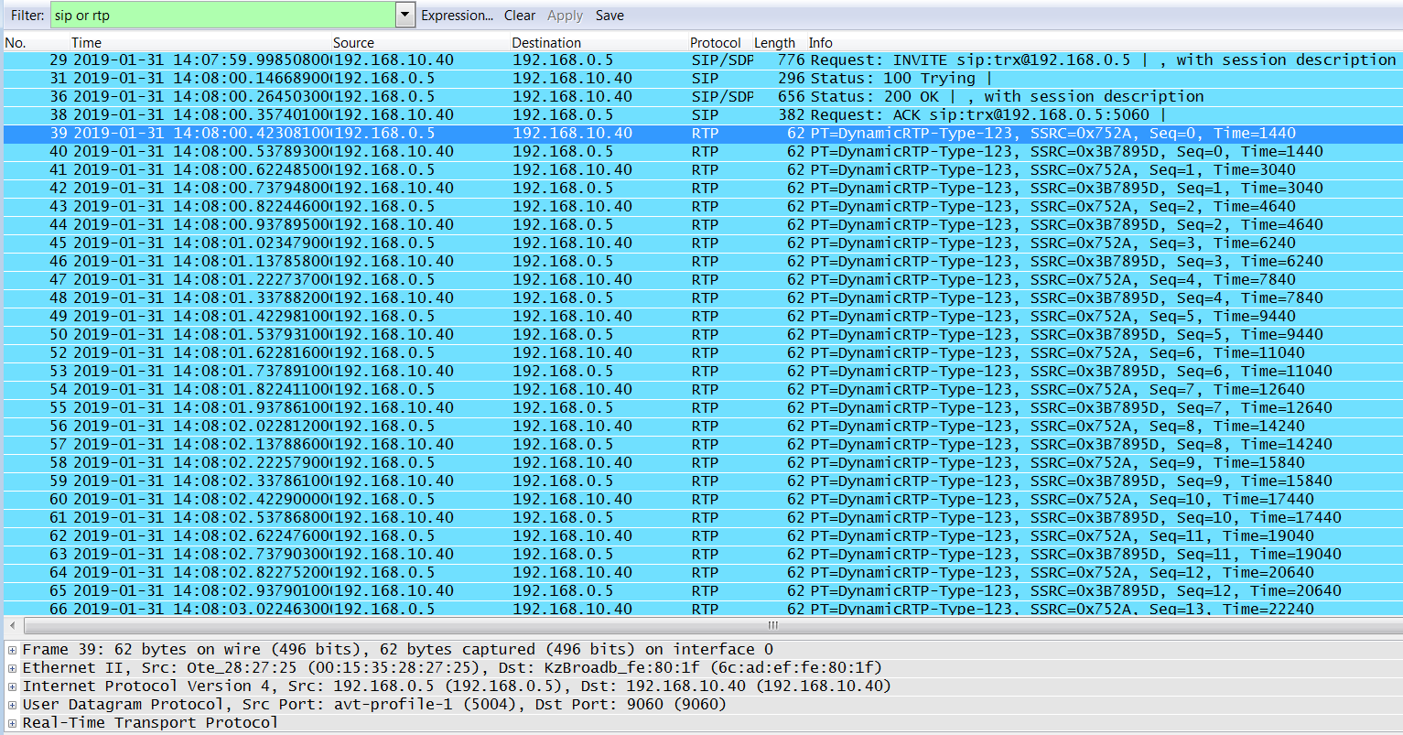
Figure 12: SIP/SDP and RTP bursts between VoIP ESs over AeroMACS

OBJ-14.2.6-TRL6-TVALP-005 Results
The Multilink concept of AeroMACS and VDL2 in ATN/OSI environment was technically validated through verification of the proper exchange of ATN/B2 messages between airborne and Ground End Systems, via the two Data Links in different scenarios.
Airborne and Ground ATN/OSI Applications were connected both to the AeroMACS and the VDL2 Access Service Networks. , as represented in Figure 13.

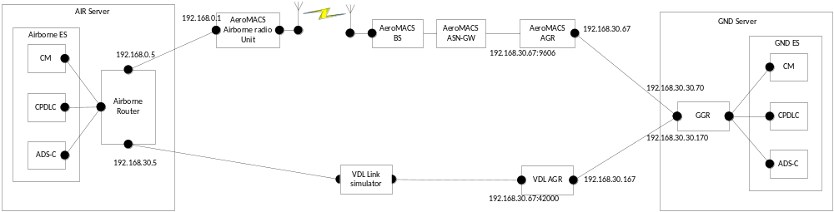
Figure 13: ATN/OSI Multilink testbed

In this scenario the airborne router is connected to both networks via two different AGRs: AeroMACS AGR and VDLM2 AGR. In particular, the airborne router establishes an IDRP adjacency with both AGRs.
The ATSC Class, as defined in [48], is used in this exercise for the link preference. In particular, different SecurityTag values are used for the two different mobile circuits.
The circuit for AeroMACS link is configured to use the Security Tag 01060101 (Class A) while the one for VDL2 link is configured to use the Security Tag 01060102 (Class B).
If "Class A" value is specified by an ATN application, the ATN router forwards the message using a route with the same class if available; otherwise, a route with a lower class is chosen. In the case of this multilink exercise, if the Class A is specified, the traffic is forwarded through the AeroMACS link if available, otherwise through the VDLM2 one.
If "Class B" value is specified by an ATN application, the ATN router forwards the message using a route with the same class if available; otherwise, a route with a higher class is chosen. If no such route is found, first known route with lower class is selected. In the case of this multilink exercise, if the Class B is specified, the traffic is forwarded through the VDLM2 link if available, otherwise through the AeroMACS one.
The Technical Validation Platform described has been built in order to be representative of real scenario. A set of ATN B2 messages (CM/CPDLC, ADS-C) will be exchanged between Air and Ground End Systems through the AeroMACS Data Link.
In particular, the following steps were executed and verified during the technical validation.
Step nr. | Action | Action description (if needed) | PCO  (Point of Control and Observation) | Result
1. | Start all the applications (GND End System, GGR, AGR AeroMACS, AGR VDL2, AIR End System) |  | GND ES, GGR, AGR AeroMACS, AGR VDL2, AIR ES | OK
2. | Establish VDL2 Link |  | VDL2 simulator | OK
3. | Establish AeroMACS Link (=>aircraft at ground) |  | Mngt PCs connected to AeroMACS BS and MS | OK
4. | Verify that End System GND has an IDRP adjacency with the GGR |  | GND ES, GGR | OK
5. | Verify that AeroMACS AGR and VDL2 AGR have established an IDRP adjacency with the Airborne Router |  | Airborne Router, AGR AeroMACS, AGR VDL2 | OK
6. | Execute CM Logon between End System AIR and End System GND (air initiated CM-Logon Start and ground CM-Logon response); Class Communication=”Class A” is used. |  | AIR ES, GND ES | OK
7. | Verify that CM Logon traffic is transmitted via the AeroMACS subnetwork | Use of Wireshark, logs on ESs | ASN-GW, AIR ES, GND ES | OK
8. | Establish a CPDLC session between End System GND and End System AIR (ground initiated); Class Communication=”Class A” is used:  - From the GND ES, send a CPDLC Start Request  - Verify that a CPDLC Start response is received from the AIR ES, via AeroMACS Data link |  | GND ES | OK
9. | Start an exchange of CPDLC messages between Air and Ground End Systems (e.g. Departure Clearance Request/Standby/Departure Cleared/Wilco):  From the AIR ES, send a Departure Clearance Request (DM125) |  | AIR ES | OK
10. | At the AIR ES, verify that a a Logical ACK (UM227) is received |  | AIR ES | OK
11. | From the GND ES, send a Standby (UM1) |  | GND ES | OK
12. | At the GND ES, verify that a Logical ACK (DM100) is received |  | GND ES | OK
13. | From the GND ES, send a Departure Cleared (UM73R) |  | GND ES | OK
14. | At the GND ES, verify that a Logical ACK (DM100) is received |  | GND ES | OK
15. | From the AIR ES, send a Wilco (DM0) |  | AIR ES | OK
16. | At the AIR ES, verify that a a Logical ACK (UM227) is received |  | AIR ES | OK
17. | Verify that all the CPDLC traffic is transmitted via the AeroMACS subnetwork | Use of Wireshark, logs on ESs | ASN-GW, AIR ES, GND ES | OK
18. | Start establishment of an “ADS-C Periodic Contract” (1s periodicity) between End System GND and End System AIR (ground initiated), using Class Communication = “Class A”:  From the GND ES, send an ADS Periodic Contract Request with 1 second periodicity (Class Communication = “Class A”) |  | GND ES | OK
19. | At the GND ES, verify that a Logical ACK is received |  | GND ES | OK
20. | At the AIR ES, issue a “Periodic response Accepted” |  | AIR ES | OK
21. | At the GND ES, verify that a sequence of ADS-C Periodic Reports is received, with the correct periodicity |  | GND ES | OK
22. | Verify that all ADS-C traffic be transmitted via the AeroMACS subnetwork | Use of Wireshark, logs on GND ES | ASN-GW, GND ES | OK
23. | Force a LEAVE EVENT message to Airborne Router on AeroMACS subnetwork to simulate “Weight on Wheels”=OFF (=>aircraft take off). |  | Airborne Router | OK
24. | Verify that all traffic (CPDLC/ADS-C) is transmitted with no interruption via the VDL2 Link | Use of Wireshark, logs on ESs | ASN-GW, AIR ES, GND ES | OK
25. | Force JOIN EVENT message to Airborne Router on AeroMACS subnetwork to simulate “Weight on Wheels”=ON (=>aircraft landed) |  | Airborne Router | OK
26. | Verify that all traffic (CM/CPDLC/ADS-C) is again transmitted with no interruption via AeroMACS Link | Use of Wireshark, logs on ESs | ASN-GW, AIR ES, GND ES | OK

The proper execution of the above Steps has technically validated the Multilink concept of AeroMACS and VDL2 in ATN/OSI environment.

Confidence in the Validation Results

Limitations of Technical Validation Results

All Exercises concerning integration of AeroMACS with ATN or VoIP Systems in various scenarios and options were performed using real AeroMACS products, real AGRs and real VoIP products. Simulators were just used to integrate in the same device network elements like Ground ATN End System and GGR (or Air ATN End System and Airborne Router), but their use had no impact on the level of significance of the results. However, all the Devices and Networks composing the Technical validation Platform were contained in a Laboratory. In other words, they were not distributed among different locations world-wide, as it will happen in a real scenario. For this reason, it was expected that the required ATN performances were fully satisfied in these Exercises. AeroMACS is ready for supporting any Very Large Demonstration relying on datalink exchanges in Wave 2, in order to support ATM Solutions in real environment.

Quality of Technical Validation Exercises Results
Performed Exercises had two different kinds of objectives: from one side, demonstrate the feasibility of the required integrations; from the other side, demonstrate that the integrations under test were not introducing excessive delays in performances. For the first kind of objective, extremely realistic ATN End Systems tools were used (in the case of VoIP, real End Systems were used). For the second kind of objective, Exercises were observed with the help of tools and automated computations that allowed a very good accuracy of results and confidence in the results.

Significance of Technical Validation Exercises Results
As already described in the present document, all the Technical Validation Exercises were executed using real AeroMACS products, real ATN AGRs and real VoIP products. This implies a high operational significance for the tests done. Verification of compliance with performance validation objectives required use of tools and automated computations that allowed a high accuracy of results and confidence in the results. In addition, the fact that performance thresholds were satisfied with big margins is fully reassuring, in view of the deployment of the various systems in airport, giving a great confidence in the obtained results.

Conclusions and recommendations

Conclusions
Solution PJ14.02.06 builds upon Solution #102 published in the SESAR 1 catalogue. AeroMACS Solution #102 reached TRL6 Maturity Level as Data Link, however in SESAR1 no specific Exercise was executed to integrate AeroMACS Access Network with ATN/OSI and ATN/IPS Networks, neither in Multilink environment, and neither with Digital Voice Systems. This was the scope of PJ14.02.06, and successful execution of the different Technical Validation Exercises demonstrated full achievement of TRL6 Maturity Level for CTE-C02d Enabler.

Conclusions on SESAR Technological Solution maturity
Achieved maturity level for CTE-C02d Enabler at the end of all the validation exercises covered in this TVALR is TRL6.

Conclusions on technical feasibility
The Technical Validation Exercises covered in this TVALR demonstrated the technical feasibility of integration of AeroMACS Access Network with the following:
- ATN/OSI Networks
- ATN/IPS Networks
- VoIP Networks
- Multilink in ATN/OSI environment

Conclusions on performance assessments
The Technical Validation Exercises covered in this TVALR demonstrated that AeroMACS Access Network integrated with the Systems indicated in 5.1.2 are compliant with performance requirements specified in the relevant standards.

Recommendations

Recommendations for next phase
.
System requirements specified in PJ14.02.06 Initial TS/IRS ([44]) have been technically validated, and should be considered as baseline, before the deployment of any AeroMACS System in Airport.

Recommendations for updating ATM Master Plan Level 2

Two Change Requests, issued after discussion among PJ14.2.6, PJ19 and SJU, remain to be approved:
- CR 03286 (pending on PJ19 approval): Link CTE-C02d to POI-0029-COM. In this CR, the proposed “TRL6 End" for CTE-C02d is 19th November 2019.
- CR 03472 (pending on SJU approval) to again modify Title and Description of PJ14.02.06 Solution, in order to better explain its Scope and differentiate it from Solution #102.

Recommendations on regulation and standardisation initiatives
All the necessary Technical Standards have been developed during SESAR1. ETSI has started the development of Harmonized European Norm (EN) covering the essential requirements of article 3.2 of the Radio Equipment Directive (RED) 2014/53/EU for AeroMACS Base Station, Fixed and Vehicle Station Radio Equipment.

References

Applicable Documents
Content Integration
- B.04.01 D138 EATMA Guidance Material
- EATMA Community pages
- SESAR ATM Lexicon
Content Development
- B4.2 D106 Transition Concept of Operations SESAR 2020
System and Service Development
- 08.01.01 D52: SWIM Foundation v2
- 08.01.01 D49: SWIM Compliance Criteria
- 08.01.03 D47: AIRM v4.1.0
- 08.03.10 D45: ISRM Foundation v00.08.00
- B.04.03 D102 SESAR Working Method on Services
- B.04.03 D128 ADD SESAR1
- B.04.05 Common Service Foundation Method
Performance Management
- B.04.01 D108 SESAR 2020 Transition Performance Framework
- B.04.01 D42 SESAR2020 Transition Validation
- B.05 D86 Guidance on KPIs and Data Collection support to SESAR 2020 transition.
- 16.06.06-D68 Part 1 –SESAR Cost Benefit Analysis – Integrated Model
- 16.06.06-D51-SESAR_1 Business Case Consolidated_Deliverable-00.01.00 and CBA
- Method to assess cost of European ATM improvements and technologies, EUROCONTROL (2014)
- ATM Cost Breakdown Structure_ed02_2014
- Standard Inputs for EUROCONTROL Cost Benefit Analyses
- 16.06.06_D26-08 ATM CBA Quality Checklist
- 16.06.06_D26_04_Guidelines_for_Producing_Benefit_and_Impact_Mechanisms
Validation
- 03.00 D16 WP3 Engineering methodology
- Transition VALS SESAR 2020 - Consolidated deliverable with contribution from Operational Federating Projects
- European Operational Concept Validation Methodology (E-OCVM) - 3.0 [February 2010]
System Engineering
- SESAR Requirements and V&V guidelines
Safety
- SESAR, Safety Reference Material, Edition 4.0, April 2016
- SESAR, Guidance to Apply the Safety Reference Material, Edition 3.0, April 2016
- SESAR, Final Guidance Material to Execute Proof of Concept, Ed00.04.00, August 2015
- SESAR, Resilience Engineering Guidance, May 2016
Human Performance
- 16.06.05 D 27 HP Reference Material D27
- 16.04.02 D04 e-HP Repository - Release note
Environment Assessment
- SESAR, Environment Reference Material, alias, “Environmental impact assessment as part of the global SESAR validation”, Project 16.06.03, Deliverable D26, 2014.
- ICAO CAEP – “Guidance on Environmental Assessment of Proposed Air Traffic Management Operational Changes” document, Doc 10031.
Security
- 16.06.02 D103 SESAR Security Ref Material Level
- 16.06.02 D137 Minimum Set of Security Controls (MSSCs).
- 16.06.02 D131 Security Database Application (CTRL_S)

Reference Documents
- ED-78A GUIDELINES FOR APPROVAL OF THE PROVISION AND USE OF AIR TRAFFIC SERVICES SUPPORTED BY DATA COMMUNICATIONS.
- Common assumptions for CBAs as maintained by Pj19 (provisionally the ones included in the 16.06.06- D68_Part 1, New CBA Model and Methods 2015, Edition 00.01.01 can be used)
- SESAR 15.02.04-D05 WA1 3 Security Risk Assessment Report (SecRAR) v00 01 01
- SESAR P15.2.7 D08.2 – AeroMACS – Security Analysis, edition 1.0, 27/03/2014
- https://www.sesarju.eu/node/3028
- https://www.linkedin.com/groups/1828459/
- ED-228A SAFETY AND PERFORMANCE REQUIREMENTS STANDARD FOR BASELINE 2 ATS DATA COMMUNICATIONS (BASELINE 2 SPR STANDARD)
- PJ14.02.06 – Initial TS/IRS, D7.1.010, Ed.01.00.11, 19th July 2019
- PJ14.02.06 – TVALP, D7.1.020, Ed. 01.00.09, 30th July 2019
- EUROCAE, ED-137B INTEROPERABILITY STANDARDS FOR VOIP ATM COMPONENTS – VOLUME 1: RADIO
- EUROCAE, ED-138 NETWORK REQUIREMENTS AND PERFORMANCES FOR VOICE OVER INTERNET PROTOCOL (VOIP) AIR TRAFFIC MANAGEMENT (ATM) SYSTEMS - PART 1: NETWORK SPECIFICATION
- ICAO, Doc 9705, MANUAL OF TECHNICAL PROVISIONS FOR THE AERONAUTICAL TELECOMMUNICATION NETWORK (ATN)
- SESAR P15.2.7 D08.1 – AeroMACS – Safety Analysis, edition 1.0, 28/03/2014
- WMF, “AeroMACS Market Size Estimates”, NRM-6, 09/03/2015
- ICAO, “Global Air navigation Plan”, Ed.5, 2016
- SESAR, “European ATM Master Plan”, Ed. 2015
- SESAR P15.2.7 D3.2 – AeroMACS Profile Definition, edition 0.2, 02/02/2012
- http://wimaxforum.org/Page/News/PR/20150911_WiMAX_Forum_Hosts_First_AeroMACS_Interoperability_Demonstration_Event
- http://wimaxforum.org/Page/News/PR/20151119_Worldwide_AeroMACS_Implementations_Prove_Their_Tremendous_Potential

  - Technical Validation Exercise #01 Report
- Summary of the Technical Validation Exercise #01 Plan
Technical Validation Exercise #01 Plan is described in [45]. It aims to the technical validation of the integration of AeroMACS with ATN/OSI.
- Technical Validation Exercise #01 description and scope
The technical validation activities proposed in this exercise are intended to validate the following areas:
- Verify the integration of AeroMACS Access Network with ATN/OSI Network, through the proper exchange of ATN B2 messages between Ground and Airborne End Systems.
- Verify the most typical scenarios, taking also into account possible roaming.
- Summary of Exercise 1 Technical Validation Objectives and success criteria
SESAR Solution Validation Objective | SESAR Solution Success criteria | Coverage and comments on the coverage of SESAR Solution Validation Objective in Exercise 001 | Exercise Validation Objective | Exercise Success criteria
OBJ-14.2.6-TRL6-TVALP-001 | CRT-14.2.6-TRL6-TVALP-001-001 | Fully covered | EX1-OBJ-14.2.6-TRL6-TVALP-001  same description as OBJ-14.2.6-TRL6-TVALP-001 | EX1-CRT-PJ14.2.6-TRL6-TVALP-001  same description as CRT-PJ14.2.6-TRL6-TVALP-001
OBJ-14.2.6-TRL6-TVALP-002 | CRT-PJ14.2.6-TRL6-TVALP-002 | Fully covered | EX1-OBJ-14.2.6-TRL6-TVALP-002  same description as OBJ-14.2.6-TRL6-TVALP-002 | EX1-CRT-PJ14.2.6-TRL6-TVALP-002  refined description from CRT-PJ14.2.6-TRL6-TVALP-002
Table 13: Validation Objectives addressed in Technical Validation Exercise 1

- Summary of Technical Validation Exercise #01 Validation scenarios
EXE01 is the first Exercise executed to integrate AeroMACS with ATN/OSI Networks.
Two different solution scenarios have been identified in relation to the two Technical Validation Objectives listed above. They are depicted in Chapter 4.2.1. The Technical Validation Platform is also described in [45].

- Summary Technical Validation Exercise #01 Assumptions

Identifier | Title | Type of Assumption | Description | Justification | Flight Phase | KPA Impacted | Source | Value(s) | Owner | Impact on Assessment
A1 | IPv4 Network | Technical | AeroMACS supports both IPv4 and IPv6. IPv4 will be used in Exercise 01 | Irrelevant to the technical validation objectives | N/A | N/A | N/A | N/A | N/A | No impact expected
A2 | IDRP | Technical | IDRP is used over the air/ground link | Compatibility with legacy systems; for further details see TS/IRS, Ch. 4.1.5.2 | N/A | N/A | N/A | N/A | N/A | No impact expected: this protocol is transparent to AeroMACS
A3 | UDP | Technical | UDP Protocol is used over the IP in the link between AGR and Airborne Routers | See detailed justification in TS/IRS, Ch. 4.1.5.2 | N/A | N/A | N/A | N/A | N/A | No impact expected: this protocol is transparent to AeroMACS
Table 14: Technical Validation Assumptions overview

  - Deviation from the planned activities
No deviation from the planned activities was put in place.
  - Technical Validation Exercise #01 Validation Results
- Summary of Technical Validation Exercise #01 Results

Technical Validation Exercise #01 Validation Objective ID | Technical Validation Exercise #01  Validation Objective Title | Technical Validation Exercise #01 Success Criterion ID | Technical Validation Exercise #01 Success Criterion | Technical Validation Exercise #01 Results | Technical Validation Exercise #01 Validation Objective Status
OBJ-14.2.6-TRL6-TVALP-001 | ATN/OSI Technical feasibility | CRT-14.2.6-TRL6-TVALP-001-001 | Ensure and maintain ATN B2 messages exchange between Airborne and Ground ATN/OSI ESs, through AeroMACS Access Network and one CSP Ground Network. | Results from EXE01 | OK
OBJ-14.2.6-TRL6-TVALP-002 | Two Service Providers connected to AeroMACS ASN in a roaming scenario (Visitor/Home) | CRT-14.2.6-TRL6-TVALP-002-001 | Verify that ATN Services messages are properly routed to/from the correct ATN/OSI End System, and meet the following performance requirements, as defined in ED-228A [43] for the most stringent cases for CPDLC (RCP130) and ADS-C (RSP160) services:  • CPDLC:  - Transaction time (RCTPCSP) < 18 s  - Transaction time (RCTPCSP)95% < 10 s  - Availability (ACSP) > 0.9995  • ADS-C:  - Transaction time (RSPCSP) < 12 s  - Transaction time (RSPCSP)95% < 5 s  - Availability (ACSP) > 0.9995 | Results from EXE01 | OK
Table 15: Technical Validation Results Exercise 1
      - Results on technical feasibility
Results described in 4.2.1 and 4.2.2 have demonstrated that AeroMACS can be integrated with ATN/OSI Systems.
      - Results per KPA
This is a Technological Solution, so KPAs defined in the Performance Framework are not directly applicable. Some Validation Objectives related to transaction times performances were identified and linked to EXE#01; they are listed in 3.2.2. In particular, results described in detail in 4.2.1 and 4.2.2 have demonstrated that B2 Services in an ATN OSI environment can be easily supported by AeroMACS Data Link. Traced Logs evidenced no message lost, and transaction times measured lower than 132 ms. If compared with the transaction times required by ED-228A for ATN B2 Services, it is possible to appreciate a difference of some orders of magnitude (see CRT-14.2.6-TRL6-TVALP-002-001).
- Analysis of Exercise 1 Results per Technical Validation objective

      - OBJ-14.2.6-TRL6-TVALP-001 Results
Analysis of Exercise 1 results per Technical Validation Objective OBJ-14.2.6-TRL6-TVALP-002 Results has been provided in Chapter 4.2.1.
      - OBJ-14.2.6-TRL6-TVALP-002 Results
Analysis of Exercise 1 results per Technical Validation Objective OBJ-14.2.6-TRL6-TVALP-002 Results has been provided in Chapter 4.2.2.
- Unexpected Behaviours/Results
No unexpected behaviours/Results were observed for EXE01.
- Confidence in Results of Validation Exercise 1
      - Level of significance/limitations of Technical Validation Exercise Results
Exercise #01 is performed using a complete AeroMACS System, together with an ATN/OSI Network composed by an AGR, an Airborne Router/End System Simulator, and a GGR/Ground End System Simulator. Simulators are used only at the End Systems, so this has no impact on the level of significance of the results. However, it is useful to underline that all the Devices and Networks composing the Technical validation Platform were contained in a Laboratory. In other words, they were not distributed among different locations world-wide, and the radio channel was not affected by interferences and propagation issues measurable in a real environment. For this reason, it was expectable that the required ATN performances were fully satisfied in this Exercise. In any case the huge margin measured in the logs is fully reassuring, in view of the deployment of whole system in airport.
AeroMACS is ready for supporting any Very Large Demonstration relying on datalink exchanges in Wave 2, in order to support ATM Solutions in real environment.

      - Quality of Technical Validation Exercises Results
No specific issue was registered affecting the quality of the results in EXE#01.
      - Significance of Technical Validation Exercises Results
The ATN/OSI Testbed used in EXE#01 has been implemented using a real AeroMACS Access Network (comprised of BS, MS, ASN-GW, AAA/DHCP Server), and a ATN network composed of a real AGR and Ground/Air Test Tools. Hence the Testbed is extremely realistic, and results are very significant from an operational point of view. Several separated tests were repeated, with the same results in terms of functional behaviour and transaction times performances. In addition to the SESAR Exercise, an Open Day was arranged the day after EXE#1, with a wide audience and good success (for more information see [41] or [42]).
- Conclusions

      - Conclusions on technical feasibility
EXE#01 demonstrated the technical feasibility of integration of AeroMACS and ATN/OSI Networks.
      - Conclusions on performance assessments
This is a Technological Solution, so KPAs defined in the Performance Framework are not directly applicable. EXE#01 demonstrated that AeroMACS System integrated with ATN/OSI Network is compliant with performance requirements specified in ED-228A [43].
- Recommendations
AeroMACS is ready for supporting any Very Large Demonstration relying on datalink exchanges in Wave 2, in order to support ATM Solutions in real environment.

- Technical Validation Exercise #02 Report

- Summary of the Technical Validation Exercise #02 Plan
Technical Validation Exercise #02 Plan is described in [45]. It aims to the technical validation of the integration of AeroMACS with ATN/IPS.
- Technical Validation Exercise #02 description and scope
The technical validation activities proposed in this exercise are intended to validate the integration of AeroMACS Access Network with ATN/IPS Network, through the proper exchange of ATN B2 messages between Ground and Airborne End Systems.
- Summary of Exercise #02 Technical Validation Objectives and success criteria

SESAR Solution Validation Objective | SESAR Solution Success criteria | Coverage and comments on the coverage of SESAR Solution Validation Objective in Exercise 002 | Exercise Validation Objective | Exercise Success criteria
OBJ-14.2.6-TRL6-TVALP-003 | CRT-14.2.6-TRL6-TVALP-003-001 | Fully covered | EX2-OBJ-14.2.6-TRL6-TVALP-001  same description as OBJ-14.2.6-TRL6-TVALP-003 | EX2-CRT-14.2.6-TRL6-TVALP-001  same description as CRT-14.2.6-TRL6-TVALP-003
Table 16: Validation Objectives addressed in Technical Validation Exercise 2

- Summary of Technical Validation Exercise #02 Validation scenarios
EXE02 is the first Exercise executed to integrate AeroMACS with ATN/IPS Network.
The Scenario, depicted in Chapter 4.2.3, is basically the same Scenario described in 4.2.1 with the difference that in this case all the devices are IPS devices.. The Technical Validation Platform is also described in [45].
- Summary Technical Validation Exercise #02 Assumptions

Identifier | Title | Type of Assumption | Description | Justification | Flight Phase | KPA Impacted | Source | Value(s) | Owner | Impact on Assessment
A1 | IPv6 Network | Technical | AeroMACS supports both IPv4 and IPv6. IPv6 will be used in Exercise 02 | Irrelevant to the technical validation objectives | N/A | N/A | N/A | N/A | N/A | No impact expected
A2 | UDP | Technical | UDP Protocol is used over the IP in the link between AGR and Airborne Routers | See detailed justification in TS/IRS, Ch. 4.1.5.2 | N/A | N/A | N/A | N/A | N/A | No impact expected: this protocol is transparent to AeroMACS
Table 17: Technical Validation Assumptions overview
  - Deviation from the planned activities
No deviation from the planned activities was put in place.
  - Technical Validation Exercise #02 Validation Results
- Summary of Technical Validation Exercise #02 Results
Technical Validation Exercise #02 Validation Objective ID | Technical Validation Exercise #02  Validation Objective Title | Technical Validation Exercise #02 Success Criterion ID | Technical Validation Exercise #02 Success Criterion | Technical Validation Exercise #02 Results | Technical Validation Exercise #02 Validation Objective Status
OBJ-14.2.6-TRL6-TVALP-003 | ATN/IPS Technical feasibility | CRT-14.2.6-TRL6-TVALP-003-001 | Verify that ATN messages exchange between Airborne and Ground ATN/IPS ESs is ensured and maintained, through AeroMACS Access Network and one CSP Ground Network, and the related B2 performance requirements defined in ED-228A [38] are met.  Note: ED-228A requires the following, for the most stringent cases for CPDLC (RCP130)and ADS-C (RSP160) services:  • CPDLC:  - Transaction time (RCTP_{CSP}) < 18 s  - Transaction time (RCTP_{CSP})95% < 10 s  - Availability (A_{CSP}) > 0.9995  • ADS-C:  - Transaction time (RSP_{CSP}) < 12 s  - Transaction time (RSP_{CSP})95% < 5 s  - Availability (A_{CSP}) > 0.9995 | Results from EXE02 | OK
Table 18: Technical Validation Results Exercise 2
      - Results on technical feasibility
Results described in 4.2.3 have demonstrated that AeroMACS can be integrated with ATN/IPS Systems.
      - Results per KPA
This is a Technological Solution, so KPAs defined in the Performance Framework are not directly applicable. Some required performances were identified in CRT-14.2.6-TRL6-TVALP-003-001 and linked to EXE#02; they are listed in 3.2.2. In particular, results described in 4.2.3 have demonstrated that B2 Services in an ATN IPS environment can be easily supported by AeroMACS Data Link. Traced logs evidenced no message lost, and average transaction times lower than 46 ms, in any case never higher than 138 ms. If compared with the transaction times required by ED-228A for ATN B2 Services, it is possible to appreciate a difference of some orders of magnitude (see CRT-14.2.6-TRL6-TVALP-003-001).
- Analysis of Exercise 2 Results per Technical Validation objective

      - OBJ-14.2.6-TRL6-TVALP-003 Results
Analysis of Exercise 2 results per Technical Validation Objective OBJ-14.2.6-TRL6-TVALP-003 Results has been provided in Chapter 4.2.3.
- Unexpected Behaviours/Results
No unexpected behaviours/Results were observed for EXE02.
- Confidence in Results of Validation Exercise 2
      - Level of significance/limitations of Technical Validation Exercise Results
Exercise #02 is performed using an ATN/IPS Network composed by an AGR, an Airborne Router/End System Simulator, and a GGR/Ground End System Simulator. Use of simulators is not expected to have any impact on the level of significance of the results. However, it is useful to underline that all the Devices and Networks composing the Technical validation Platform were contained in a Laboratory. In other words, they were not distributed among different locations world-wide, as it happens in a real scenario. For this reason, it was expectable that the required ATN performances were fully satisfied in this Exercise. In any case the huge margin registered in the logs is fully reassuring, in view of the deployment of whole system in airport.
AeroMACS is ready for supporting any Very Large Demonstration relying on datalink exchanges in Wave 2, in order to support ATM Solutions in real environment.
      - Quality of Technical Validation Exercises Results
No specific issue was registered affecting the quality of the results in EXE#02.
      - Significance of Technical Validation Exercises Results
The ATN/IPS Testbed used in EXE#02 has been implemented using a real AeroMACS Access Network (comprised of BS, MS, ASN-GW, AAA/DHCP Server), and a ATN network composed of a real AGR and Ground/Air Test Tools. Hence the Testbed is extremely realistic, and results are very significant from an operational point of view. Several separated tests were repeated, with the same results in terms of functional behaviour and transaction times performances.
- Conclusions

      - Conclusions on technical feasibility
EXE#02 demonstrated the technical feasibility of integration of AeroMACS and ATN/IPS Networks.
      - Conclusions on performance assessments
This is a Technological Solution, so KPAs defined in the Performance Framework are not directly applicable. EXE#02 demonstrated that AeroMACS System integrated with ATN/IPS Network is compliant with performance requirements specified in ED-228A [43].
- Recommendations
AeroMACS is ready for supporting any Very Large Demonstration relying on datalink exchanges in Wave 2, in order to support ATM Solutions in real environment.

- Technical Validation Exercise #03 Report

- Summary of the Technical Validation Exercise #03 Plan
Technical Validation Exercise #03 Plan is described in [45]. It aims to the technical validation of the integration of AeroMACS with Digital Voice.
- Technical Validation Exercise #03 description and scope
The activities proposed in this exercise are intended to technically validate the integration of AeroMACS Access Network with VoIP Network, through the proper exchange of SIP/RTP packets between mobile and ground VoIP End Systems.
- Summary of Exercise #03 Technical Validation Objectives and success criteria

SESAR Solution Validation Objective | SESAR Solution Success criteria | Coverage and comments on the coverage of SESAR Solution Validation Objective in Exercise 002 | Exercise Validation Objective | Exercise Success criteria
OBJ-14.2.6-TRL6-TVALP-004 | CRT-14.2.6-TRL6-TVALP-004-001 | Fully covered | EX3-OBJ-14.2.6-TRL6-TVALP-001  same description as OBJ-14.2.6-TRL6-TVALP-004 | EX3-CRT-14.2.6-TRL6-TVALP-001  same description as CRT-14.2.6-TRL6-TVALP-004
Table 19: Validation Objectives addressed in Technical Validation Exercise 3

- Summary of Technical Validation Exercise #03 Validation scenarios
EXE03 is the first SESAR Exercise executed to integrate AeroMACS with VoIP Networks. The Scenario is described in Chapter 4.2.4. The Technical Validation Platform is also described in [45].
- Summary Technical Validation Exercise #03 Assumptions

Identifier | Title | Type of Assumption | Description | Justification | Flight Phase | KPA Impacted | Source | Value(s) | Owner | Impact on Assessment
A1 | IPv4 Network | Technical | AeroMACS supports both IPv4 and IPv6. IPv4 will be used in Exercise 03 | Irrelevant to the technical validation objectives | N/A | N/A | N/A | N/A | N/A | No impact expected
Table 20: Technical Validation Assumptions overview
  - Deviation from the planned activities
No deviation from the planned activities was put in place.
  - Technical Validation Exercise #03 Validation Results
- Summary of Technical Validation Exercise #03 Results
Technical Validation Exercise #03 Validation Objective ID | Technical Validation Exercise #03  Validation Objective Title | Technical Validation Exercise #03 Success Criterion ID | Technical Validation Exercise #03 Success Criterion | Technical Validation Exercise #03 Results | Technical Validation Exercise #03 Validation Objective Status
OBJ-14.2.6-TRL6-TVALP-004 | Digital Voice capability | CRT-14.2.6-TRL6-TVALP-004-001 | To confirm that AeroMACS is capable to support Digital Voice according to protocol ED-137 B , meeting the following ED-138 performance requirements (see [43]):  • SIP/RTP packet loss lower or equal to 0.5%  • Mean jitter lower or equal to 15 ms | Results from EXE03 | OK
Table 21: Technical Validation Results Exercise 3
      - Results on technical feasibility
Results described in 4.2.4 have demonstrated that AeroMACS can be integrated with Digital Voice Systems.
      - Results per KPA
This is a Technological Solution, so KPAs defined in the Performance Framework are not directly applicable. However some required performances were identified in CRT-14.2.6-TRL6-TVALP-004-001 and linked to EXE#03; they are listed in 3.2.2. In particular, RTP Packet Losses and jitters measured have demonstrated that AeroMACS can easily support digital voice (see 4.2.4).
- Analysis of Exercise 3 Results per Technical Validation objective

      - OBJ-14.2.6-TRL6-TVALP-004 Results
Analysis of Exercise 3 results per Technical Validation Objective OBJ-14.2.6-TRL6-TVALP-004 Results has been provided in Chapter 4.2.4.
- Unexpected Behaviours/Results
No unexpected behaviours/Results were observed for EXE03.
- Confidence in Results of Validation Exercise 3
      - Level of significance/limitations of Technical Validation Exercise Results
Exercise #03 was performed using a real VoIP System composed of a couple of VoIP VHF Radios connected back to back, and remotely connected to a VoIP Radio Controller (VRC) via the AeroMACS Data Link. So this test validation platform is composed of real products and has potential applications in an airport. In [44] this and other scenarios have been shown, that can be implemented in an airport.
      - Quality of Technical Validation Exercises Results
No specific issue was registered affecting the quality of the results in EXE#03.
      - Significance of Technical Validation Exercises Results
The Testbed used in EXE#03 has been implemented using a real AeroMACS Access Network (comprised of BS, MS, ASN-GW, AAA/DHCP Server), and a real VoIP System composed of two VoIP VHF Radios and a VoIP Radio Controller. Hence the Testbed is extremely realistic, and results are very significant from an operational point of view.
- Conclusions

      - Conclusions on technical feasibility
EXE#03 demonstrated the technical feasibility of integration of AeroMACS and Digital Voice.
      - Conclusions on performance assessments
This is a Technological Solution, so KPAs defined in the Performance Framework are not directly applicable. EXE#03 demonstrated that AeroMACS System integrated with Digital Voice System is compliant with performance requirements specified in [47].
- Recommendations
For the deployment of any AeroMACS System integrated with VoIP there is no specific recommendation except the obvious one to consider VoIP systems complying with [46] and [47]. Voice over new Data Links like AeroMACS is not intended for now to be used as a primary means of communications. However it can constitute an important service enhancement. The aeronautical community is invited to consider these results for potential deployments in airport.

- Technical Validation Exercise #04 Report

- Summary of the Technical Validation Exercise #04 Plan
Technical Validation Exercise #04 Plan is described in [45]. It aims to the technical validation of the Multilink concept of AeroMACS and VDL2, in ATN/OSI environment.
- Technical Validation Exercise #04 description and scope
The technical validation activities proposed in this exercise are intended to validate the Multilink concept of AeroMACS and VDL2 in ATN/OSI environment, through the proper exchange of ATN B2 messages between Ground and Airborne End Systems.
The Scenario validated is described in 4.2.5. The same Chapter also describes the Technical Validation procedure used.

- Summary of Exercise #04 Technical Validation Objectives and success criteria

SESAR Solution Validation Objective | SESAR Solution Success criteria | Coverage and comments on the coverage of SESAR Solution Validation Objective in Exercise 004 | Exercise Validation Objective | Exercise Success criteria
OBJ-14.2.6-TRL6-TVALP-005 | CRT-14.2.6-TRL6-TVALP-005-001 | Fully covered | EX4-OBJ-14.2.6-TRL6-TVALP-001  same description as OBJ-14.2.6-TRL6-TVALP-005 | EX4-CRT-14.2.6-TRL6-TVALP-001  same description as CRT-14.2.6-TRL6-TVALP-005
Table 22: Validation Objectives addressed in Technical Validation Exercise 4

- Summary of Technical Validation Exercise #04 Validation scenarios

EXE04 is the first Exercise executed to integrate AeroMACS with Multilink in ATN/OSI Networks. The Scenario is described in Chapter 4.2.5. The Technical Validation Platform is also described in [45].

- Summary Technical Validation Exercise #02 Assumptions

Identifier | Title | Type of Assumption | Description | Justification | Flight Phase | KPA Impacted | Source | Value(s) | Owner | Impact on Assessment
A1 | IP Network | Technical | AeroMACS supports both IPv4 and IPv6. IPv4 will be used in Exercise 04. | Irrelevant to the technical validation objectives | N/A | N/A | N/A | N/A | N/A | No impact expected
A2 | IDRP | Technical | IDRP is used over the air/ground link in case of ATN/OSI applications | Compatibility with legacy systems; for further details see TS/IRS, Ch. 4.1.5.2 | N/A | N/A | N/A | N/A | N/A | No impact expected: this protocol is transparent to AeroMACS
A3 | UDP | Technical | UDP Protocol is used over the IP in the link between AGR and Airborne Routers | See detailed justification in TS/IRS, Ch. 4.1.5.2 | N/A | N/A | N/A | N/A | N/A | No impact expected: this protocol is transparent to AeroMACS
Table 23: Technical Validation Assumptions overview

  - Deviation from the planned activities
No deviation from the planned activities was put in place.
  - Technical Validation Exercise #02 Validation Results

- Summary of Technical Validation Exercise #02 Results

Technical Validation Exercise #04 Validation Objective ID | Technical Validation Exercise #04  Validation Objective Title | Technical Validation Exercise #04 Success Criterion ID | Technical Validation Exercise #04 Success Criterion | Technical Validation Exercise #04 Results | Technical Validation Exercise #04 Validation Objective Status
OBJ-14.2.6-TRL6-TVALP-005 | Integration of AeroMACS with Multilink in ATN/OSI environment | CRT-14.2.6-TRL6-TVALP-005-001 | Ensure that ATN B2 exchange is properly executed through AeroMACS when aircraft is on the Airport Surface, and through VDL2 when aircraft is in flight or taking off/landing | Results from EXE04 | OK
Table 24: Technical Validation Results Exercise 4
      - Results on technical feasibility
Results described in 4.2.5 have demonstrated that AeroMACS can be integrated with Multilink in ATN/OSI environment.
      - Results per KPA
This is a Technological Solution, so KPAs defined in the Performance Framework are not directly applicable. The proper execution of the Steps described in 4.2.5 has demonstrated that all ATN B2 traffic (CM/CPDLC/ADS-C) was echanged with no interruption during the transitions from AeroMACS to VDL2 and vice-versa.
- Analysis of Exercise 2 Results per Technical Validation objective

      - OBJ-14.2.6-TRL6-TVALP-005 Results
Analysis of Exercise 4 results per Technical Validation Objective OBJ-14.2.6-TRL6-TVALP-005 Results has been provided in Chapter 4.2.5.
- Unexpected Behaviours/Results
No unexpected behaviours/Results were observed for EXE04.
- Confidence in Results of Validation Exercise 4
      - Level of significance/limitations of Technical Validation Exercise Results

Exercise #04 is performed using a complete AeroMACS System, together with an ATN/OSI Networkcomposed by an AGR, an Airborne Router/End System Simulator, and a GGR/Ground End System Simulator. In addition, the VDL2 Data Link is simulated. Use of simulators is not expected to have any impact on the level of significance of the results.
      - Quality of Technical Validation Exercises Results
No specific issue was registered affecting the quality of the results in EXE#04.
      - Significance of Technical Validation Exercises Results

The ATN/OSI Testbed used in EXE#04 has been implemented using a real AeroMACS Access Network (comprised of BS, MS, ASN-GW, AAA/DHCP Server), and a ATN network composed of a real AGR and Ground/Air Test Tools. Hence the Testbed is extremely realistic, and results are very significant from an operational point of view.
- Conclusions

      - Conclusions on technical feasibility

EXE#04 demonstrated the technical feasibility of integration of AeroMACS with Multilink in ATN/OSI environment.
      - Conclusions on performance assessments

This is a Technological Solution, so KPAs defined in the Performance Framework are not directly applicable. EXE#04 demonstrated that all ATN B2 traffic (CM/CPDLC/ADS-C) was echanged with no interruption during the transitions from AeroMACS to VDL2 and vice-versa.

- Recommendations

AeroMACS is ready for supporting any Very Large Demonstration relying on datalink exchanges in Wave 2, in order to support ATM Solutions in real environment.

- Safety Assessment Report (SAR)
An AeroMACS Safety Analysis was already developed in SESAR1 [49] (also available in Stellar), and contributed to the definition of the AeroMACS system profile and requirements. All the safety requirements and recommendations in [49] take into account design and maintenance organisation of real systems and consequently manufacturers and communications service providers shall pay attention to them while implementing AeroMACS at a given airport. The Safety Analysis was developed considering typical characteristics for the Airport Domain (e.g. the percentage of aircraft equipped with data communications, average aircraft count per Airport sector during busy hour, peak instantaneous aircraft count per Airport sector, etc.) and, starting from the identification of abnormal events at AeroMACS level leading to Operational Safety Hazards affecting the CPDLC, ADS-C and FIS Applications, derived safety requirements for both ground (ACSP) and airborne segments of the AeroMACS network, allowing AeroMACS to reach a TRL6 Maturity Level.

- Security Assessment Report (SecAR)

Information on Security Assessment Report for AeroMACS System, also as part of the Future Communication Infrastructure, is reported in [39] and [40]. In particular, a quantitative risk assessment methodology for network security based on risk propagation was described and applied to the AeroMACS deployment scenarios. The proposed methodology estimated the network risk level quantitatively based on several criteria such as the complexity of the conducted attack, or its impact within the network. This approach is in line with the one defined in SecRAM 2.0.
AeroMACS security was analyzed using the risk assessment methodology, the experimental results highlighted some weaknesses of the AeroMACS system in an isolated network topology (i.e. without additional security features), meaning that the system needed more considerations from a security point of view. Following several guidance’s drawn after the preliminary results, the AeroMACS network topology was improved step by step allowing to minimize the network security risk. Details of this analysis can be found in [40].
In addition, a security risk assessment for AeroMACS was performed in SESAR1 as part of the overall Future Communications Infrastructure (FCI) security risk assessment, reported in 15.02.04-D05 WA1 3 Security Risk Assessment Report (SecRAR) v00 01 01 [39]. The FCI analysis took as its scope the complete air-ground communications system including SATCOM, LDACS air-ground link, AeroMACS air-ground link, Routers, and all associated supporting equipment. The analysis identified the Primary Assets as those related to ATS and AOC air-ground datalink, viz CM, CPDLC, ADS-C, ADS-B, FIS, AOC and, based on this, compiled a comprehensive catalogue of Supporting Assets (i.e. datalink infrastructure). Based on a set of threat scenarios, the analysis then identified the impact of cyber security threats on the Supporting Assets, which then led to identification of risks. Finally, the security controls (counter-measures) required to mitigate the risks were identified.
These two analyses, the top-down FCI security risk assessment perfor[39][39]med in [39] [39][39][39]and the bottom-up AeroMACS security analysis performed in [40], provide a comprehensive approach to cyber security for aeronautical use of AeroMACS. Guidance arising from this risk assessment on AeroMACS should be considered by manufacturers and network operators in order to reduce the network security risk.
In addition, after these SESAR1 analyses, further crucial activities have been led by the WiMAX Forum, concerning the following:
- Definition of an WMF Public Key Infrastructure, that was recognized and used by ICAO in the subsequent development of the AeroMACS Technical Manual
- Technical validation of the Security requirements thanks to a Multivendor Interoperability Campaign executed in 2015 by several AeroMACS Manufacturers in the WiMAX Forum certified laboratories (see [54] and [55] for details).

- Human Performance Assessment Report (HPAR)
Not applicable, as this is a Technological Solution and does not focus on impact of human behaviours on performances. Performances are analysed only from a technological point of view.

- SESAR Technological Solution(s) Maturity Assessment
A maturity assessment of the PJ14.02.06 Technological solution has been provided in STELLAR, based on SESAR Maturity criteria after the exercises covered in this TVALR. Below an attachment.
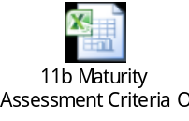

- High level Economic Appraisal

- Objectives and scope of this Appendix

The aim of this appendix is to show the Airport Data Link Solution features in order to evaluate the performance-benefit ratio in a pre-operational environment.

- Problem(s) addressed by the Solution

The R&D International Programmes aim to develop and improve solutions and technologies to support the future ATM global system, mainly in the following (see also [51] and [52]):

- Surface Data Sharing to let a huge data exchange for an effective and efficient airport operations
- New Data Communications infrastructure to reduce the ATCo Workload avoiding misunderstandings and improve the efficiency (e.g. introduction of AeroMACS on Airport Surface Management but not only)
- Collaborative Air Traffic Management (CATM) to support the ATCos, pilots, airport operators to achieve the best decision using the same picture

AeroMACS shall represent the main mean to support the different Airport Surface Operational needs and heterogeneous data exchange providing a secure wireless data, gathering data from fixed or mobile resources, flight service vehicles and weather stations.
The development of AeroMACS is focused on the proposal of an answer to some well-known technological drivers summarized in the following:
- Need for performing ATC airport applications on ATN/IPS and ATN/OSI connectivity (worldwide application ATS services)
- Need for airport wireless cabling using rings backup or substitution with a more cost-effective solution
- Reduction of AOC airport applications bandwidth-consuming on VHF spectrum (ACARS and VDL2)
Need for common and simultaneously fixed and mobile sensor management (e.g. alerts, real time data management etc..).

The airport domain is a very fragmented and all the stakeholders involved In the data exchange have very different and heterogeneous needs to be satisfied. For this reason, the following section depicts a list of the required capabilities from the end-user perspective and the Improvement Areas.

- System Capacity and Service Reliability, to:
  - Optimise the Take-Off and Landing procedures in time and space
  - Optimise the Turnaround activities with an adequate Airport Surface Management by DataLink infrastructure
  - Reduction of Fuel Cost and CO2 Emission towards the Green Airport concept by the minimization of the taxi time
- Air-Ground Integration of ATS End Users, to increase Airport Throughput
- Integration among the Airport Users, to optimize the Infrastructure Deployment
The above description reports what has to be addressed and solved by a common Airport Communication Infrastructure to be sure that all the Stakeholders receive the requested information according to their accountabilities, optimising the technological and operational resources.

- Stakeholders involvement description

The current section reports the main key actors and/or domain to be involved in terms of potential investment cost and return of the investment (ROI) consequently. It is worth to be noted that the ROI estimation will be developed by a qualitative approach, since the appendix is relevant to a future deployment of the Airport infrastructure based on the AeroMACS Technology.
- Civil CNS Service Providers
- Military CNS Service Providers
- Civil APT Operators
- Military APT Operators
- Civil Scheduled Aviation
- Civil Business Aviation-Fixed Wing
- Civil Flight Operations Centre

- Reference Scenario

The situation in which the AeroMACS solution has to operate can be developed according to some different awards criteria starting from a description of the environment scenario without the deployment of the Communication Infrastructure.
This approach is based on the paradigm for the optimisation of the Technological Ecosystem pillars.
In other terms, we can identify for each criteria the potential current situation to be coped with during the Airport Daily operations.

AWARDS CRITERIA:
- CAPACITY, means the ability to cope with and meet the end users request in any condition and time, peak time included
- FLIGHT EFFICIENCY in TIME, means the ability to respect the planned slot in arrival and departure time in order to minimise the flight delay
- PREDICTABILITY, means the ability to provide the same service application in a dependable way in order to be able to operate on schedule
- RESILIENCE, means the ability to be robust against any breach of the airport common information repository in order to be sure to have at any time aligned and updated information to be distributed among the stakeholders according to their roles and responsibilities
- SAFETY, means to avoid any unexpected behaviour which could entail a potential disruption of the E2E service application provision with impact on the Airport framework operability
- SECURITY, means the ability to be protected against any intentional and malicious attack and /or threats

The operational current Reference Scenarios, potentially impacted by AeroMACS technology for each capability, are listed in a summary dashboard, as follows:
The table below reports in:
- Column 2 – The awards criteria intended as capabilities potentially impacted by the presence/absence of the AeroMACS technology
- Column 3 – The current scenario, intended as operational stage of flight
- Column 4 – The optimizations need on the referred stage of flight.

ID | AWARDS CRITERIA | CURRENT SCENARIO WITH NO COMMON COMMUNICATION PLATFORM BASED ON AEROMACS | OPTIMIZATION NEEDS
1 | CAPACITY | - Non optimized impact on Airport Throughput  - Taxi time increase | - Optimisation of Taxi time and increase of air movements in the airside (GND capacity)  - Optimisation of airport movements in the airside (GND capacity) with an optimisation of the turnaround activities
2 | FLIGHT EFFICIENCY IN TIME | - Fragmented arrival and departure procedures with no complete airport situation awareness  - Potential delay in Taxi procedures | - Decrease in ATFM delay, pre-departure delays and Additional Time during taxing  - Decrease of need of Additional Time during taxing and improving in the airport throughput (for all airport vehicles) due to an optimisation of the guidance instructions
3 | PREDICTABILITY | - Fragmented data sharing among all the stakeholders with potential loss of data, or delayed delivery with not optimized data processing and Airport movements consequently | - Improvement in terms of dependability aspects in order to provide Provision of the appropriate level of performance ensuring the planned schedules
4 | RESILIENCE | - Fragmented Airport Environment with scant ability to recover information in case of Airport System Disruption with potential loss of information consequently | - Decrease of Rrecovery time from unplanned events (e.g. storm) for the nominal performance levels  - Improvement of the Domino effects in Airport operational framework to avoid domino effects
5 | SAFETY | - Fragmented Operational Environment  - Not best coverage / performance ratio  - Potential interferences among different communication infrastructure with likely service disruption | - Increasing of the Airport situation awareness due to a more accurate forecast  - Increasing of the Airport Provision for situation awareness due to a steady communication among the apt users to support a seamless integrated approach for IOP aspects
6 | SECURITY | - Potential intentional cyber attacks in one or more of the different Airport Subsystems with no guarantee of aligned and secure data with potential impact on safety aspects related to the Airport daily operations  - Potential intrusions in the Commercial Communication networks with not negligible likelihood in sensible data hijacking | - Data sharing integrity increase guarantee due by the use toof secure communications ( through the increase of resilience to MITM attacks)

Table 25 – Awards criteria, current scenarios and optimization needs

- Solution Scenario and Benefits

A qualitative Economical Appraisal requires to define the parameters and figures of merit to provide the benefits estimation of the previous operational scenarios under evaluation.

For this reason, it is reported, starting from the previous Awards Criteria table, the situation with the AeroMACS solution implemented and a description of the impact based on its usage at Total Airport Management level.
The table below reports in:
• Column 2 – The awards criteria intended as capabilities potentially impacted by the presence/absence of the AeroMACS technology, as for Table 1
• Column 3 – The improvements to the scenario, intended as operational stage of flight, due to the presence of the AeroMACs technology
• Column 4 – The impact of the improvements of Column 3 on the Total Management Concept.

ID | AWARDS CRITERIA | SCENARIO WITH COMMON COMMUNICATION PLATFORM BASED ON AEROMACS | IMPACT ON TOTAL AIRPORT MANAGEMENT CONCEPT
1 | CAPACITY | - Harmonized and coordinated Airport Surface Management (Air Side) among all the Airport Stakeholders. The high bandwidth and reliability provided by AeroMACS enables the use of live information in surface management applications such as A-SMGCS and other tools to handle parking, apron, taxiing and runway capacity  - Optimization of Airport supported services to improve the Parking Bay management, but not only, and the increase of the Airport Peak capacity | - Exploiting of all Airport Resources for enhancing the SMAN Capability and to improve the Decision Support process in daily operations and crisis management as well
2 | FLIGHT EFFICIENCY IN TIME | - Optimization of the airport movements flexibility for saving parking and taxi time  - Improvement of the Airport Throughput following an optimization of the trajectory for arrival and departure sequence | - Improving in the Departure and Arrival processes and procedures with an optimised usage of the runways, roadways, and taxiways
3 | PREDICTABILITY | - Optimisation of the airport movements flexibility through user-driven prioritization processes and data flow algorithms guaranteeing an aligned data sharing  - Compatibility with current ATM/ATC systems in airport | - Full Interoperability for all the Airport Subsystems to ensure the data exchange timely and according to the Role and Responsibility of the Airport Stakeholders
4 | RESILIENCE | - Improving in the Data Exchange management and thanks to shared and connected Airport Subsystems, the Overall Airport domain is resilient to unexpected disruption of the services.  - Ability to manage degraded situation with alternative paths start up, identified by a common cause analysis. | - Embedded redundancy of the information sharing with optimized information management
5 | SAFETY | - Harmonised and coordinated Operational Environment based on a real-time situation awareness  - Optimisation of the supported services according to Safety target levels  - Provision of relief to congested VHF Spectrum at Airport Surface | - Harmonised and aligned data sharing according to roles and responsibility of all stakeholders
6 | SECURITY | - Capability of supporting all types of critical and safety communications at Airport surface  - Ensure Airport Operations in protected C-Band spectrum, allowing also to maintain and secure the usage of C-Band for aviation in future  - Availability of Secure algorithms and policy embedded in the Airport Communication Platform | - Ability to manage Confidential and Safety Critical information in a very complex environment  - Ability to share heterogeneous information according to different policies of confidentiality and according to the areas of Responsibility of the End-Users  - Possibility to manage different Data Flows in segregated mode

Table 26 Improvements to the current scenario in presence of the proposed technology

In the following there are some examples, based on general purpose applications services to be compliant with, to give a maximum range of the AeroMACS constituents to be deployed in three different Airport categories.
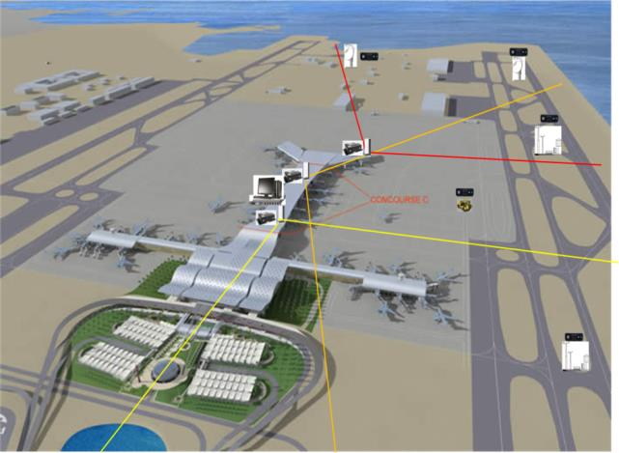


BS + ASN-GW Indoor
RF unit
RF unit
RF unit
Vehicular SS Station
Fixed SS Station
Fixed SS Station
Fixed SS Station
Fixed SS Station
Vehicular SS Station

- Small Airports:
  - Up to 6 Ground Stations;
  - Up to 120 Subscriber Stations;
  - Up to 2 CSN served by the AeroMACS network;
  - No redundancy;
  - Air Interface Encryption

- Medium Airports:
  - Up to 20 Ground Stations;
  - Number of Subscriber Stations between 120 and 360;
  - Up to 4 CSN served by the AeroMACS network;
  - Partial redundancy;
  - Air Interface Encryption / E2E Encryption for military airports

- Large Airports:
  - Up to 35 Ground Stations;
  - Number of Subscriber Stations between 360 and 600;
  - Up to 5 CSN served by the AeroMACS network;
  - Full redundancy;
  - Air Interface Encryption / E2E Encryption for military airports

Concerning the Airport categories, it is worth to be noted that it is a very complex and fragmented environment composed by the following macro-areas in which different systems has to be interoperable:
- Airport Airfield Systems (including Surveillance Systems)
- Ground Navigation Aids Systems
- Airborne Systems
- Ground Security Systems
- Efficient Terminal Management Systems
- ATM Planning Systems

Due to the previouspotential interoperability issues between legacy and new Systems, and/or between different stakeholders, AeroMACS is able to provide economic benefits for the End-Users, exploiting its main features and taking advantages on its key strength points (listed below)

- Strong Service and Customer Oriented Solution covering wide market needs and demands (high modularity for traditional and innovative requests) useful to develop a Data Link efficient and effective Infrastructure solution safe and secure in terms of architectural design
- Ability to provide Turn-key and end-to-end solutions, by means of open, modular and flexible Infrastructure focused on operational fixed and mobile services availability, integrity, confidentiality and operational needs of different stakeholders relevant to any local procedures and site-specific requirements according to Airport complexity
- Unique Ground Communication Solution which supports all fixed (e.g. Meteo, video-surveillance, etc..) and mobile (e.g. ATC/ATM application and advisory) services.
- International standards, as RTCA DO-345 and DO-346, ED-222, and ED-223 Fully Compliant
- Airport Communication Solutions Dependability (Reliability, Availability, Maintainability and Safety/Security - RAMS) oriented

The following summarising dashboard reassumes economic benefits, expressed per airport category:

ID | AWARDS CRITERIA | ECONOMICAL ASPECT FOR END-USERS | AIRPORT CATEGORY AFFECTED
1 | CAPACITY | - Reducing of Air Navigation Services (ANS) operating costs for ANSPs and ANS charges per flights for the Airspace users | - Medium and Large Airport
2 | FLIGHT EFFICIENCY IN TIME | - Cost savings to airspace users | - Medium and Large Airport
3 | PREDICTABILITY | - Appropriate Evaluation of scalable operational scenarios, according the target functionalities, for maximization of return of Investment (ROI) | - All Categories
4 | RESILIENCE | - Investment and Management Costs shared among all the Airport Stakeholders based on a Communication Platform with a high level of robustness  And  - Reduction overall costs thanks to synergies gained in sharing infrastructure | - All Categories
5 | SAFETY | - Best CNS Resource allocation and decrease of Airport costs management | - Medium and Large Airport
6 | SECURITY | - No needs Additional Investment costs for the implementation of other Security infrastructures in support of the Main Airport Communication Platform | - All Categories
Table 27: Economic benefits per airport category

High level Benefits & performances estimation

Taking into account all the above consideration, we can already conclude that the introduction of AeroMACS is highly beneficial for any kind of Airport. However, we can try to model the above results with the following quantitative representation, that takes into account all the possible types of Airports, given that the impact provided by AeroMACS may vary, depending on the complexity and technology level of Airport considered.
The following approach is derived for an AeroMACS performance –benefit estimation.
According to the Airport configuration, a weight score for each Airport Typology has been calculated, based on the following classification.
        - Complexity (C) of the airport:
- Small Airport Low Complexity: weight : 1
- Medium Airport Medium Complexity : weight 2
- Large Airport High Complexity: weight : 4
        - On the other side, the technological impact provided by AeroMACS on the current implemented Airport infrastructures needs to be considered, being in countertrend respect to airport complexity. The following Technological Improvement factor (I) is introduced, on the current implemented Airport Infrastructure:
- Small Airport High Impact: weight : 3
- Medium Airport Medium Impact : weight 2
- Large Airport Low Impact: weight : 1
So that , the final Score (S) is obtained according to the rule: S= [C x I ] for the three types of Airport is:
- Small Airport Score weight :3
- Medium Airport Score weight : 4
- Large Airport Score weight : 4
The total amount of the different End Users affected, which have a direct benefit exploiting the usage of the AeroMACS solution have been estimated according to the amount of service applications implemented on the same common communication platform. For this reason, it has been identified a score for three groups of affected stakeholder following the number and type of different stakeholders involved
- Single Stakeholder typology (e.g. Airport Operator only) weight : 1
- All Civil Stakeholders /All Military Stakeholder typology weight : 1,5
- All Airport Stakeholder typologies weight : 2
So that, the following table reports the different combinations according to the axes (Airport score in horizontal axes and Stakeholder affected in vertical axes).

Airport Typology | Small Airport | Medium Airport | Large Airport
Number of Stakeholders Affected
Single | 3 | 4 |  | 4
All Civil / All Military | 4,5 | 6 |  | 6
All | 6 | 8 |  | 8
Table 28: Benefits&Performances: an example of numerical estimation

It has to be underlined that the above table is purely indicative, due to the intrinsically rigid nature of the numbers assigned for the various categorizations. For this reason it should not be taken as a recommendation, but it may be indicative of advantages provided by the usage of AeroMACS for the Airport typologies with the following rationales.
- Very high Benefit (Total Score >= 6) , due to a unique communication platform in which all the Airport Stakeholders are direct beneficiaries in terms of Airport Data Exchanges aligned and updated (e.g. Information needed for Fixed application service as Surveillance, Video Surveillance, Weather or mobile service application as Guidance, etc…in the context of A-CDM, AOP, etc..)
- High Benefit (4≤ Total Score <6) , due to a unique communication platform in which some of the Airport Stakeholders are direct beneficiaries in terms of Airport Data Exchanges aligned and updated
- Reasonable Benefit (Total Score <4), in which the unique communication platform benefit is to be balanced with respect to the real deployment issues and the stakeholders operational needs.

- Conclusions
The high level economic appraisal described in this Appendix allows to evidence the benefits provided by the introduction of AeroMACS Solutions in different categories of Airport. It can be concluded that the introduction of AeroMACS is highly beneficial for all possible combinations of Airports sizes and involved Stakeholders.




The EUROCAE ED-78A has been used as an initial guidance material. ED-78A is useful, but is not an applicable document, because it mostly addresses the V4-V5 phases, whilst the SESAR R&D programme is focussed on development (V1-V2-V3, and because of its partial compliance with safety regulatory requirements).
Airport categorization takes into account available analyses like [51]

