 | SESAR 2020 Final TS IRS - PJ14.02.06
 | Deliverable ID: | D7.3.010
 | Dissemination Level: | PU
 | Project Acronym: | EECNS
 | Grant: | 734168
 | Call: | [H2020-SESAR-2015-2]
 | Topic: | SESAR.IR-VLD.Wave1-17-2015
 | Consortium Coordinator: | LDO
 | Edition Date: | 8th November 2019
 | Edition: | 01.00.03
 | Template Edition: | 02.00.02

INDUSTRIAL RESEARCH



Authoring & Approval
Authors of the document
Name/Beneficiary | Position/Title | Date
Giulio Vivaldi/LDO | T2/T3 Leader and WP7 Solution Manager | 01/11/19

Reviewers internal to the project
Name/Beneficiary | Position/Title | Date
Nikos Fistas/ECTL | T1 Leader | 08/11/19
Victor Flores Gomez/ECTL | Contributor | 08/11/19
Giulio Di Tillio/AIRTEL | T4 Leader | 08/11/19
Simona Pierattelli/LDO | Contributor | 08/11/19

Approved for submission to the SJU By - Representatives of beneficiaries involved in the project
Name/Beneficiary | Position/Title | Date
Giulio Vivaldi / LDO | Leonardo Focal Point | 08/11/19
Giulio Di Tillio/AIRTEL | Airtel Focal Point | 08/11/19
Nikos Fistas / ECTL | EUROCONTROL Focal Point | 08/11/19

Rejected By - Representatives of beneficiaries involved in the project
Name/Beneficiary | Position/Title | Date

Document History
Edition | Date | Status | Author | Justification
00.00.01 | 11/09/19 | Draft | Giulio Vivaldi | Draft version of the Final TS/IRS
01.00.00 | 20/09/19 | Final | Giulio Vivaldi | Final version of the Final TS/IRS
01.00.01 | 01/11/19 | Final Draft | Giulio Vivaldi | Final Draft after revision of SJU comments
01.00.02 | 06/11/19 | Final | Giulio Vivaldi | Final TS/IRS approved by Partners
01.00.03 | 08/11/19 | Final | Giulio Vivaldi | SJU comment incorporated
Copyright Statement
© – 2019 – Leonardo AIRTEL Eurocontrol
All rights reserved. Licensed to the SJU under conditions.
The opinions expressed herein reflect the author’s view only. Under no circumstances shall the SESAR Joint Undertaking be responsible for any use that may be made of the information contained herein.

EECNS
PJ14 EECNS

This deliverable is a Technical Specification and is part of a project that has received funding from the SESAR Joint Undertaking under grant agreement No 734168 under European Union’s Horizon 2020 research and innovation programme.


Abstract

This Final TS/IRS, targeting TRL6 maturity level, describes Architecture and Technical Requirements related to the Integration of AeroMACS System with the ATN/OSI Network. It also addresses Multilink in ATN/OSI environment. Integration with ATN/IPS Network in Multilink environment has been addressed in coordination with 14.02.04 Solution activities related to the definition of the Future Communication Infrastructure (FCI) of which AeroMACS will be a Subnetwork.

Table of Contents

Abstract 4
1 Executive summary 9
2 Introduction 10
2.1 Purpose of the document 10
2.2 Scope 10
2.3 Intended readership 10
2.4 Background 11
2.5 Structure of the document 11
2.6 Acronyms and Terminology 11
3 SESAR Solution Impacts on Architecture 15
3.1 Target Solution Architecture 16
3.2 Changes imposed by the SESAR Solution on the baseline Architecture 22
4 Technical Specifications 24
4.1 Functional architecture overview 24
4.2 Functional and non-Functional Requirements 35
5 Implementation Options 53
5.1 Implementation Option 1: Integration of AeroMACS and ATN/OSI Systems (Implementation Option 1) 53
5.2 Implementation Option 2: Multilink in ATN/OSI environment 70
5.3 Implementation Option 3: Integration of AeroMACS and ATN/IPS Systems 76
5.4 Implementation Option 4: Multilink in ATN/IPS environment 81
5.5 Implementation Option 5: Integration of AeroMACS with Digital Voice 89
5.6 Traceability between implementation options and requirements 91
6 Assumptions 94
7 References and Applicable Documents 95
7.1 Applicable Documents 95
7.2 Reference Documents 96
Appendix A Service Description Document (SDD) 99
Appendix B Service Technical Design Document (STDD) 100

List of Tables
Table 1: Acronyms and terminology 14
Table 2: SESAR Solution PJ14.02.06 Scope and related Functional Blocks/roles & Enablers 19
Table 3: List of Capability Configuration required for the SESAR Solution 22
Table 4: List of changes due to the SESAR Solution 23
Table 5: Field Types of the AGR-AeroMACS Control Interface 60
Table 6: Primitive Formats of the AGR-AeroMACS Control Interface 60
Table 7: LOGOFF_IND Primitive of the AGR-AeroMACS Control Interface 61
Table 8: Field Types of the AAR-AeroMACS Control Interface 65
Table 9: Primitive Formats of the AAR-AeroMACS Control Interface 65
Table 10: JOIN Primitive of the AAR-AeroMACS Control Interface 65
Table 11: LEAVE Primitive of the AAR-AeroMACS Control Interface 66

List of Figures
Figure 1: EATM System Architecture Overview Capability Configuration 15
Figure 2: EATM Technical Systems Overview 16
Figure 3: Example of AeroMACS Applications 17
Figure 4: AeroMACS Generic Applications and Communications Overview 18
Figure 5: Network Reference Model 24
Figure 6: WMF ASN Profile C 25
Figure 7: ATN/OSI Data Link System Functional Architecture 27
Figure 8: ATN/IPS Data Link System Functional Architecture 30
Figure 9: Resource Infrastructure Connectivity View (NSV-2) modelled in MEGA/EATMA 32
Figure 10: Uplink Data Transfer Sequence Flow Diagram 33
Figure 11: Downlink Data Transfer Sequence Flow Diagram 34
Figure 12: AeroMACS Network Layout 54
Figure 13: Message sequence diagram for fixed IP address when IDRP is used 57
Figure 14: Protocol Stack of the AGR-AeroMACS Interface 58
Figure 15: Logical Network Layout of the AGR-AeroMACS Interface 59
Figure 16: Use Cases of the AGR-AeroMACS Interface with the Control Interface 61
Figure 17: Use Cases of the AGR-AeroMACS Interface without the Control Interface 62
Figure 18: Protocol Stack of the AAR-AeroMACS Interface 63
Figure 19: Logical Network Layout of the AAR-AeroMACS Interface 63
Figure 20: ATN Airborne Router State Machine 64
Figure 21: AAR-AeroMACS Interface Protocol Phases 67
Figure 22: Scenario 1- one single Service Provider connected to ASN 68
Figure 23: Scenario 2 - one single Service Provider connected to ASN 69
Figure 24: Scenario 3: two Service Providers connected to the same ASN 70
Figure 25: Multilink ATN/OSI network topology 71
Figure 26: Multilink ATN/OSI logical architecture 71
Figure 27: First ATN/OSI multilink scenario: aircraft before landing 73
Figure 28: First ATN/OSI multilink scenario: aircraft inside the airport environment 73
Figure 29: First ATN/OSI multilink scenario: aircraft departed 74
Figure 30: Second ATN/OSI scenario: aircraft inside the airport environment 75
Figure 31: AeroMACS and ATN/IPS environment 77
Figure 32 AeroMACS IPS: initialization and link establishment 79
Figure 33 Interfaces between IPS airborne router and AeroMACS MS 80
Figure 34: The Future Communications Infrastructure 82
Figure 35: FCI Functional Block Diagram and related interfaces 83
Figure 36: AeroMACS Access Subnet connecting ATN/IPS End Systems in a Multilink environment 83
Figure 37: Airborne Radio-Airborne Router protocol stack 85
Figure 38: Airborne Radio endpoint operation 86
Figure 39: AIAP Message Format 87
Figure 40: AIAP Option Format 87
Figure 41: Datalink ID Option 87
Figure 42: Datalink status Option 88
Figure 43: AeroMACS Network Layout with Voice Service 90
Figure 44: A possible application for VoiP over AeroMACS 90
Figure 45: Other VOIP/AeroMACS application: Mobile Remote Control Site 91

Executive summary
This is the Final TS/IRS for Solution PJ14.02.06 (Completion of AeroMACS Development) for TRL6 phase, after technical validations executed within the Solution timeframe.
Solution PJ14.02.06 builds upon Solution #102 published in the SESAR 1 catalogue. AeroMACS Solution #102 reached TRL6 Maturity Level as Data Link, however in SESAR1 no activity was done to integrate AeroMACS with ATN/OSI, ATN/IPS and Multilink. This is the main goal of PJ14.02.06.
This document provides the overall architectural design description and technical requirements for the AeroMACS System, integrated with the ATN environment (both OSI and IPS). In addition, it covers the deployment of AeroMACS in the context of the Future Communication Infrastructure (FCI), which AeroMACS will be a part of, together with LDACS and the future SATCOM Systems. Hence the AeroMACS System needs to be integrated with the Multilink Function, that will be a crucial part of the FCI. The Multilink Function has been initially considered under the SESAR1 activities, and has been further refined in the SESAR2020 activities in solution PJ14.02.04.
Technical requirements described in the present deliverable have been consolidated after exercises completion.

Introduction
This document contains the requirements describing the functional behaviour of the AeroMACS System integrated with the relevant network systems and components supporting ATN/OSI, ATN/IPS and multilink operations (FCI). It builds on the technical requirements of the AeroMACS technology defined in detail in the context of the SESAR1 AeroMACS projects (e.g. P15.02.07,[8],[9],[10],[11]) and focuses particularly on interfaces and requirements among the various blocks composing the global System; ATN/OSI is a legacy network and its requirements are well defined while ATN/IPS and FCI Multilink Requirements are currently under definition by the relevant Standardization Authorities (ICAO, EUROCAE/RTCA, AEEC), and SESAR2020 PJ14 COM solutions are actively contributing to their definition and standardisation. Also integration of Digital Voice with AeroMACS System is evaluated, in order to support the definition and agreement on possible future use of A/G Digital Voice in the Future Communication Infrastructure.

Purpose of the document
This Final Technical Specification provides the requirements specification covering the functional, non-functional and interface requirements related to SESAR Solution PJ14.02.06. In particular, the following implementation options are described:
- AeroMACS System integrated with ATN/OSI Network
- AeroMACS System integrated in a Multilink Environment with ATN/OSI Network
- AeroMACS System integrated with ATN/IPS Network
- AeroMACS System integrated in a Multilink Environment with ATN/IPS NetworkAeroMACS System integrated with Digital Voice.

All of these options are described in terms of System Architecture and Technical Requirements, that have been validated by means of specific Exercises.

Scope
The present document is the Final TS/IRS for Solution PJ14.02.06, consolidated after execution of all the Technical Validation Exercises VAL.010, VAL.020, VAL.030, VAL.040, and analysis of their results.
This Final TS/IRS covers functional, non-functional and interface requirements related to SESAR Solution PJ14.02.06. Requirements have been consolidated after exercises completion.

Intended readership
Parties generally interested in the AeroMACS technical requirement and interfaces will find this document useful.
Being this deliverable a Final TS/IRS document, its Intended readership is primarily covering PJ14.02.06 and PJ14.02.04 Partners and SJU. Other Parties or Stakeholders are expected to be interested, the complete list is indicated below:
- SJU
- PJ14.01.01, PJ14.02.01, PJ14.02.02, PJ14.02.04, PJ03a.01, PJ17.01, PJ19, PJ20
- Deployment and Certification Bodies: SDM, EASA, WiMAX Forum
- Standardization Bodies: ICAO, EUROCAE/RTCA, AEEC, ETSI

Background
The AeroMACS solution PJ14-02-06 continues the work of the SESAR1 Solution #102, published in the SESAR 1 catalogue, that reached TRL6 Maturity Level as Data Link, thanks to the work done by projects P15.02.07 and P9.16, in addition to PJ12.03.04, that investigated the use of D-TAXI with AeroMACS. Therefore All the deliverables produced by these SESAR1 Projects are relevant and constitute Background Information.

Structure of the document
Chapter 1 contains the document Executive Summary.
Chapter 2 describes the scope of the document, identifies the intended readership and the list of references and list of acronyms.
Chapter 3 describes the AeroMACS Target Architecture, listing the various components of such an architecture, that are described in Chapter 5.
Chapter 4 contains the AeroMACS Technical Specifications for the various Implementation Options.
Chapter 5 describes the various AeroMACS Implementation Options.
Chapter 6 describes Assumptions taken throughout the present document, that have an impact on the technical specifications described.
Chapter 7 contains References and Applicable Documents.

Acronyms and Terminology

Term | Definition
AAA | Authentication, Authorization, and Accounting
AAA Server | Computer system performing AAA services (authentication, authorization, accounting)
AAR | Airborne ATN Router
AC-R | Access Router
ADD | Architecture Description Document
ADS-B | Automatic Dependent Surveillance - Broadcast
ADS-C | Automatic Dependent Surveillance - Contract
AGR | Air Ground Router
AOC | Aeronautical Operational Control
AOC | Airport Operations Centre
ARU | Avionic Radio Unit
ASN | Access Service Network
ASN-GW | ASN Gateway
ATM | Air Traffic Management
ATN | Air Traffic Network
ATS | Air Traffic Service
ATSC | Air Traffic Service Communication
BIS | Boundary Intermediate System
BS | Base Station
C-ATSU | Current Air Traffic Service Unit
CC | Capability Configuration
CINR | Carrier to Interference and Noise Ratio
CLNP | Connectionless Network Protocol
CM/CPDLC | Context Management/Controller Pilot Data Link Communications
COS | Class Of Service
CPE | Customer Premises Equipment (it refers to both Avionic and Ground Radio equipment, mobile or fixed)
CSN | Connectivity Service Network
DHCP | Dynamic Host Configuration Protocol
EAP-TLS | Extensible Authentication Protocol - Transport Layer Security
EATMA | European ATM Architecture
E-ATMS | European Air Traffic Management System
ES | End System
FAA | Federal Aviation Administration
FOC | Civil AU Flight Operations Centre
GGR | Ground-Ground Router
HA | Home Agent
IDRP | Inter Domain Routing Protocol
IER | Information Exchange Requirement
INTEROP | Interoperability Requirements
IPS | Internet Protocol Suite
IRS | Interface Requirements Specification
IS | Intermediate System
ISH | Intermediate System Hello
LISP | Location Identifier Separation Protocol
ISRM | Information Services Reference Model
MS | Mobile Station
NAF | NATO Architecture Framework
NAP | Network Access Provider
NSOV | NAF Service Oriented View
NSP | Network Service Provider
NOV | NAF Operational View
NSV | NAF System View
OSI | Open System Interconnection
OSED | Operational Service and Environment Definition
PDU | Protocol Data Unit
PIRM | Programme Information Reference Model
PKI | Public Key Infrastructure
QoS | Quality of Service
RRA | Radio Resource Agent
RRC | Radio Resource Controller
RRM | Radio Resources Management
SDD | Service Description Document
SDU | Service Data Unit
SESAR | Single European Sky ATM Research Programme
SJU | SESAR Joint Undertaking (Agency of the European Commission)
SNDCF | SubNetwork Dependent Convergence Function
SNPA | SubNetwork Point of Attachment
SoaML | Service Oriented Architecture Modelling Language
SPR | Safety and Performance Requirements
SS | Subscriber Station
SWIM | System Wide Information Model
TRL | Technology Readiness Level
TS | Technical Specification
UML | Unified Modelling Language
V&V | Validation and Verification
WMF | WiMAX Forum
WSDL | Web Services Definition Language
XSD | XML Schema Definition
Table 1: Acronyms and terminology

SESAR Solution Impacts on Architecture
The eATM portal overviews the ATM system architecture contest displaying the external connectivity of the European ATM system and the internal connectivity between the Capability Configurations used as reference in the European ATM architecture.
The European ATM System Architecture Overview provides a set of reference Capability Configurations required to support the full set of ATM capabilities and activities defined in the SESAR Concept of Operation.
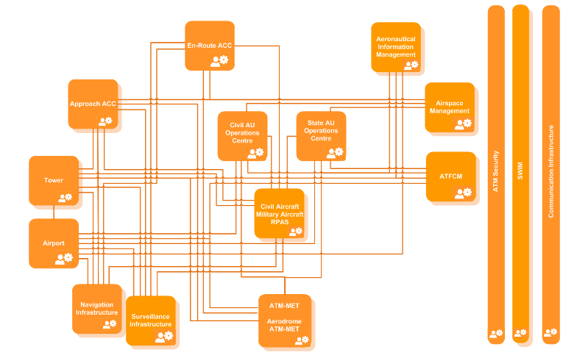

Figure 1: EATM System Architecture Overview Capability Configuration

The Communication Infrastructures, implemented by COM Service providers, provides the communication services needed to convey Voice and Data flows over the Ground-Ground and Air-Ground segments. In the following picture, the Technical Systems overview displays all technical systems used as reference in the European ATM Architecture
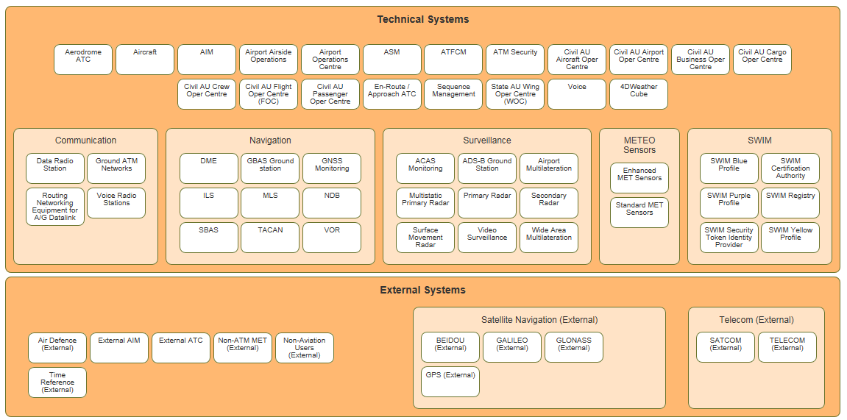
Figure 2: EATM Technical Systems Overview
The Communication Infrastructures functional block contains the following Communication technical systems:
• Data Radio Station
• Ground ATM Networks
• Routing Networking Equipment for A/G Datalink
• Voice Radio Stations (enables voice communication between FOC, ATC and Aircraft)
The Data Radio Station is devoted to enable air-ground data communication with aircraft via Datalink by the improvement of a number of enablers, one of which relate directly to the proposed PJ14-02-06 SESAR technological solution.
The Voice Radio Stations enables voice communication between FOC (Civil AU Flight Operations Centre), ATC, AOC (Airport Operations Centre) and Civil/Military Aircraft including the use of digital Air-Ground voice, which is considered in the proceeding of PJ14-02-06 SESAR technological solution.
The PJ14-02-06 relationships with EATMA architecture elements and enablers are listed in Table 2 below. Applicable EATMA/DS version to the present document is DS19. AeroMACS Modelling is ongoing in DS20 Draft/EATMA V13.0 Draft.

Target Solution Architecture

AeroMACS Solution Overview
AeroMACS can support a wide variety of services, such as voice, video, data communications and information exchanges, among fixed and mobile users at the airport.
AeroMACS provides communication services to support the following aviation services: Air Traffic Services (ATS), Aeronautical Operational Control (AOC) Services and Airport Authority Services (see Figure 3). Within these broad categories, the various services/applications can be described as either fixed or mobile communications, based on the mobility of the end user.
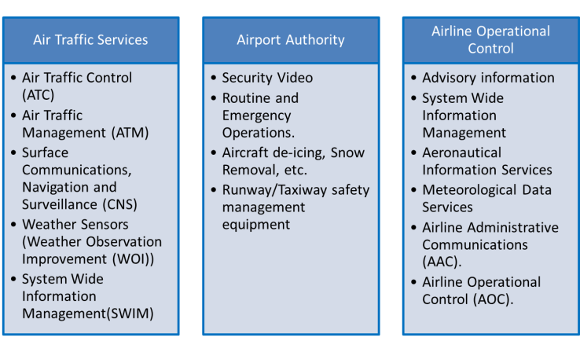
Figure 3: Example of AeroMACS Applications

The applications that a user will be connected to may vary depending on the user type. For instance aircraft, which are mobile assets, are expected to have connectivity to both Air Traffic Services group of applications as well as Airline Operational Control group of applications and may also have connection to Airport Authority group of applications such as Aircraft de-icing. Airport Sensor systems, which are generally fixed assets, are expected to connect to an Airport Authority type of application such as Security Video. Nomadic and non-aircraft Mobile system may have connections to all three of the above cited groups of applications depending on their needs and authorizations.
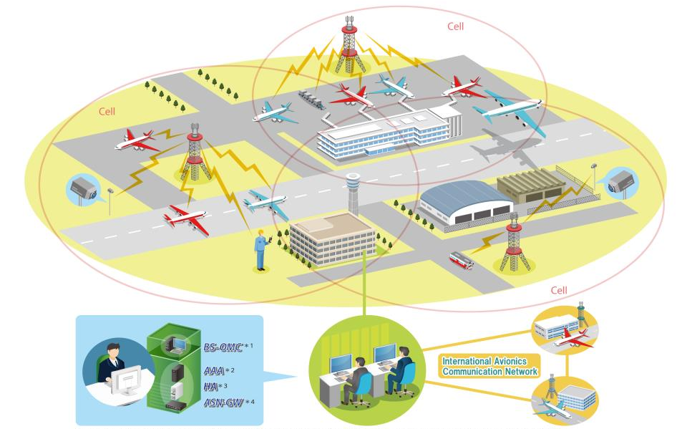

Figure 4: AeroMACS Generic Applications and Communications Overview
Focusing on Air Traffic Services (ATS), the Target solution Architecture is expected to be reached through the following Roadmap, composed of the following steps:
Step 1: AeroMACS will be integrated with the legacy ATN/OSI network.
Step 2: AeroMACS will be integrated with Multilink environment in a ATN/OSI network
Step 3: AeroMACS will be integrated with the ATN/IPS network.
Step 4: AeroMACS will be integrated with Multilink environment in a ATN/IPS network.
Step 5: AeroMACS will be integrated with Digital Voice System.
It is important to underline that it is not necessarily expected that all the steps be deployed, or that they be deployed sequentially.

SESAR Solution ID and Title |  | Functional Blocks/Role impacted by the SESAR Solution (from EATMA) |  | Enabler ID (from EATMA) |  | Enabler Title (from EATMA) | Enabler coverage
Technological Solution PJ14.02.06 – Completion of AeroMACS Development | Communication Infrastructure (PJ14.02.06) - Data Radio Station AeroMACS (PJ14.02.06) – Civil Aircraft (PJ14.02.06) |  | CTE-C02d |  | New Airport Datalink technology (AEROMACS) |  | Fully
Table 2: SESAR Solution PJ14.02.06 Scope and related Functional Blocks/roles & Enablers

Deviations with respect to the SESAR Solution(s) definition

At the start of the Solution activities, the CTE-C02d Title was “New Airport Datalink technology (AEROMACS) - New wireless technology for the Airport Datalink AEROMACS over ATN/IPS, based on IEEE 802.16 WiMax, as a new standard for airport surface communications (ATS, AOC and APOC) for the Aircraft and Vehicles.”
The Enabler Description was dealing only with ATN/IPS. However, since PJ14.02.06 Solution validates also the integration of AeroMACS with ATN/OSI, then the Enabler Description was modified accordingly, thanks to Change Request “CR 01757 Update CTE-C02d (PJ.14-02-06)”, endorsed by SJU.
The same CR has then completed the set of stakeholders with the following ones, which were missing initially:
- Airspace Users - Scheduled
- Airspace Users - BA Fixed Wing
- Airspace Users – FOC
- Military CNS Service Provider
- Military APT operator
Subsequently following coordination with SJU, PJ19, PJ20, the following modifications were done on the Solution and the related Operational Improvements:
- In order to better differentiate Solution #102 (SESAR1 Solution for AeroMACS) from Solution PJ14.02.06 (SESAR2020), a new Enabler CTE-C02d0 linked with Solution #102, and different from CTE-C02d, was created. This was accomplished with two CRs:
  - CR 03226 to create the Enabler CTE-C02d0, linked to CNS-0001-B OI Step
  - CR 03233 to link CNS-0001-B OI Step to Solution #102

- As a consequence of Architectural Issue #46, Solution PJ14.02.06, as all Technological Solutions, was requested to be linked to a new Performance Operational Improvement, created with CR 03013: “POI-0029-COM_ATM High Performance Airport Datalink”. In the same context, link of PJ14.02.06 with Operational Improvement CNS-0001-B was removed (CR 02827). In addition, CR 03286 was issued to link Enabler CTE-C02d to the new POI-0029-COM, proposing 19th November 2019 as "V3 End" for CTE-C02d. (Solution #102 had instead reached V3 in 2014). CR 03286 is today pending on SJU approval.

- Finally, CR 03472 was issued (today pending on SJU approval) to again modify Title and Description of PJ14.02.06 Solution, in order to better explain its Scope and differentiate it from Solution #102.
  - Proposed Title: “AeroMACs integrated with ATN, Digital Voice and Multilink”
  - Proposed Description: “The solution consists of the integration of AeroMACs with ATN systems, in both ATN/OSI and ATN/IPS options, with (VoIP) digital voice communication and multilink in ATN/OSI environment (beyond solution #102 in SESAR 1).”

Relevant Use Cases
The Airport Surface Datalink or AeroMACS has already been validated and standardized in SESAR1.
What is pending after SESAR1 is the integration of AeroMACS with the ATN Network (both OSI and IPS/Multilink options). AeroMACS will be part of the Future Communications Infrastructure to support future aeronautical requirements for data communications and shall support ATN IPS infrastructure to provide ATN-B2 and ATN-B3 service to Aircraft.
Concerning the Ground Network, typical use cases have been identified. They are described in the following subchapters.

Applicable standards and regulations
- ED-222/DO-345, Aeronautical Mobile Airport Communications System (AeroMACS) Profile, edition 2013
- ED-223/DO-346, Minimum Operational Performance Standards (MOPS) for the Aeronautical Mobile Airport Communication System (AeroMACS) , edition 2013
- ED-227, Minimum Aviation System Performance Standards (MASPS) for the Aeronautical Mobile Airport Communication System (AeroMACS) , edition 2016
- ICAO Annex 10, Volume 3 Chapter 7, Aeronautical Mobile Airport Communications System (AeroMACS ) SARPs, edition2016
- ICAO Doc 10044, Manual on the Aeronautical Mobile Airport Communications System (AeroMACS) , edition 2017
- ICAO Doc 9880 Part III, Manual on Detailed Technical Specifications for the Aeronautical Telecommunication Network (ATN) using ISO/OSI Standards and Protocols, Part III - Upper Layer Communications Service (ULCS) and Internet Communications Service (ICS)
- ARINC 766: AeroMACS Transceiver and Aircraft Installation Standards, edition 2017
- NWG Stage 2 Specifications for Release 1 are published in 4 parts.
WMF-T32-001-R010v05 , (2009-03-19), WiMAX Forum® Network Architecture (Stage 2: Architecture Tenets, Reference Model and Reference Points) [Part 0]
WMF-T32-002-R010v05 , (2009-03-19), WiMAX Forum® Network Architecture (Stage 2: Architecture Tenets, Reference Model and Reference Points) [Part 1]
WMF-T32-003-R010v05 , (2009-03-19), WiMAX Forum® Network Architecture (Stage 2: Architecture Tenets, Reference Model and Reference Points) [Part 2]
WMF-T32-004-R010v05 , (2009-03-19), WiMAX Forum® Network Architecture (Stage 2: Architecture Tenets, Reference Model and Reference Points) [Part 3 – Informative Annex]
- WiMAX Forum® T32-006-R010v01 AeroMACS PKI Certificate Policy, edition 2017
- EUROCAE, ED-137B INTEROPERABILITY STANDARDS FOR VOIP ATM COMPONENTS – VOLUME 1: RADIO, January 2012
- EUROCAE ED-228A, SAFETY AND PERFORMANCE REQUIREMENTS STANDARD FOR BASELINE 2 ATS DATA COMMUNICATIONS (BASELINE 2 SPR STANDARD), edition March 2016

Capability Configurations required for the SESAR Solution
SESAR Solution ID and Title | Capability Configurations (CCs) (from EATMA) | Sub-Operating Environment(s) where the CCs operate | Capabilities (from EATMA) | Nodes (from EATMA) | Stakeholders (from EATMA)
PJ14.02.06.- Completion of AeroMACS Development | AeroMACS Communication Infrastructure | Airport | Airport Operations Management  Surface Guidance and Route  Execute Trajectory  Sequencing and Merging  Spacing  Separation Provision  Aeronautical Information Provision  Trajectory Management  Meteorological Information Provision | Airport Operations  Airspace User Operations  ATS Operations | Civil CNS Service Provider  Civil APT operator  Airspace Users – Scheduled  Airspace Users - BA Fixed Wing  Airspace Users - FOC  Military CNS Service Provider  Military APT operator

Table 3: List of Capability Configuration required for the SESAR Solution

Changes imposed by the SESAR Solution on the baseline Architecture
Enabler ID (from EATMA) | Enabler Title (from EATMA) | Changes
CTE-C02d | New Airport Datalink technology (AEROMACS) | Enabler description was modified as follows: “New wireless technology for the Airport Datalink AEROMACS over ATN/OSI and ATN/IPS, based on IEEE 802.16 WiMax, as a new standard for airport surface communications (ATS, AOC and APOC) for the Aircraft and Vehicles.”.
CTE-C02d | New Airport Datalink technology (AEROMACS) | Stakeholders linked to the enabler, to be updated to include:  Airspace Users - Scheduled  Airspace Users - BA Fixed Wing  Airspace Users – FOC  Military CNS Service Provider  Military APT operator
CTE-C01b | New Digital A/G Voice | Need to include a link to the EATMA architecture between the enabler CTE-C01b and the Voice Radio station
CTE-C02d0 | New Airport Datalink technology (AEROMACS) | This Enabler, different from CTE-C02d, was created “in the past” for Solution #102 (SESAR1 Solution for AeroMACS), in order to better differentiate it from Solution PJ14.02.06 (SESAR2020). This Enabler CTE-C02d0 was linked with Solution #102 and with CNS-0001-B OI Step. This was accomplished with CR 03226 and CR 03233 mentioned in 3.1.1.1.  Enabler Description: “New wireless technology for the Airport Datalink AEROMACS, based on IEEE 802.16 WiMax, as a new standard for airport surface communications (ATS, AOC and APOC) for the Aircraft and Vehicles.”

Table 4: List of changes due to the SESAR Solution

Technical Specifications

Functional architecture overview

AeroMACS System
The AeroMACS Functional Architecture was defined during SESAR1. Below there is a summary of the High-level AeroMACS Architecture, including some key definitions. This architecture below may be modified in the final version considering the FCI ATN/IPS and Multilink functionalities.
An AeroMACS Network is composed of the macro-blocks identified by the Network Reference Model (NRM) described in [12] and [17]. The NRM identifies functional entities and reference points over which interoperability is achieved between functional entities.
Each of the entities, MS, ASN and CSN represent a grouping of functional entities.
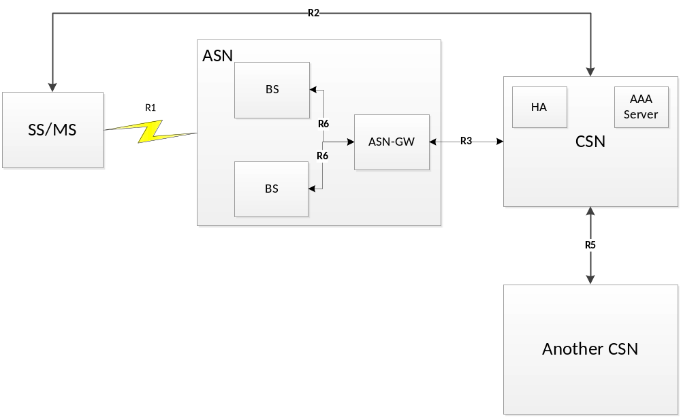
Figure 5: Network Reference Model
The AeroMACS Architecture specification is based on the AeroMACS System Profile ([2]), that supports ASN interoperability Profile C defined by WMF, that is briefly described here below (for further details, see [12]).
According to Profile C, ASN functions are mapped into ASN-GW and BS as shown in Figure 6. Key attributes of Profile C are:
HO Control is in the Base Station.
Radio Resource Control (RRC) is in the BS, that allows Radio Resource management (RRM) within the BS. An “RRC Relay” is in the ASN GW, to relay the RRM messages sent from BS to BS via R6.

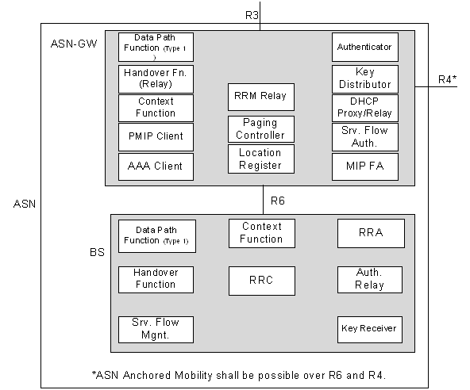
Figure 6: WMF ASN Profile C
For more details on WMF Profile C, see [12].
A list of definitions for the various Reference Points (RP) mentioned above is given in the following subchapters.

Reference Points Definitions
Figure 5 introduces several interoperability reference points. A reference point is a conceptual point between two groups of functions that reside in different functional entities on either side of it. These functions expose various protocols associated with an RP. Definitions of reference points between the major functional entities are the following:
- Reference Point R1 consists of the protocols and procedures between MS and ASN as per the air interface (PHY and MAC) specifications.
- Reference Point R2 consists of protocols and procedures between the MS and CSN associated with Authentication, Services Authorization and IP Host Configuration management. This reference point is logical in that it does not reflect a direct protocol interface between MS and CSN.
- Reference Point R3 consists of the set of Control Plane protocols between the ASN and the CSN to support AAA, policy enforcement and mobility management capabilities. It also encompasses the Bearer Plane methods (e.g. tunneling) to transfer user data between the ASN and the CSN.
- Reference Point R4 consists of the set of Control and Bearer Plane protocols originating/terminating in various functional entities of an ASN that coordinate MS mobility between ASNs and ASN-GWs.
- Reference Point R5 consists of the set of Control Plane and Bearer Plane protocols for internetworking between the CSN operated by the home NSP and that operated by a visited NSP.
Reference point R6 consists of the set of Control and Bearer Plane protocols for communication between the BS and the ASN-GW.

AAA Server
AAA Server is a crucial component of a PKI. It provides the following Services:
- Authentication Services. These include device, user, or combined device and user authentication
- Authorization Services. These include the delivery of information to configure the session for access, mobility, QoS and other applications.
Accounting Services. These include the delivery of information for the purpose of billing (both prepaid and post-paid billing) and information that can be used to audit session activity by both the home NSP and visited NSP.

ATN/OSI System
ATN/OSI System is intended to provide a network infrastructure for Air Traffic Services (ATS) safety service applications.
The following diagram presents the ATN/OSI functional architecture.

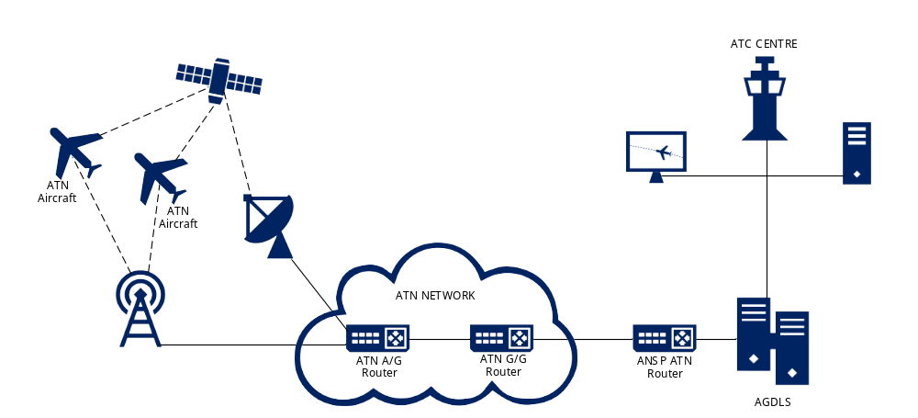
Figure 7: ATN/OSI Data Link System Functional Architecture

The components of Air Navigation Service Provider (ANSP) domain are:
- ATS Access Router (ANSP ATN/OSI Router): it is a CNS/ATM SARPS compliant end-domain Ground/Ground router (ICAO Doc 9705 Class 4) tailored for use in an ATS centre. The ANSP ATN/OSI Router is an essential component in constructing an ATN/OSI-compliant ATC centre as it provides connectivity for the centre with the ACSP Domain and the aircraft.
- ATN Air/Ground Data Link System (AGDLS): it is responsible for handling Data Link communications between the ATC System to aircraft via the ATN Network; it implements the Data Link Services required by the DLS implementing rule (EC No 29/2009). It supports ATN communications application such as Context Management (CM), Controller Pilot Data Link (CPDLC), ADS-C (Automatic Dependent Surveillance – Contract). It handles two configurations:
  - Data Link Front End Processor (DL-FEP): FDPS implements the data link services and the DL-FEP handles message formatting and communications with the aircraft
  - Data Link Server (DLS): DLS also implements ATC services, simplifying the implementation in the FDPS.
- Data Processing Unit: it represents the technical infrastructure where data link functionality is to be integrated. This architecture supports typical functions such as Surveillance and Flight Data Processing, Operational Display, Data and Voice Communications.

The components of the ATN/OSI Network are:
- ATN/OSI Air/Ground Router (AGR): it is a CNS/ATM SARPS compliant Air/Ground router (ICAO Doc 9705 Class 5). It provides the ATN connectivity between the airborne router via the mobile subnetwork and the ground ATN/OSI Network. It is the entry point of the ATN network from the airborne side.
- ATN/OSI Ground/Ground Router (GGR): it is a CNS/ATM SARPS compliant transit domain Ground/Ground router (ICAO Doc 9705 Class 4). It is used to build the ground part of the ATN/OSI Network.

The components of the Aircraft Domain are:
- Onboard ATN End System: it provides end-to-end communication service for Air/Ground applications.
- ATN/OSI Airborne Router (AAR): it provides the ATN connectivity to the ground ATN/OSI Network via the ATN/OSI Air/Ground Router.
- AeroMACS CPE: it refers to both Avionic and Ground Radio equipment, mobile or fixed

The Data Link applications are:
- Context Management (CM): the CM application is a system application used to establish communication between air and ground end systems and to exchange addressing and flight plan information enabling unambiguous association of flights with flight plans in the ground systems.
- Controller Pilot Data Link Communications (CPDLC): the CPDLC application entity allows ground and air systems to establish, maintain and terminate an association for the exchange of operational CPDLC messages, which are composed of uplink and downlink message elements. CPDLC is a means of communication between controller and pilot, using data link for ATC communications. These include a set of clearance/information/request message elements which correspond to voice phraseology employed by Air Traffic Control procedures.
- Automatic Dependent Surveillance - Contract (ADS-C): the ADS-C application entity allows to report information of the status of the flight, like altitude, position, speed, to the ground systems. ADS-C relies on specific contracts being established between the ground system and the aircraft's avionics; the ground system initiates the communication requesting for a contract. Three different contracts are defined: demand, periodic and event.

The Data Link services are:
- Data Link Initiation Capability (DLIC): DLIC is a data link service that is derived from the Context Management application to provide the necessary information to make data link communications possible between an ATS Unit and aircraft.
- ATC Communications Management (ACM): the ACM service provides automated assistance to flight crew and controllers for conducting the transfer of ATC communications (voice and CPDLC), respecting the operational rule that there is only one ATC controlling authority at any given time.
- ATC Clearances (ACL): the ACL service allows flight crews and controllers to conduct operational exchanges. The ACL service permits:
  - flight crew to make requests and reports to controllers.
  - controllers to issue clearances, instructions and notifications to flight crew.
- Departure Clearance (DCL): The DCL service supports operational ATC data communication between the flight crew and the ground system/controller of the Current Air Traffic Service Unit (C-ATSU). The DCL service uses CPDLC messages for departure clearance delivery, request and response.
- ATC Microphone Check (AMC): the AMC service allows a controller to send an instruction to all CPDLC equipped aircraft in a given sector, at the same time, in order to instruct flight crews to verify that their voice communication equipment is not blocking the sector’s voice channel. This instruction will be issued only to those aircraft for which the controller currently has responsibility.

ATN/IPS System
ATN/IPS System is intended to provide a network infrastructure for Air Traffic Services (ATS) safety service applications as per the ATN/OSI System.
Figure 8 represents the ATN/IPS functional architecture.

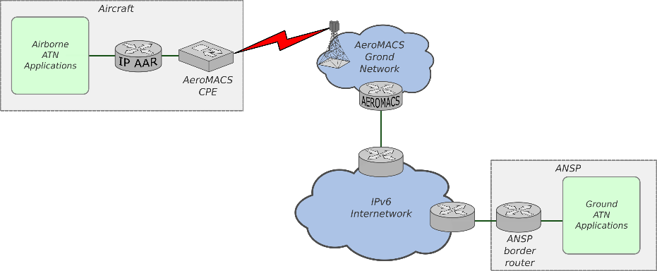
Figure 8: ATN/IPS Data Link System Functional Architecture
The components of Air Navigation Service Provider (ANSP) domain are:
- Ground ATN Applications : IPv6 end-systems that host ATN applications.
- ANSP Border Router: IPv6 access router that provides connectivity with IPS IPv6 internetwork.
The components of the ATN IPv6 Internetwork are:
- ATN/IPS Air/Ground Router: It is the entry point of airborne network traffic to the ATN/IPS internetwork. It provides the ATN/IPS connectivity between the IPS airborne router and the ground ATN/IPS Network.
- IPS routers: they are used to interconnect Administrative Domains participating in the ATN/IPS internetwork.

The components of the Aircraft Domain are:
- Airborne ATN Applications: it is the same as described in section 4.1.2 for the Onboard ATN End System.
- ATN/IPS Airborne Router (IP AAR): it provides the ATN/IPS connectivity to the ground ATN/IPS internetwork via the ATN/IPS Air/Ground Router.
- AeroMACS CPE: it is the same as described in section 4.1.2 for the ATN/OSI System.

The Data Link applications and services are the same as described in section 4.1.2 for the ATN/OSI System.
Refer to [22] for more information on the ATN/IPS routers and protocols.

Resource Connectivity Model
Not applicable, as AeroMACS describes the infrastructure layer supporting ATM exchanges (the infrastructure does not provide/consume ATM data).

Resource Orchestration view
AeroMACS describes the infrastructure layer supporting ATM exchanges. A couple of representative High Level Use Cases has been implemented in MEGA/EATMA for the AeroMACS Infrastructure; they are shown in 4.1.6.1.

Infrastructure connectivity model
The picture shown below represents the AeroMACS Communication Infrastructure as modelled in MEGA, together with its high level interactions with other Systems and Stakeholders. Such a structure has been modelled in MEGA/EATMA environment.
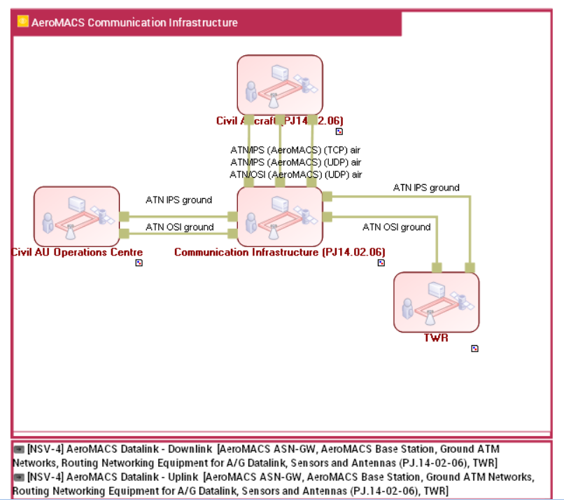
Figure 9: Resource Infrastructure Connectivity View (NSV-2) modelled in MEGA/EATMA

High Level Use Cases
A couple of representative High Level Use Cases has been implemented in MEGA/EATMA for the AeroMACS Infrastructure; they are shown in the following subchapters.
Concerning the operational use cases that AeroMACS can enable, AeroMACS can support all ATS and AOC data services related to safety and regularity of flight as encountered at airport surface level. In addition, it can support the necessary Network Management services (NET) as required by the supported safety of life and flight regularity services.
ATS Services are briefly described in 4.1.2, however, for a complete analysis of all the potential Services enabled by AeroMACS, see the AeroMACS Deployment & Integration Analysis developed in [25].

Uplink Data Transfer

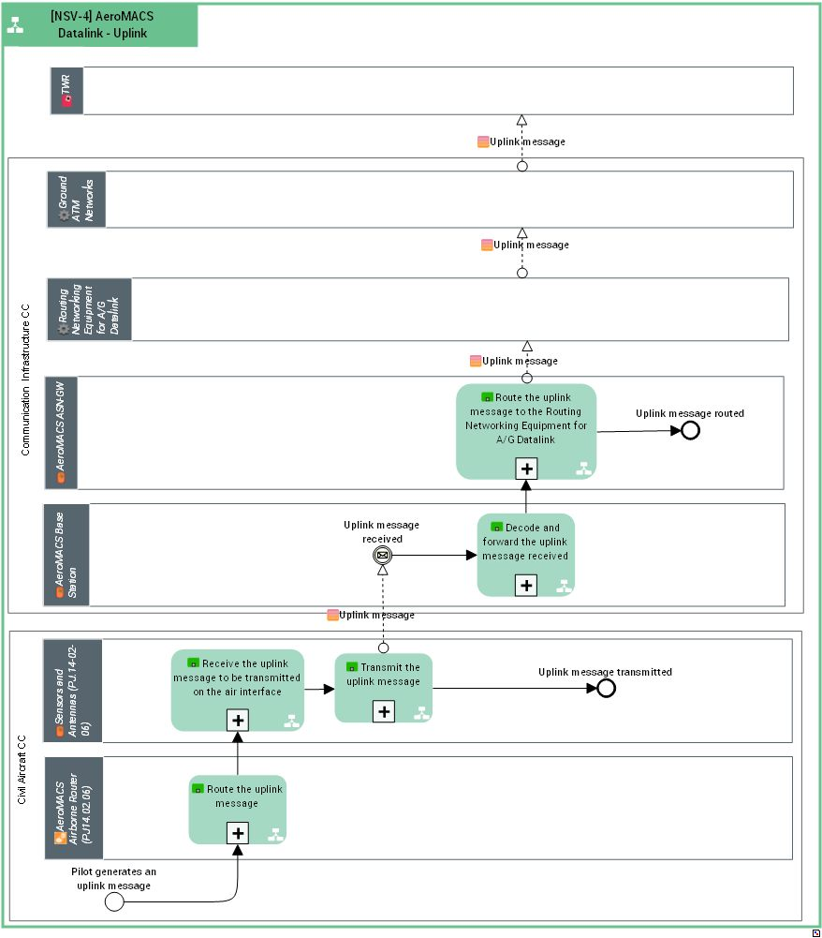
Figure 10: Uplink Data Transfer Sequence Flow Diagram
Note: this Sequence Flow Diagram models the uplink Data Transfer between TWR and Civil Aircraft. A similar Sequence Flow Diagram can be implemented to model the uplink Data Transfer between Civil AU Operations Centre and Civil Aircraft.

Downlink Data Transfer
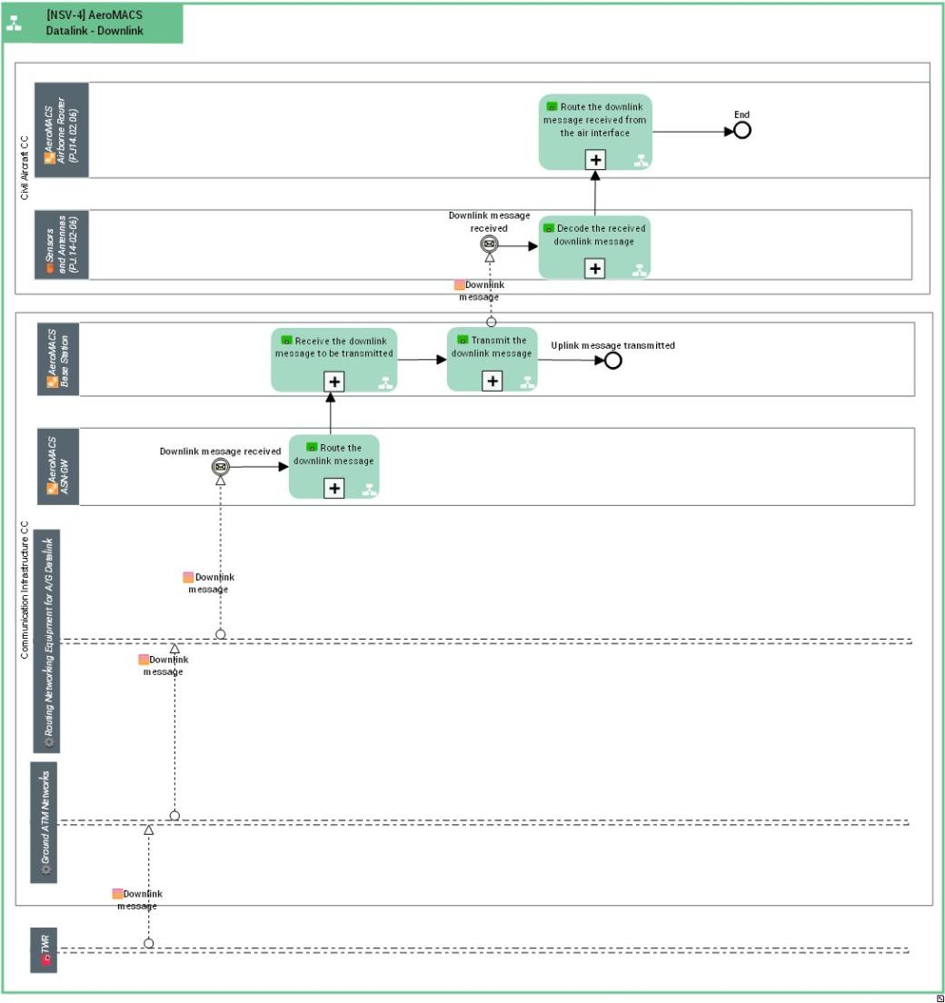
Figure 11: Downlink Data Transfer Sequence Flow Diagram
Note: this Sequence Flow Diagram models the downlink Data Transfer between TWR and Civil Aircraft. A similar Sequence Flow Diagram can be implemented to model the downlink Data Transfer between Civil AU Operations Centre and Civil Aircraft.

Service view
Not Applicable, as AeroMACS describes the infrastructure layer supporting ATM exchanges.

Service description
Not applicable.

Service Provisioning
Not applicable.

Service Realization
Not applicable.

Functional and non-Functional Requirements
The following sub-chapters list and specify the requirements to be implemented in AeroMACS/ATN Systems, that have been validated by PJ14.02.06 activities. They are grouped logically in 4 categories: General requirements, Digital Voice requirements, ATN/OSI requirements and ATN/IPS requirements. FRD and OSED are not present in the PJ14.02.06 Data Pack, as Solution PJ14.02.06 builds upon Solution #102, that reached TRL6 Maturity Level as Data Link already in SESAR1. In fact requirements specified in the following sub-chapters can be considered linked to requirements specified in the following SESAR1 Deliverables:
- SESAR P15.2.7 D04 - AeroMACS Deployment & Integration Analysis [25]
- SESAR P15.2.7 D05.1 - System Implementation Deliverable Part1: AeroMACS Ground Prototypes Description [26]
- SESAR P9.16 D03 - AeroMACS Airborne System Requirements and Architecture Dossier [27]
- SESAR P9.16 D04 - Airborne AeroMACS Prototype Specification [28]

General Requirements
[REQ]
Identifier | REQ-14.02-06-TS-IRS-0001
Title | Compliance with AeroMACS Standards
Requirement | All of the Elements composing the AeroMACS System shall comply with:  AeroMACS EUROCAE/RTCA MOPS and System Profile  ICAO SARPs and Technical Manual  ARINC 766: AeroMACS Transceiver and Aircraft Installation Standards
Status | <validated>
Rationale | Interoperability
Category | <Standard> , <Interoperability>

[REQ Trace]
Relationship | Linked Element Type | Identifier
<ALLOCATED_TO> | <SESAR Solution> | 14-02-06
<ALLOCATED_TO> | <Functional block> | Sensors and Antennas (PJ.14-02-06)  AeroMACS Base Station  AeroMACS ASN-GW
<ALLOCATED_TO> | <Enabler> | CTE-C02d_New Airport Datalink technology (AEROMACS)

[REQ]
Identifier | REQ-14.02-06-TS-IRS-0002
Title | Security - Interoperability
Requirement | MSs from different manufacturers shall be EAP-TLS authenticated by the Ground AeroMACS System (AAA Server), accordingly with the WMF Reference release R010v05 for networking specifications, and AeroMACS PKI Certificate Policy for Certificates Formats
Status | <validated>
Rationale | Requirement partially verified in SESAR1; AeroMACS Access Devices shall interoperate accordingly with the PKI standards defined in WMF and ICAO
Category | <Security>

[REQ Trace]
Relationship | Linked Element Type | Identifier
<ALLOCATED_TO> | <SESAR Solution> | 14-02-06
<ALLOCATED_TO> | <Functional block> | AeroMACS ASN-GW  AeroMACS Base Station  Sensors and Antennas (PJ.14-02-06)
<ALLOCATED_TO> | <Enabler> | CTE-C02d_New Airport Datalink technology (AEROMACS)

[REQ]
Identifier | REQ-14.02-06-TS-IRS-0015
Title | Compliance with Performance Requirements
Requirement | AeroMACS and ATN Infrastructure shall satisfy ED-228A Performance Requirements
Status | <validated>
Rationale | Need to comply with performance requirements
Category | <Performance>

[REQ Trace]
Relationship | Linked Element Type | Identifier
<ALLOCATED_TO> | <SESAR Solution> | 14-02-06
<ALLOCATED_TO> | <Functional block> | AeroMACS ASN-GW  Sensors and Antennas (PJ.14-02-06)  AeroMACS Base Station  AeroMACS Airborne Router (PJ14.02.06)
<ALLOCATED_TO> | <Enabler> | CTE-C02d_New Airport Datalink technology (AEROMACS)

Digital Voice Requirements

[REQ]
Identifier | REQ-14.02-06-TS-IRS-0011
Title | Digital Voice capability
Requirement | AeroMACS shall be capable to support digital voice based on ED-137B standard
Status | <validated>
Rationale | Voice is not intended to be used as the primary means of communications, but can constitute an important service enhancement.
Category | <Functional>

[REQ Trace]
Relationship | Linked Element Type | Identifier
<ALLOCATED_TO> | <SESAR Solution> | 14-02-06
<ALLOCATED_TO> | <Functional block> | AeroMACS ASN-GW  AeroMACS Base Station  Sensors and Antennas (PJ.14-02-06)
<ALLOCATED_TO> | <Enabler> | CTE-C02d_New Airport Datalink technology (AEROMACS)

ATN/OSI Requirements
[REQ]
Identifier | REQ-14.02-06-TS-IRS-0003
Title | AGR/AeroMACS Interface
Requirement | ATN-OSI AGR and Airborne Routers shall be able to communicate by encapsulating OSI Protocol Data Units (PDUs) in UDP PDUs (OSI Protocol Data Units over UDP/IP)
Status | <validated>
Rationale | The use of the UDP protocol over the IP has some advantages:  • The UDP port number can differentiate between multiple services on the same host, using the same L3 identification (IP address). Using IP only it wouldn't be possible to host multiple services on the same machine and easily differentiate between them.  Service separation would be required to separate the traffic on control and data planes.  • Open an UDP socket does not require root privileges even though it is required if a port in range [1, 1023] is used  • The UDP header has the checksum field that guarantees integrity of the PDU. Note, that UDP checksum covers IP header data. Also, that IP protocol header does not include any checksum unless authentication header (AH) is used.
Category | <Functional>

[REQ Trace]
Relationship | Linked Element Type | Identifier
<ALLOCATED_TO> | <SESAR Solution> | 14-02-06
<ALLOCATED_TO> | <Functional block> | AeroMACS ASN-GW  AeroMACS Airborne Router (PJ14.02.06)
<ALLOCATED_TO> | <Enabler> | CTE-C02d_New Airport Datalink technology (AEROMACS)

[REQ]
Identifier | REQ-14.02-06-TS-IRS-0004
Title | ATN/OSI PDUs on AGR/AeroMACS Interface
Requirement | The AGR/AeroMACS Interface shall be used to exchange the following ATN/OSI PDUs both in uplink and downlink, on an AeroMACS sub-network.  • ISH PDU  • CLNP PDU containing CM, CPDLC or ADS-C in Transport Protocol (TP4) PDUs  • CLNP PDU containing Inter-Domain Routing Protocol (IDRP) PDUs
Status | <validated>
Rationale | The listed PDUs are the ones currently exchanged between ATN OSI Systems and Legacy Data Links
Category | <Functional>

[REQ Trace]
Relationship | Linked Element Type | Identifier
<ALLOCATED_TO> | <SESAR Solution> | 14-02-06
<ALLOCATED_TO> | <Functional block> | AeroMACS ASN-GW  AeroMACS Base Station  AeroMACS Airborne Router (PJ14.02.06)
<ALLOCATED_TO> | <Enabler> | CTE-C02d_New Airport Datalink technology (AEROMACS)

[REQ]
Identifier | REQ-14.02-06-TS-IRS-0005
Title | AGR/AeroMACS Traffic Interface
Requirement | AGR/AeroMACS Traffic Interface shall leave unchanged the ATN/OSI PDUs content and only a standard 8-byte UDP header shall be added.
Status | <validated>
Rationale | UDP protocol is chosen in order to minimize overhead on the AGR/AeroMACS Traffic Interface
Category | <Functional>

[REQ Trace]
Relationship | Linked Element Type | Identifier
<ALLOCATED_TO> | <SESAR Solution> | 14-02-06
<ALLOCATED_TO> | <Functional block> | AeroMACS Base Station  AeroMACS ASN-GW  AeroMACS Airborne Router (PJ14.02.06)
<ALLOCATED_TO> | <Enabler> | CTE-C02d_New Airport Datalink technology (AEROMACS)

[REQ]
Identifier | REQ-14.02-06-TS-IRS-0006
Title | AAR/AeroMACS Interface
Requirement | The AAR/AeroMACS Interface shall be used to exchange the following ATN/OSI PDUs both in uplink and downlink, on an AeroMACS sub-network.  • ISH PDU  • CLNP PDU containing CM, CPDLC or ADS-C in Transport Protocol (TP4) PDUs  • CLNP PDU containing Inter-Domain Routing Protocol (IDRP) PDUs
Status | <validated>
Rationale | The listed PDUs are the ones currently exchanged between ATN OSI Systems and Legacy Data Link Systems
Category | <Functional>

[REQ Trace]
Relationship | Linked Element Type | Identifier
<ALLOCATED_TO> | <SESAR Solution> | 14-02-06
<ALLOCATED_TO> | <Functional block> | AeroMACS Airborne Router (PJ14.02.06)  Sensors and Antennas (PJ.14-02-06)
<ALLOCATED_TO> | <Enabler> | CTE-C02d_New Airport Datalink technology (AEROMACS)

[REQ]
Identifier | REQ-14.02-06-TS-IRS-0007
Title | AAR/AeroMACS Traffic Interface
Requirement | AAR/AeroMACS Traffic Interface shall leave unchanged the ATN/OSI PDUs content and only a standard 8-byte UDP header shall be added.
Status | <validated>
Rationale | AAR/AeroMACS Traffic Interface shall introduce minimum overhead
Category | <Functional>

[REQ Trace]
Relationship | Linked Element Type | Identifier
<ALLOCATED_TO> | <SESAR Solution> | 14-02-06
<ALLOCATED_TO> | <Functional block> | AeroMACS Airborne Router (PJ14.02.06)  Sensors and Antennas (PJ.14-02-06)
<ALLOCATED_TO> | <Enabler> | CTE-C02d_New Airport Datalink technology (AEROMACS)

[REQ]
Identifier | REQ-14.02-06-TS-IRS-0008
Title | AAR/AeroMACS Control Interface
Requirement | The following primitives shall be exchanged through the AAR/AeroMACS Control Interface between Airborne Router and AeroMACS avionic:  • JOIN: it is received by the ATN Airborne Router. It is used to advise that the CPE has registered to the AeroMACS mobile sub-network.  • LEAVE: it is received by the ATN Airborne Router. It is used to advise that the CPE has de-registered from the AeroMACS mobile sub-network.
Status | <validated>
Rationale | The AAR needs to be informed about the AeroMACS Link establishment/closure
Category | <Functional>

[REQ Trace]
Relationship | Linked Element Type | Identifier
<ALLOCATED_TO> | <SESAR Solution> | 14-02-06
<ALLOCATED_TO> | <Functional block> | AeroMACS Airborne Router (PJ14.02.06)  Sensors and Antennas (PJ.14-02-06)
<ALLOCATED_TO> | <Enabler> | CTE-C02d_New Airport Datalink technology (AEROMACS)

[REQ]
Identifier | REQ-14.02-06-TS-IRS-0009
Title | Logon Procedure
Requirement | When the JOIN message is received, the airborne router shall start sending the ISH packets to the SNPA specified in the JOIN message
Status | <validated>
Rationale | Airborne Router shall initiate the connection establishment with the AGR
Category | <Functional>

[REQ Trace]
Relationship | Linked Element Type | Identifier
<ALLOCATED_TO> | <SESAR Solution> | 14-02-06
<ALLOCATED_TO> | <Functional block> | AeroMACS Airborne Router (PJ14.02.06)
<ALLOCATED_TO> | <Enabler> | CTE-C02d_New Airport Datalink technology (AEROMACS)

[REQ]
Identifier | REQ-14.02-06-TS-IRS-0010
Title | Logoff Procedure
Requirement | The Airborne Router shall remove the adjacency with the AGR when the LEAVE message is received
Status | <validated>
Rationale | Mandatory LEAVE Message sent by CPE needs to be handled by the AAR
Category | <Functional>

[REQ Trace]
Relationship | Linked Element Type | Identifier
<ALLOCATED_TO> | <SESAR Solution> | 14-02-06
<ALLOCATED_TO> | <Functional block> | AeroMACS Airborne Router (PJ14.02.06)
<ALLOCATED_TO> | <Enabler> | CTE-C02d_New Airport Datalink technology (AEROMACS)

[REQ]
Identifier | REQ-14.02-06-TS-IRS-0024
Title | Multilink ATN/OSI in Airborne Routers
Requirement | The ATN/OSI Airborne Router shall be able to manage Link preferences according to predefined policies.
Status | <validated>
Rationale | In case of multiple Data Links available (e.g. VDL2 and AeroMACS) the Airborne Router needs to be able to select the Data Link according to predefined policies.  For example it can associate different ATSC Classes (defined in [22], Table 1-1) to different available Data Links.
Category | <Functional>

[REQ Trace]
Relationship | Linked Element Type | Identifier
<ALLOCATED_TO> | <SESAR Solution> | 14-02-06
<ALLOCATED_TO> | <Functional block> | AeroMACS Airborne Router (PJ14.02.06)
<ALLOCATED_TO> | <Enabler> | CTE-C02d_New Airport Datalink technology (AEROMACS)

[REQ]
Identifier | REQ-14.02-06-TS-IRS-0025
Title | Multilink ATN/OSI in Ground-Ground Routers
Requirement | The ATN/OSI Ground-Ground Router shall be able to manage Link preferences according to predefined policies.
Status | <validated>
Rationale | In case of multiple Data Links available (e.g. VDL2 and AeroMACS) the Ground-Ground Router needs to be able to select the Data Link according to predefined policies.  For example it can associate different ATSC Classes (defined in [22], Table 1-1) to different available Data Links.
Category | <Functional>

[REQ Trace]
Relationship | Linked Element Type | Identifier
<ALLOCATED_TO> | <SESAR Solution> | 14-02-06
<ALLOCATED_TO> | <Enabler> | CTE-C02d_New Airport Datalink technology (AEROMACS)

[REQ]
Identifier | REQ-14.02-06-TS-IRS-0026
Title | Multilink ATN/OSI - Link selection policy in Airborne Routers and Ground Ground Routers
Requirement | In case of VDL2 and AeroMACS simultaneous availability, AeroMACS Subnetwork should be preferred.
Status | <validated>
Rationale | Theoretically, at ground AeroMACS should always be preferred. However, reasons may exist (logistic, or economical, etc.) for which in specific cases this is not the best solution for the Users. For this reason the requirement is kept in the form of "should" statement.
Category | <Functional>

[REQ Trace]
Relationship | Linked Element Type | Identifier
<ALLOCATED_TO> | <SESAR Solution> | 14-02-06
<ALLOCATED_TO> | <Functional block> | AeroMACS Airborne Router (PJ14.02.06)
<ALLOCATED_TO> | <Enabler> | CTE-C02d_New Airport Datalink technology (AEROMACS)

[REQ]
Identifier | REQ-14.02-06-TS-IRS-0012
Title | Logon Procedure
Requirement | When the first ISH message is received on the traffic interface, the AGR shall initiate the IDRP protocol
Status | <validated>
Rationale | Need to establish a IDRP connection between AGR and AAR
Category | <Functional>

[REQ Trace]
Relationship | Linked Element Type | Identifier
<ALLOCATED_TO> | <SESAR Solution> | 14-02-06
<ALLOCATED_TO> | <Functional block> | AeroMACS Airborne Router (PJ14.02.06)
<ALLOCATED_TO> | <Enabler> | CTE-C02d_New Airport Datalink technology (AEROMACS)

[REQ]
Identifier | REQ-14.02-06-TS-IRS-0013
Title | Data Transfer
Requirement | When the IDRP connection is established with an airborne router, the AGR shall route CLNP PDU on both uplink and downlink directions
Status | <validated>
Rationale | AGR implements the needed IP-SNDCF function
Category | <Functional>

[REQ Trace]
Relationship | Linked Element Type | Identifier
<ALLOCATED_TO> | <SESAR Solution> | 14-02-06
<ALLOCATED_TO> | <Functional block> | AeroMACS Airborne Router (PJ14.02.06)
<ALLOCATED_TO> | <Enabler> | CTE-C02d_New Airport Datalink technology (AEROMACS)

[REQ]
Identifier | REQ-14.02-06-TS-IRS-0014
Title | Logoff Procedure
Requirement | If the Control Interface is supported, the AGR should remove the adjacency with the airborne router when the LOGOFF_IND message is received
Status | <validated>
Rationale | If the Control Interface is supported, the AGR adjacency with the Airborne Router should be removed when the AeroMACS Link is closed
Category | <Functional>

[REQ Trace]
Relationship | Linked Element Type | Identifier
<ALLOCATED_TO> | <SESAR Solution> | 14-02-06
<ALLOCATED_TO> | <Functional block> | AeroMACS Airborne Router (PJ14.02.06)
<ALLOCATED_TO> | <Enabler> | CTE-C02d_New Airport Datalink technology (AEROMACS)

ATN/IPS Requirements
[REQ]
Identifier | REQ-14.02-06-TS-IRS-0016
Title | AeroMACS Support to ATN/IPS
Requirement | AEROMACS devices (MSs, BSs, ASN-GWs, AAA Servers) shall provide mechanisms to transport Aeronautical Telecommunication Network / Internet Protocol Suite (ATN/IPS) based messaging
Status | <validated>
Rationale | Requirement is self-explaining
Category | <Functional>

[REQ Trace]
Relationship | Linked Element Type | Identifier
<ALLOCATED_TO> | <SESAR Solution> | 14-02-06
<ALLOCATED_TO> | <Functional block> | AeroMACS ASN-GW  AeroMACS Base Station  Sensors and Antennas (PJ.14-02-06)
<ALLOCATED_TO> | <Enabler> | CTE-C02d_New Airport Datalink technology (AEROMACS)

[REQ]
Identifier | REQ-14.02-06-TS-IRS-0017
Title | AeroMACS Airborne Support to ATN/IPS
Requirement | AEROMACS Airborne Radio Unit shall support interface towards Airborne Router of Aircraft ATN/IPS Infrastructure
Status | <validated>
Rationale | Requirement is self-explaining
Category | <Functional>

[REQ Trace]
Relationship | Linked Element Type | Identifier
<ALLOCATED_TO> | <SESAR Solution> | 14-02-06
<ALLOCATED_TO> | <Functional block> | AeroMACS Airborne Router (PJ14.02.06)  Sensors and Antennas (PJ.14-02-06)
<ALLOCATED_TO> | <Enabler> | CTE-C02d_New Airport Datalink technology (AEROMACS)

[REQ]
Identifier | REQ-14.02-06-TS-IRS-0018
Title | AeroMACS Airborne Support to ATN/IPS – IPv6
Requirement | AeroMACS MS shall support DHCP or Link Local mechanisms for IPv6 Address allocation
Status | <validated>
Rationale | Requirement is self-explaining
Category | <Functional>

[REQ Trace]
Relationship | Linked Element Type | Identifier
<ALLOCATED_TO> | <SESAR Solution> | 14-02-06
<ALLOCATED_TO> | <Functional block> | Sensors and Antennas (PJ.14-02-06)
<ALLOCATED_TO> | <Enabler> | CTE-C02d_New Airport Datalink technology (AEROMACS)

[REQ]
Identifier | REQ-14.02-06-TS-IRS-0019
Title | AeroMACS Ground Support to ATN/IPS
Requirement | AEROMACS ground Infrastructure shall support interface towards ground ATN/IPS Infrastructure
Status | <validated>
Rationale | Requirement is self-explaining
Category | <Functional>

[REQ Trace]
Relationship | Linked Element Type | Identifier
<ALLOCATED_TO> | <SESAR Solution> | 14-02-06
<ALLOCATED_TO> | <Functional block> | AeroMACS ASN-GW  AeroMACS Base Station
<ALLOCATED_TO> | <Enabler> | CTE-C02d_New Airport Datalink technology (AEROMACS)

[REQ]
Identifier | REQ-14.02-06-TS-IRS-0020
Title | ATN and AeroMACS Support to IPv6
Requirement | In ATN/IPS environment, both ATN/IPS Devices (End Systems, AARs, AGRs, GGRs) and AeroMACS devices (BSs, MSs, ASN-GWs, AAA Servers) shall support IPv6 addressing and numbering plans, according to [21]
Status | <validated>
Rationale | Requirement is self-explaining; ATN and AeroMACS devices need to maintain alignment with the reference standards
Category | <Interoperability>

[REQ Trace]
Relationship | Linked Element Type | Identifier
<ALLOCATED_TO> | <SESAR Solution> | 14-02-06
<ALLOCATED_TO> | <Functional block> | AeroMACS ASN-GW  AeroMACS Base Station  AeroMACS Airborne Router (PJ14.02.06)  Sensors and Antennas (PJ.14-02-06)
<ALLOCATED_TO> | <Enabler> | CTE-C02d_New Airport Datalink technology (AEROMACS)

[REQ]
Identifier | REQ-14.02-06-TS-IRS-0021
Title | Airborne AeroMACS Link Status
Requirement | AeroMACS Airborne Radio Unit shall export Link Status to Airborne Router, based on Link Quality evaluation
Status | <validated>
Rationale | Needed for Link and Multilink Management
Category | <Functional>

[REQ Trace]
Relationship | Linked Element Type | Identifier
<ALLOCATED_TO> | <SESAR Solution> | 14-02-06
<ALLOCATED_TO> | <Functional block> | AeroMACS Airborne Router (PJ14.02.06)  Sensors and Antennas (PJ.14-02-06)
<ALLOCATED_TO> | <Enabler> | CTE-C02d_New Airport Datalink technology (AEROMACS)

[REQ]
Identifier | REQ-14.02-06-TS-IRS-0023
Title | Airborne AeroMACS Link Quality evaluation
Requirement | AeroMACS Airborne Radio Unit shall perform Link Quality evaluation based on CINR measurements
Status | <validated>
Rationale | Needed for both Link and Multilink Management
Category | <Functional>

[REQ Trace]
Relationship | Linked Element Type | Identifier
<ALLOCATED_TO> | <SESAR Solution> | 14-02-06
<ALLOCATED_TO> | <Functional block> | Sensors and Antennas (PJ.14-02-06)
<ALLOCATED_TO> | <Enabler> | CTE-C02d_New Airport Datalink technology (AEROMACS)

Implementation Options
The Implementation Options for AeroMACS, described in this Chapter, are the following:
- AeroMACS System integrated with ATN/OSI Network
- AeroMACS System integrated in a Multilink Environment with ATN/OSI Network
- AeroMACS System integrated with ATN/IPS Network, in standalone configuration
AeroMACS is identified as one of the sub-networks of FCI, which is the subject of SESAR2020 solution 14.02.04. As a sub-network of FCI, AeroMACS would be required to conform to the FCI architecture and interface standards (such as ATN IPS). On the other hand, if AeroMACS is deployed standalone, i.e. not in an FCI environment, then some of the details may be different. This thus represents an option to be identified when it comes to deployment.
- AeroMACS System integrated in a Multilink Environment with ATN/IPS Network. This implementation option is described and technically validated in PJ14.02.04.
- AeroMACS System integrated with Digital Voice.

Implementation Option 1: Integration of AeroMACS and ATN/OSI Systems (Implementation Option 1)
Having described separately the AeroMACS and ATN/OSI Systems in the previous Chapters, this Chapter describes the choices done to integrate them in a common Architecture.
In terms of Network Layout, several scenarios are possible. Figure 12 represents one of the most typical cases, assuming that:
- More than one Network Service Provider (NSP) is present with its Connectivity Service Network (CSN). In this specific scenario, only 2 Service Providers are hypothesized.
- CSN2 is connected to the AeroMACS Access Service Network through the CSN1. Hence it is assumed that, if the airplane is a subscriber of the NSP 2 it is necessary to use roaming to permit to the CSN 1 to ask information about the airplane to the CSN 2.

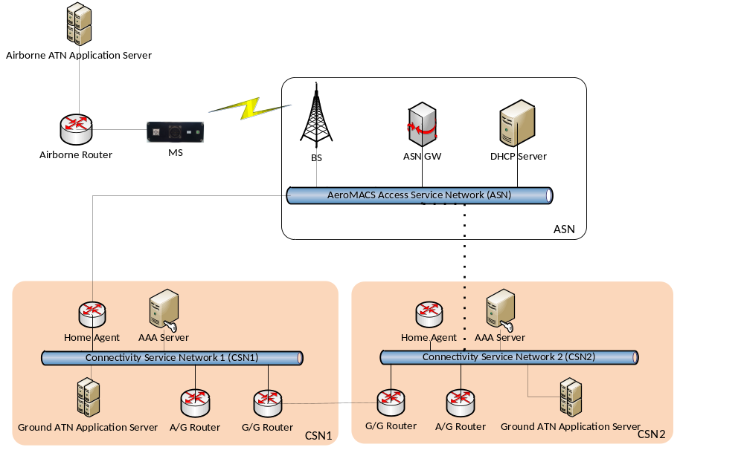
CPE
Figure 12: AeroMACS Network Layout
The CPE has two network interfaces: one towards the AeroMACS Access Service Network (external interface) and one towards the airborne router (internal interface).
The authentication procedure is briefly summarized here below.
- The CPE registers and authenticates itself on AeroMACS network, getting its external IP address from the Ground DHCP Server.
When the procedure is completed, the ASN-GW creates an association in the routing table between CPE MAC address, CPE AeroMACS IP address and the BS ID.

Configuration and IP Addressing
A crucial aspect in integration of AeroMACS and ATN/OSI Networks is represented by the addressing of the various Network elements involved. In fact IP-SNDCF protocol will be used (see [7]), and Aircraft and Air Ground Router (AGR) must exchange IP and ATN/OSI addressing information.
This paragraph describes a list of information and assumptions done concerning Addressing.
- AeroMACS supports both IPv4 or IPv6; IPv4 is assumed to be used in Exercises.
- Multiple BS (Base Station) can be connected to an ASN-GW
- ASN-GW is connected to a single AGR
- Each AGR has both:
  - A fixed OSI Address
  - A fixed IP address, preferably a private address (e.g. 192.168.001.x)
- Each Airborne Router has both:
  - A fixed OSI AddressA dynamic IP address acquired by the DHCP server running on the CPE.

PDUs exchanged
In order to define the protocols formats of PDUs exchanged between the ATN-OSI AGR and Airborne Routers, some assumptions/decisions are needed. They are described in the present subchapter.

- IDRP will be used over the air/ground link.
IDRP is a standardized and industry-used routing protocol included in ATN/OSI SARPs. Such a protocol is considered the best option for AeroMACS.
Note: it is understood that IDRP may be considered for removal by VDL2 because of the impact on Capacity, however this is not an issue for AeroMACS as the AeroMACS channels provide significantly higher capacity than VDL2.
For these reasons, IDRP is assumed to be used over the air/ground link.
- ATN-OSI AGR and Airborne Routers will communicate by encapsulating OSI Protocol Data Units (PDUs) in UDP PDUs (OSI Protocol Data Units over UDP/IP). The use of the UDP protocol over AeroMACS has the following advantages:
- The UDP port number can differentiate between multiple services on the same host, using the same L3 identification (IP address). Using IP only it wouldn't be possible to host multiple services on the same machine and easily differentiate between them.
Service separation would be required to separate the traffic on control and data planes.
- Open an UDP socket does not require root privileges even though it is required if a port in range [1, 1023] is used
- The UDP header has the checksum field that guarantees integrity of the PDU. Note, that UDP checksum covers IP header data. Also, that IP protocol header does not include any checksum unless authentication header (AH) is used.
The disadvantage of using the UDP protocol is the overhead of the UDP header (8 bytes), but this is not a significant issue if we consider the Capacity of an AeroMACS channel..

Summarizing, ATN-OSI AGR and Airborne Routers communicate by encapsulating OSI Protocol Data Units (PDUs) in:
  - OSI-IP Protocol PDU (Protocol Type =80) (OSI Protocol Data Units over IP)
  - UDP PDU (OSI Protocol Data Units over UDP/IP)
- The OSI PDUs are:
  - ISH (Intermediate System Hello) PDU
  - CLNP (Connectionless Network Protocol) PDU containing CM, CPDLC or ADS-C in Transport Protocol (TP4) PDUs
  - CLNP (Connectionless Network Protocol) PDU containing Inter-Domain Routing Protocol (IDRP) PDUs

Message Sequence Diagram
This chapter describes a typical exchange of messages between AGR and AAR, through the AeroMACS Network, in order to establish a connection, exchange data, and close the connection. Further details are provided in chapter 5.1.4, dedicated to Interfaces description.
- AGR IP Address is fixed using a private address (e.g. 192.168.001.080)
- CPE sends a JOIN indication to the Airborne Router when it completes its AeroMACS registration getting an IP address
- Airborne Router sends ISH to AGR
  - Src-Addr = Airborne Router IP address
  - Dest-Addr = AGR IP Address
- AGR sends ISH Response
- AGR initiates IDRP connection with short Keepalive timer or uses ISH on short timer
- Data are exchanged
- The link is maintained by the IDRP KEEPALIVE packets
- When the AeroMACS network is lost, the CPE sends LEAVE event to Airborne Router in order to terminate connection

The JOIN and LEAVE events are used in the VDL Mode 2 sub-network to, respectively, indicate availability of a communications path air to ground and, conversely, the loss of that path.
The same mechanism can be reused in the AeroMACS sub-network. The CPE sends:
- the JOIN message to the airborne router when it registers and authenticates itself on an AeroMACS network
- the LEAVE message to the airborne router when it de-register from an AeroMACS network
The two control events are not mandatory. The airborne router starts to send the ISH packets as soon as it is started and the mobile circuit activated. If the CPE is not registered on the AeroMACS network, it discards the packets. When the CPE registers on the AeroMACS network, the packets are forwarded to the BS and the connection with the AGR can be established. When the CPE de-register from the AeroMACS network, it does not communicate the event to the airborne router which maintains the connection until the protocol timers (IDRP Hold Time or ISH timer) expire. For VDL Mode 2 sub-network, the IDRP Hold Time interval for the mobile link is 900s.
It is recommended to use the JOIN and LEAVE events.
The same logic is applicable to the Logoff event on the AGR side. It is not mandatory but it is recommended as it speeds up the connection recovery.
Figure 13 shows the message sequence when the IDRP protocol is used.
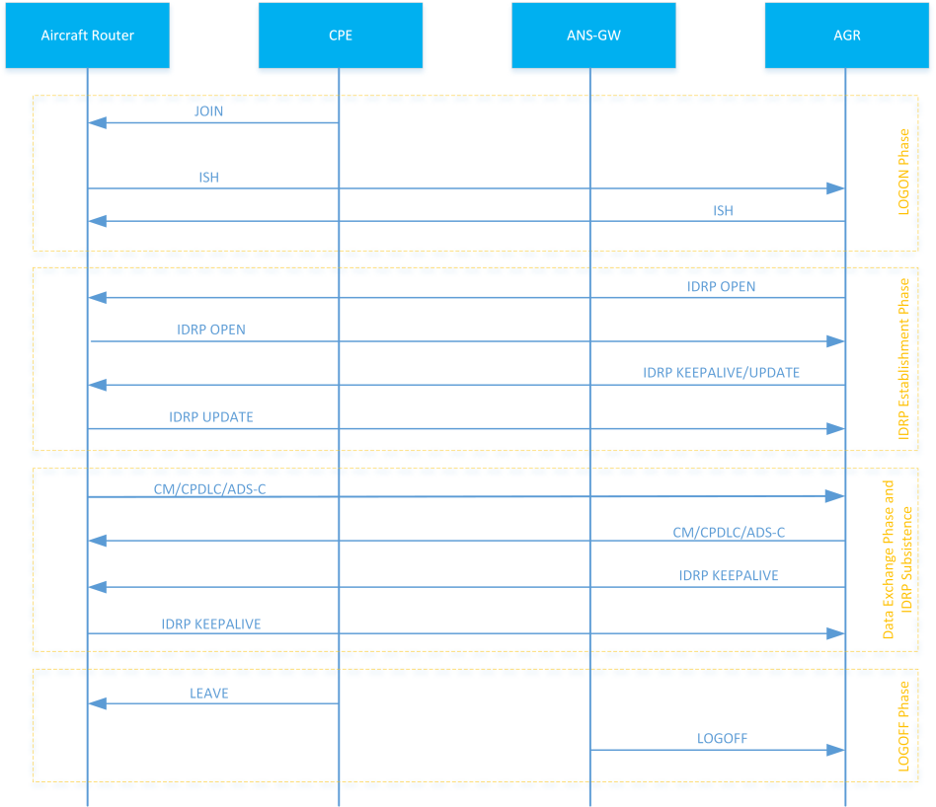
Figure 13: Message sequence diagram for fixed IP address when IDRP is used

Interfaces

ATN AGR/AeroMACS Interface
The AGR-AeroMACS Interface is used to exchange ATN/OSI PDUs in both directions, uplink and downlink, on an AeroMACS sub-network.
The ATN/OSI Protocol Data Units (PDUs) are:
- ISH PDU
- CLNP PDU containing CM, CPDLC or ADS-C in Transport Protocol (TP4) PDUs
- CLNP PDU containing Inter-Domain Routing Protocol (IDRP) PDUs
In conjunction with the ATN/OSI PDUs, Control PDUs can be exchanged to advise the ATN Air/Ground Router that an aircraft has logged off the AeroMACS sub-network.
The AGR-AeroMACS Interface is divided in two sub-interfaces:
- Traffic Interface: used to exchange ATN/OSI PDUs between the ATN Air/Ground Router (AGR) and the ATN Airborne Router (AAR).
- Control Interface: used to exchange Control PDUs between the ATN Air/Ground Router (AGR) and the ASN-GW. It is optional.

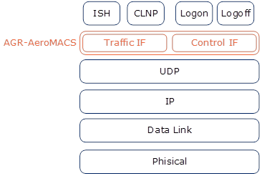
Figure 14: Protocol Stack of the AGR-AeroMACS Interface
The AGR-AeroMACS Interface is designed to work over an unreliable transport service and to be platform independent.
Figure 15 presents the Logical network layout.
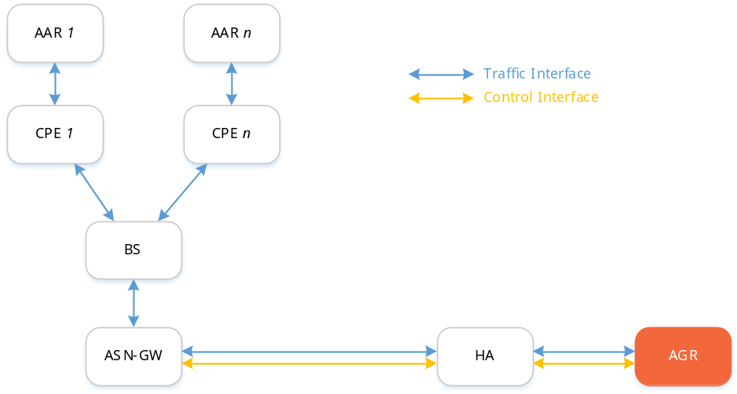
Figure 15: Logical Network Layout of the AGR-AeroMACS Interface

Traffic Interface
The Traffic Interface is designed to exchange ATN/OSI PDUs over a UDP/IP connectionless interface. There is no transformation of the ATN/OSI PDUs and no additional bytes added other than a standard 8-byte UDP header.
The bind IP address and UDP port of the AGR-AeroMACS Interface is configurable.
The IP address represents the SNPA of the Traffic Interface.
The ATN Air/Ground Router uses only one IP address and UDP port pair to communicate with all aircraft. The remote IP address represents the aircraft SNPA and it should be unique per aircraft.
The Traffic Interface is required for the AGR-AeroMACS Interface.

Control Interface
The Control Interface is designed to exchange Control PDUs over a UDP/IP connectionless interface.
The bind IP address and UDP port is configurable. It must be different to the one used by the Traffic Interface.
The Control Interface defines one primitive:
LOGOFF_IND: it is received by the AGR. It is used to advice that an aircraft has logged out to the AeroMACS mobile sub-network.
The Control Interface is optional for the AGR-AeroMACS Interface.

Control Primitive Format
The following field types are used to define the Control primitives.
Name | Bytes
OCTET | 1
UINT16 | 2
UINT32 | 4
OCTET[1...n] | n
Table 5: Field Types of the AGR-AeroMACS Control Interface
All Control primitives have the same header:
Version
UINT16
Length of Data Segment (in octets)
UINT16
Data Segment
See next sections
Table 6: Primitive Formats of the AGR-AeroMACS Control Interface

A primitive is encoded into a byte stream before it is sent between two entities. Encoding involves serialising each individual field of the primitive into a datagram. The datagram created from one primitive is stored within a buffer. The software entity receiving the primitive (buffer) decodes the datagram to extract the individual primitive fields. Decoding involves de-serialising the datagram into the individual primitive fields. Primitive fields that are greater than one byte are serialised in network byte order (big-endian). Fields that are arrays “OCTET[1...n]” are serialised directly into the datagram without changing the order of the bytes.

LOGOFF_IND
The LOGOFF_IND is received by the AGR to notify that an aircraft has logged off from the AeroMACS mobile sub-network.
The format of the LOGOFF_IND primitive is as follows:
Field | Type | Value (range) | Description
Version | UINT16 | 0 | Version. Always set to 0
Length | UINT16 | 5+n | Number of bytes of data in this primitive excluding the Version and length fields.
Primitive | UINT32 | 0x01 | The value is LOGOFF_IND (prim=0x01)
MobileSnpaLen | OCTET | n | Length of the Mobile SNPA
MobileSnpa | OCTET[n] | [0, 0xFF] | Mobile SNPA
Table 7: LOGOFF_IND Primitive of the AGR-AeroMACS Control Interface
When the LOGOFF_IND primitive is received, the ATN Air/Ground Router shall close the connection with the aircraft specified by the mobile SNPA.
The MobileSnpa shall match the aircraft SNPA used in the Traffic Interface

Control Interface Configuration
Two possible scenarios are defined:
- The Control Interface is configured
- The Control Interface is not configured

Control Interface Configured
Figure 16 shows the different phases of the protocol when the Control Interface is configured.
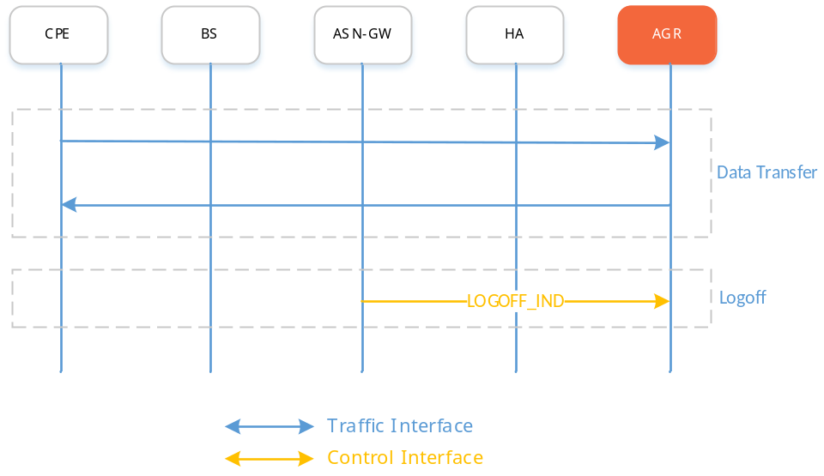
Figure 16: Use Cases of the AGR-AeroMACS Interface with the Control Interface

Data Transfer Phase
In the Data Transfer phase, the AGR can exchange ATN/OSI PDUs over the Traffic Interface.

Logoff Phase
When the ASN-GW detects that the CPE de-registers from the AeroMACS mobile sub-network or the activity timer expires, a LOGOFF_IND message is sent by the ASN-GW to the AGR which removes all information related to the connection with the aircraft.

Control Interface NOT Configured
Figure 17 shows the different phases of the protocol when the Control Interface is not configured.
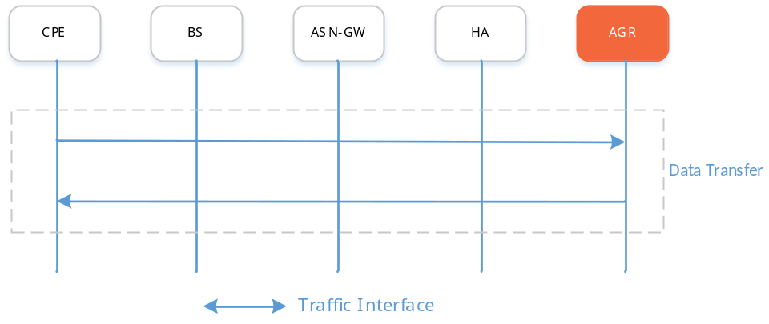
Figure 17: Use Cases of the AGR-AeroMACS Interface without the Control Interface
In this configuration, only the Data Transfer phase is available.
The AGR removes the aircraft information when upper protocol timer (IDRP Hold Timer or ISH timer) expires.

ATN AAR/AeroMACS Interface
The AAR-AeroMACS Interface is used to exchange ATN/OSI PDUs in both directions, uplink and downlink, on an ATN Airborne Router over the AeroMACS sub-network.
The ATN/OSI Protocol Data Units (PDUs) are:
- ISH PDU
- CLNP PDU containing CM, CPDLC or ADS-C in Transport Protocol (TP4) PDUs
- CLNP PDU containing Inter-Domain Routing Protocol (IDRP) PDUs
In conjunction with the ATN/OSI PDUs, Control PDUs could be exchanged in order to advice the ATN Airborne Router that the CPE has either logged on or logged off on the AeroMACS sub-network.
The AAR-AeroMACS Interface is divided in two sub-interfaces:
- Traffic Interface: used to exchange ATN/OSI PDUs between the ATN Airborne Router (AAR) and ATN Air/Ground Router (AGR)
- Control Interface: used to exchange Control PDUs between the ATN Airborne Router (AAR) and the CPE
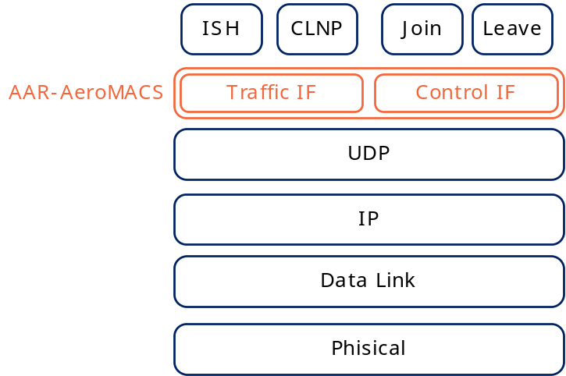
Figure 18: Protocol Stack of the AAR-AeroMACS Interface
The AAR-AeroMACS Interface is designed to work over an unreliable transport service and to be platform independent.
Figure 19 presents the Logical network layout.
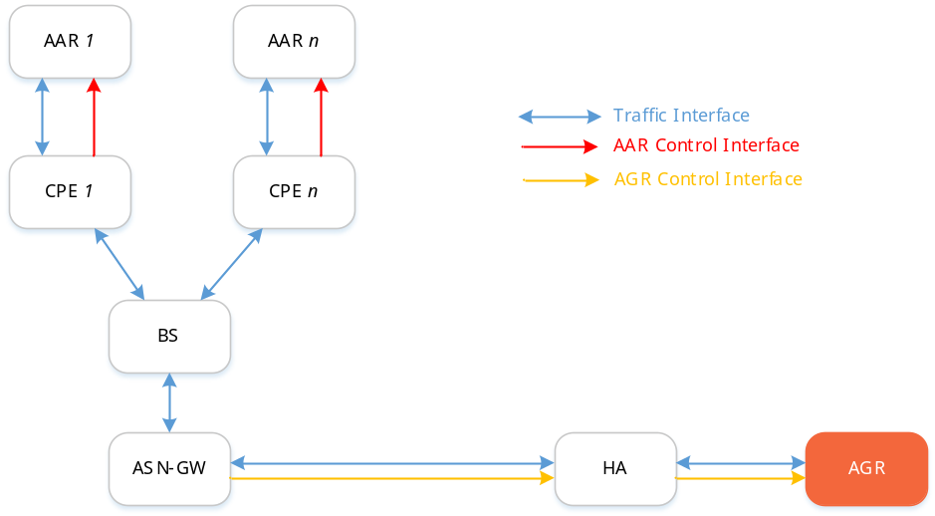
Figure 19: Logical Network Layout of the AAR-AeroMACS Interface

Traffic Interface
The Traffic Interface is designed to exchange ATN/OSI PDUs over a UDP/IP connectionless interface. There is no transformation of the ATN/OSI PDUs and no additional bytes added other than a standard 8-byte UDP header.
The bind IP address and UDP port of the AAR-AeroMACS Interface is configurable.
The IP address represents the SNPA of the Traffic Interface.
The ATN Airborne Router uses only one IP address and UDP port pair to communicate with the ATN Air/Ground Router. The remote IP address and UDP port is learned from the JOIN message. The remote IP address and UDP port pair represents the ATN Air/Ground Router SNPA.
The Traffic Interface is required for the AAR-AeroMACS Interface.

Control Interface
The Control Interface is designed to exchange Control PDUs over a UDP/IP connectionless interface.
The bind IP address and UDP port is configurable. It must be different than the one used by the Traffic Interface.
The Control Interface defines two primitives:
- JOIN: it is received by the ATN Airborne Router. It is used to advise that the CPE has registered to the AeroMACS mobile sub-network.
- LEAVE: it is received by the ATN Airborne Router. It is used to advise that the CPE has de-registered from the AeroMACS mobile sub-network.
The Control Interface is required for the AAR-AeroMACS Interface.

State Machine
The ATN Airborne Router has a state machine as illustrated in Figure 20.
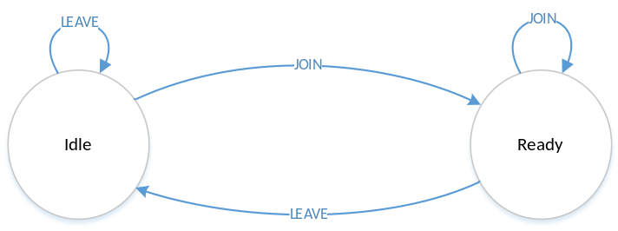
Figure 20: ATN Airborne Router State Machine
The ATN Airborne Router starts in Idle state. When a JOIN message is received, it switches to Ready state and starts to send the ISH message to the ATN Air/Ground Router.
When the state machine is in Ready state and a LEAVE message is received, the connection with the ATN Air/Ground Router, if present, is closed and the state machine switches to Idle state.

Control Primitive Format
The following field types are used to define the Control primitives.
Name | Bytes
OCTET | 1
UINT16 | 2
UINT32 | 4
OCTET[1...n] | n
Table 8: Field Types of the AAR-AeroMACS Control Interface
All Control primitives have the same header:
Version
UINT16
Length of Data Segment (in octets)
UINT16
Data Segment
See next sections
Table 9: Primitive Formats of the AAR-AeroMACS Control Interface
A primitive is encoded into a byte stream before it is sent between two entities. Encoding involves serialising each individual field of the primitive into a datagram. The datagram created from one primitive is stored within a buffer. The software entity receiving the primitive (buffer) decodes the datagram to extract the individual primitive fields. Decoding involves de-serialising the datagram into the individual primitive fields. Primitive fields that are greater than one byte are serialised in network byte order (big-endian). Fields that are arrays “OCTET[1...n]” are serialised directly into the datagram without changing the order of the bytes.

JOIN
The JOIN is received by the ATN Airborne Router to notify that the CPE has registered on to the AeroMACS mobile sub-network.
The format of the JOIN primitive is as follows:
Field | Type | Value (range) | Description
Version | UINT16 | 0 | Version. Always set to 0
Length | UINT16 | 5+n | Number of bytes of data in this primitive excluding the Version and length fields.
Primitive | UINT32 | 0x1001 | The value is JOIN (prim=0x1001)
DestSnpaLen | OCTET | n | Length of the destination SNPA
DestSnpa | OCTET[n] | [0, 0xFF] | Destination SNPA
Table 10: JOIN Primitive of the AAR-AeroMACS Control Interface
The JOIN primitive should be sent only once, when the CPE registers on the AeroMACS mobile sub-network. Anyway, if the JOIN primitive is received periodically, the ATN Airborne Router will ignore them if it is in Ready state.

LEAVE
The LEAVE is received by the ATN Airborne Router to notify that the CPE has de-registered from the AeroMACS mobile sub-network.
The format of the LEAVE primitive is as follows:
Field | Type | Value (range) | Description
Version | UINT16 | 0 | Version. Always set to 0
Length | UINT16 | 5+n | Number of bytes of data in this primitive excluding the Version and length fields.
Primitive | UINT32 | 0x1002 | The value is LEAVE (prim=0x1002)
DestSnpaLen | OCTET | n | Length of the destination SNPA
DestSnpa | OCTET[n] | [0, 0xFF] | Destination SNPA
Table 11: LEAVE Primitive of the AAR-AeroMACS Control Interface
The LEAVE primitive should be sent only once, when the CPE de-registers from the AeroMACS mobile sub-network. Anyway, if the LEAVE primitive is received periodically, the ATN Airborne Router shall ignore them if it is in Idle state

AAR/AeroMACS Interface Protocol phases
Figure 21 shows the three different phases of the protocol.
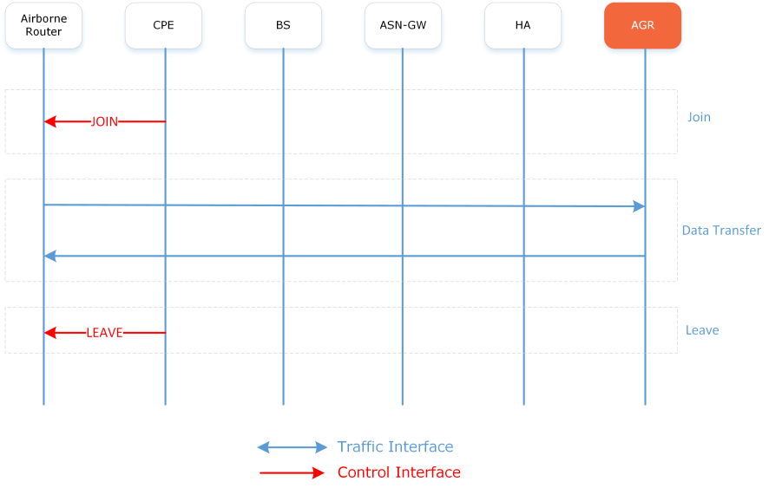
Figure 21: AAR-AeroMACS Interface Protocol Phases

Join Phase
When the aircraft registers onto the AeroMACS mobile sub-network, the CPE sends the JOIN message to the AAR and the protocol moves to the Data Transfer phase.
Any ATN/OSI PDU received in the Join phase on the Traffic Interface are discarded by the AAR.

Data Transfer Phase
In the Data Transfer phase, the AAR can exchange ATN/OSI PDUs over the Traffic Interface.

Leave Phase
When the CPE de-registers from the AeroMACS mobile sub-network, a LEAVE message is sent to the AAR which removes all information related to the connection with the AGR.

Scenarios
This Chapter describes the most representative operational scenarios.
Use Case 1: one single Service Provider connected to ASN
Use Case 2: two Service Providers connected to ASN in a roaming scenario (Visitor/Home)
Use Case 3: two Service Providers connected to the same ASN
These Scenarios will be described in the next sub-chapters.

Scenario 1: one single Service Provider connected to ASN

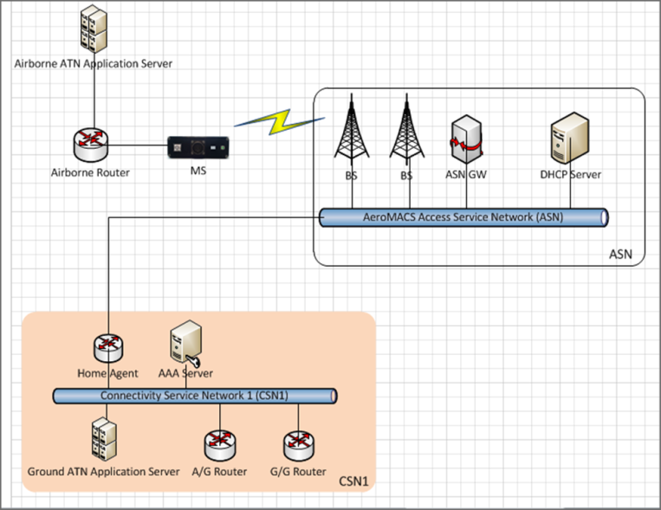
Figure 22: Scenario 1- one single Service Provider connected to ASN

The following features should be supported by this basic Use Case :

  - End-to-end ATN/OSI CM/CPDLC, ADSC
  - Ground/Ground Interoperability (ASN/CSN)
  - Airborne ATN Router/ AeroMACS CPE interoperability
  - Air/Ground interoperability

Scenario 2: two Service Providers connected to ASN in a roaming scenario (Visitor/Home)
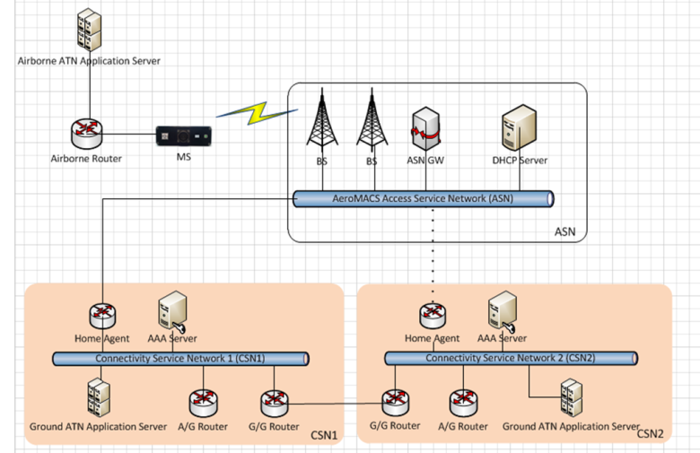
Figure 23: Scenario 2 - one single Service Provider connected to ASN
Identified features are:
  - ASN connected to one CSN1 providing access to a second CSN2 ( V-Home Scenario)
  - End-to-end CM/CPDLC, ADSC
  - Ground/Ground Interoperability (CSN1/CSN2/ASN)
  - Airborne ATN Router/ AeroMACS CPE interoperability
  - Air/Ground interoperability

Scenario 3: two Service Providers connected to the same ASN

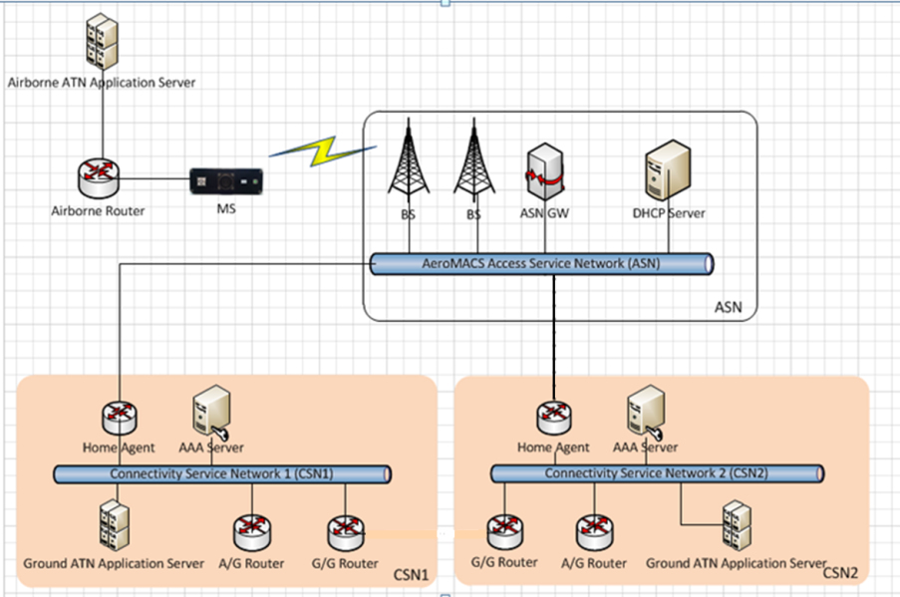
Figure 24: Scenario 3: two Service Providers connected to the same ASN
Identified features are:
  - ASN connected to two CSN (CSN1 & CSN2)
  - End-to-end CM/CPDLC, ADSC
  - Ground/Ground Interoperability (CSN1/CSN2/ASN)
  - Airborne ATN/ AeroMACS CPE interoperability

Implementation Option 2: Multilink in ATN/OSI environment
The AeroMACS A/G data link subnetwork is part of the future terrestrial data link systems and it will be integrated with the other data link systems (VDL2, LDACS and SATCOM) in Solution PJ14-02-04 to demonstrate the ATN/IPS multilink concept.
In the scope of the SESAR 2020 PJ14-02-06 Solution, the AeroMACS A/G datalink is integrated with the multilink environment considering only the VDL2 data link system. The full multilink environment with all data link systems is part of Solution PJ14-02-04.
The network topology for supporting the Multilink environment is shown in Figure 25 where the aircraft is able to connect to both AeroMACS and VDL2 networks.
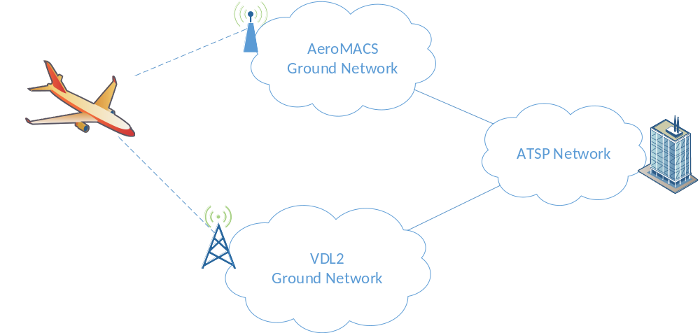
Figure 25: Multilink ATN/OSI network topology
Figure 25 shows that the AeroMACS and VDL2 networks are both directly connected to the ATSP (Air Traffic Service Provider) network even though the AeroMACS Ground CSN network can be connected to the ATSP network through the VDL2 one; for example, the AeroMACS network could reach the ATSP through SITA and/or ARINC. The definition and design of the Ground/Ground network is out of the scope of this section.
Figure 26 shows the logical architecture for supporting the Multilink environment.
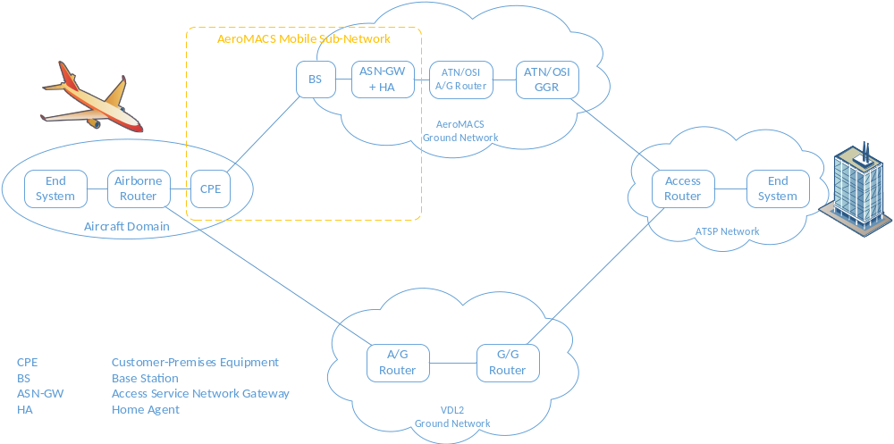
Figure 26: Multilink ATN/OSI logical architecture
An ATN Air/Ground Router is defined for each network, one for AeroMACS and one for VDL2; they are in different RD (Routing Domain). An ATN Ground/Ground Router is displayed in the AeroMACS ground network for completeness but it is not strictly required; it depends on the network complexity. Furthermore, the AeroMACS GGR could be connected to the VDL2 GGR instead of directly to the ATSP Access Router.
The AeroMACS network is different from the other legacy networks; the two main differences related to the multilink environment are:
- AeroMACS is available only on ground (in the airport environment) while the others (e.g. VDL2) are available in the en-route phase of flight as on ground.
- AeroMACS offer capabilities and performances not available in other Legacy Systems like VDL2 (e.g. high throughput, availability of Security Capabilities like Authentication/Encryption).
The above differences prompt a consideration that the technology handover (the process of transferring the communication from one network to another one without disconnecting the user session) is the natural concept to be used in the multilink environment in the scope of this Solution. When the aircraft is on ground, a new link is created with the AeroMACS network and it is used all the time until the aircraft leave the airport.
In Solution PJ14-02-04 a different multilink concept is under study where a new entity is defined on the ground network to calculate the performance and other operational parameters of each Air/Ground data link and decide which one to be used. The algorithm is based on different parameters like QoS, Transit Delay, user (i.e. airline) preference for data link and CSP and so on. Refer to PJ14-02-04 documentation for more details.
In order to take into account the different multilink concepts, different scenarios have been identified; they are described in section 5.2.1.

Relevant Scenarios

Technology Handover/Single Link
The first Scenario covers the case where the technology handover is used and the aircraft is connected to only one network at the time.
When the aircraft is outside of the AeroMACS coverage, it uses the VDL2 network.
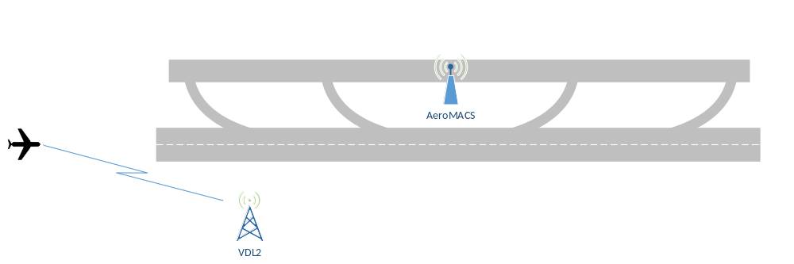
Figure 27: First ATN/OSI multilink scenario: aircraft before landing
When the aircraft enters inside the airport area and the AeroMACS network is available, it creates a new data link over the AeroMACS network and closes the old VDL2 data link.

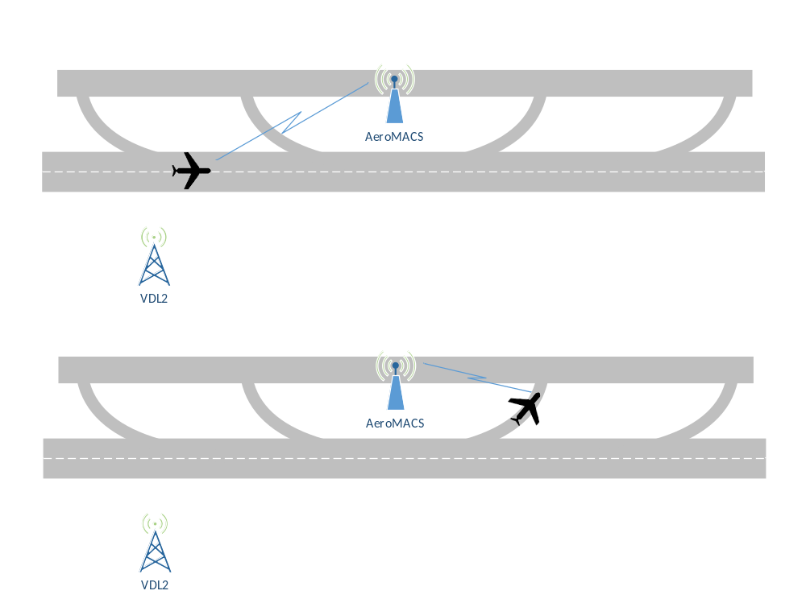
Figure 28: First ATN/OSI multilink scenario: aircraft inside the airport environment
When the aircraft departs, it re-creates the data link over the VDL2 network and closes the AeroMACS data link.
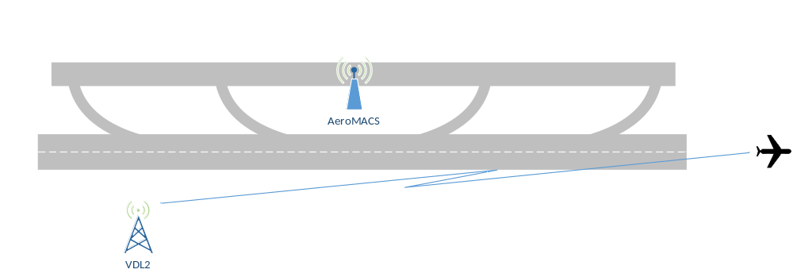
Figure 29: First ATN/OSI multilink scenario: aircraft departed
The characteristics of the scenario are:
- Technology handover.
- Only one data-link available at the time.
- The Aircraft Avionic is in charge of establishing and closing the VDL2 Link at take-off and landing respectively depending on the AeroMACS Link Status Information.
- The VDL and AeroMACS Ground Network have no responsibilities: it is the Aircraft System that has the responsibility to decide the Technology Handover, basing exclusively on the WoW (Weight on Wheels) indication.
- The Aircraft Avionic is in charge of establishing and closing the AeroMACS Link at landing and take-off respectively.

Technology Handover/Dual Link
The second scenario covers the case where the technology handover is used and the aircraft is connected to both networks at the same time.
When the aircraft is outside of the AeroMACS coverage, it uses the VDL2 network (see Figure 27).
When the aircraft enters inside the airport area and the AeroMACS network is available, it creates a new data link over the AeroMACS network without closing the old VDL2 data link; two data links are available at the same time.
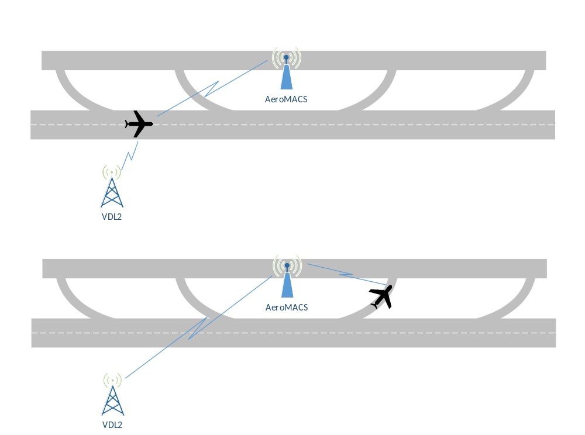
Figure 30: Second ATN/OSI scenario: aircraft inside the airport environment
When the aircraft departs, it closes the AeroMACS data link and only the VDL2 remains active (see Figure 29).
When both data links are available, both Aircraft->GS and GS->Aircraft traffic could preferably be routed using the AeroMACS Link;
In this case, the Ground Routers should be forced to prefer AeroMACS Routes, and hence changes would be required on the ground network.
In this Scenario/Use Case the VDL2 link can be used as backup.
The characteristics of the scenario are:
- Technology handover.
- Both data links available simultaneously in the airport environment.
- Changes required on the airborne side to establish AeroMACS link at ground and to prefer AeroMACS Route in case of availability of both links.
- Changes would be required on the ground side.

Multilink Ground Based
The third scenario covers the case where the aircraft is connected to both networks simultaneously (where possible) and the decision of the best Air/Ground data link is made on the ground network.
When the aircraft is outside of the AeroMACS coverage, it uses the VDL2 network (see Figure 27).
When the aircraft enters inside the airport area and the AeroMACS network is available, it creates a new data link over the AeroMACS network without closing the old VDL2 data link; two data links are available at the same time (see Figure 28).
When the aircraft departs, it closes the AeroMACS data link and only the VDL2 remains active (see Figure 29).

The characteristics of the scenario are:
- Multilink link based on new algorithm on the ground
- Both data links available simultaneously in the airport environment
- Changes required on the airborne side
- Major changes required on the ground side

Implementation Option 3: Integration of AeroMACS and ATN/IPS Systems

Having described separately the AeroMACS and ATN/IPS Systems in the previous Chapters, this Chapter describes the choices done to integrate them in a common Architecture. It is to be underlined that this Section considers the “Stand-alone” case, that is the AeroMACS System integrated with ATN/IPS. The Multilink System in ATN/IPS environment is defined in 14.02.04 Solution and includes not only the AeroMACS System, but also other potential Data-Links, like LDACS and SATCOM. For information on the Multilink System in ATN/IPS environment, and its impacts in AeroMACS System, see Section 5.4.
An overview of the AeroMACS System integrated with the ATN/IPS System is shown in Figure 31.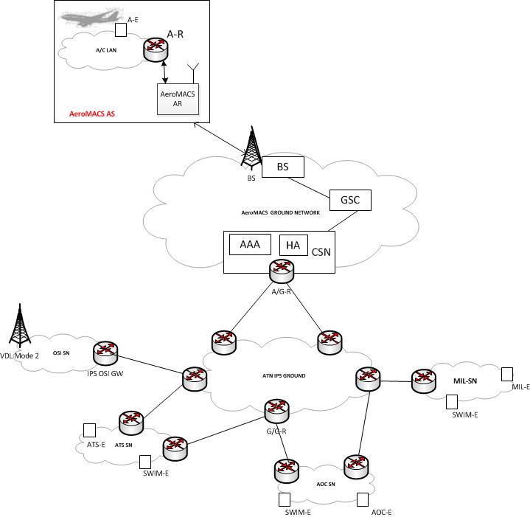
Figure 31: AeroMACS and ATN/IPS environment
In terms of Network Layout, several scenarios are possible. In particular, the same scenarios described in Section 5.1 apply also to the ATN/IPS case.
It is important to note that in this mode AeroMACS link fully operates in layer 2. That is, the air-ground router (A/G-R) is the next hop router for the airborne router (A-R). In other words A/G-R and A-R are on the same link.

Configuration and IP Addressing
In ATN/IPS environment, both ATN Devices (End Systems, AARs, AGRs, GGRs) and AeroMACS devices (BSs, MSs, ASN-GWs, AAA Servers) shall support IPv6 addressing and numbering plans, according to [22].
Multiple BSs (Base Stations) can be connected to an ASN-GW.
ASN-GW is connected to a single AGR.
Each AGR/GGR has:
- fixed link-local IPv6 address fe80::ff:fe00:1/64 on the interface towards ASN-GW.
- fixed global IPv6 address
Each Airborne Router has:
- unique link-local IPv6 address: ff80::/64 on the interface towards AeroMACS MS.
- fixed global IPv6 address.
The Airborne End-System has its global IPv6 address assigned by means of IPv6 stateless address auto-configuration (SLAAC).

PDUs exchanged
The AeroMACS system initialisation executes in two main stages:
- Airborne End-System configuration.
- Air-Ground Link establishment and prefix exchange between airborne router and the air/ground router.
These stages are shown in Figure 32 below.
Once the two stages complete successfully, the A/G link is considered operational and is ready to carry the application traffic.
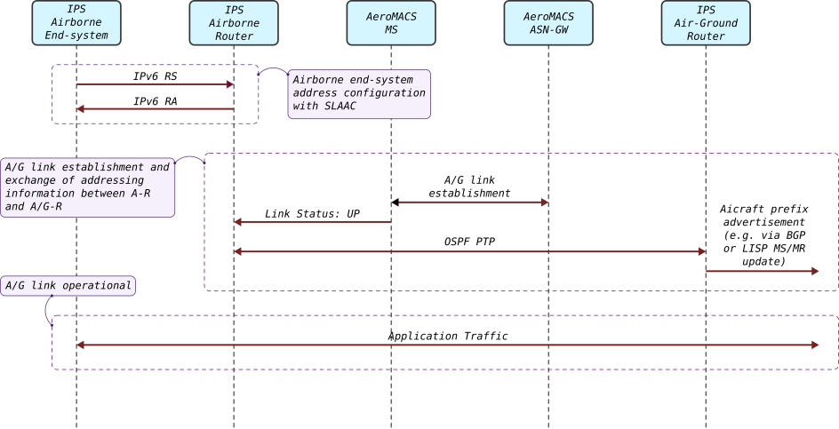
Figure 32 AeroMACS IPS: initialization and link establishment

Airborne end-system configuration
Airborne IPS end-system configures itself by means of IPv6 Stateless Address Auto Configuration (SLAAC) [20]. In principle this process consists of two stages:
- First, the end-system assigns a link-local IPv6 address to its network interface towards the airborne router. At this stage the Duplicate Address Detection (DAD) procedure may be executed. This step is not shown in Figure 32.
- Next, the end-system sends Router Solicitation (RS) over that network interface. Airborne router responds with Router Advertisement (RA) that contains the global IPv6 prefix of the aircraft. Based on that prefix the end-system configures its global IPv6 address.

A/G link setup
Once AeroMACS Mobile Station establishes the link with the AeroMACS ground infrastructure it sends the link state notification to the IPS airborne router over the management interface that is running AIAP protocol (see [18], Annex 1). AeroMACS MS sends “Status Info” message with the link status value “UP”.
This message is the indication to the airborne router that the A/G link is now operational at layer 2 and that the router can now exchange packets with the air-ground router.
Airborne router initiates OSPFv3 point-to-point (OSPF PTP) session with the air/ground router (see [18], Annex 2). The purpose of this session is to notify the router on the ground about the global prefix of the aircraft.
Note, that in the AeroMACS prototype the AIAP protocol between the airborne router the AeroMACS MS may not be operational. In this case the airborne router constantly tries to initiate OSPF PTP. If the A/G link is not available this will fail due to timeout. The airborne router will then try again after some timeout.
Once the air/ground router learns the prefix of the aircraft it can distribute the corresponding routes in the ground segment of the IPS network. The particular mechanism can vary depending on the particular deployment on the ground. For example, the new routes can be distributed via BGP routeing protocol, or LISP mapping system (MS/MR) can be updated.
Note, that OSPF PTP is a solution that is used in Sesar2020 PJ14 solutions. The operational mechanism of exchanging the addressing information may be different and may be standardised by ICAO.
After airborne router and air/ground router exchange the addressing information the A/G link can carry IPv6 application traffic. This traffic can be different depending on the particular application. For ATN applications (CM, CPDLC, ADS-C) UDP packets will be exchanged.

Interfaces

ATN AGR/AeroMACS Interface
The interface between AeroMACS (ASN-GW) and the ATN Air/Ground Router is a standard Ethernet as it supports IPv6 natively.
A/G-R considers ASN-GW as a network bridge, that is A-G/R and all connected aircraft will be in the same LAN segment.

ATN AAR/AeroMACS Interface
Airborne IPS router and AeroMACS MS are interconnected with Ethernet.
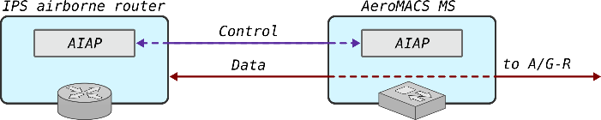
There are two interfaces between IPS airborne router and AeroMACS MS: the data interface and control interface. The interfaces are illustrated in Figure 33.
Figure 33 Interfaces between IPS airborne router and AeroMACS MS

The control interface operates AIAP protocol as described in [18], Annex 1.The purpose of AIAP protocol is to provide the IPS airborne router with the information about the current state of the AeroMACS A/G link and its quality at any given time. See 5.4 for details of AIAP messages format.
The link state information determines whether the Data interface is operational or not.
The link quality information is used by router to make the decision regarding link selection for the egress traffic when more than one A/G links are available.
In a situation where AIAP is not running the airborne router assumes that the Data interface is operational.
The Data interface is available only when AeroMACS MS establishes the link with the ground infrastructure. This is the native IPv6 interface. The egress IPv6 traffic from the airborne router is delivered without any modification to the air/ground router on the ground.
Before the Data interface is used to carry the application traffic, an address exchange between airborne router and air-ground router is required. This exchange is described in section 5.3.2.2.

Implementation Option 4: Multilink in ATN/IPS environment
The following two pictures represent respectively the ATN/IPS Multilink Architecture Overview and the FCI Functional Block Diagram.

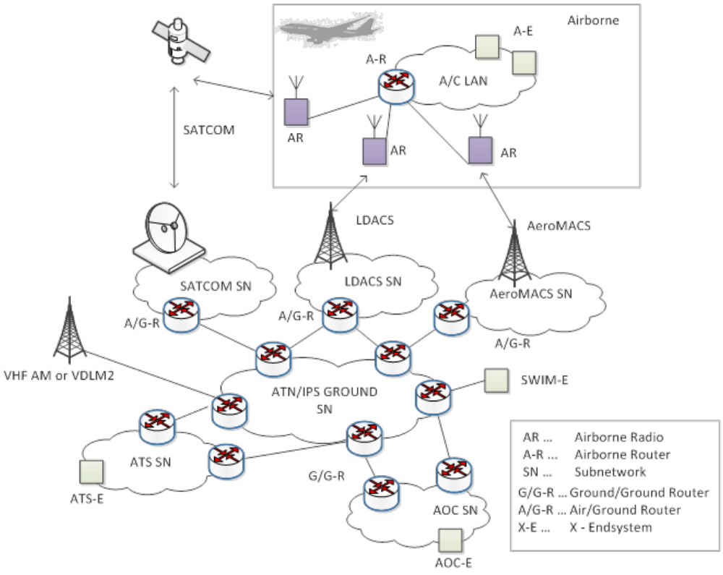
Figure 34: The Future Communications Infrastructure

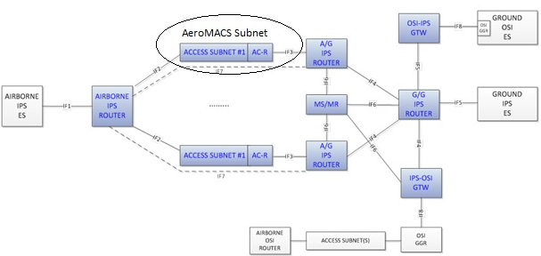
Figure 35: FCI Functional Block Diagram and related interfaces

The sub-blocks evidenced in blue are the FCI Constituents, while the other ones are the sub-blocks which the FCI is interfaced to.
This implementation option is validated in PJ14.02.04. The meanings of all the sub-blocks in the diagram are explained in PJ14.02.04 TS/IRS deliverable. In this Section it is important to describe the requirements to be implemented in AeroMACS devices in order to support Multilink protocols.
The AeroMACS Access Subnetwork is evidenced in the picture above. “Zooming” the Architecture of the AeroMACS Access Subnet, and taking also into account the Airborne/Ground End Systems, we have the following diagram:
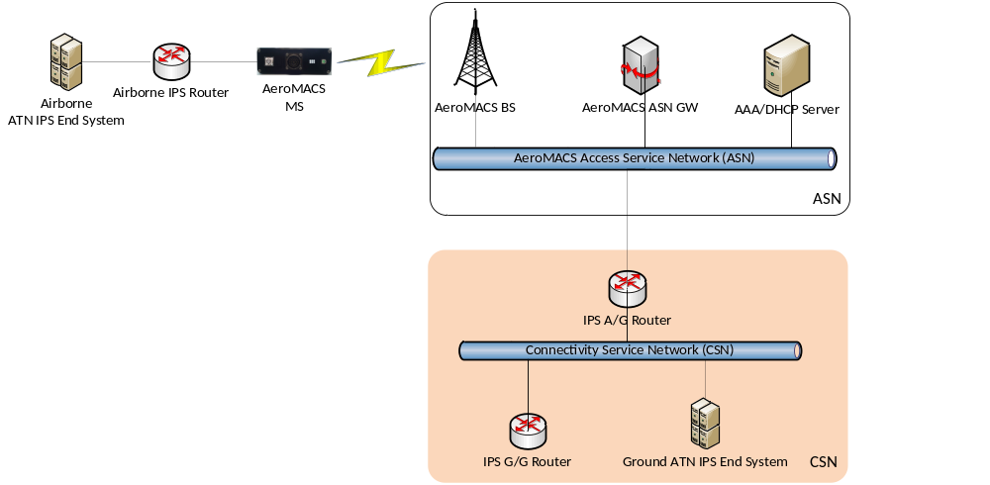
Figure 36: AeroMACS Access Subnet connecting ATN/IPS End Systems in a Multilink environment
The AeroMACS platform made available for 14.02.04 technical validations is composed by CPE with Layer 3 functionality, BS and ASN-GW. IP Convergence Sublayer (IP CS) is mandatory for AeroMACS, while Ethernet Convergence Sublayer (ETH CS) is optional (see [2]). This means that AeroMACS is a pure layer 3 “tube” in its mandatory version. In particular, it is not possible to configure Leonardo CPE as a pure Layer 2 radio device, as required by 14.02.04 Implementation Option. In order to overcome this limitation a “Mediation Device” (MD) is introduced between CPE and Airborne Router, as part of the CPE, and a GRE tunnel is configured between this “MD” and the AGR. The MD implements also the AIAP interface with the Airborne Router required by 14.02.04 (see [18], Annex 1).

Interfaces

ATN IPS AGR/AeroMACS Interface

The interface between AeroMACS (ASN-GW) and the ATN Air/Ground Router is a standard Ethernet as it supports IPv6 natively.
A/G-R considers ASN-GW as a network bridge, that is A-G/R and all connected aircraft will be in the same LAN segment.

ATN IPS AAR/AeroMACS Interface

Addressing on the interface between Airborne Router and AeroMACS Airborne Radio Unit is IPv6 Link Local.
The AeroMACS Airborne MS shall implement the Simple ATN/IPS Aircraft Protocol (AIAP), as defined in PJ14.02.04, to communicate with the Airborne IPS Router. Below a brief description of the protocol to be implemented by the AeroMACS Airborne MS. For a complete description of the AIAP Protocol, see [18].
AIAP Protocol is designed to exchange control PDUs between ATN/IPS Airborne Router and Airborne Radio on a connectionless UDP/IP interface; binding IP address and UDP port are configurable on the MS.
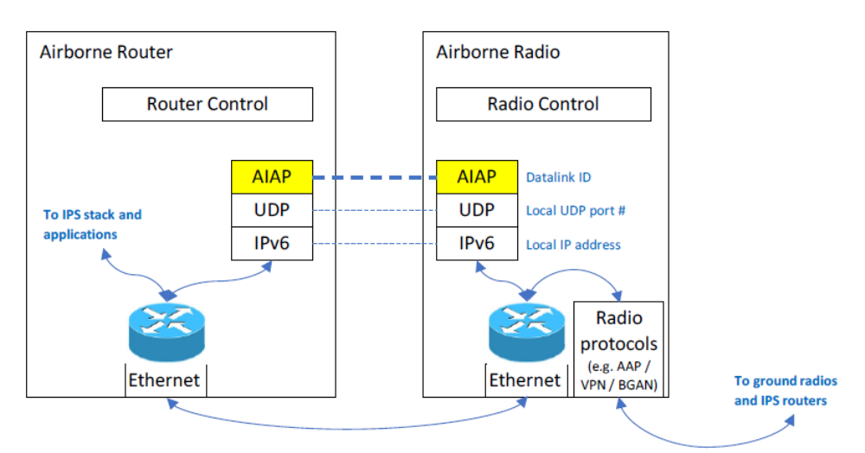
Figure 37: Airborne Radio-Airborne Router protocol stack
AIAP operates between a pair of endpoints. Each pair consists of one Airborne Router endpoint and one Airborne Radio endpoint (AeroMACS MS in this case).
Each endpoint is configured with:
- Datalink ID
  - Both endpoints in a pair MUST be configured with the same ID. The ID must be unique for this pair within the aircraft.
  - A Datalink ID Option with this ID MUST be sent in every message produced by this endpoint.
  - Only messages containing a corresponding option with this identifier should be accepted.

  - Datalink ID is an integer in range 0 to 255.
- Local IP address and port.
  - AIAP endpoint listens to UDP packets on this socket.
  - There might be multiple AIAP endpoints using single UDP socket. The endpoints are distinguished by Datalink ID.
- Remote IP address and port
  - Address of the other endpoint in a pair. Outgoing messages are sent to this IP address & port.

Airborne Radio endpoint operation
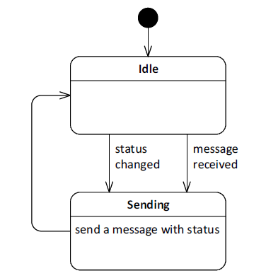
Figure 38: Airborne Radio endpoint operation
The Airborne AeroMACS MS endpoint shall behave as a simple responder. It shall send a message containing Datalink Status Option whenever:
- a message is received from Airborne Router endpoint
- the datalink status changes.

AIAP Message Format
AIAP message is carried as payload of an UDP packet.

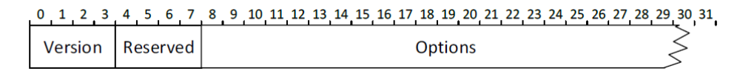
Figure 39: AIAP Message Format
Fields:
- Version 1
- Reserved This field is unused. It MUST be initialized to zero by the sender and MUST be ignored by the receiver.
- Options Sequence of zero or more options
AIAP message contains sequence of zero or more options. Order of options is not significant. Unrecognized options MUST be ignored by the receiver.

AIAP Option format
Figure 40: AIAP Option Format
Fields:
- Type 8-bit identifier of the type of option.
- Length 16-bit unsigned integer. The length of the option payload (excluding the type and length fields) in units of octets.
- Payload Variable-length data. Format is type-specific.

Datalink ID Option
Figure 41: Datalink ID Option
Fields:
- Type 1
- Length Length of the datalink ID in octets. 1 or more.
- ID 8-bit unsigned integer representing datalink ID.
This option identifies a datalink.

The following IDs are assigned to Datalinks:
1 --> AeroMACS
2 --> LDACS
3 --> SATCOM

Datalink Status Option

Figure 42: Datalink status Option
Fields:
- Type 2
- Length 1 or more
- Status 8-bit unsigned integer
o 0 = unknown
  - This value is intended for internal usage in Airborne Router endpoint and SHOULD NOT be used in Datalink Status Option to report status.
o 1 = up
o 2 = down
o 3 = best effort
  - Degraded with an unknown performance and impact on the user traffic
o 4 = degraded
  - Degraded with a known performance degradation and impact on the user traffic
This option specifies current status of a datalink managed by an Airborne Radio endpoint. If the length of Datalink Status Option is greater than 1, payload following the first byte MUST be ignored by the receiver.
Length of Datalink Status Option must be set to 1 by the sender.

The value of the “Status” field in the Datalink Status Option message is determined by Link Quality evaluation based on CINR measurements done by the Airborne AeroMACS MS.

Implementation Option 5: Integration of AeroMACS with Digital Voice
AeroMACS system can easily support voice communications, besides a wide variety of other IP data/video information exchanges among mobile and fixed users at the airport. However, legacy voice links between pilots and Air Traffic Controllers are not intended to be replaced, at least for the time being. In other words, voice over new Data Links like AeroMACS is not intended for now to be used as a primary means of communications. However it can constitute an important service enhancement.
Also in this case, several Network Layouts are possible, also depending on the specific use of Voice. They are listed in the subchapters below.

AeroMACS Network Layout with Voice Service
In Figure 43, we have considered one possible scenario, adding commercial VoIP telephones to the ATN Architecture described in4.1.2.
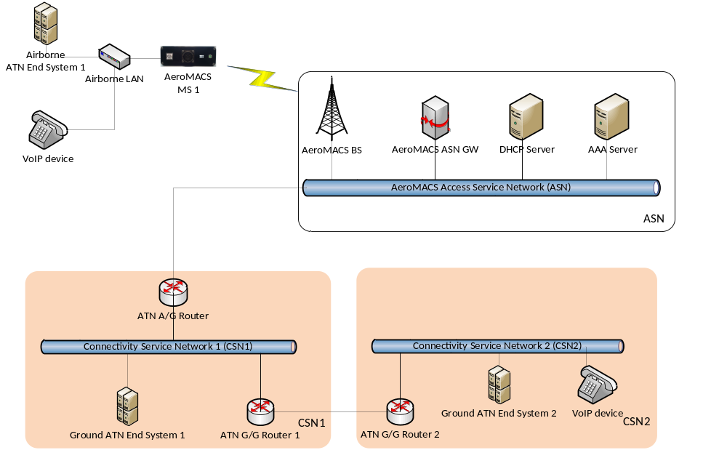
Figure 43: AeroMACS Network Layout with Voice Service
Another possible application of AeroMACS with VoIP is given in Figure 44, with a VoIP Radio Controller reaching remote users via VOIP over AeroMACS.

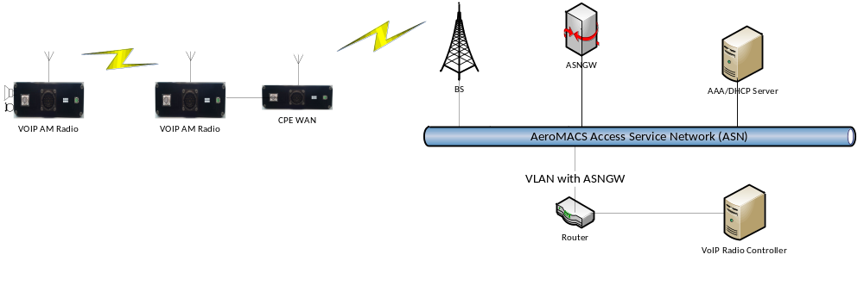
Figure 44: A possible application for VoiP over AeroMACS

VoIP Mobile Remote Control Site
In Figure 45, the scenario has been inverted, with the VoIP Radio Controller being hosted in the same location (for instance a car) as the AeroMACS Mobile Station, reaching Remote Radio Sites through AeroMACS Data Link.
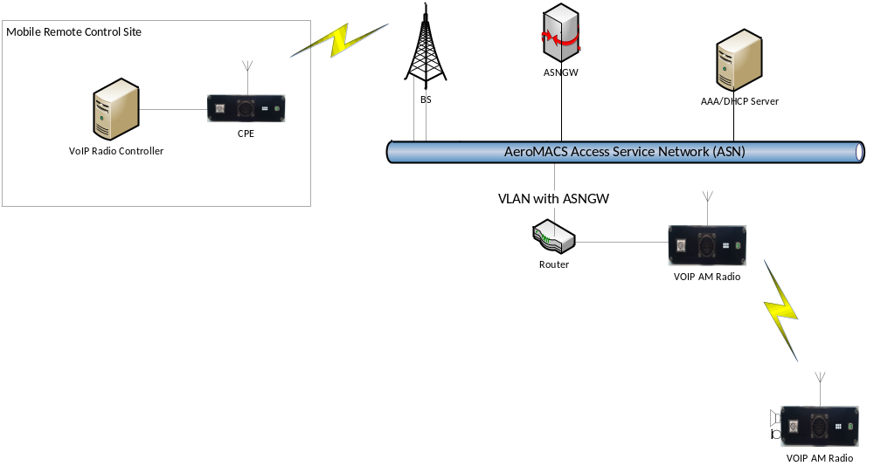
Figure 45: Other VOIP/AeroMACS application: Mobile Remote Control Site

Traceability between implementation options and requirements
The following Table indicates which requirements are applicable for each implementation option. Some requirements refer to multiple Options.
In case of implementation of more than one Option simultaneously, the requirements from all of them shall be implemented.
Implementation Option # | Requirement ID
IO#1 | REQ-14.02-06-TS-IRS-0001
IO#1 | REQ-14.02-06-TS-IRS-0002
IO#1 | REQ-14.02-06-TS-IRS-0003
IO#1 | REQ-14.02-06-TS-IRS-0004
IO#1 | REQ-14.02-06-TS-IRS-0005
IO#1 | REQ-14.02-06-TS-IRS-0006
IO#1 | REQ-14.02-06-TS-IRS-0007
IO#1 | REQ-14.02-06-TS-IRS-0008
IO#1 | REQ-14.02-06-TS-IRS-0009
IO#1 | REQ-14.02-06-TS-IRS-0010
IO#1 | REQ-14.02-06-TS-IRS-0012
IO#1 | REQ-14.02-06-TS-IRS-0013
IO#1 | REQ-14.02-06-TS-IRS-0014
IO#1 | REQ-14.02-06-TS-IRS-0015
IO#2 | REQ-14.02-06-TS-IRS-0001
IO#2 | REQ-14.02-06-TS-IRS-0002
IO#2 | REQ-14.02-06-TS-IRS-0003
IO#2 | REQ-14.02-06-TS-IRS-0004
IO#2 | REQ-14.02-06-TS-IRS-0005
IO#2 | REQ-14.02-06-TS-IRS-0006
IO#2 | REQ-14.02-06-TS-IRS-0007
IO#2 | REQ-14.02-06-TS-IRS-0008
IO#2 | REQ-14.02-06-TS-IRS-0009
IO#2 | REQ-14.02-06-TS-IRS-0010
IO#2 | REQ-14.02-06-TS-IRS-0012
IO#2 | REQ-14.02-06-TS-IRS-0013
IO#2 | REQ-14.02-06-TS-IRS-0014
IO#2 | REQ-14.02-06-TS-IRS-0024
IO#2 | REQ-14.02-06-TS-IRS-0025
IO#2 | REQ-14.02-06-TS-IRS-0026
IO#3 | REQ-14.02-06-TS-IRS-0001
IO#3 | REQ-14.02-06-TS-IRS-0002
IO#3 | REQ-14.02-06-TS-IRS-0015
IO#3 | REQ-14.02-06-TS-IRS-0016
IO#3 | REQ-14.02-06-TS-IRS-0017
IO#3 | REQ-14.02-06-TS-IRS-0018
IO#3 | REQ-14.02-06-TS-IRS-0019
IO#3 | REQ-14.02-06-TS-IRS-0020
IO#3 | REQ-14.02-06-TS-IRS-0021
IO#3 | REQ-14.02-06-TS-IRS-0023
IO#4  (validated in PJ14.02.04) | REQ-14.02-06-TS-IRS-0001
IO#4  (validated in PJ14.02.04) | REQ-14.02-06-TS-IRS-0002
IO#4  (validated in PJ14.02.04) | REQ-14.02-06-TS-IRS-0015
IO#4  (validated in PJ14.02.04) | REQ-14.02-06-TS-IRS-0016
IO#4  (validated in PJ14.02.04) | REQ-14.02-06-TS-IRS-0017
IO#4  (validated in PJ14.02.04) | REQ-14.02-06-TS-IRS-0018
IO#4  (validated in PJ14.02.04) | REQ-14.02-06-TS-IRS-0019
IO#4  (validated in PJ14.02.04) | REQ-14.02-06-TS-IRS-0020
IO#4  (validated in PJ14.02.04) | REQ-14.02-06-TS-IRS-0021
IO#4  (validated in PJ14.02.04) | REQ-14.02-06-TS-IRS-0023
IO#5 | REQ-14.02-06-TS-IRS-0001
IO#5 | REQ-14.02-06-TS-IRS-0002
IO#5 | REQ-14.02-06-TS-IRS-0011

Assumptions
This section describes the assumptions made that have an impact on the technical specifications described in Section 4.
In Implementation Options 1 (AeroMACS integrated with ATN/OSI) and 2 (Multilink in ATN/OSI) the following assumptions have been done:
- AeroMACS supports both IPv4 or IPv6. COTS ATN and AeroMACS devices use IPv4 addressing.
- AGR has fixed IP address
- AAR acquires the IP address via DHCP running on the CPE
- IDRP is used over the air/ground link
- UDP Protocol is used over the IP in the link between AGR and Airborne Routers

In Implementation Options 3 (AeroMACS integrated with ATN/IPS) and 4 (Multilink in ATN/IPS) the following assumptions have been done:
- AeroMACS supports both IPv4 and IPv6.
- AGR has fixed IPv6 address
- AAR has fixed IPv6 address

References and Applicable Documents

Applicable Documents
Content Integration
- B.04.01 D138 EATMA Guidance Material
- EATMA Community pages
- SESAR ATM Lexicon
Content Development
- B4.2 D106 Transition Concept of Operations SESAR 2020
System and Service Development
- 08.01.01 D52: SWIM Foundation v2
- 08.01.01 D49: SWIM Compliance Criteria
- 08.01.03 D47: AIRM v4.1.0
- 08.03.10 D45: ISRM Foundation v00.08.00
- B.04.03 D102 SESAR Working Method on Services
- B.04.03 D128 ADD SESAR1
- B.04.05 Common Service Foundation Method
Performance Management
- B.04.01 D108 SESAR 2020 Transition Performance Framework
- B.04.01 D42 SESAR2020 Transition Validation
- B.05 D86 Guidance on KPIs and Data Collection support to SESAR 2020 transition.
- 16.06.06-D68 Part 1 –SESAR Cost Benefit Analysis – Integrated Model
- 16.06.06-D51-SESAR_1 Business Case Consolidated_Deliverable-00.01.00 and CBA
- Method to assess cost of European ATM improvements and technologies, EUROCONTROL (2014)
- ATM Cost Breakdown Structure_ed02_2014
- Standard Inputs for EUROCONTROL Cost Benefit Analyses
- 16.06.06_D26-08 ATM CBA Quality Checklist
- 16.06.06_D26_04_Guidelines_for_Producing_Benefit_and_Impact_Mechanisms
Validation
- 03.00 D16 WP3 Engineering methodology
- Transition VALS SESAR 2020 - Consolidated deliverable with contribution from Operational Federating Projects
- European Operational Concept Validation Methodology (E-OCVM) - 3.0 [February 2010]
System Engineering
- SESAR 2020 Requirements and Validation Guidelines
Safety
- SESAR, Safety Reference Material, Edition 4.0, April 2016
- SESAR, Guidance to Apply the Safety Reference Material, Edition 3.0, April 2016
- SESAR, Final Guidance Material to Execute Proof of Concept, Ed00.04.00, August 2015
- SESAR, Resilience Engineering Guidance, May 2016
Human Performance
- 16.06.05 D 27 HP Reference Material D27
- 16.04.02 D04 e-HP Repository - Release note
Environment Assessment
- SESAR, Environment Reference Material, alias, “Environmental impact assessment as part of the global SESAR validation”, Project 16.06.03, Deliverable D26, 2014.
- ICAO CAEP – “Guidance on Environmental Assessment of Proposed Air Traffic Management Operational Changes” document, Doc 10031.
Security
- 16.06.02 D103 SESAR Security Ref Material Level
- 16.06.02 D137 Minimum Set of Security Controls (MSSCs).
- 16.06.02 D131 Security Database Application (CTRL_S)

Reference Documents
- ED-78A GUIDELINES FOR APPROVAL OF THE PROVISION AND USE OF AIR TRAFFIC SERVICES SUPPORTED BY DATA COMMUNICATIONS.
- EUROCAE/RTCA ED-222/DO-345, Aeronautical Mobile Airport Communications System (AeroMACS) Profile, edition 2013
- EUROCAE/RTCA ED-223/DO-346, Minimum Operational Performance Standards (MOPS) for the Aeronautical Mobile Airport Communication System (AeroMACS), edition 2013
- EUROCAE ED-227, Minimum Aviation System Performance Standards (MASPS) for the Aeronautical Mobile Airport Communication System (AeroMACS) , edition 2016
- ICAO Annex 10, Volume 3 Chapter 7, Aeronautical Mobile Airport Communications System (AeroMACS ) SARPs, edition 2016
- ICAO DoC 10044, Manual on the Aeronautical Mobile Airport Communications System (AeroMACS), edition 2017
- ICAO Doc 9880 Part III, Manual on Detailed Technical Specifications for the Aeronautical Telecommunication Network (ATN) using ISO/OSI Standards and Protocols, Part III - Upper Layer Communications Service (ULCS) and Internet Communications Service (ICS)
- SESAR P15.2.7 D01-T1.1a - IEEE 802.16-2009 SYSTEM ANALYSIS FOR AEROMACS USE, edition 2.0, 30/11/2010
- SESAR P15.2.7 D01-T1.1b - AeroMACS System Requirements Document, edition 1.0, 29/11/2010
- SESAR P15.2.7 D01-T1.2/T1.3 - AeroMACS Profile Analysis, edition 1.0, 19/11/2010
- SESAR P15.2.7 D01-T1.4 -AeroMACS Functional Architecture Definition, edition 1.0, 22/11/2010
- NWG Stage 2 Specifications for Release 1 are published in 4 parts.
WMF-T32-001-R010v05 , (2009-03-19), WiMAX Forum® Network Architecture (Stage 2: Architecture Tenets, Reference Model and Reference Points) [Part 0]
WMF-T32-002-R010v05 , (2009-03-19), WiMAX Forum® Network Architecture (Stage 2: Architecture Tenets, Reference Model and Reference Points) [Part 1]
WMF-T32-003-R010v05 , (2009-03-19), WiMAX Forum® Network Architecture (Stage 2: Architecture Tenets, Reference Model and Reference Points) [Part 2]
WMF-T32-004-R010v05 , (2009-03-19), WiMAX Forum® Network Architecture (Stage 2: Architecture Tenets, Reference Model and Reference Points) [Part 3 – Informative Annex]
- EUROCAE ED-228A, SAFETY AND PERFORMANCE REQUIREMENTS STANDARD FOR BASELINE 2 ATS DATA COMMUNICATIONS (BASELINE 2 SPR STANDARD), March 2016
- SESAR Future Communications Infrastructure (FCI) Functional Requirements Document (FRD), PJ.14.02.04
- ARINC 766: AeroMACS Transceiver and Aircraft Installation Standards, edition 2013
- WiMAX Forum® DRAFT-T32-006-R010v01 AeroMACS PKI Certificate Policy, edition 2017
- WMF-T33-001-R010v05, (2010-02-07), WiMAX Forum® Network Architecture, (Stage 3: Detailed Protocols and Procedures)
- SESAR2020 PJ14.02.04, FCI: Prototype Specification, edition 0.4, 31/07/2018
- SESAR2020 PJ14.02.04, Initial TS/IRS, edition 1.11, 19/07/2019
- RFC-2462 IPv6 Stateless Address Autoconfiguration, S. Thomson (Cisco), T. Narten (IBM), T. Jinmei (Toshiba), September 2007
- EUROCAE, ED-137B INTEROPERABILITY STANDARDS FOR VOIP ATM COMPONENTS – VOLUME 1: RADIO, January 2012
- ICAO Doc 9896 “Manual for the ATN using IPS Standards and Protocols”, Edition II
- ICAO, Doc 9705, MANUAL OF TECHNICAL PROVISIONS FOR THE AERONAUTICAL TELECOMMUNICATION NETWORK (ATN), edition 2

- EUROCAE, ED-138 NETWORK REQUIREMENTS AND PERFORMANCES FOR VOICE OVER INTERNET PROTOCOL (VOIP) AIR TRAFFIC MANAGEMENT (ATM) SYSTEMS - PART 1: NETWORK SPECIFICATION
- SESAR P15.2.7 D04 - AeroMACS Deployment & Integration Analysis, Edition 1.0, 21/09/2012
- SESAR P15.2.7 D05.1 - System Implementation Deliverable Part1: AeroMACS Ground Prototypes Description, Edition 1.0, 25/5/2013
- SESAR P9.16 D03 - AeroMACS Airborne System Requirements and Architecture Dossier, Edition 1.0, 23/12/2011
- SESAR P9.16 D04 - Airborne AeroMACS Prototype Specification, Edition 1.0, 09/01/2012

- Service Description Document (SDD)
Not Applicable.
No Service Description Document is planned to be developed in the context of PJ.14-02-06
- Service Technical Design Document (STDD)

Not Applicable.
No Service Technical Design Document is planned to be developed in the context of PJ.14-02-06.
-END OF DOCUMENT-




https://www.atmmasterplan.eu/rnd/technical-systems-overview?sys=4B9F615F54C61152
The EUROCAE ED-78A has been used as an initial guidance material. ED-78A is useful, but is not an applicable document, because it mostly addresses the V4-V5 phases, whilst the SESAR R&D programme is focussed on development (V1-V2-V3, and because of its partial compliance with safety regulatory requirements).

