 | [SESAR SOLUTION Pj14.03.04: COST BENEFIT ANALYSIS (CBA) FOR DME/DME RNP REVERSION FOR V3]
 | Deliverable ID: | D10.3.02 Economical Appraisal and or CBA for V3
 | Dissemination Level: | PU
 | Project Acronym: | EECNS
 | Grant: | 734168
 | Call: | [H2020-SESAR-2015-2]
 | Topic: | SESAR.IR-VLD.Wave1-17-2015
 | Consortium coordinator: | Leonardo
 | Edition date: | 30th October 2019
 | Edition: | 00.01.00
 | Template Edition: | 02.00.01

INDUSTRIAL RESEARCH



Authoring & Approval
Authors of the document
Name/Beneficiary | Position/Title | Date
Víctor Gordo/INECO | CNS Expert | 31.07.19
Carlos Parra/INECO | CBA Analyst | 31.07.19
J. Andrés Maroto/INECO | CBA Expert | 31.07.19

Reviewers internal to the project
Name/Beneficiary | Position/Title | Date
Valeriu Vitan/Eurocontrol | Senior Navigation Infrastructure Expert | 31/07/2019
Luca Saini / THALES ATM | Safety Assurance Manager | 01/08/2019

Approved for submission to the SJU By - Representatives of beneficiaries involved in the project
Name/Beneficiary | Position/Title | Date
Valeriu Vitan/Eurocontrol |  | 30/08/2019
Luca Saini/Thales |  | 30/08/2019

Rejected By - Representatives of beneficiaries involved in the project
Name/Beneficiary | Position/Title | Date

Document History
Edition | Date | Status | Author | Justification
0.1 | 29/08/19 | Delivered | Victor Gordo | Draft edition sent to the SJU
1.0 | 30/09/19 | Delivered | Victor Gordo | Modifications based on SJU comments
Copyright Statement

EECNS
Pj14.03.04 A-PNT

This CBA is part of a project that has received funding from the SESAR Joint Undertaking under grant agreement No 734168 under European Union’s Horizon 2020 research and innovation programme.


Abstract

The present report contains a detailed analysis of the benefits and costs of the project Solution 14.03.04 Short Term Alternative Position, Navigation and Timing (A-PNT). The aim of this CBA is to help to take a decision regarding the implementation of Short Term A-PNT, based on DME/DME RNP Reversion.

Table of Contents

Abstract 3
1 Executive Summary 6
2 Introduction 7
2.1 Purpose of the document 7
2.2 Scope 7
2.3 Intended readership 7
2.4 Structure of the document 8
2.5 Background 8
2.6 Glossary of terms 9
2.7 List of Acronyms 10
3 Objectives and scope of the CBA 12
3.1 Problem addressed by the solution 12
3.2 SESAR Solution description 12
3.3 Objectives of the CBA 13
3.4 Stakeholders identification 15
3.5 CBA Scenarios and Assumptions 15
4 Benefits 21
4.1 Airlines 21
4.2 Airports 26
4.3 Air Navigation Service Providers (ANSP) 27
4.4 Passengers 28
4.5 Rest of Society 29
5 Cost assessment 34
5.1 ANSPs costs 34
6 CBA Model 36
6.1 Data sources 37
7 CBA Results 38
7.1 Detailed results for Madrid TMA 39
7.2 Detailed results for Valencia TMA 40
8 The first analysis shows that high activity TMAs such as Madrid tend to be more fitted for the solution proposed, reason why a deployment in the medium activity TMAs of the ECAC area might not be optimal. However, the assumptions adopted in the analysis, especially the probability of even and its duration, make result quite ambiguous. For this reason, these variables are studied in depth in the sensitivity and risk analysis, among others. Sensitivity analysis 41
8.1 Sensitivity analysis 41
9 Recommendations and next steps 44
10 References and Applicable Documents 45
10.1 Applicable Documents 45
10.2 Reference Documents 45
11 Appendix 1 46
12 Appendix 2 49
12.1 Scope 49
12.2 Methodology 50
12.3 Results 51
12.4 Conclusions 56
13 Appendix 3 57

List of Tables
Table 1: SESAR Solution Pj14.03.04 Scope and related OI steps 13
Table 2: OI steps and related Enablers 13
Table 3: SESAR Solution Pj14.03.04 CBA Stakeholders and impacts 15
Table 4: SESAR Solution Pj14.03.04 CBA Solution Scenario 20
Table 5: Results of the benefits monetisation per KPA 33
Table 6: Number of investment instances - ANSPs 35
Table 7: Cost per Unit – ANSP 35
Table 8: Mapping between ATM Master Plan Performance Ambition KPAs and SESAR 2020 Performance Framework KPAs, Focus Areas and KPIs 48

Executive Summary
The present report contains a detailed analysis of the benefits and costs of the project Solution 14.03.04 Short Term Alternative Position, Navigation and Timing (A-PNT). The aim of this CBA is to help to take a decision regarding the implementation of Short Term A-PNT, based on DME/DME RNP Reversion.
The analysis is intended to help determine the suitability and profitability of the solution for specific cases, achieving an understanding of the disruptive effects that the solution is to prevent, and the variables in which results depend.
Under the set of conditions and assumptions described later in this document, the consultant team has estimated substantial gains derived from the prevention of the negative effects of disruptions in GNSS signal lost affecting air navigation systems. These consist of different associated negative effects, but mostly, the delay and cancellation of departing flights and the reactionary delays provoked by these in the rest of the ECAC area. Due to this, the main beneficiaries of the solution implementation happen to be the airlines and the passengers. On the other hand, the ANSPs, main promoters of the project, have been considered to bear all the costs without having any major benefit. The payback period results to be 3 year in weighted case for Madrid and 11 years in Valencia.
However, the results of the analysis are surrounded by a great deal of uncertainty due to the lack of information, especially about two main variables which are the probability of occurrence of GNSS outages and their duration. Level of activity and complexity of TMA also plays an important role in the suitability of the solution, having a higher impact in the busiest TMAs.
Based on these results, a deployment of the solution in the high activity TMAs in the ECAC area would yield an aggregated net present value of 390 million €.
So it can be concluded that the deployment of a DME/DME RNP Reversion system in a High Density TMA would be clearly beneficial, whereas for a Medium Density TMA the costs and benefits are almost even.
Finally, as the benefits calculated are highly dependent on the frequency, and even the duration, of a GNSS outage, it is recommended to develop further studies on the likelihood of these events. It also has to be considered that, although a GNSS MC/MF full outage should not be very common, currently most of the fleet is equipped only with GPS L1, so the likelihood and impact of a GNSS outage can be not so rare.

Introduction

Purpose of the document
The present document provides the Cost Benefit Analysis (CBA) carried out for the evaluation of Solution 14.03.04 Short Term Alternative Position, Navigation and Timing (A-PNT) at a V3 level.
The aim of this CBA is to serve to take a decision regarding the implementation of Solution 14.03.04 Short Term A-PNT, based on DME/DME RNP Reversion, which is assumed to take place in 2020-2021.
The CBA results are expected to support the decision of interested stakeholders (e.g. ANSPs) to move towards operational implementation. The results of CBA are specified for the promoter of the project (the ANSP) but also are disaggregated as for the rest of stakeholders in order to check the convenience of the solution for all parties involved.

Scope
This CBA addresses the SESAR2020 Pj14.03.04 A-PNT Short Term Solution; the mid term and long term solutions are not evaluated in this document. The analysis conducted in for the CBA considers the benefits and stakeholders which are described in following sections.
The time period considered for the analysis extends from 2020 to 2040.
The geographical scope of the Cost-Benefit Analysis has been limited to Terminal Operational Environment, as the proposed solution is not deemed necessary for En Route. The CBA provides results at two levels:
- Firstly, at an individual level, the analysis has been developed for a High Complexity Mixed OE (Madrid ACC) and a Medium Complexity Terminal OE (Valencia TACC), considered as examples of the affected Terminal OEs.
- Then consolidated at the ECAC level about the economic and financial viability of deploying the Solution Pj14.3.4 S/T A-PNT at the European scale, extending the results to the rest of High/Very High Complexity and Medium Complexity Terminal OEs.

Intended readership
The intended audience for this document consists of:
- The identified stakeholders which will benefit from the deployment of an A-PNT solution:
  - Airlines (commercial aviation), that will benefit for the avoidance of the disruptions due to GNSS outages, that are expected to cause delays, diversions and cancellations of flights.
  - Airport manager, that will not see its revenues diminish due to the same disruption.
  - Air Navigation Service Provider (ANSP), that will defray the costs of the project and
  - Passengers, that will benefit from the avoidance of delays, diversions and cancellations of flights.
- Other interested parties: such as the Solution Pj014 SESAR project members PJ19 and SESAR Programme, Eurocontrol, ANSPs, aviation safety authorities or others.

Structure of the document
The present document is structured as follows:
- Section 1 contains the executive summary with the main conclusions of the study conducted.
- Section 2 presents the background of the project and the purpose of this study.
- Section 3 defines the objectives and scope of the analysis, setting the base components and the starting point of the analysis according to the methodology of SESAR.
- Section 4 details the monetization process of the benefits identified at the BIM and included in the Cost Benefit Analysis.
- Section 5 describes the costs of the project considered in the analysis.
- Section 6 encloses the excel file with the CBA model used for the analysis.
- Section 7 presents the quantitative results of the analysis in detail, along with comments and an interpretation of these by the consultants.
- Section 8 contains an extension of the analysis, taking a deeper look in to the most sensitive and uncertain variables.
- Section 9 presents the conclusions of the study conducted.
- Section 10 details the references consulted and employed in the analysis.

Background
The analysis of the evolution of the navigation applications and the supporting infrastructure was performed within WP 15.3 of SESAR 1, which comprised Projects 15.3.1 (federating project), 15.3.2 (focused on terrestrial infrastructure) and 15.3.4 (focused on overall GNSS infrastructure). As a result project 15.3.1 produced the deliverable D9 [9], which describes the SESAR Navigation Baseline defined as the optimal combination of Navigation Systems (e.g. Conventional Navigation aids, GNSS and Alternative PNT) to support Navigation applications (e.g. PBN) considering also related regulations (e.g. PCP on PBN).
This document included a cost efficiency assessment, providing a qualitative indication of difficulty of the efforts to develop and install an aircraft capability. The analysis concluded that for High Density/ High Complexity En Route and TMA operational environment, the preferred scenario considered a navigation baseline including MC/MF GNSS core constellations and augmentations but also A-PNT (based on DME/DME) due to the higher availability to support RNP 1 in case of GNSS outages.

Glossary of terms

Term | Definition | Source of the definition
B/C Ratio | B/C Ratio is the ratio of the discounted sum of benefits over the discounted sum of costs. | Own definition
Benefit | Positive monetized flow of funds or social utility. | Own definition
Business Case | Analysis of a specific situation though to be representative and extendable to a similar reality | Own definition
Cash | Funds, monetary resource and utility | Own definition
Cost | Negative monetized flow of funds or social utility. | Own definition
Delay | Significant waiting time | Own definition
Discount rate | Devaluation of flows in function of time | Own definition
Flow | A measurement of quantity over a specified period of time, measuring entering or exiting funds or utility | Own definition
FOC | Beginning of benefits collection | Own definition
Internal Rate of Return | Internal Rate of Return (IRR) is the discount rate at which the NPV of the project becomes positive. | Own definition
IOC | State achieved when a capability is available in its minimum usefully deployable form | Investopedia
Net Present Value | Net Present Value (NPV) is the sum of all discounted cash inflows and outflows during the time horizon period. | Investopedia
Sensitivity Analysis | Analysis that determines how different values of an independent variable affect a particular dependent variable under a given set of assumptions | Investopedia
Stakeholder | Agent or party with an interest in the project | Own definition
Time horizon | End of evaluation period | Own definition

List of Acronyms

Acronym | Definition
ACC | Area Control Centre
ANSP | Air Navigation Service Provider
A-PNT | Alternative Position, Navigation and Timing
ATC | Air Traffic Control
ATCO | Air Traffic Controller
ATFCM | Air Traffic Flow and Capacity Management
ATFM | Air Traffic Flow Management
ATM | Air Traffic Management
BADA | Base of Aircraft Data
BIM | Benefit and Impact Mechanism
CAGR | Compound Annual Growth Rate
CBA | Cost Benefit Analysis
CNS | Communications, Navigation and Surveillance
DME | Distance Measuring Equipment
DORA | Documento de Regulación Aeroportuaria
ECAC | European Civil Aviation Conferences
FMS | Flight Management System
FOC | Final Operational Capability
GNSS | Global Navigation Satellite Systems
HC | High complexity (airport)
IATA | International Air Transport Association
ICAO | International Civil Aviation Organisation
IOC | Initial Operational Capability
KPA | Key Performance Area
KPI | Key Performance Indicator
LC | Low complexity (airport)
LDACS | L-band Digital Aeronautical Communications System
LTO | Landing and Take Offs
MAD | Madrid ATM
MTOW | Maximum Take Off Weight
NEST | Network Strategic Modelling Tool
NPV | Net Present Value
NSP | Navigation Systems Panel
OBPMA | On Board Performance Monitoring and Alerting
OE | Operating Environment
OI | Operational Improvement
PAR | Performance Assessment Report
PBN | Performance Based Navigation
PCP | Pilot Common Project
PIRM | Programme Information Reference Model
RNAV | Area Navigation
RNP | Required Navigation Performances
RoS | Rest of Society
SESAR | Single European Sky ATM Research Programme
SJU | SESAR Joint Undertaking (Agency of the European Commission)
TACAN | Tactical Air Navigation System
TACC | Terminal ACC
TMA | Terminal Manoeuvring Area
VLC | Valencia ATM
VTTS | Value of Travel Time Savings

Objectives and scope of the CBA

Problem addressed by the solution
Alternative-Position, Navigation and Timing (A-PNT) is a technological enabler related with the need to introduce ground and airborne systems that can support currently defined and standardized PBN and other CNS-based operations and provide a backup with the required level of performance in case of corruption, degradation and absence/loss of GNSS.
The objective of Air Navigation is to maintain the safety, regularity and efficiency of air transport. Accordingly, the objective of A-PNT systems, as every air navigation system will be to assure these three requirements in contingency conditions.
This objective is aligned with ICAO Job Card NSP.009.02, which states that “the objective of an APNT strategy is to maintain air navigation services to the maximum extent possible in the event of a GNSS signal outage by taking advantage of current systems and defining a realistic evolution path that maintains safety and an acceptable level of efficiency…”

SESAR Solution description
Three different configurations have been suggested to be tackled in Pj14.3.4, depending on the level of modifications they would require to the existing infrastructure/avionic. These 3 configurations are:
- Short Term Solution (RNP Reversion using DME/DME): The integrity rate for the DME ground station that may be used in the design of RNP procedures should be improved to meet a certain minimum integrity level, not less than 1-10^{‐6} per hour. The short term solution develops standards for the DME transponder architecture to ensure the required integrity level.
- Mid Term Solution (Airborne Multi DME Architecture): The Mid‐term solution investigates the possibility to improve DME based localization algorithms in the airborne FMS to fully support the OBPMA integrity requirements defined for a RNP navigation specification in the PBN manual.
- Long Term APNT: L‐Band Digital Aeronautical Communication System (LDACS) will include a navigation capability to enable ranging and/or pseudoranging and will be eligible to be used as a future APNT systems in combination with other ranging sources like DME and eLoran.
This CBA is focused on the Short Term Solution. The short term A-PNT solution seeks therefore to enhance legacy technologies (e.g. DME), and hence make use of existing infrastructure and equipage, with minor adaptations. Accordingly, DME network (including TACAN for civil operations) will provide the main support for reversionary PBN operations in En-route and TMA airspace.

SESAR Solution ID | OI Steps ref. (coming from the Integrated Roadmap) | OI Steps definition (coming from the Integrated Roadmap) | OI step coverage | Comments on the OI step title / definition
SESAR Solution Pj14.03.04 A-PNT | OIS01155 | Increase Performance Based Navigation robustness (Short-Term Solution) | Fully | N/A
Table 1: SESAR Solution Pj14.03.04 Scope and related OI steps
OI Steps ref. | Enabler ref. | Enabler definition | Enabler coverage | Applicable stakeholder | Comments on the Enabler / definition
OIS01155 |  |  | Fully (system required to support RNP 1 reversion based on DME/DME) | ANSPs
Table 2: OI steps and related Enablers

Objectives of the CBA
The main objective of the present CBA is to determine whether the expected benefits of the short term A-PNT solution proposed justify the costs of its implementation. To this end, different circumstances have been considered in order to test the suitability of the solution and the resilience of the positive results.
The analysis is to provide differentiated results for the following cases:
- Aggregated and disaggregated results per stakeholder, in which the rationality of the project is analysed for its promoter, the ANSP, and then is compared with the overall result. This comparison is to signal whether additional funding from a public institution is expected to be needed.
- Financial and socioeconomic results, to test the financial viability of the project itself.
- ATM-local and ECAC level results, to check which part of the total of benefits remain in the area of implementation and which part is expected to reach the rest of the ECAC network.
- One hour and four hours duration of the event, to analyse the impact of different durations of a blackout of GNSS service.
- High density TMA and medium density TMA OEs, for which the TMAs of Madrid and Valencia respectively are going to be considered.
Moreover, as described in section 8, the robustness of the results is to be tested with, first, a sensitivity analysis and, second, a risk analysis based on Monte Carlo iterations. These trials are expected to shed light to the variables most surrounded by uncertainty.
Finally, results for high and medium activity airports are extrapolated to the whole of ECAC area.

Stakeholders identification

Stakeholder | The type of stakeholder and/or applicable sub-OE | Type of Impact | Involvement in the analysis | Quantitative results available in the current CBA version
ANSP | En-route and TMA ANS providers. | Avoidance of revenues derived from cancelled flights. Other benefits not quantified (reputation).  Investment costs to be defray. | ENAIRE, the Spanish ANSP, has taken part of this analysis | Partially on benefits and fully on costs
Airport Operators | Airports in which incoming flights that would have meant aeronautical and commercial revenues are cancelled. | Avoidance of cancellation of incoming flights. | Not involved in the analysis. | Only benefits but partially, no costs.
Scheduled Airlines (Mainline and Regional) | All airlines with programmed arrivals or departures during the failure of the system, plus airlines affected in other ECAC airports due to the disruption created (network delays). | Avoidance of significant impact in the ATM operations that would derive in delays, diversions and cancellation of flights. | Not involved in the analysis. | Only benefits but partially, no costs.
Other impacted stakeholders:  Passengers | Passengers of affected flights, both in affected airport and in the rest of the ECAC network. | Avoidance of delays, diversions and cancellation of flights provoked by the disruption. | Not involved in the analysis. | Only benefits but partially, no costs.
Table 3: SESAR Solution Pj14.03.04 CBA Stakeholders and impacts

CBA Scenarios and Assumptions
The assessment presented compares a “with project” situation in which the reversion system described prevents the negative effects of the GNSS signal temporary outage against a “without project” situation in which no back up measures are deployed (no conventional nor RNAV back up systems), having a negative impact in the capacity for operations of the airport in case of outage. As described in section 3.3, this comparison of scenarios is done for two different TMAs, Madrid ACC (MAD) and Valencia TACC (VLC), and two different cases, which differ on the assumed duration of the outage after which the service of GNSS for navigation is restored and navigation services can be provided as usual (this is, one and four hours of outages).
This section describes the two scenarios to be compared, along with the set of assumptions that compose the framework in which the solution is assessed.

Reference Scenario
As mentioned before, the “without project” scenario considers the negative impact of a GNSS blackout when no backup navigation systems are deployed, having an impact on the capacity of the TMA for meeting the arrivals and departures demand. This reduction in the capacity provokes increased ATCO workload (as radar vectoring will be required for every aircraft), causing aircraft circling that result in local delays and also reactionary tactical ATFM delays. When these delays become too long, diversions and cancellations become necessary to alleviate the congestion problem in the TMA. At the same time, departures are cancelled in order to focus the resources in attending landing needs.
The impact related to the event here described is weighed with its calculated probability of occurrence. Traffic forecasts in Spanish airports from the Official Document of Airport Regulation (DORA) [11] have been incorporated to this analysis, having a constant growth over time that is taken into account in the analysis. However, reference scenario does not consider an evolution of technology along the period analysed, assuming that no back up measures will be deployed for all the period under consideration. This implies that capacity fall in case of event will be constant. Given the high discount rate, the differences with a “rolling basis” scenario with an evolving reference technology would be minimum.

Solution Scenario
The “Delta” approach is considered in this section for the description of the Solution scenario. This implies the differential benefits and costs associated to the implementation of an A-PNT solution based on DME/DME RNP Reversion, which limits to the installation of a number of DME transponders in the TMAs, i.e., no airborne investment are required, as the current DME receivers will provide the required capabilities. The project is considered to be implemented in 2020 to start operating in 2021. Time horizon is set in 2040.
The discount rate applied is 8% as recommended in the Common Assumptions. The evolutions of traffic are considered to be similar to the reference scenario, so there is no differential growth.
The bulk of the benefits calculated are the absence of negative effects, mostly the ones associated to delays and cancellations. In case of blackout, the backup system under evaluation allows the TMA to keep managing traffic without having its capacity reduced. Due to this, the blackout does not have a significant disruption in the air traffic management and operations do not have to be delayed nor diverted or cancelled.
To sum up, it is assumed that in the “with project” scenario the blackout considered does not have any effect. Therefore, the differential benefits between both scenarios are the ones derived of the prevention of the disrupting effects of the event weighed with its calculated probability, while the differential costs are the ones derived from the implementation of the solution.

Cases studied
As described in the objectives, several cases have been studied to gain perspective of the suitability of the solution.
- TMA: the analysis have been conducted for a high density TMA, Madrid, and a medium density TMA, Valencia.
- Duration of the event: the analysis has been conducted considering disruptions periods of one hour, four hours and a mixed cased combining a 66,6% of probability of 1h event and a 33,3% of probability of 4h event.

Assumptions
Due to the complexity of the analysis, several assumptions have been considered. These are listed in this section, along with a description when necessary. Assumptions have been grouped following the classification presented in the Common Assumptions document.
Common assumptions: the main settings of the CBA are described here. These are already mentioned in the solution scenario.
- The discount rate to be applied is an 8%.
- The timeline of the project is as follows:
  - 2019: year zero, to which flows are discounted.
  - 2020: implementation year, when investment costs are allocated.
  - 2021: start of operation, IOC=FOC.
  - 2040: Last year of social evaluation.
- Traffic evolution has been derived from the DORA 2017-2021.
- Fuel price is assumed to remain constant during the whole evaluation period.
- The event occurs in a peak hour. Deviations from this are considered in the sensitivity and risk analysis.
- Safety is assumed to be ensured in every scenario, so it doesn’t enter the analysis in any point.
- The Cost Benefit Model has been constructed to allow testing deviations, but these have not been considered in the cases analysed.
- The probability of occurrence of the disruption has been treated as follows. A given probability of event is considered, similar for all TMAs, assuming is 0.5 times/year. This implies that, on average, a disruption would take place every two years. Independently of this, this event can have different durations, having been considered in the cases one hour, four hours, or the weighted case that combines a 66,6% of probability for the first one and a 33,3% for the second one.
Local assumptions: These refer to a specific TMA, in this case, either Madrid or Valencia.
- No navigation backup systems to GNSS are deployed in the TMAs. Accordingly, in case of event, every aircraft will be managed by ATC using radar vectoring.
- In case of event, the TMA will suffer the following falls in airspace capacities, which differ due to the complexity of the TMA and its workload.
  - Arrivals:
    - MAD, 30% capacity fall (ATCO will vector inbound flights, but for safety reasons the capacity will be reduced)
    - VLC, 15% capacity fall (also vectoring will be provided, but as the number of inbound aircraft is not so large, ATC will be able to handle most of them).
  - Departures:
    - 100% capacity fall (once detected this contingency, the first measure taken by ATC would be to stop all departures)
- Calculations for diversions consider an alternative TMA for every TMA analysed, which are:
  - Zaragoza (ZGZ) for Adolfo Suarez Madrid Barajas (MAD), for which is assumed:
    - 30 min of incremental flying time.
    - 160 min Incremental total travel time from ZAZ to Madrid for passenger (including the additional 30 min flying time).
    - 70€ of incremental cost of diversion per passenger.
  - Alicante (ALC) for Valencia (VLC), for which is assumed:
    - 20 min of incremental flying time.
    - 160 min Incremental total travel time from ALC to Valencia for passenger (including the additional 20 min flying time).
    - 28€ of incremental cost of diversion per passenger.
- Madrid TMA will require 8 DME facilities for the RNP reversion solution.
- Valencia TMA will require 6 DME facilities.
- Traffic evolution: derived from the DORA 2017-2021:
  - Forecasted operations growth, MAD: 1,2% CAGR
  - Forecasted passengers growth, MAD: 1,6% CAGR
- Traffic evolution: derived from the DORA 2017-2021:
  - Forecasted operations growth, VLC: 1,1% CAGR
  - Forecasted passengers growth, VLC: 1,5% CAGR

Performance assumptions: these aim to simplify technical complexities of the analysis.
- The “Delays calculation model” is based on the methodology described in Evaluation of the Capacity and Delay of Terminal Air Traffic Control Automation, by S.B. Boswell, Lincoln Laboratory, M.I.T. [12]. This has been modified in order to incorporate “aborted” flights in the calculations, which refers to diverted and cancelled flights which do not make use of the TMA eventually and help to decongest the airspace. The model is used to calculate delays for incoming flights and outgoing flights. The resulting model is further explained in 13 Appendix 3 and works under an own set of assumptions, which are here described:
  - Programmed operations flow of incoming and outgoing flights is constant.
  - There are no considerations regarding fuel constrains.
  - The model treats arrivals and departures separately.
One of the main tools that the air traffic managers have to deal with unexpected capacity falls are the holding of departing flights. These can be either delayed or cancelled (directly or after waiting). Air traffic managers can also decide upon arriving flights but relying more on diversions. In both cases, it is assumed that wide body aircrafts are given priority over smaller aircrafts.
- The arrivals are treated according to the following assumptions:
  - For the 1 hour outage, no diversion nor cancellation are considered.
  - For the 4 hours outage,
    - no diversion nor cancellation are considered in the first hour,
    - diversions of small narrow body aircraft flights are allowed in the second and third hour, but not considered in the cases studied.
    - cancellations of small narrow body aircraft flights are considered in the fourth hour.
  - Wide body aircraft flights are considered to be given priority. Diversions and cancellations only might affect narrow body flights.
  - Notwithstanding, in the cases analysed diversions and cancellations of incoming flights have not been applied, as the maximum delay is around 30 minutes, which is considered acceptable.
- The departures have a different treatment, due to the ability of air traffic managers to delay or cancel flights before the take-off, limiting the losses and risk of the disruption.
  - For the 1 hour outage, flights with small narrow body aircrafts (which are supposed to be more common in national flights and have a higher frequency and lower cancellation impact) are cancelled, while the others are delayed one hour time (which is added to the later processing time that the TMA needs to serve the accumulated flights).
  - For the 4 hours outage, all flights with small narrow body aircrafts cancelled for similar reasons, as the other flights in the first three hours. Flights with medium and wide aircrafts in the last fourth hour are delayed for one hour.
  - However, as mentioned before, the cases studied have not considered deviations.
- Number and timing of diversions and cancellations are not calculated with the “Delays calculation model”. These are assumed with the experts criteria and based on the queues predicted. However, it is assumed that the number of these disruptions will increase with the duration of the event. To reflect this, aborted flights will double each hour starting the second one.
- Programmed departures after the restore of GPS are not affected by disruption and are served as usual. Delayed departures are served in the backlog phase with the remaining capacity of the ATM, having no preference over the programmed flights. This is an accounting simplification without any effect on the results, given that the order of operations does not influence the quantification of benefits.
- Programmed arrivals, on the other hand, are affected after the disruption if they arrive in the backlog phase. On arriving, they join the waiting line, incurring in a delay until the TMA is able to serve them.
- Air traffic has been classified in three categories, which are small narrow body, medium narrow body and wide body. Each category has taken a representative aircraft (A319, A320 and A340 respectively) to be considered for input values of fuel consumption, aircraft operating costs, cancellation costs and compensations, emissions and capacities.
Auxiliary assumptions: In order to quantify specific benefits, some other assumptions have been required. These are described in the benefits sections when applied.

Scenario feature |  | Year 0, 2019 | Year 1, 2020 | Year 21, 2040 | Source
Discount rate applied |  | 8% | 8% | 8% | Common Assumptions, SESAR
Capacity fall in case of event (reference scenario) | MAD | 30% | 30% | 30% | Experts opinion
Capacity fall in case of event (reference scenario) | VLC | 15% | 15% | 15% | Experts opinion
Operations traffic | MAD | 414,250 | 419,221 | 532,174 | DORA  2017-2018
Operations traffic | VLC | 67,991 | 68,739 | 85,551 | DORA  2017-2018
Passengers traffic | MAD | 58,788,758 | 59,729,378 | 82,046,896 | DORA  2017-2018
Passengers traffic | VLC | 7,868,531 | 7,986,559 | 10,756,737 | DORA  2017-2018
Table 4: SESAR Solution Pj14.03.04 CBA Solution Scenario

Benefits
The present section provides with a detailed description of the monetised expected benefits derived from the implementation of the solution Pj14.03.04 in the scenario previously described.
The estimation of benefits has been based on the Performance Assessment previously carried out. The Benefit Monetisation Mechanisms has been carefully followed, having the excel template filled in order to feed the CBA model. The estimations have also followed the document SESAR 16.06.06-D26_03, Methods to Assess Costs and Monetise Benefits for CBAs, Edition 00.02.02 when possible and reasonable, and taken a closely similar approach when benefits were no explicitly stated in the document.
The team of consultants has taken a conservative approach, discarding unclear or unquantifiable benefits such as safety ones, as the risk and cost of an accident due to a GNSS outage. In the analysis conducted some side effects of the implementation of the project have been identified, which are later described. The most uncertain benefits and variables are pointed out in order to be further studied in the sensitivity and risk analysis.
Given that the SESAR CBA methodology does not specify nor recommend any conversion using shadow prices, these have not been applied at any point of the calculations.
In order to quantify the benefits some auxiliary assumptions were required. These are described where applied. Benefits have been calculated per stakeholder group as required in the BIM. This way, objectives presented in section 3.3 can be met.
It is important to mention that the benefits as they are presented in this section are first calculated in case of event. To calculate the flows of benefits to be compared against the costs, these are weighted with the probability of event to compute the expected benefits, and then extrapolated to all time period taking into account the forecasted growth of traffics per year.

Airlines
The airlines are considered the main beneficiary of the implementation of the project. The benefits identified consist of avoided operating costs due to avoided delays and diversions, avoided cancellations and avoided network delays in other ECAC airports

Avoided operating costs due to avoided delays and diversions.
The studied blackout is to affect both incoming and outgoing flights. As for the arriving flights, the blackout provokes the extension of some of the flights in curse to the affected airport, incurring in additional costs. Most of these will have to wait to land due to the reduced capacity, while others will be diverted to decongest the ATM. The quantification of this avoided cost is separated into fuel saving and the rest of operating costs for a better traceability and understanding. On the other hand, departing flights are affected in land, so this separation does not apply.

Fuel savings due to avoided delays and diversions (arrivals):
Savings in additional fuel expenditure are estimated as follows:
Fuel Savings (arrivals) | = | ( | Accumulated minutes of delay, arrivals (1) | + | No of diverted flights (2) | x | Average diversion increase time (3) | ) | x | Average Fuel Consumption (4) | x | Fuel Price (5)
€ |  |  | min |  | flights |  | min |  |  | Kg/min |  | €/kg
Assumptions:
In order to evaluate the fuel consumption, three kind of aircrafts are considered (small narrow body, medium narrow body and large wide body) according to its size. The weighted average value of the fuel consumption is obtained multiplying the fuel burn rate of each kind of airplane, times the proportion of that class of aircraft that operate in that airport.
The number of diverted flights has been established by the experts based on the accumulation of delays calculated.
An average excess of time incurred by the arriving aircrafts diverted to other airports is also assumed. To be quantified, a closest commercial airport has been considered (Zaragoza -ZAZ- for Madrid and Alicante -ALC- for Valencia), along with an average increase in flying (30 and 20 min respectively).
Data requirements:
(1) | Accumulated minutes of delay, arrivals | Source: Own calculation
(2) | No of diverted flights | Source: based on demand and experts criteria.
(3) | Average diversion increase time | Source: estimation based on distance an transport services available.
Parameters applied and sources:
(4) | Fuel Consumption | Source: EUROCONTROL
(5) | Fuel price | Source: IATA Jet Fuel Price Monitor

Rest of operating costs savings due to avoided delays and diversions (arrivals):
The rest of operating costs saved are estimated as follows:
Rest of operating cost savings (arrivals) | = | ( | Accumulated minutes of delay, arrivals (1) | + | No of diverted flights (2) | x | Average diversion increase time (3) | ) | x | Delay cost for airline, en-route (4) | - | Fuel Savings (arrivals)
€ |  |  | min |  | No of flights |  | min |  |  | €/min |  | €
Assumptions:
Given that parameter proposed by Eurocontrol for the delay cost per minute includes fuel, the previous benefit has been subtracted from this in order to prevent double counting.
The number of diverted flights has been established by the experts based of the accumulation of delays calculated.
An average excess of time incurred by the arriving aircrafts diverted to other airports is also assumed. To be quantified, a closest commercial airport has been considered (Zaragoza -ZAZ- for Madrid and Alicante -ALC- for Valencia), along with an average increase in flying (30 and 20 min respectively).
Data requirements:
(1) | Accumulated minutes of delay, arrivals | Source: Own calculation
(2) | No of diverted flights | Source: based on demand and experts criteria.
(3) | Average diversion increase time | Source: estimation based on distance an transport services available.
 | Fuel Savings (arrivals) | Source: Benefit 4.1.1.2

Parameters applied and sources:
(4) | Delay Cost per minute | Source: EUROCONTROL

Operating cost savings (departures)
The calculation of operating costs of delayed flights leaving the airport differs from the formula for incoming flights, mainly due to
Operating costs savings (departures) | = | Accumulated minutes of delay, departures (1) | x | Delay cost for airline, at gate (2)
€ |  | min |  | €/min
Assumptions:
Only some of the affected departing flights are to be delayed, the rest are supposed to be cancelled as described in section 3.5.4. The additional costs here described limit to the leaving flights that are not cancelled because they were programmed in the last hour of the blackout and they are attended before being cancelled (cancellation only takes place after one hour of delay).
Delays for outgoing flights are supposed to take place with aircrafts in land, reason why costs are lower and there is no additional fuel expenditure.
Data requirements:
(1) | Accumulated minutes of delay, arrivals | Source: Own calculation
Parameters applied and sources:
(2) | Delay cost for airline, at gate | Source: EUROCONTROL

Avoided cancellation of flights
One of the main tools that the air traffic managers have to deal with unexpected capacity falls are the holding of departing .
The bulk of the benefits calculated in this analysis accrue for the avoidance of a significant number of cancellations, especially in the departures, that air traffic managers decide to reduce congestion.

Avoided arrival cancellations.
This section presents the quantification of cancellation costs for arrivals:
Cancellation Savings (arrivals) | = | Number of incoming cancelled flights (1) | x | Small narrow body cancellation cost (2)
€ |  | flights |  | €/flight
Assumptions:
As mentioned in section 3.5, cancellations in the incoming side of operations will always affect small narrow body aircrafts. This is based on several considerations, such us:
- By targeting small narrow body aircrafts, air traffic managers limit the negative effects of cancellations.
- Short flights (that rely on smaller aircrafts) can be cancelled in advance more easily.
Data requirements:
(1) | Number of incoming cancelled flights | Source: based on demand and experts criteria.
Parameters applied and sources:
(2) | Small narrow body cancellation cost | Source: EUROCONTROL

Avoided departure cancellations.
This section presents the quantification of cancellation costs for departures.
Cancellation Savings (departures) | = | Number of outgoing flights cancelled before the last hour of blackout (1) | x | Average cancellation cost (2) | + | Number of outgoing flights cancelled in the last hour of blackout (3) | x | Small narrow body cancellation cost (4)
€ |  | flights |  | €/flight |  | flights |  | €/flight
Assumptions:
As mentioned in section 3.5, air traffic managers will cancel first the smaller aircraft flights, holding on the wide body aircrafts for one hour before cancellation. Therefore, in the three hours case, all flights in first three hours are cancelled, while in the fourth hour the small narrow body aircraft flights are cancelled and the others are delayed that hour.
Data requirements:
(1) | Number of outgoing flights cancelled before the last hour of blackout | Source: based on demand data and previous assumptions.
(2) | Average cancellation cost | Source: based on demand data and EUROCONTROL cancellation cost references.
(3) | Number of outgoing flights cancelled in the last hour of blackout | Source: based on demand data and previous assumptions.
Parameters applied and sources:
(4) | Small narrow body cancellation cost | Source: EUROCONTROL

Reactionary ATFM delays in the ECAC network
This section presents the quantification of the additional costs prevented in other airports of the ECAC area due to avoided reactionary tactical ATFM delays.
Avoided delays in ECAC area | = | Mean impact in ECAC area (delays provoked) (1) | x | Delay cost for airline, at-gate (2)
€ |  | minutes |  | €/minute
Assumptions:
In order to simplify the quantification, it is assumed that in the rest of the ECAC area the disruption only provokes delays, not diversions nor cancellations. Therefore, ANSPs in other ATM are not affected, neither are the other airports. The only other group with a quantifiable cost are the passengers.
Data requirements:
(1) | Mean impact in ECAC area (delays provoked) | Source: calculations performed in NEST tool (see Appendix 2).
Parameters applied and sources:
(4) | Delay cost for airline, at-gate | Source: EUROCONTROL

Airports
This section presents the quantification of the lost revenues of the airport manager in case of event. It is assumed that significant losses will only be derived from the cancellation of flights, as the other affected flights will make use of the infrastructure.
Lost revenues are composed of the aeronautical revenues, which are here calculated per operation (landings and take offs), and the commercial revenues, which are calculated per passenger.
Airport revenues loss revenues avoidance | = | Number of cancelled flights (incoming and outgoing) (1) | x | ( | Average aeronautical income per operation of airport manager, 2018 (2) | + | Average No of passengers per flight (3) | x | Average income per passenger of airport manager, 2018 (4) | )
€ |  | Operations (LTO) |  |  | €/operation |  | passengers/  flight-operation |  | €/pax
Assumptions:
As mentioned before, only cancelled operations are taken into account for this quantification. Delays are not deemed relevant in airport revenues, and diversion are assumed to require a similar service with a similar price in other airport.
In order to simplify the quantification, it is assumed that in the rest of the ECAC area the disruption only provokes delays, not diversions nor cancellations. Therefore, ANSPs in other ATM are not affected, neither are the other airports. The only other group with a quantifiable cost are the passengers.
In order to consider the avoided lost revenue a benefit, the assumption of marginal cost of zero for providing the service to the flight is assumed, so no costs are discounted.
Data requirements:
(1) | Number of cancelled flights (incoming and outgoing) | Source: based on demand data, experts criteria and own assumptions.
(2) | Average aeronautical income per operation of airport manager, 2018 | Source: AENA Financial Statements and AENA Statistics
(3) | Average No of passengers per flight | Source: AENA Statistics
(4) | Average income per passenger of airport manager, 2018 | Source: AENA Financial Statements and AENA Statistics

Air Navigation Service Providers (ANSP)
As with the benefits of airports, the benefit of the ANSP consists of avoided revenue losses. Again, these only arise when cancellations take place and are quantified as follows:
ANSP revenues loss revenues avoidance | = | ( | Number of incoming flights cancelled (1) | + | Number of national outgoing flights cancelled (2) | ) | x | Average ANSP Fees per incoming flight (3)
€ |  |  | flights |  | flights |  |  | €/flight
Assumptions:
As with the benefits of airports, only cancellations are supposed to affect lost revenues.
Given that ANSP fees are only charged to incoming flights, only outgoing flights with a national destination are taken into account. This might not take into account the revenue derived from navigation services of international outgoing flights, but is the conservative approach to quantify. Due to this, the following average values have been taken considering national flights (mostly narrow body airliners).
In order to quantify an Average ANSP fee, the following assumptions have been made when applying ENAIRE methodology for the calculation of fees:
- Average distance coefficient = 8.19 | Unit: (100) km | Source: AENA statistics
- Average weight Coefficient = 1,22 | Unit: [(MTOW/ 50) ^0,5] tn | Average MTOW of 75 tn considered (Airbus A321, Boeing 737)
- Average Service Units = 1,33 | Unit: [(MTOW/ 50) ^0,7] tn | Average MTOW of 75 tn considered (Airbus A321, Boeing 737)
Again, in order to consider the avoided lost revenue a benefit, the assumption of marginal cost of zero for providing the service to the flight is assumed, so no costs are discounted.
Data requirements:
(1) | Number of incoming flights cancelled | Source: based on demand and experts criteria.
(2) | Number of national outgoing flights cancelled | Source: based on demand data and previous assumptions
(3) | Average ANSP Fees per incoming flight | Source: Guía de Tasas de Navegación Aérea 2019 (Enaire) and previous assumptions

Passengers
The benefits calculated for the agents previously described do not take into account the delays suffered by passengers unless these times exceed certain thresholds and airlines incur in compensation costs. However, not surpassing these thresholds does not imply that there are not any losses for passengers. These are calculated in this section for delayed and diverted flights. Cancellations do not enter in the analysis as they are compensated by the airlines (or the agent responsible).

Time savings in affected ATM (avoided delays)
The travel time increase for passengers of inbound or outbound flights are quantified as follows:
Time savings in affected ATM (avoided delays) | = | ( | Accumulated minutes of delay, arrivals (1) | + | Accumulated minutes of delay, departures (2) | + | No of diverted flights (3) | x | Total incremental travel time for diverted flight (4) | ) | x | VTTS Spain/60 (5)
€ |  |  | minutes |  | minutes |  | flights |  | minutes/flight |  |  | €/min
Assumptions:
The total incremental travel time for diverted flight is estimated with the flying distance between airports and the transport services available that connect both urban centres.
Data requirements:
(1) | Accumulated minutes of delay, arrivals | Source: Own calculation
(2) | Accumulated minutes of delay, departures (2) | Source: Own calculation
(3) | Number of diverted flights | Source: based on demand data and experts criteria
Parameters applied and sources:
(4) | Total incremental travel time for diverted flight | Source: estimation based on distance an transport services available.
(5) | VTTS Spain/60 | Source: HEATCO D5 2005, adjusted to 2018

Time saving in the rest of the ECAC area
The reactionary delays suffered by passengers and provoked by the disruption in the other ATMs of the ECAC area is quantified as follows
Time saving in the rest of the ECAC area | = | ( | Mean impact in ECAC area (reactionary delays provoked) (1) | x | Average No of passengers per flight in ECAC Area (2) | ) | x | VTTS EU25/60 (3)
€ |  |  | minutes |  | minutes/flight |  |  | €/min
Assumptions:
In order to simplify the quantification, it is assumed that in the rest of the ECAC area the disruption only provokes delays, not diversions nor cancellations.
Data requirements:
(1) | Mean impact in ECAC area (reactionary delays provoked) | Source: calculations performed in NEST tool (see Appendix 2).
Parameters applied and sources:
(2) | Average No of passengers per flight in ECAC Area | Source: EUROCONTROL
(3) | VTTS EU25/60 | Source: HEATCO D5 2005, adjusted to 2018

Rest of Society
The effect that the disruption has on the external cost of pollution is here analysed. At a first glance, this effect is ambiguous. The delays and diversions would require an additional fuel consumption but the cancellations would spare the fuel for programmed flights that eventually do not take place. The quantification is as follows.

Incremental pollution due to delays (arrivals)
Flights arriving in any of the phases (build up or backlog) of the disruption will have to wait on air, having an extended flying time but with a reduced consumption of fuel. This is quantified as follows:
Incremental pollution due to delays (arrivals) | = | Accumulated Delays (arrivals) (1) | x | Weighted average waiting emission cots (2)
€ |  | minutes |  | €/minute
Assumptions:
Delays with aircrafts in land are supposed not to emit pollution of any kind.
The weighted average waiting emission cots is computed as follows:
Weighted average waiting emission cots (2) | = | Average waiting speed (3) / 60 | x | Mix of airplane types (4) | x | Emissions cost per type of aircraft (5
€/minute |  | km/min |  | % |  | €/km
The average waiting speed is supposed to be 425 km/h.
The reference aircrafts proposed in the “Handbook on External Costs of Transport” for the emission costs (Fokker100 for short haul. A320 for medium haul and B747 for long haul) are thought to be similar and comparable in pollution terms to references used in this report (A319, A320 and A340).
Data requirements:
(1) | Accumulated Delays (arrivals) | Source: Own calculation.
(4) | Mix of airplane types | Source: AENA Statistics
Parameters applied and sources:
(3) | Average waiting speed | Source: Experts criteria.
(5) | Emissions cost per type of aircraft | Source: Handbook on External Costs of Transport, Ricardo AEA, January 2014

Incremental pollution due to diversions (arrivals)
Flights diverted to other airports make use of additional fuel, with an additional external cost. This is calculated as follows:
Incremental pollution due to diversions (arrivals) | = | No of diverted flights (1) | x | Incremental flight time for diverted flight (2) | x | Weighted average en route emission cots (3)
€ |  | No of flights |  | minutes |  | €/minute
Assumptions:
The weighted average en route emission cots is computed as follows:
Weighted average en route emission cots (3) | = | Average en route speed (4) / 60 | x | Mix of airplane types (5) | x | Emissions cost per type of aircraft (6)
€/minute |  | km/min |  | % |  | €/km
The average waiting speed is supposed to be 800 km/h.
The reference aircrafts proposed in the “Handbook on External Costs of Transport” for the emission costs (Fokker100 for short haul. A320 for medium haul and B747 for long haul) are thought to be similar and comparable in pollution terms to references used in this report (A319, A320 and A340).
Data requirements:
(1) | No of diverted flights | Source: based on demand and experts criteria.
(5) | Mix of airplane types | Source: AENA Statistics
Parameters applied and sources:
(2) | Incremental flight time for diverted flight | Source: estimation based on distance.
(4) | Average en route speed | Source: Experts criteria.
(6) | Emissions cost per type of aircraft | Source: Handbook on External Costs of Transport, Ricardo AEA, January 2014

Decremental pollution due to cancellations (both arrivals and departures)
Cancelled flights do not consume fuel, what implies savings in the external costs of transport in the form of avoided pollution. This is a positive side effect of the disruption, which is calculated as follows:
Decremental pollution due to cancellations | = | No of cancellations (arrivals and departures) (1) | x | Weighted average flying time (2) | x | Weighted average en route emission cots (3)
€ |  | flights |  | minutes/flight |  | €/min
Assumptions:
The weighted average flying time is calculated as follows:
Weighted average flying time (2) | = | Mix of flights per flying distance (4) | x | Flying time per type of flight (5)
minutes/flight |  | % |  | minutes/flight
The weighted average en route emission cots is computed as follows:
Weighted average en route emission cots (3) | = | Average en route speed (6) / 60 | x | Mix of airplane types (7) | x | Emissions cost per type of aircraft (8)
€/minute |  | km/min |  | % |  | €/km
The average en route speed is supposed to be 800 km/h.
The reference aircrafts proposed in the “Handbook on External Costs of Transport” for the emission costs (Fokker100 for short haul. A320 for medium haul and B747 for long haul) are thought to be similar and comparable in pollution terms to references used in this report (A319, A320 and A340).
Data requirements:
(1) | No of cancellations (arrivals and departures) | Source: based on demand and experts criteria
(4) | Mix of flights per flying distance | Source: AENA Statistics
(7) | Mix of airplane types | Source: AENA Statistics
Parameters applied and sources:
(5) | Flying time per type of flight | Source: Experts criteria
(6) | Average en route speed | Source: HEATCO D5 2005, adjusted to 2018
(8) | Emissions cost per type of aircraft | Source: Handbook on External Costs of Transport, Ricardo AEA, January 2014

Performance Framework KPA |  | Focus Area | KPI/PI from the  Performance Framework | Unit | Metric for the CBA |  | Unit |  | Year 2020 |  | Year 2030 |  | Year 2040
Capacity | Resilience |  | RES4a  Minutes of delays | Minutes |  | Tactical delay cost (avoided-; additional +) |  | €/year |  | Weighted case, MAD: average of 1,053 min plus average of 18,310 min in the ECAC Area  (- €)  Weighted case, VLC: average of 1,924 min in the ECAC Area  (- €) |  | Weighted case, MAD: average of 1,200 min plus average of 20,873 min in the ECAC Area  (735,348 €)  Weighted case, VLC: average of 2,193 min in the ECAC Area  (+68,562 €) |  | Weighted case, MAD: average of 1,348 min plus average of 23,439 min in the ECAC Area  (806,098 €)  Weighted case, VLC: average of 2,463 min in the ECAC Area  (78,885 €)
Capacity |  |  | RES4b  Cancellations | % and # movements |  | Cost of cancellations |  | €/year |  | Weighted case, MAD: average of 128 flights  (- €)  Weighted case, VLC: average of 50 flights  (- €) |  | Weighted case, Mad: average of 146 flights  (669,764 €)  Weighted case, VLC: average of 57 flights  (215,360 €) |  | Weighted case, Mad: average of 163 flights  (215,360 €)  Weighted case, VLC: average of 64 flights  (240,526 €)
Capacity |  |  | Diversions | % and # movements |  | Cost of diversions |  | €/year |  | Not considered |  | Not considered |  | Not considered
Table 5: Results of the benefits monetisation per KPA

Cost assessment
This section 5 describes the differential costs per stakeholder expected from the scenarios described in section 3.5. All costs derived from the implementation of the project are expected to be met by the ANSP. Rest of stakeholders are not expected to bear any differential cost, so they are not included in this point.

ANSPs costs
The expected costs of the project are the following:
- Implementation costs:
  - Capital costs, Equipment & System: estimated in 150,000€ per DME.
  - One-off costs, Installation & Commissioning: estimated in 150,000€ per DME.
- Operating costs, Maintenance & Repair, Hardware & Software: estimated in 30,000€ per DME/year.

ANSPs cost approach
The DME acquisition and commissioning costs were obtained from ENAIRE’s experts, based on the current costs of the DME facilities for this ANSP.
An operating cost of 10% of the equipment cost, per year, is a common assumption in ATM.

ANSPs cost assumptions
This CBA assumes that currently there are not DME transponders deployed in the studied TMAs. This is a very pessimistic assumption, as in most cases, there are already a number of these facilities installed in most TMAs in Europe. Accordingly, the figures described hereafter refer to the total number of DME transponder required in the TMA; in the reality, only some of them would be required, which would be new facilities or substitutions of existing facilities.
It has been considered that a High Density TMA OE (e.g. Madrid) will require 8 DME facilities to provide a DME/DME reversion system in the whole TMA; similarly, a Medium Density TMA OE (e.g. Valencia) will require 6 DME facilities. These figures are aligned with the Assessment of DME/DME performance in major TMAs performed in SESAR1 Project 15.3.2 D2.3 [10], as well as with the total figure of 750 DME for the whole ECAC Area in Step 2 identified in this document, which implies an average of almost 6 DME per Medium or High Density TMA.
The number of required DME facilities will depend, in fact, of the complexity, orography and size of the TMA, but the number of facilities should not differ significantly from those figures in similar TMAs.
It has to be noted that, currently, a certain TMA could have a large number of DME installed, but this fact would be due to a non-optimal deployment for DME/DME navigation, based on a former deployment of VOR/DME facilities for conventional navigation. An Optimum geographical distribution of facilities should cover a TMA with the number of DMEs considered and even less.

Number of investment instances (units)
The number of investment instances at ECAC level has been obtained from the En-route and Terminal OEs Dataset (April 2017). En-route and Terminal OEs Dataset is compiled by SESAR 2020 PJ20 sWP2.2 WG.

Airport |  |  |  | TMA |  |  | ACC
HC | HS | LC | LS | H | M | L | H | M | L
 |  |  |  | 41 | 92 | 0
Table 6: Number of investment instances - ANSPs

Cost per unit
The cost per High Density and Medium Density TMA are listed below, considering that High Density TMA OE (e.g. Madrid) will require 8 DME facilities and Medium Density TMA OE (e.g. Valencia) will require 6 DME facilities.

Cost category | Airport |  |  |  | TMA |  |  | ACC
Cost category | HC | HS | LC | LS | H | M | L | H | M | L
Pre-Implementation Costs
Implementation costs |  |  |  |  | 2,400 k€ | 1,800 k€
Operating costs |  |  |  |  | 120 k€/year | 90 k€/year
Table 7: Cost per Unit – ANSP
Rest of stakeholders are not expected to bear any differential cost, as every RNP capable aircraft is already equipped with DME receiver, and the on board equipment will not require modifications for the short term solution.

CBA Model
Excel file containing the CBA model used for the analysis can be found in the icon below.


The excel model is structured as follows:
- Sheets “Project intro” and “Project & CBA scope” (in green) contain the main information of the problem addressed, the solution to be tested and the background of the project. These sheets are not supposed to be edited by the user of the model.
- Next five sheets (in violet) provide a breakdown of the benefits and costs of the project according to the BIM methodology. These sheets are not supposed to be edited by the user of the model.
- Next four sheets (in orange) contain the capacity/congestion model’s calculators, which compute the delay accumulations according to the demand and capacity parameters. First two sheet correspond to the 1 hour and 4 hours cases in the departures’ side of the TMA, while the next two are similar but for the arrivals. These sheets are not supposed to be edited by the user of the model.
- Next four sheets (in blue) are composed of the following elements:
  - “Inputs” sheet, that contains all parameters and references later applied in the calculations. If the model was to be used to analyse another TMA, this sheet would be the one to edit. Parameters are organized in the following categories:
    - The main settings of the CBA, which are the discount rate and the timeline.
    - The unit costs and the externality references.
    - The income, operations and passengers managed by Spanish AENA.
    - Other unit inputs required for the quantifications.
    - Data and parameters dependent on the TMA.
  - “Mid calculations” sheets for both 1 hour and 4 hours cases. These sheets contain intermediate calculations to facilitate the traceability of the quantification of costs and benefits. It changes with the selection of TMA and case, so user does not need to mind them unless want to check a specific quantification.
  - The “Flows calculations” sheet contains the computed non-discounted flows on a yearly basis. These have been grouped per stakeholder. This sheet is not supposed to be edited by the user of the model.
- The “Results” sheet, which allows to select the TMA and case to analyse and visualize its results. It also contains the analysis of sensitivity. Besides selecting this variables, the sheet is not supposed to be edited by the user of the model.

Data sources
The following data sources were used for the analysis:
- Standard Inputs for EUROCONTROL Cost-Benefit Analyses 2018, EUROCONTROL
- HEATCO Project D5 2005, European Commission
- Public Airport Corner, PRISME, EUROCONTROL
- Base of Aircraft Data (BADA), EUROCONTROL
- Handbook on External Costs of Transport, Ricardo AEA, January 2019
- Airport Regulation Official Document (DORA), 2017 - 2021
- Air Navigation Fees Guide 2019 (Enaire)
- AENA Financial Statements
- AENA Statistics open data
- IATA Jet Fuel Price Monitor

CBA Results
The main results are here described for the TMAs of Madrid and Valencia. The analysis has consider a weighted probability of 66,6% for a 1 hour and 33% for a 4 hours duration of the breakdown. Assuming that the disruptions occur with a probability of 0,5 times per year, this implies that the one hour disruption will take place every three years and the 4 hours disruption every six years, on average.
Madrid | Valencia
Social Net Present Value: 9,427,763 € | Social Net Present Value: 42,670 €
Social Internal Rate of Return: 49% | Social Internal Rate of Return: 8%
Benefit/Cost Ratio: 3,85 | Benefit/Cost Ratio: 1,02
Payback period: 3 years | Payback period: 11 years
In the main case considered for each TMA, the results appear to be clearly positive in Madrid and almost neutral in Valencia. Given that these results depend on several assumptions subject to a high level of complexity and uncertainty, these are presented in detail as mentioned in section 3.3, with the following breakdown:
- Per stakeholder. As clarification, stakeholders mentioned with NPV means that have both benefits and costs, while stakeholders mentioned with benefits only have benefits.
- Financial results, this is, leaving aside the non-monetary costs and benefits. In this case, these are the time savings for passengers and the external costs of pollution.
- One hour and four hours duration of the event, and also the blended case mentioned at the beginning of this section.

Detailed results for Madrid TMA
The analysis conducted reveals that the main beneficiaries are the airlines (airspace users) and the passengers (final users). Most of these are due to the knock off effects in the ECAC area and, mostly, the cancellation of departing flights. On the other hand, the ANSP bear the bulk of costs. Profitability of the project depends very much on the duration of the event, as there is a big difference between scenarios. Financial result is always below social result due to the time savings of passengers.
TMA under analysis | Madrid | Madrid | Madrid
Case study | 1 h | Weighted case | 4 h
Airlines Benefits | 1.045.187 | 7.253.177 | 19.669.156
Airport Benefits | 136.302 | 499.774 | 1.226.719
ANSP NPV | -3.297.728 | -3.256.664 | -3.174.534
Passengers Benefits | 904.283 | 4.986.501 | 13.150.937
RoS NPV | -15.230 | -55.025 | -134.616
Overall Social Net Present Value | -1.227.186 | 9.427.763 | 30.737.662
Overall Financial Net Present Value | -2.116.239 | 4.496.287 | 17.721.341
Internal Rate of Return | 0% | 49% | 138%
B/C Ratio | 0,63 | 3,85 | 10,28
Payback period | N/A | 3 | 1
However, overall results are mostly positive. Assuming that the probability of occurrence of the event remains at 0,5 times per year, the threshold of event duration that on average would yield positive results is set at 1h 10 min . Also, in the weighted case, the profitability threshold for the probability of occurrence of the event is 0.125 times per year.
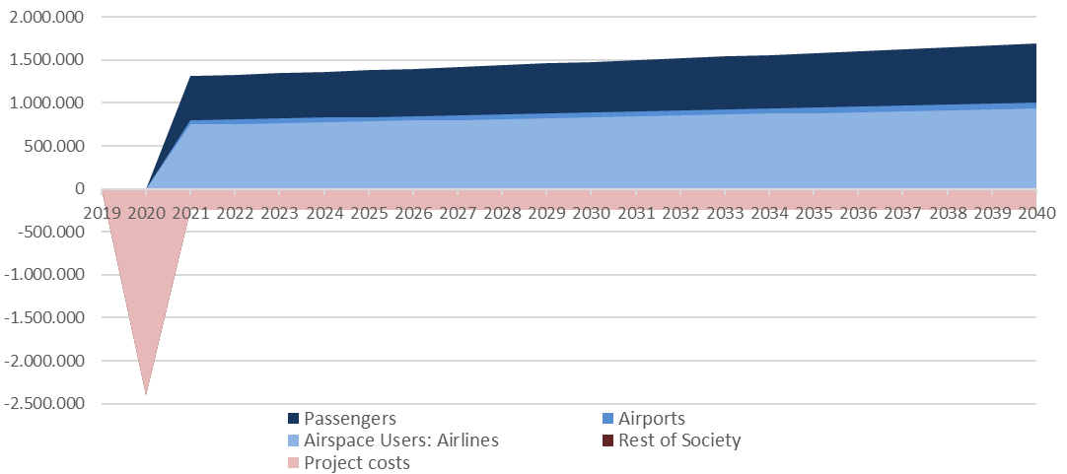
Figure 1: Discounted cost and benefit flows per stakeholder in weighted case for Madrid.

Detailed results for Valencia TMA
As for the medium traffic TMA, the analysis for Valencia TMA has given less profitable results. Insights regarding the different outcomes for stakeholders are similar, being airlines and passengers the main beneficiaries and the ANSP bearing the implementation costs. Social result is also better that the overall financial result due to the time savings of passengers.
TMA under analysis | Valencia | Valencia | Valencia
Case study | 1 h | Weighted case | 4 h
Airlines Benefits | 315.154 | 1.864.258 | 4.962.464
Airport Benefits | 44.393 | 177.573 | 443.934
ANSP NPV | -2.478.591 | -2.459.829 | -2.422.304
Passengers Benefits | 158.542 | 472.646 | 1.100.854
RoS NPV | -2.994 | -11.978 | -29.944
Overall Social Net Present Value | -1.963.496 | 42.670 | 4.055.004
Overall Financial Net Present Value | -2.119.044 | -417.998 | 2.984.094
Internal Rate of Return | N/A | 8% | 33%
B/C Ratio | 0,21 | 1,02 | 2,63
Payback period | N/A | 11 | 4

Again, under the applied set of assumptions, when it comes to the duration of the event the profitability remains in between both cases of one and four hours. Here, the threshold appears to be at 2h 05 min. Also, in the weighted case, the profitability threshold for the probability of occurrence of the event is pretty much the very same 0.5 times per year.
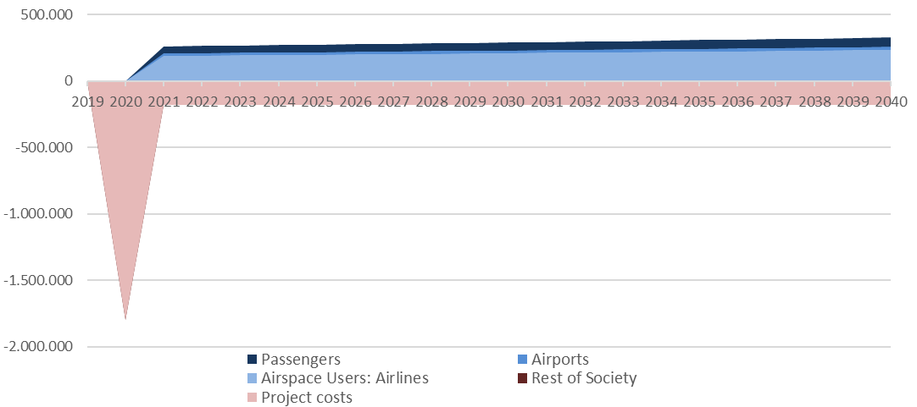
Figure 2: Discounted cost and benefit flows per stakeholder in weighted case for Valencia.
Assuming that the weighted case is an average result for a high and medium activity TMAs, the implementation of the project in the 41 and 92 TMAs with these characteristics present in the ECAC area would imply an aggregated NPV of 390 million €.

The first analysis shows that high activity TMAs such as Madrid tend to be more fitted for the solution proposed, reason why a deployment in the medium activity TMAs of the ECAC area might not be optimal. However, the assumptions adopted in the analysis, especially the probability of even and its duration, make result quite ambiguous. For this reason, these variables are studied in depth in the sensitivity and risk analysis, among others. Sensitivity analysis
This analysis have tested the model focusing on a group of five variables, which are the operations demand, the capacity loss, the duration of the event, the probability of event, and the implementation costs.

Sensitivity analysis
Considering the weighted case previously described, which on average has a NPV of 9,427,763 € for the TMA of Madrid, the sensitized variables produce the following results with 50% up and down variations:
- Alpha (Demand) per airport: the analysis of the influence of the operations’ demand on the results show that when this is a 50% lower, the negative effects of the disruption are very limited. Under the assumptions considered, that only departing flights would be affected, having an overall social NPV negative. However, an disruption at a moment of high demand would have a large impact on the management of the arriving flights, increasing the negative effects and, the NPV of the solution. Therefore, the demand, which depends mostly on the moment during the day when the disruption takes place, has an extreme impact on the profitability of the solution.
- As for the capacity loss provoked by the disruption: when this is reduced the effect is very little, given that the spare capacity is enough to attend the demand. However, it is assumed that departing cancellations and ECAC reactionary delays are independent of the capacity loss and still affect heavily. When the loss is greater, the solution NPV grows.
- Time of breakdown (in hours): average duration of the event has also an extreme impact on the profitability of the solution. Nevertheless, NPV remains positive considering a decrease in times of 50%.
- Probability of event: this variable has the most significant impact of all. A reduced occurrence of the event would make the solution of little use, and therefore not profitable. On the other hand, if occurrence is higher than expected, the solution would become very profitable, given that would prevent large negative effects.
- Implementation, capital costs: variation in the costs of implementation has a certain impact on the profitability of the solution, but small compared to the other sensitized variables. However, as it is explained in section 5.1, this CBA assumes that the total number of DMEs required in the TMA will have to be commissioned; this is a very pessimistic assumption, so the results with a 50% reduction of the costs show a more realistic case.

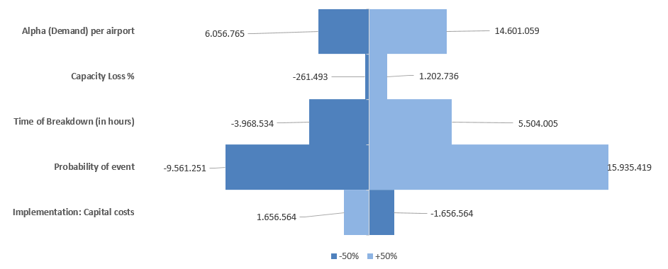
Figure 3: Tornado graphic of the sensitivity analysis of Madrid TMA.
The analysis for the TMA of Valencia, which firstly yielded a social NPV of 42,670 €, results in similar conclusions, but less profitable on average. Under the current set of assumptions and parameters, variations in the capacity loss are not big enough to affect the result, given there is always spare capacity to manage arrivals. Duration of the event and its probability remain as the most important variables. Again, results are extremely variant, making in many cases the result as ambiguous as the variable at issue itself. This can be seen in the implementation costs, that being very similar to the ones in Madrid, their variation has a much bigger impact in the result.
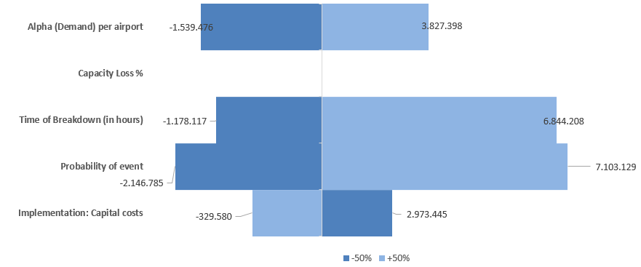
Figure 4: Tornado graphic of the sensitivity analysis of Valencia TMA.
The following graphic presents an extrapolated sensitivity analysis for high and medium activity TMAs in ECAC area, having as NPV the 390 mill. € mentioned before.

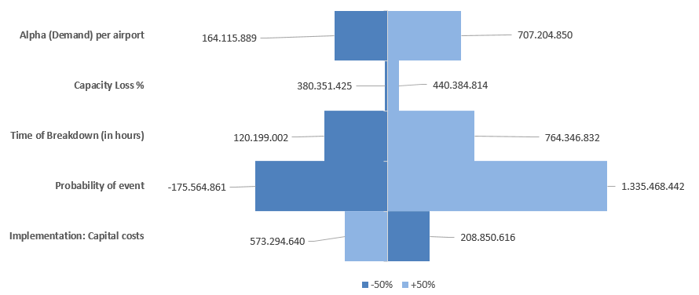
Figure 5: Tornado graphic of the sensitivity analysis of high and medium activity TMAs in Europe

Recommendations and next steps
The assessment carried out in this CBA shows that the deployment of a DME/DME RNP Reversion system in a High Density TMA would be clearly beneficial, whereas for a Medium Density TMA the costs and benefits are almost even. However, as it has already been explained, this CBA assumes that the ANSP will require to commission all the DME transponders needed for each TMA; it is a very pessimistic assumption as in most TMAs there are already a number of DMEs, and in case of reduction of the total capital costs requires, the sensitivity analysis shows that the project would be also beneficial for a medium density TMA.
On the other hand, the benefits calculated are highly dependent on the frequency, and even the duration, of a GNSS outage. Accordingly, it is recommended to develop further studies on the likelihood of these events. It also has to be considered that, although a GNSS MC/MF full outage should not be very common, currently most of the fleet is equipped only with GPS L1, so the likelihood and impact of a GNSS outage can be not so rare.

References and Applicable Documents

Applicable Documents
- SESAR 2020 Project Handbook
- SESAR 16.06.06-D26_04, Guidelines for Producing Benefit and Impact Mechanisms, Edition 03.00.01
- SESAR 16.06.06-D26_03, Methods to Assess Costs and Monetise Benefits for CBAs, Edition 00.02.02

Reference Documents
- Common assumptions for CBAs as maintained by Pj19 (provisionally the ones included in the 16.06.06- D68_Part 1, New CBA Model and Methods 2015, Edition 00.01.01 can be used)
- European ATM Master Plan Portal https://www.atmmasterplan.eu/
- SESAR C.02-D110, Updated D02 after MP Campaign, Edition 00.01.00
- SESAR 2020 D108, Transition Performance Framework, Edition 00.06.00
- SESAR 2020 D86, Guidance on KPIs and Data Collection – Support to SESAR2020 transition
- SESAR 15.3.1 D09 SESAR Navigation Baseline and Roadmap, Edition 00.01.01, July 2016
- SESAR 15.3.2 D2.3 Rationalisation Planning for ECAC-Consolidated deliverable with Contribution of 15.03.07, January 2016
- Spanish Document on Airport Regulations https://www.seguridadaerea.gob.es/media/4628954/dora_mfom.pdf
- Evaluation of the Capacity and Delay of Terminal Air Traffic Control Automation, by S.B. Boswell, Lincoln Laboratory, M.I.T, April 1993, Report for the Federal Aviation Administration.
- HEATCO Project Deliverable 5 2005, European Commission
- Standard Inputs for EUROCONTROL Cost-Benefit Analyses, Edition 8, 2018, EUROCONTROL
- Handbook on External Costs of Transport, Ricardo AEA, January 2019, European Commission
- Air Navigation Fees Guide 2019 (Guía de Tasas de Navegación Aérea 2019), Enaire
- AENA Financial Statements, 2018
- Public Airport Corner, PRISME, EUROCONTROL

Appendix 1
Mapping between ATM Master Plan Performance Ambition KPAs and SESAR 2020 Performance Framework KPAs, Focus Areas and KPIs, source reference [7]
ATM Master Plan SESAR Performance Ambition KPA | ATM Master Plan SESAR Performance Ambition KPI | Performance Framework KPA | Focus Area | #KPI / (#PI) / <Design goal> | KPI definition
Cost efficiency | PA1 - 30-40% reduction in ANS costs per flight | Cost efficiency | ANS Cost efficiency | CEF2 | Flights per ATCO hour on duty
 |  |  |  | CEF3 | Technology Cost per flight
Capacity | PA7 - System able to handle 80-100% more traffic | Capacity | Airspace capacity | CAP1 | TMA throughput, in challenging airspace, per unit time
 |  |  |  | CAP2 | En-route throughput, in challenging airspace, per unit time
Capacity | PA6 - 5-10% additional flights at congested airports | Capacity | Airport capacity | CAP3 | Peak Runway Throughput (Mixed Mode)
Capacity | PA6 - 5-10% additional flights at congested airports | Capacity | Capacity resilience | <RES1> | % Loss of airport capacity avoided
 |  |  |  | <RES2> | % Loss of airspace capacity avoided
Capacity | PA4 - 10-30% reduction in departure delays | Predictability and punctuality | Departure punctuality | PUN1 | % of Flights departing (Actual Off-Block Time) within +/- 3 minutes of Scheduled Off-Block Time after accounting for ATM and weather related delay causes
Operational Efficiency | PA5 - Arrival predictability: 2 minute time window for 70% of flights actually arriving at gate | Predictability and punctuality | Variance of actual and reference business trajectories | PRD1 | Variance of differences between actual and flight plan or Reference Business Trajectory (RBT) durations
Operational Efficiency | PA2 - 3-6% reduction in flight time | Environment | Fuel efficiency | (FEFF3) | Reduction in average flight duration
Operational Efficiency | PA3 - 5-10% reduction in fuel burn | Environment | Fuel efficiency | FEFF1 | Average fuel burn per flight
Environment | PA8 - 5-10% reduction in CO2 emissions | Environment | Fuel efficiency | (FEFF2) | CO2 Emissions
Safety | PA9 - Safety improvement by a factor 3-4 | Safety | Accidents/incidents with ATM contribution | <SAF1>  see section 3.4 | Total number of fatal accidents and incidents
Security | PA10 - No increase in ATM related security incidents resulting in traffic disruptions | Security | Self- Protection of the ATM System / Collaborative Support | (SEC1) | Personnel (safety) risk after mitigation
 |  |  |  | (SEC2) | Capacity risk after mitigation
 |  |  |  | (SEC3) | Economic risk after mitigation
 |  |  |  | (SEC4) | Military mission effectiveness risk after mitigation
Table 8: Mapping between ATM Master Plan Performance Ambition KPAs and SESAR 2020 Performance Framework KPAs, Focus Areas and KPIs

Appendix 2
The aim of this study is to provide the impact in ATFCM delay resulting from a capacity breakdown at two different airports caused by a GNSS outage.

Scope
This study will consider a capacity breakdown at two airports of different sub operational environment:
- High Complexity TMA: Madrid (LEMD)
- Medium Complexity TMA: Valencia (LEVC)

The capacity breakdown is caused by a GNSS outage, that takes place during the day of operations as follows:
- A capacity breakdown during the peak hour of operations
- A capacity breakdown during 4 peak hours of operations
To determine the most representative period at which the measures might be applied, there have been analyzed the movements at both airports for two weeks, from 6th to 19th of May 2019.
The traffic distribution at Madrid Airport, presents its peak hour in the period from 8:00 to 9:00 with a maximum average of 79 movements. The 4 hour peak encompasses the period from 7:00 to 11:00
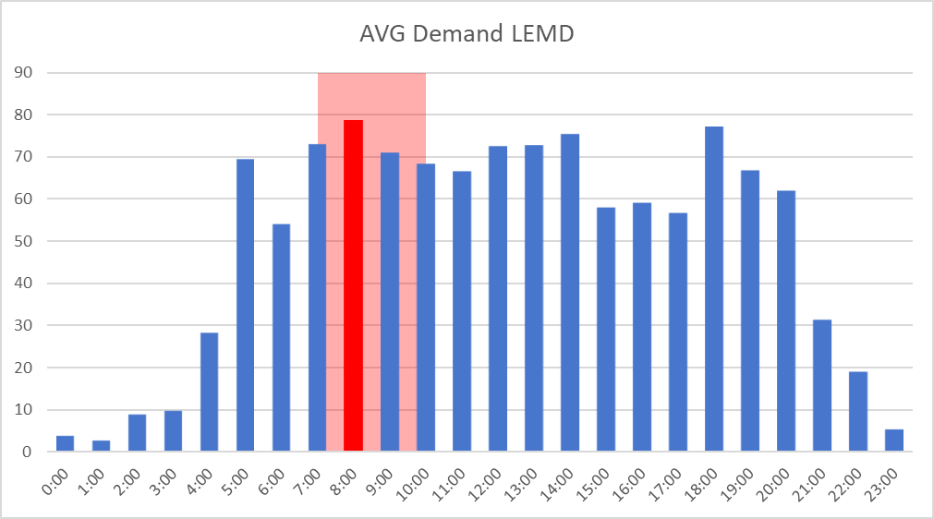
Figure 6: Average demand per day hours, Madrid
For Valencia airport, the peak hour considered encompasses the period from 11:00 to 12:00 with a maximum average of 15 movements. The 4 hour peak considered for the study encompasses the period from 9:00 to 13:00.
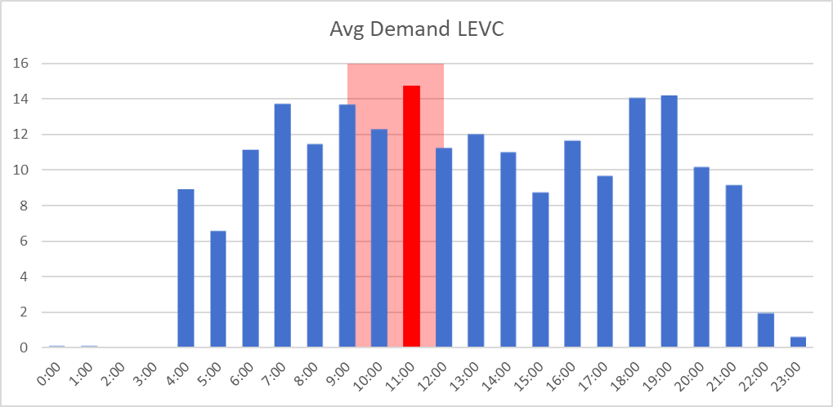
Figure 7: Average demand per day hours, Valencia
The capacity reduction considered has different values for departures and arrivals and has been defined based on the feedback provided by operational experts and considering the complexity of operations at both airports.
1 hour Capacity reduction | Departures |  | Arrivals
 | Reduction | Hourly Rate | Reduction | Hourly Rate
Madrid | 100% | 0 | 0% | 51
Valencia | 100% | 0 | 0% | 20

4 hour Capacity reduction | Departures |  | Arrivals
 | Reduction | Hourly Rate | Reduction | Hourly Rate
Madrid | 100% | 0 | 30% | 36
Valencia | 100% | 0 | 15% | 17

Methodology
The delay analysis has been undertaken with NEST (NEtwork Strategic Tool) from Eurocontrol. The Regu-Builder simulation functionality allowed to create the new regulations associated with the capacity reductions defined and the delay simulation functionality allowed to calculate ATFM delays over an entire day for any scenario, considering the network effect.

Results
To assess the impact caused by the capacity reduction, the delay has been compared at ECAC level between a scenario with no capacity issues against the scenarios with the capacity reductions. The following figure shows the initial ECAC delay for the reference scenario.
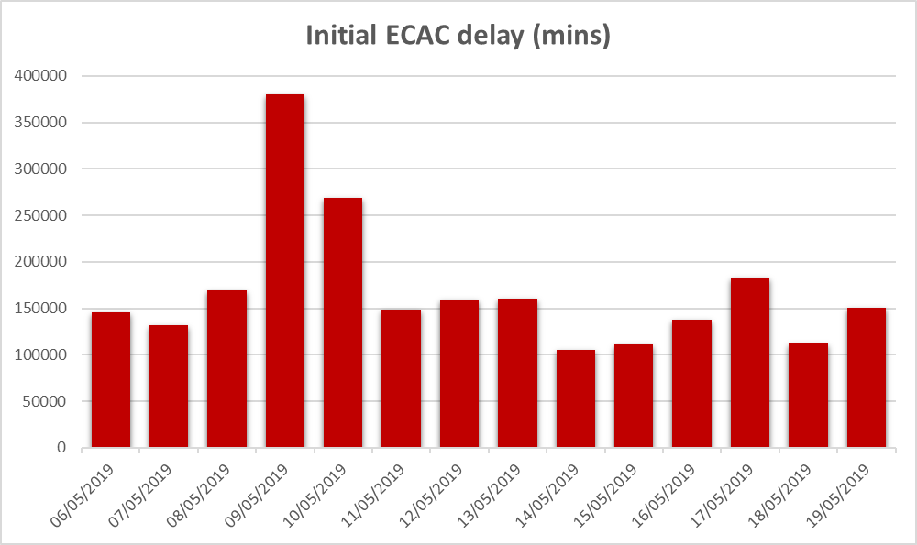
Figure 8: Accumulated delays in ECAC network, May 2019
As the delay values may differ significantly among all days, the study will be focused on the highest delay increase between scenarios. The delay increment calculated will represent the impact, that the regulations produced at the airport under assessment, caused to the total ECAC delay.
The secondary network effects, caused by the accommodation of the regulated demand in collateral airspaces, has not been calculated. For this reason, the ATFCM delay provided represents the less penalizing scenario under the capacity breakdown considered.

Madrid
Reference Scenario:
In the reference scenario Madrid Airport presents several regulations at both, departures and arrivals, with a total delay of 7,104 minutes over the whole period under study and in which the worst day registered was the 10th of May with 1,067 minutes of delay.
1 hour Capacity reduction Scenario:
After applying the capacity reduction (54 to 0 Rate) during the peak hour to departures, the ATFCM delay increases an average of the 2% in the ECAC area.
The most penalized day is the 15th of May, where the delay increases a 4% in the ECAC area with a total delay of 114,728 minutes. The traffic distribution after applying the capacity reduction resulted as follows:
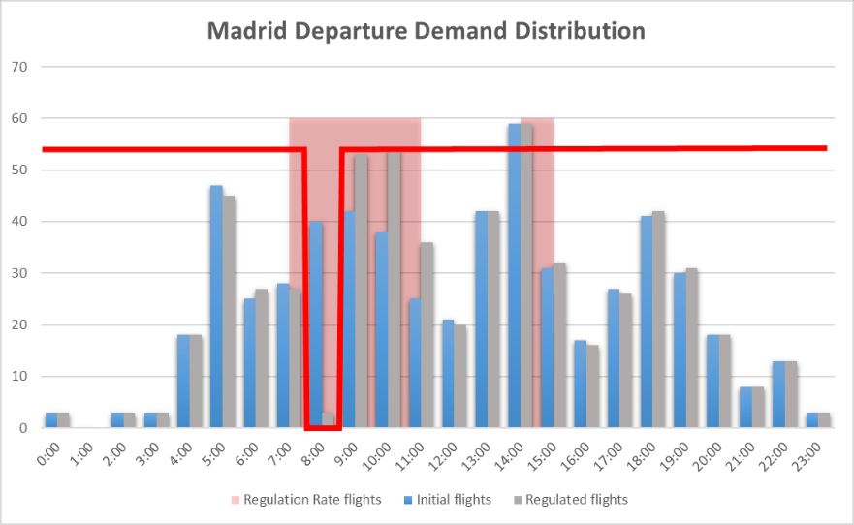
Figure 9: One hour impact in programmed departures, Madrid
The regulation due to capacity reduction in departures was set from 6:50 till 11:50, and caused 4,042 minutes of delay, impacting 176 flights and where de delay per flight was 32 minutes.
4 hour Capacity reduction Scenario:
When applying a capacity reduction to arrival (51 to 36 Rate) and departures (54 to 0 Rate) during 4 hours, the ATFCM delay increases an average of the 32% in the ECAC area.
The most penalized day is the 15th of May, where the delay increases a 43% in the ECAC area, with a total delay of 158,157minutes. The traffic distribution after applying the capacity reduction in departures resulted as follows:
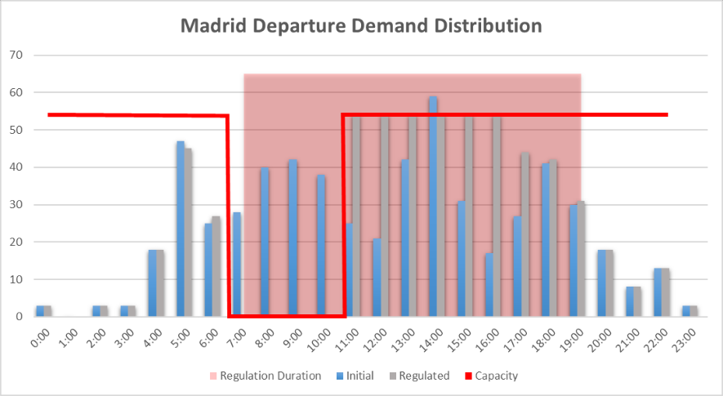
Figure 10: Four hour impact in programmed departures, Madrid
The regulation due to capacity reduction in departures was set from 6:50 till 18:59, and caused 47,217 minutes of delay, impacting 418 flights and where the delay per flight was 133 minutes.
The arrivals were also regulated due to capacity reduction, the traffic distribution resulted as follows:
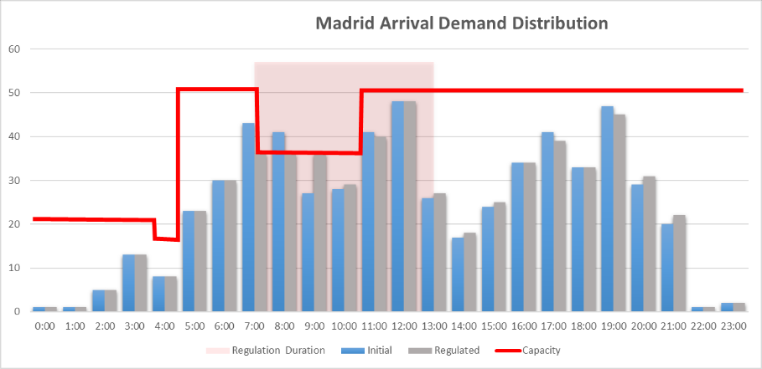
Figure 11: Four hour impact in programmed arrivals, Madrid
The regulation due to capacity reduction in arrivals was set from 7:10 till 13:20, and caused 1,352 minutes of delay, impacting 232 flights and where the delay per flight was 16 minutes.

Valencia
Reference Scenario:
In the reference scenario, Valencia airport has no capacity issues and consequently no regulations.
1 hour Capacity reduction Scenario:
After applying the capacity reduction, from 20 to 0 rate, during the peak hour to departures, the ATFCM delay increases an average of the 0.33% in the ECAC area.
The most penalized day is the 10th of May, where the delay increases a 1.06% in the ECAC area with a total delay of 271,627 minutes. The traffic distribution after applying the capacity reduction resulted as follows:
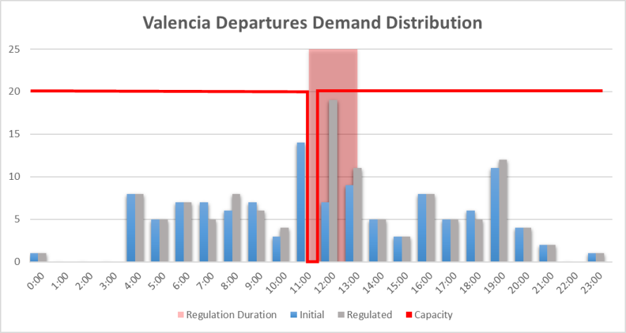
Figure 12: One hour impact in programmed departures, Valencia
The regulation due to capacity reduction was set from 11:00 till 13:10, and caused 921 minutes of delay, impacting 22 flights where the delay per flight was 46 minutes.
4 hour Capacity reduction Scenario:
When applying a capacity reduction to arrival (20 to 17 Rate) and departures (20 to 0 Rate) during 4 hours, the ATFCM delay increases an average of the 3% in the ECAC area.
The most penalized day is the 18th of May, where the delay increases a 4% in the ECAC area, with a total delay of 116,291 minutes. The traffic distribution after applying the capacity reduction in departures resulted as follows:
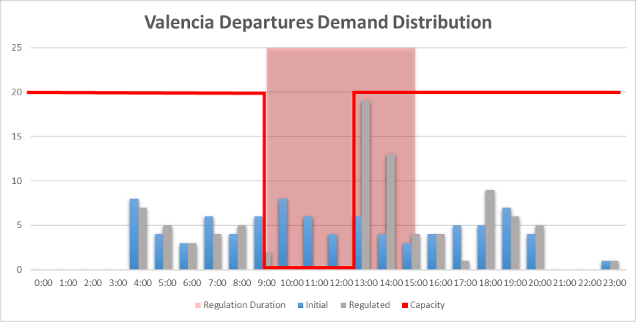
Figure 13: Four hour impact in programmed departures, Valencia
The regulation due to capacity reduction in departures was set from 9:00 till 14:50, and caused 4.362 minutes of delay, impacting 32 flights and where the delay per flight was 140.7 minutes.
There were no regulations in arrivals, despite of the capacity reduction.

Conclusions
The impact of ATFCM delay at ECAC area derived from a capacity breakdown is more significant when it occurs in a high utilization airport.
 | ECAC Delay-Madrid increase |  | ECAC Delay-Valencia increase
 | Delay 1h constraint | Delay 4h constraint | Delay 1h constraint | Delay 4h constraint
06/06/2019 | 3,930 | 48,655 | 388 | 5,009
07/06/2019 | 3,456 | 46,607 | 454 | 4,184
08/06/2019 | 3,983 | 52,886 | 538 | 3,226
09/06/2019 | 2,223 | 35,123 | 480 | 2,623
10/06/2019 | 4,844 | 59,970 | 2,856 | 6,110
11/06/2019 | 2,670 | 46,492 | -213 | 3,269
12/06/2019 | 3,958 | 51,730 | 618 | 4,135
13/06/2019 | 3,659 | 54,255 | 323 | 5,174
14/06/2019 | 3,606 | 39,516 | 203 | 3,433
15/06/2019 | 3,929 | 47,358 | 283 | 4,175
16/06/2019 | 3,021 | 46,020 | 1,153 | 5,341
17/06/2019 | 2,537 | 53,352 | 611 | 4,757
18/06/2019 | 2,423 | 46,236 | -6 | 4,444
19/06/2019 | 2,770 | 46,810 | 760 | 2,744
MEDIAN | 3,531 | 47,084 | 467 | 4,180
MEAN | 3,358 | 48,215 | 603 | 4,187

Appendix 3
This appendix provides an explanation of the capacity/congestion model applied for the calculation of accumulated delays. It is widely assumed in Air Traffic Management that there is a relation between capacity in use (Demand/Capacity) and delays. Since delays are cumulative due to the capacity constraints this relation is thought to be exponential. For this same reason, the duration of the system breakdown is very determinant in the outcome.
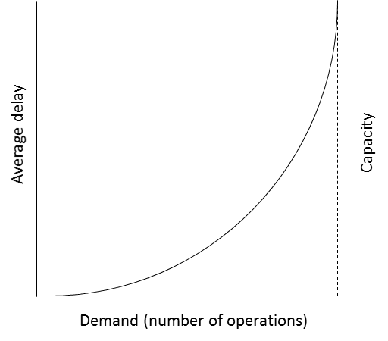
Figure 14: Theoretical relationship between delay and demand/capacity
As GPS failure in ATM services will affect TMA operations and provoke delays on take offs and landings, the final delays derived from a disruption of the service can be estimated as the sum of the accumulated effects. The methodology applied to calculated this accumulated delays is based on the one applied in the paper Evaluation of the Capacity and Delay of Terminal Air Traffic Control Automation, by S.B. Boswell, Lincoln Laboratory, M.I.T. In this paper, Expected Waiting Time is calculated during congestion episodes in airports, considering the following variables:
- The duration of the build-up or congestion phase τ_1 , when demand exceeds capacity due to the GPS breakdown.
- The average service rates μ_1 and μ_2 (similar to the capacity or throughput rate) for both the build-up phase and the backlog assimilation phase, when all delayed flights are processed eventually.
- And finally the demand for service α. (traffic volume).
All this is connected through the following formulas:
$${EW}^{(τ_{1})}=\frac{\left[{\left(ατ_{1}\right)}^{2}+ ατ_{1}\right]}{2}\left[\frac{1}{μ_{1}}-\frac{1}{α}\right]$$
$${EW}^{(τ_{2})}=\frac{\left[{\left(ατ_{2}\right)}^{2}+ ατ_{2}\right]}{2}\left[ \frac{1}{α}-\frac{1}{μ_{2}}\right]$$
Where,

- ${EW}^{(τ_{1})}$ stands for the expected delay of the last plane affected before restoring the service.
- ${EW}^{(τ_{2})}$ stands for the expected delay of the first plane affected by the disruption once the service has been restored (at the beginning of the assimilation phase).
Once ${EW}^{(τ_{1})}$ is calculated, we can also calculate $τ_{2}$ (considering $α$ remains constant) and therefore ${EW}^{(τ_{2})}$. because ${EW}^{(τ_{1})}={EW}^{(τ_{2})}$. This means that last aircraft affected before putting the GPS back on line will have to wait the same as the next aircraft, the first one arriving after restoring the full capacity, or at least a very similar time that for practical matters we will consider equal.
Once we know $τ_{2}$ we are able to compute the delay times of all affected aircraft. Let us consider that there is a number X of affected airplanes in the build up phase, being xi each of them. We likewise consider there is a similar number Y of airplanes yi affected in the assimilation phase. Through a similar formulation we can compute the delay time of each aircraft:
$${EW}_{x_{i}}=\frac{\left[{\left(x_{i}\right)}^{2}+ x_{i}\right]}{2}\left[\frac{1}{μ_{1}}-\frac{1}{α}\right]$$
$${EW}_{y_{i}}=\frac{\left[{\left(y_{i}\right)}^{2}+ y_{i}\right]}{2}\left[ \frac{1}{α}-\frac{1}{μ_{2}}\right]$$
Therefore, the total delay of all affected aircrafts would be $\sum_{X+Y}{EW}=\sum_{X=x_{i}}{{EW}_{x_{i }}}+ \sum_{Y=y_{i}}{{EW}_{y_{i}}}$. The CBA model employs this methodology to calculate separately delays in the arrivals and in the departures side of the TMA. The formulation in it has been slightly altered in order to take into account the relieve effect in the congestion that aborted incoming flights (diverted and cancelled) imply.

-END OF DOCUMENT-

This includes System, Procedural, Human, Standardisation and Regulation Enablers
Note that the terminology used to describe AU stakeholders in the CBA differs from that associated with Enablers in the dataset. This is due to costing being provided for different types of aircraft regardless of the operations they perform.
For information, the mapping to the Performance Ambition KPAs (used in the ATM Master Plan) is available in the Appendix.
As defined in EATMA https://www.eatmportal.eu/working/performance_needs
Bear in mind that these are simulated delay values over the initial traffic, the real delay registered during the period under study was 5,992 minutes

