 | SESAR PJ.14-03-04 Short Term APNT Solution TS-IRS
 | Deliverable ID: | D10.3.01
 | Dissemination Level: | PU
 | Project Acronym: | EECNS
 | Grant: | 734168
 | Call: | H2020-SESAR-2015-2
 | Topic: | SESAR.IR-VLD-Wave1-17-2015
 | Consortium Coordinator: | LEONARDO
 | Edition Date: | 10/2019
 | Edition: | 00.02.00
 | Template Edition: | 02.00.02

INDUSTRIAL RESEARCH



Authoring & Approval
Authors of the document
Name/Beneficiary | Position/Title | Date
Valeriu Vitan / EUROCONTROL | NAV Infrastructure Expert | 16/10/2019

Reviewers internal to the project
Name/Beneficiary | Position/Title | Date
Luca Saini / THALES ATM | Safety Assurance Manager | 01/08/2019
Victor Gordo / INECO | CNS Expert | 28/08/2019
Jean-Pierre Arethens /  THALES AVIONICS | Architecte Senior Système Avionique | 22/02/2019

Approved for submission to the SJU By - Representatives of beneficiaries involved in the project
Name/Beneficiary | Position/Title | Date
Boubeker Belabbas / DLR | Solution Leader | 18/10/2019
Gerhard Berz / Eurocontrol | Navigation Systems Expert | 18/10/2019
Luca Saini / THALES ATM | Safety Assurance Manager | 18/10/2019
Victor Gordo / INECO | CNS Expert | 18/10/2019

Rejected By - Representatives of beneficiaries involved in the project
Name/Beneficiary | Position/Title | Date

Document History
Edition | Date | Status | Author | Justification
00.00.01 | 15/06/2019 | Draft | Valeriu Vitan | Initial draft
00.00.02 | 11/07/2019 | Draft | Valeriu Vitan | Updated draft
00.00.03 | 30/07/2019 | Draft | Valeriu Vitan | Draft for internal review
00.00.04 | 28/08/2019 | Draft | Valeriu Vitan | Internal comments
00.01.00 | 29/08/2019 | Final Draft | Valeriu Vitan | SJU submission
00.02.00 | 16/10/2019 | Final | Valeriu Vitan | Update following SJU review

Copyright Statement
© – 2019 – EUROCONTROL, ENAIRE, THALES Air Systems, THALES Avionics, DLR, Honeywell. All rights reserved. Licensed to the SJU under conditions.
EECNS
PJ14 EECNS - Essential and Efficient Communication Navigation and Surveillance Integrated System

This TS-IRS is part of a project that has received funding from the SESAR Joint Undertaking under grant agreement No 734168 under European Union’s Horizon 2020 research and innovation programme.


Abstract
This TS-IRS covers mainly performance requirements applicable to the ground DME infrastructure, in particular to the DME Transponders, in order to provide an alternative navigation service in case GNSS becomes unusable, and permit RNP 1 departure and arrival operations. The scope is limited to this particular 14-03-04 sub-solution, referred to as the Short-Term A-PNT solution. The document does not cover the other two other sub-solutions (Mid-Term and Long-Tem A-PNT).
The document is one of the key deliverables of the V3(TRL 6) data-pack for the “DME Enhanced” system.

Table of Contents

Abstract 4
1 Executive summary 8
2 Introduction 9
2.1 Purpose of the document 9
2.2 Scope 9
2.3 Intended readership 10
2.4 Background 10
2.5 Structure of the document 11
2.6 Glossary of terms 11
2.7 Acronyms and Terminology 13
3 SESAR Solution Impacts on Architecture 16
3.1 Target Solution Architecture 16
3.1.1 SESAR Solution(s) Overview 16
3.1.1.1 Deviations with respect to the SESAR Solution(s) definition 18
3.1.1.2 Relevant Use Cases 18
3.1.1.2.1 Regulatory context 18
3.1.1.2.2 Operational Context 19
3.1.1.2.3 Technical implementation 19
Technical Systems and Functional Blocks description 19
3.1.1.3 Applicable standards and regulations 21
3.1.2 Capability Configurations required for the SESAR Solution 22
3.2 Changes imposed by the SESAR Solution on the baseline Architecture 24
4 Technical Specifications 26
4.1 Functional architecture overview 26
4.1.1 Resource Connectivity Model 26
4.1.2 Resource Orchestration view 30
4.1.2.1 [NSV-4] GNSS Reversion 30
4.1.3 Infrastructure connectivity model 32
4.1.4 Service view 33
4.1.4.1 Service description 33
4.1.4.2 Service Provisioning 34
4.1.4.3 Service Realization 35
4.1.4.3.1 Interaction Navigation Infrastructure status.APP ACC_CC and Navigation Infrastructure Ground Based_CC 35
4.1.4.3.2 Interaction Navigation Infrastructure status.ER ACC_CC and Navigation Infrastructure Ground Based_CC 35
4.1.4.3.3 Interaction Range.Civil Aircraft (Step 2)_CC and Navigation Infrastructure Ground Based_CC 36
4.2 Functional and non-Functional Requirements 36
4.2.1 Functional and non-Functional for Enhanced DME Transponder Requirements 37
5 References and Applicable Documents 40
5.1 Applicable Documents 40
5.2 Reference Documents 40
Appendix A Safety Considerations 42
Safety Desk Study on A-RNP reversion in case of GPS loss (NAV-SAFREP-2013-0101-IR) 42
15.3.1 D12 – Report on RTS (Real Time Simulations) on RNP reversion 43
15.3.2 D12 - Analysis of DME Enhancement Needs in Support of Near-term A-PNT 43
Conclusions 45
Appendix B Requirements Derivation 46
Appendix C Functional and non-Functional Requirements for Short-Term A-PNT 53

List of Tables
Table 1: Glossary 13
Table 2: Acronyms and terminology 15
Table 3: SESAR Solution 14-03-04 ST A-PNT Scope and related Functional Blocks/roles & Enablers 18
Table 4: List of Capability Configuration required for the SESAR Solution 24
Table 5: List of changes due to the SESAR Solution 25
Table 6: List of use case functions 26
Table 7: Description of use case functions 32
Table 8: Service Provisioning Interactions 35

List of Figures
Figure 1 Overview of the European ATM Technical System Architecture 16
Figure 2 Overview of Technical Systems in the ATM System Architecture 17
Figure 3 Typical FMS interfaces 20
Figure 4 Aircraft Technical System – Functional Breakdown 27
Figure 5 Civil Aircraft Centric Diagram 28
Figure 6 Navigation Infrastructure Breakdown 28
Figure 7 Ground Based Navigation Infrastructure Breakdown 29
Figure 8 DME Interactions 29
Figure 9 [NSV-4] GNSS Reversion 30
Figure 10 DME ports 32
Figure 11 DME connectivity model 33

Executive summary
This TS-IRS covers mainly performance requirements applicable to the ground DME infrastructure, in particular to the DME Transponders, in order to provide an alternative navigation service in case GNSS becomes unusable, and permit RNP 1 departure and arrival operations. The scope is limited to this particular 14-03-04 sub-solution, referred to as the Short-Term A-PNT solution. The document does not cover the other two sub-solutions (Mid-Term and Long-Tem A-PNT).
In accordance with the description of the Short-Term A-PNT solution, several changes have been implemented in EATMA:
- A new System Enabler was introduced: CTE-N08c Enhanced DME
- Update of the DME infrastructure connectivity model
- Description of the GNSS reversion use case based on this A-PNT sub-solution
Previous work performed in SESAR 1 concluded that the actual performance of the latest generations of DME transponders is substantially better than the standards requirements and that DME/DME is the best candidate to provide a GNSS backup in the near future. The document aims to contribute to the harmonization of the applicable standards with the achieved performance of modern DMEs which are already in operation at present. Therefore it is not in the scope of this document to support the development of even more performant DMEs, instead the goal is that the already achieved performance is formally recognized in the SESAR architecture, through the introduction of the DME Enhanced system, with a TRL6 maturity level. The objective of the document is not to reproduce a complete technical specification for the DME transponder. Instead only the specific features which support the Short-Term A-PNT are identified (e.g. accuracy, integrity, continuity).
Considering that these high performance DMEs (called “DME Enhanced” in SESAR context) have been deployed and in operation for many years, it was considered unnecessary to define and run validation exercises (this is reflected in the agreed content of the sub-solution data pack). In this context the work was focused on the update and definition of relevant standards in the framework of EUROCAE WG 107. The objective of this work group is twofold:
- Update of ED-57 Minimum Operational Performance Specification for Distance Measuring Equipment - Ground Equipment (to take credit for the actual performance of the latest generations of transponders)
- Write Minimum Aviation System Performance Standards for the RNP reversion based on DME/DME
Part of the contribution of PJ14-03-04 to WG107 is summarised in this TS-IRS.
It should be noted that the activity of WG107 will continue after the closure of SESAR 2020 wave 1, and the completion of the above documents is foreseen for end 2020.
is one of the key deliverables of the V3 (TRL6) data-pack for the “DME Enhanced” system.

Introduction

The document captures all relevant contributions to the impacted EATMA views (clearly identifying what the changes are from the baseline architecture) applicable to this particular SESAR Solution.

Purpose of the document
This document provides the requirements specification related to SESAR Solution 14-03-04 Short-Term A-PNT and is one of the key deliverables of the V3 data-pack for the “DME Enhanced” system.

Scope
This TS/IRS covers mainly performance requirements applicable to the ground DME infrastructure, in particular to the DME Transponders, in order to provide an alternative navigation service in case GNSS becomes unusable, and permit RNP 1 departure and arrival operations. The scope is limited to this particular 14-03-04 sub-solution, referred to as the Short-Term A-PNT solution. The document does not cover the other two other sub-solutions (Mid-Term and Long-Tem A-PNT).
Previous work performed in SESAR 1 concluded that the actual performance of the latest generations of DME transponders is substantially better than the standards requirements and that DME/DME is the best candidate to provide a GNSS backup in the near future. The document aims to contribute to the harmonization of the applicable standards with the achieved performance of modern DMEs which are already in operation at present. Therefore it is not in the scope of this document to support the development of even more performant DMEs, instead the goal is that the already achieved performance is formally recognized in the SESAR architecture, through the introduction of the DME Enhanced system, with a TRL6 maturity level.
The objective of the document is not to reproduce a complete technical specification for the DME transponder. Instead only the specific features which are key for supporting the RNP 1 reversion are identified (e.g. accuracy, integrity, continuity).
Considering that these performant DMEs (called “DME Enhanced” in SESAR context) have been deployed and in operation for many years, it was considered unnecessary to define and run validation exercises (this is reflected in the agreed content of the sub-solution data pack).
Last but not least the document reflects the contribution of SESAR 14-03-04 to EUROCAE WG107. The objective of this work group is twofold:
- Update of ED-57 Minimum Operational Performance Specification for Distance Measuring Equipment (Ground Equipment)
- Write Minimum Aeronautical System Performance Standards for the RNP reversion based on DME/DME
PJ14-03-04 Short-Term A-PNT Solution provided a major contribution to the activity of WG107, part of this contribution is reflected in this TS-IRS.
It should be noted that the activity of WG107 will continue after the closure of SESAR 2020 wave 1, and the completion of the above documents is foreseen for end 2020. Therefore this document does not include all details regarding the concept of RNP reversion based on DME/DME.

Intended readership
This document is intended mainly as a reference document for the definition of the Short-Term A-PNT solution in context of PJ14-03-04.
The document is also of interest for the other navigation solutions included in PJ14, notably for PJ.14-01-01 for the definition of the future integrated CNS solutions.
One other category of projects for which this TS-IRS may be relevant is formed by the projects addressing the development and validation of navigation operations:
- PJ01 “Enhanced Arrivals and Departures”
- Pj06 “Trajectory based Free Routing”
- PJ18 “4D Trajectory Management”
Moreover, since the document has implications in the definition of the future navigation applications and the supporting infrastructure, it is of general interest for all aviation stakeholders, e.g.:
- Airspace users (civil and military including RPAS operators)
- Air Navigation Services Providers
- Regulatory Authorities

Background
In the framework of SESAR 1, the project 15.3.1 has analysed the foreseen evolution of the navigation applications and the supporting navigation infrastructure. The project has identified a potential issue related with the reversionary operations for RNP applications in case of GNSS outages, due to the fact that the RNP navigation specifications require the use of GNSS. For landing operations the ILS provides a level of performance equal or better than GNSS, therefore the reversion issue applies mainly to the en-route and terminal operations where the ground infrastructure supports lower performance levels, in terms of accuracy and integrity of the positioning service. Therefore project 15.3.1 has performed a safety study and real time simulations aimed at identifying the conditions in which the DME/DME(IRS) navigation can be used as GNSS backup in En-route and terminal phases of flight.
Also in the framework of SESAR 1, the project 15.3.2 carried out a study to investigate the possibility to perform RNP operations in case of GNSS unavailability (caused for example by a system loss or GPS outage). RNP operations targeted were mainly RNP 1 and, depending on demonstrated performances, RNP 0.5 or RNP 0.3, in terminal areas. The applicability of the reversion to DME/DME/IRS on aircraft in their current state (i.e. with existing certified avionic systems, without envisaging systems evolutions) was the main objective of this study performed by Airbus and its partners Thales and Honeywell.
The study has first identified the ground and on‐board failure modes and error types that can impact the accuracy and/or integrity of the DME/DME/IRS solution. The impact of all these potential failure modes has been assessed by laboratory tests. Based on AC20‐138C requirements for RNP 1 (which is not dedicated to DME infrastructure) test objective was to assess avionics system behaviour in case of detected or undetected erroneous data in the DME positioning chain, and in the presence of existing FMS protection mechanisms. The study concluded that:
- Requirements for RNP Terminal (RNP 1) can be satisfied as long as DME ground stations used in the RNP operation guarantee an integrity rate of not less than 10^{‐5} per hour.
- This capability could be implemented by ensuring that DME ground stations used during the procedure have a guaranteed integrity rate. The feasibility of and need for this would need to be investigated further.
Although ICAO Annex 10 and EUROCAE ED-57 requires that that executive monitors are provided to shut down the transponder in case that the reply delay is outside tolerance, no integrity level is specified in terms of maximum probability to transmit this misleading information. However, also in SESAR I project 15.3.2, Thales ATM, as a major manufacturer of DME transponders, has assessed their products integrity performance and showed that all current Thales transponders meet a certain integrity level requirement. Therefore, the improvement of transponder integrity as a requirement may not be necessary. Rather, it would be necessary to formalize the actual DME performance (including integrity level baseline) in a standard, define a concept for using the DME/DME/IRS solution to provide GNSS backup for RNP 1 operations and ensure that transponders fielded in RNP1 operational environment meet the required performance.
The work on Short-Term A-PNT performed in PJ14-03-04 is a continuation of the work performed in SESAR 1. It builds on the initial findings and conclusions included in SESAR 1 deliverables (in particular [11], [12] and [13]) and refines them where necessary.

Structure of the document
The content of the document is organised in accordance with the SESAR TS-IRS Template version 02.00.02. The main sections are:
- Section 3: SESAR Solution Impacts on Architecture.
This section gives an overview of the Short-Term A-PNT Solution, a brief description of the technical systems involved and identifies the updates introduced in EATMA
- Section 4: Technical Specifications
Gives a functional architecture overview and lists the requirements applicable to this solution
- Section 5: References and Applicable Documents
- Appendix A – Safety considerations
Makes reference to the safety aspects related to the solution implementation
- Appendix B – Requirements Derivation
Provides details on the derivation and rationale for the requirements defined in Section 4.

Glossary of terms
Term | Definition | Source of the definition
Activity | A logical process, specified independently of how the process is carried out | ADD SESAR 1 (EATMA Guidance)
Area navigation | A method of navigation which permits aircraft operation on any desired flight path within the coverage of ground- or space-based navigation aids or within the limits of the capability of self-contained aids, or a combination of these. | ICAO PBN Manual
Capability Configuration | Combination of Roles and Technical Systems configured to provide a Capability derived from operational and /or business need(s) of a Stakeholder type | ADD SESAR 1 (EATMA Guidance)
Function | An activity which is specified in context of the resource (human or machine) that performs it | ADD SESAR 1 (EATMA Guidance)
Functional Block | A logical and cohesive grouping of automated functions in a Technical System | ADD SESAR 1 (EATMA Guidance)
Navigation Aid (NAVAID) infrastructure. | NAVAID infrastructure refers to space-based and or ground-based NAVAIDs available to meet the requirements in the navigation specification. | ICAO PBN Manual
Navigation specification | A set of aircraft and aircrew requirements needed to support Performance-based Navigation operations within a defined airspace. | ICAO PBN Manual
Performance-based navigation | Area navigation based on performance requirements for aircraft operating along an ATS route, on an instrument approach procedure or in a designated airspace. | ICAO PBN Manual
RNAV specification | A navigation specification based on area navigation that does not include the requirement for on-board performance monitoring and alerting, designated by the prefix RNAV, e.g. RNAV 5, RNAV 1. | ICAO PBN Manual
RNAV system | A navigation system which permits aircraft operation on any desired flight path within the coverage of station-referenced navigation aids or within the limits of the capability of self-contained aids, or a combination of these. | ICAO PBN Manual
RNP specification. | A navigation specification based on area navigation that includes the requirement for on-board performance monitoring and alerting, designated by the prefix RNP, e.g. RNP 4, RNP APCH. | ICAO PBN Manual
RNP system | An area navigation system which supports on-board performance monitoring and alerting. | ICAO PBN Manual
Role | An aspect of a person or organisation that enables them to fulfil a particular function | ADD SESAR 1 (EATMA Guidance)
Technical System | A collection of Functional Blocks or Functions. | ADD SESAR 1 (EATMA Guidance)
Table 1: Glossary

Acronyms and Terminology
Term | Definition
ACC | Area Control Centre
ADD | Architecture Description Document
A-PNT | Alternative Positioning Navigation and Timing
APP | APProach
ATC | Air Traffic Control
ATM | Air Traffic Management
ATS | Air Traffic Services
CC | Capability Configuration
CDU | Control and Display Unit
CNS | Communication Navigation Surveillance
CTA | Control Area
DME | Distance Measuring Equipment
EATMA | European ATM Architecture
E-ATMS | European Air Traffic Management System
ER | En-Route
FAA | Federal Aviation Administration
FMS | Flight Management System
GNSS | Global Navigation Satellite System
IER | Information Exchange Requirement
INS | Inertial Navigation System
INTEROP | Interoperability Requirements
IRE | Instrument Runway End
IRS | Inertial Reference System
IRS | Interface Requirements Specification
ISRM | Information Services Reference Model
MASPS | Minimum Aviation Systems Performance Standards
MOPS | Minimum Operational Performance Specification
NAF | NATO Architecture Framework
NOV | NAF Operational View
NSOV | NAF Service Oriented View
NSV | NAF System View
OBPMA | On Board Performance Monitoring System
OSED | Operational Service and Environment Definition
PBN | Performance Based Navigation
PIRM | Programme Information Reference Model
QoS | Quality of Service
RF | Radius to Fix
RNAV | Area Navigation
RNP | Required Navigation Performance
SDD | Service Description Document
SESAR | Single European Sky ATM Research Programme
SID | Standard Instrument Departure
SJU | SESAR Joint Undertaking (Agency of the European Commission)
SoaML | Service Oriented Architecture Modelling Language
SPR | Safety and Performance Requirements
ST A-PNT | Short-Term A-PNT
STAR | Standard Instrument Arrival
SWIM | System Wide Information Model
TRL | Technology Readiness Level
TS | Technical Specification
UML | Unified Modelling Language
V&V | Validation and Verification
VOR | VHF Omnidirectional Radio Range
WSDL | Web Services Definition Language
XSD | XML Schema Definition
Table 2: Acronyms and terminology

SESAR Solution Impacts on Architecture

Target Solution Architecture

SESAR Solution(s) Overview
The European ATM System Architecture Overview provides a set of reference Capability Configurations required to support the full set of ATM capabilities and activities defined in the SESAR Concept of Operation. The various Capability Configurations (CC) and the interactions between them are represented in a simplified diagram in Figure 1.

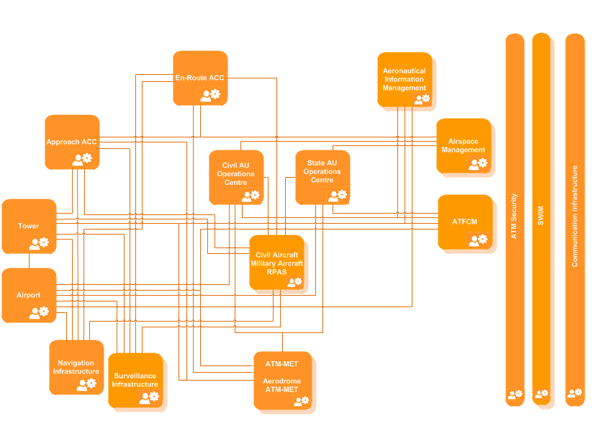
Figure 1 Overview of the European ATM Technical System Architecture
A Capability Configuration is defined as a “Combination of Roles and Technical Systems configured to provide a Capability derived from operational and /or business need(s) of a Stakeholder type”. The main Capability Configurations involved in the provision and use of the Short-Term Alternative Position, Navigation and Timing (A-PNT) SESAR service are:
- Navigation Infrastructure
- Aircraft (Civil)
The brief description of these capability configurations is provided below:
Navigation Infrastructure
The primary role of Navigation Infrastructure is to support Navigation Applications, used by all airspace users, including Military.
Navigation Infrastructure Satellite Based
Implemented in space by Satellite Navigation Service Providers to provide navigation facilities to the Aircraft. Satellite Navigation Service Providers mainly represents the space part of the satellite-based navigation systems (GNSS, EGNOS, etc.).
Navigation Infrastructure Ground Based
Implemented on the ground by Navigation Service Providers to provide navigation facilities to the Aircraft.
Civil Aircraft
Reflects the generic implementation of the Aircraft Technical System by a Civil Airspace User (except RPAS operating AUs) to perform its operations in the Air or on the APRON / Runway / Taxiway.
The notion of ‘Technical System’ is an architecture concept used to describe all possible features of the system in terms of composition (Functional Blocks) and interfaces (services or point-to-point), irrespective of the specific implementation (Capability Configuration). The Diagram in Figure 2 shows all the Technical Systems identified in the ATM System Architecture.

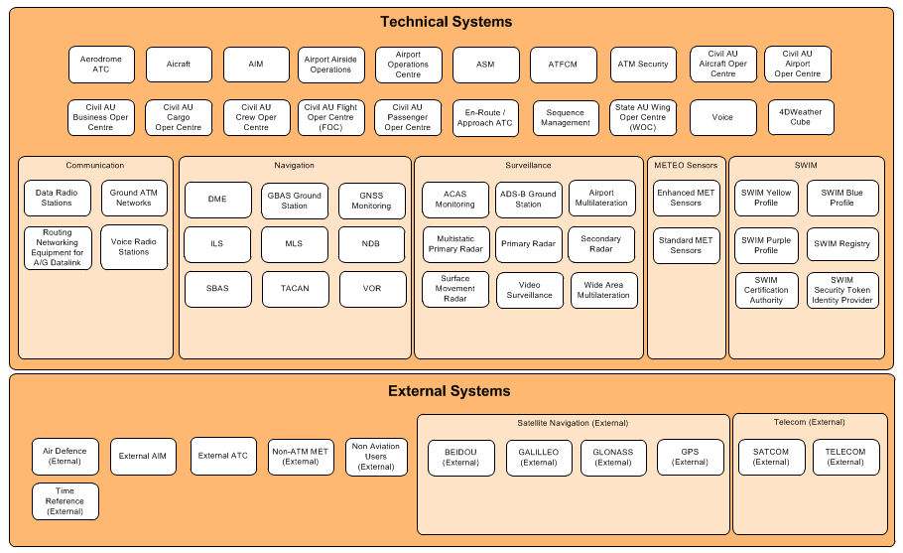
Figure 2 Overview of Technical Systems in the ATM System Architecture
The Short-Term Alternative Position, Navigation and Timing (ST A-PNT) SESAR Solution will have an impact on only one of the Capability Configurations: Navigation Infrastructure (Ground Based), and more specifically on the DME Technical System. This solution does not foresee any changes at aircraft level. As such only one technical enabler is associated with this solution, as indicated in the following table.

SESAR Solution ID and Title | Functional Blocks/Role impacted by the SESAR Solution (from EATMA) | Enabler ID (from EATMA) | Enabler Title (from EATMA) | Enabler coverage
14-03-04 Short-Term A-PNT | DME (ground system) | CTE-N08c  (CR 02759) | Enhanced DME Transponder | Fully
Table 3: SESAR Solution 14-03-04 ST A-PNT Scope and related Functional Blocks/roles & Enablers

Deviations with respect to the SESAR Solution(s) definition
This TS-IRS does not introduce any deviation with regard to the SESAR Solution definition in the applicable version of EATMA.

Relevant Use Cases
The main use case for the ST A-PNT solution is described as follows:
Operational Use Case | Description
GNSS Reversion | Support RNP 1 reversion based on DME/DME navigation in case GPS becomes unusable.  The operational objective is to enable the Operational Improvement Step AOM-0603: Enhanced Terminal Airspace for RNP-based Operations

A narrative description of the use case and of the involved technical systems and functional blocks is provided in the following sub-sections.
The use case is modelled in EATMA with the code: [NSV-4] GNSS Reversion. The modelling diagram and the description of the roles and functions defined by this use case are available in section 4.1.

Regulatory context
EU Regulatory provisions require that ANSPs publish RNAV and RNP procedures in Member States of the European Union and in those States where European ANSP/ATSP provide a service. (See Commission Implementing Regulation (EU) 716/2014, known as the PCP IR [14], and Commission Implementing Regulation (EU) 2018/1048, known as the PBN IR [15]). The relevant requirements for the scope of the current solution are the following:
- Implement RNP1 + RF SID and STAR at all PCP airports by 25 Jan 2024 (PCP IR AF#1)
- Implement RNAV 1 or RNP 1 (+RF) for existing and new SID and STAR – one procedure per IRE by 25 Jan 2024 and all procedures by 06 Jun 2030

Operational Context
RNP enables more advanced PBN airspace concepts compared to RNAV. According to the ICAO PBN manual, aircraft who qualify for RNP operations must be equipped with GNSS (because GNSS is the only sensor which enables all RNP specifications). The use of DME/DME to support RNP is not excluded in the PBN Manual but only in addition to GNSS.
A large majority of air transport category aircraft are equipped with DME/DME avionics, therefore, in the case of a GNSS outage, many aircraft in a given airspace will revert to DME/DME operations, often supported by INS. In airspaces that take advantage of the greater capabilities of RNP, such a situation is called RNP reversion.
While practically all DME/DME equipped aircraft are certified for RNAV 1 operations, only some of these aircraft are certified to provide RNP 1 operations based on DME/DME only. The operational objective of RNP reversion is to enable safe operations during GNSS outages for all aircraft equipped with DME/DME capabilities. While some operational mitigations may be necessary, the aim is to enable such operations for as long as possible, rather than only during the time it takes to clear the airspace. This is expected to bring significant “airspace robustness benefits” in regions where a high level of both aircraft and ground DME equipage exists, as is the case in most parts of the European region.

Technical implementation
The target navigation specification for RNP reversion is RNP1. While currently DME/DME positioning performance meet RNP 1 accuracy requirements (i.e. 1 NM, same as for RNAV 1) some other aspects of the RNP 1 specification may not be met by the current avionics, e.g. the On Board Performance Monitoring and Alerting function. When using GNSS, OBPMA is in general a by-product of the RAIM feature (Receiver Autonomous Integrity Monitoring) which estimates and monitors the integrity of the GNSS solution and issues an alert when the estimated accuracy or integrity levels are less than required.
For DME/DME positioning, a set of “Reasonableness Checks” is implemented in order to avoid erroneous solutions (as required by FAA AC 20-138) but in general a full OBMA compatibility is not demonstrated and certified. Therefore the ST A-PNT solution imposes more stringent requirements on the navigation infrastructure, more exactly on the DME transponders used to enable the RNP reversion, in order to cater for the absence of a certified OBPMA function.
It is important to note also that due to the technological evolution, practically all the DME Transponder models produced at present have better performance than the applicable standards and comply with the requirements of ST A-PNT solution (defined in section 4). Therefore, this solution was focused on:
- Updating the EUROCAE DME Transponder MOPS (ED-57 [22]) to reflect the actual performance of the modern systems
- Defining a RNP reversion concept, which will be formalized in an EUROCAE MASPS document
The requirements captured in section 4 are the essential requirements applicable to the DME Transponder defined in the above EUROCAE documents.

Technical Systems and Functional Blocks description
Flight Management System - FMS
The Flight Management System (FMS) provides sophisticated multisensor navigation, optimized four-dimensional flight planning/guidance systems.
The general purpose of the FMS is to aid the flight crew in managing automatic navigation, in-flight performance optimization, fuel monitoring, and flight deck displays. Automatic flight functions include the position calculation and management of the aircraft navigation both for the lateral flight path (LNAV) and vertical flight path (VNAV). The FMS provides the primary navigation, flight planning, and optimized route determination and En-route guidance for the aircraft through the aircraft functional blocks defined in EATMA architecture: position determination, flight plan management, prediction, lateral/longitudinal and vertical navigation. The flight crew enters the desired route and flight data into the CDUs. The FMS uses its navigation database, aircraft position and supporting system data to calculate commands for manual or automatic flight path control.
The multisensor capability of the FMS enables this system to automatically select the positioning solution from the available sensors in a predefined order. The nominal selection priority is:
- GNSS
- DME/DME
- VOR/DME
When INS is also available, usually it is integrated with the position updating obtained from the active sensor. The navigation accuracy is constantly estimated and indicated to the pilot.
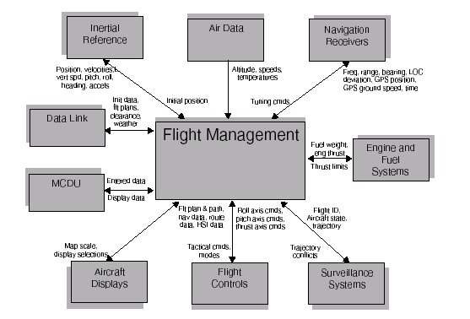
The FMS can automatically tune the radio navigation aids (such as DMEs and VORs) for position updating. The FMS navigation database provides the location and parameters of the ground stations and necessary data to fly routes, SIDs, STARs, instrument approaches, holding patterns, and procedure turns. To accomplish these functions the flight management system must interface with several other avionics systems. The implementations of these interfaces can vary widely depending upon the aircraft but generally fall into the following generic categories: Navigation sensors and radios, displays, Flight control system, Engine and fuel system, Data link system, Surveillance systems. Figure 3 depicts a typical interface block diagram.
Figure 3 Typical FMS interfaces
DME interrogator
A DME system determines a distance from a land-based transponder by sending and receiving pulse pairs – two pulses of fixed duration and separation. The ground stations are typically collocated with VORs or ILS systems. A low-power DME can be collocated with an ILS glide slope antenna installation where it provides an accurate distance to touchdown function.
The DME system comprises a UHF transmitter/receiver (interrogator) in the aircraft and a UHF receiver/transmitter (transponder) on the ground.
The DME interrogator has two operating modes:
- Search mode: 150 interrogation pulse-pairs per second. The aircraft interrogates the ground transponder with a series of pulse-pairs (interrogations) and, after a precise time delay (typically 50 microseconds), the ground station replies with an identical sequence of pulse-pairs. The DME receiver in the aircraft searches for reply pulse-pairs (X-mode=12 microsecond spacing) with the correct interval and reply pattern to its original interrogation pattern.
- Track mode: less than 30 interrogation pulse-pairs per second, as the average number of pulses in Search and Track mode is limited to max 30 pulse pairs per second. The aircraft interrogator locks on to the DME ground station once it recognizes a particular reply pulse sequence has the same spacing as the original interrogation sequence. Once the receiver is locked on, it has a narrower window in which to look for the echoes and can retain lock.
The time difference between interrogation and reply, minus the 50 microsecond ground transponder delay, is measured by the interrogator's timing circuitry and converted to a distance measurement (slant range).
A single Airborne DME equipment may have the ability to track only one, or up to five DME stations at once.
DME Transponder
A DME ground technical system, commonly named transponder, performs the following main functions:
- Replies to interrogations received from on-board sensors (DME interrogators from on-board DME or TACAN interrogators)
- Sends periodic identification signals and alive signals (squitters)
- Monitors output signals for integrity
- Determines its internal operational state
- Performs transmission control (shutdown) of emitted signals
- Provides external indications (to controllers/maintenance) of its internal operational state

Applicable standards and regulations
This section identifies the list of standards and regulations that are applicable to the SESAR Solution 14.03.04 – Short-Term A-PNT.
Reference Standards for the FMS
ARINC 702A, Advanced Flight Management Computer System [16]
Reference Standards for the DME Interrogator
ICAO Annex 10 Vol 1 “Radio Navigation Aids” [17], Section 3.5: Specification for UHF distance measuring equipment (DME).
RTCA DO-189; MOPS for Airborne Distance Measuring Equipment (DME) Operating within the Radio Frequency Range of 960-1215 Megahertz [18]
FAA TSO C166C: Distance Measuring Equipment (DME) Operating Within The Radio Frequency Range Of 960-1215 Megahertz [19]
ARINC 709: MARK 5 AIRBORNE DISTANCE MEASURING EQUIPMENT [20]
EUROCAE ED54 “Minimum Performance Specifications for Distance Measuring Equipment Interrogator (DME/N and DME/P) Operating within the Frequency Range 960 to 1215 MHz (Airborne Equipment) January 1987 [21]
Reference Standards for the DME Transponder
ICAO Vol 1, Annex 10 [17], Section 3.5: Specification for UHF distance measuring equipment (DME). Sixth edition July 1996
EUROCAE ED57 “Minimum Performance Specifications for Distance Measuring Equipment Interrogator (DME/N and DME/P) (Ground Equipment) December 1986 [22]
As highlighted above, in 3.1.1.2.3, due to the technological evolution, the DME Transponder models produced at present have better performance than the above standards. This sub-solution aims at formalizing this higher performance level and defining an acceptable means to support RNP 1 reversion based on DME/DME navigation. Therefore, the need for updating / introducing the following standards was identified :
- Update the EUROCAE ED57 to reflect the actual performance of the modern systems
- Introduce new EUROCAE MASPS, defining the concept of RNP reversion based on DME/DME

Capability Configurations required for the SESAR Solution
The table below lists the Capability Configurations (CCs) required by this SESAR Solution, the relevant (sub)-Operating Environments where the CCs operate, and the links between CCs and Capabilities, Nodes and Stakeholders.
Short-Term Alternative Position, Navigation and Timing (A-PNT) |  |  | En-Route Terminal Airspace
CC | Op Env | Capability |  | Node | Stakeholder
APP ACC | Terminal Airspace; | Air Traffic Complexity Management;  Air Traffic Flow Management;  Airspace Configuration Management;  Airspace Infringement Avoidance;  Airspace Reservation Management;  Arrival Sequencing;  Arrival/Departure Routes Management;  Clearance/Instruction Management;  Coordination and Transfer;  Crisis Management;  CTA/CTO Management;  Integrated Arrival/Departure Sequencing;  Interval Management (IM);  Mid-Air Collision Avoidance;  Minimum Pair Separation Provision;  Separation Provision (airspace);  Separation Technique Management;  Trajectory Conformance Monitoring;  Trajectory Information Synchronisation;  Trajectory Management;  Trajectory Revision in Execution;  Wake Turbulence Separation Provision;  Weather-Dependent Separation Provision; |  | Air Traffic Flow and Capacity Management;  Airspace Management;  Airspace Organisation;  En-Route/Approach ATS; | Air Navigation Service Provider;
Civil Aircraft (Step 2) | En-Route;  Terminal Airspace; | Adverse Condition Operations Provision;  ATSAW-Spacing Monitoring Execution;  Clearance/Instruction Management;  CTA/CTO Management;  Ground Collision Avoidance;  Interval Management (IM);  Meteorological Observation and Forecasting Provision;  Mid-Air Collision Avoidance;  Optimised Climb Execution;  Optimised Descent Execution;  Optimised Take-Off / Landing Execution;  PinS Operations Execution;  RNP based Operations Execution;  Separation Technique Management;  Surface Route Management;  Trajectory Information Synchronisation;  Trajectory Revision in Execution;  Wake Turbulence Separation Provision; |  | Airspace User Operations;  Flight Deck;
Communication Infrastructure |  | Airport Operations Management; |  | Flight Deck; | Air Navigation Service Provider;
ER ACC | En-Route | Air Traffic Flow Management;  Airspace Configuration Management;  Airspace Infringement Avoidance;  Arrival/Departure Routes Management;  Crisis Management;  Mid-Air Collision Avoidance;  Separation Provision (airspace);  Trajectory Management; |  | Air Traffic Flow and Capacity Management;  Airspace Management;  Airspace Organisation;  En-Route/Approach ATS; | Air Navigation Service Provider;
Navigation Infrastructure Ground Based (PJ.14-03-04) | Airport;  En-Route;  Terminal Airspace; |  |  | En-Route/Approach ATS; | Civil CNS Service Provider;  Military CNS Service Provider;
Table 4: List of Capability Configuration required for the SESAR Solution

Changes imposed by the SESAR Solution on the baseline Architecture
In what regards the technical implementation it is important to highlight that:
- The ST A-PNT solution requires that the DME Transponder performance is superior to the requirements defined in the ICAO standards (in line with the actual performance of the latest generations of transponders)
- The ST A-PNT does not foresee any change in what regards the interface between ground and airborne systems;
- The ST A-PNT does not require any functional or performance change for airborne systems.
Therefore:
- The only EATMA system impacted by the solution is the DME (ground system)
- The impact is limited to the required performance of the Range information provided to the on board systems
- No EATMA architecture change is foreseen in what regards the systems and functional blocks interaction, ports or interfaces.
These characteristics are reflected in Table 5

Enabler ID (from EATMA) | Enabler Title (from EATMA) | Changes
CTE-N08c  (CR 02759) | Enhanced DME Transponder | High performance of the Range information provided by the DME Transponder (Ground Navigation Infrastructure)
Table 5: List of changes due to the SESAR Solution

Technical Specifications

Functional architecture overview
This section [NSV-4] GNSS Reversion
Table 6

Role | Technical System / Functional Block | Function
[NSV-4] GNSS Reversion
 | Alerts (PJ.14-03-04) | Provide Alternative Position Source Alert;  Provide GNSS Unavailable Alert;  Provide Low Accuracy Alert;
Flight Crew (PJ.14-03-04) |  | Monitor Flight Guidance;
 | Flight Plan Management (PJ.14-03-04) | Select Alternative Position Source;
Table 6: List of use case functions

Resource Connectivity Model
As described in Table 6, this solution involves the interaction between ground infrastructure systems, aircraft systems and flight crew. Therefore in order to give the general context of these interactions, we present below the EATMA models of the aircraft and Navigation Infrastructure systems.
Figure 4 shows the functional breakdown of the aircraft technical system. The main functional block involved in the realization of the Short-Term A-PNT solution is the Flight Plan Management, which is a function implemented in the FMS (Flight Management System), that was briefly described in 3.1.1.2.3. Note that in case of DME/DME navigation the Lateral Position Determination function is also included in the FMS, therefore this functional block is not identified separately in the use case modelling.

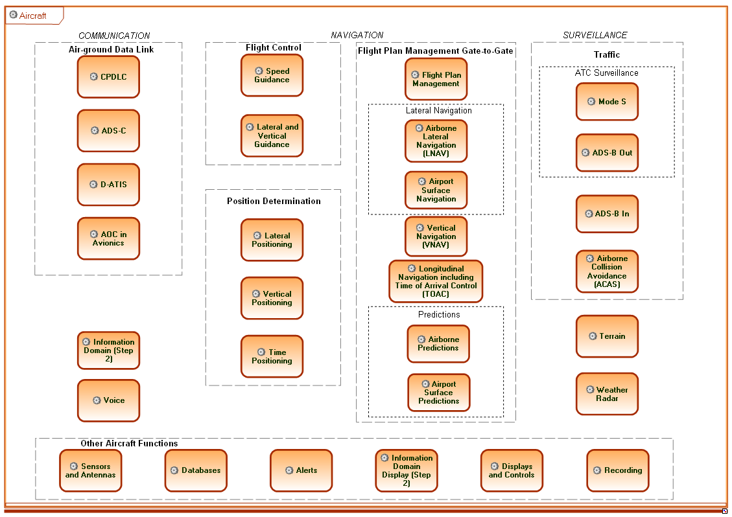
Figure 4 Aircraft Technical System – Functional Breakdown
Figure 5 shows the civil aircraft centric diagram, which depicts at high level all the interactions of this capability configuration. Of interest in this context are the interactions with:
- The Navigation Infrastructure GNSS Based, which provides the primary navigation service
- The Navigation Infrastructure Ground Based, in particular DME system which provides the backup navigation service (through the Range information)
- ER ACC and APP ACC which provide the traffic management functions
The overall Navigation infrastructure breakdown is shown in Figure 6, for both GNSS and Ground based systems, while Figure 7 shows a more detailed view of the Ground Based infrastructure. In this view it can be seen that the DME has only two interfaces:
- Range
- Navigation Infrastructure Status
The DME centric interactions model is shown in Figure 8 which provides a high-level view on the linked Use Case - GNSS Reversion. This View describes Resource and Infrastructure Connectivity in the context of Alternative Position, Navigation and Timing (A-PNT) - Short-Term A-PNT.

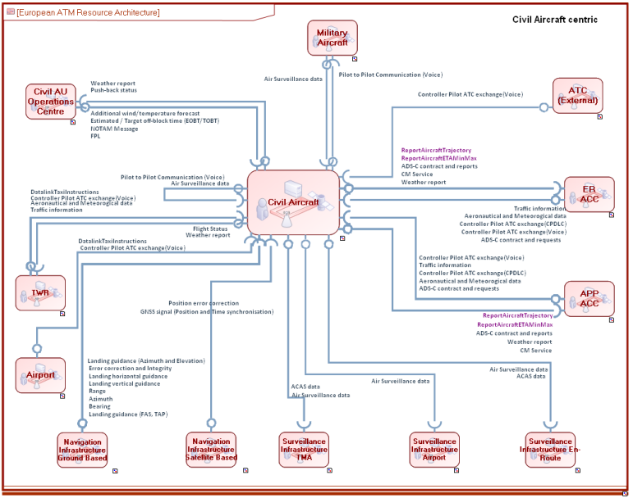
Figure 5 Civil Aircraft Centric Diagram
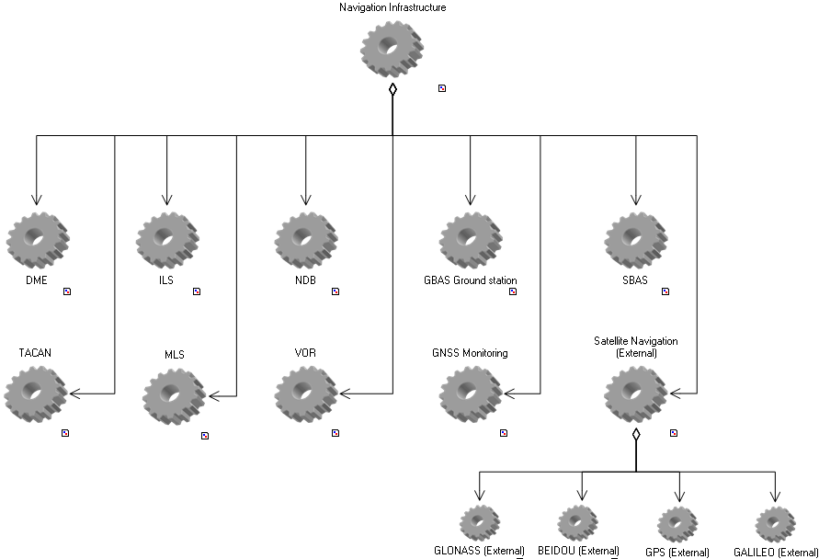
Figure 6 Navigation Infrastructure Breakdown
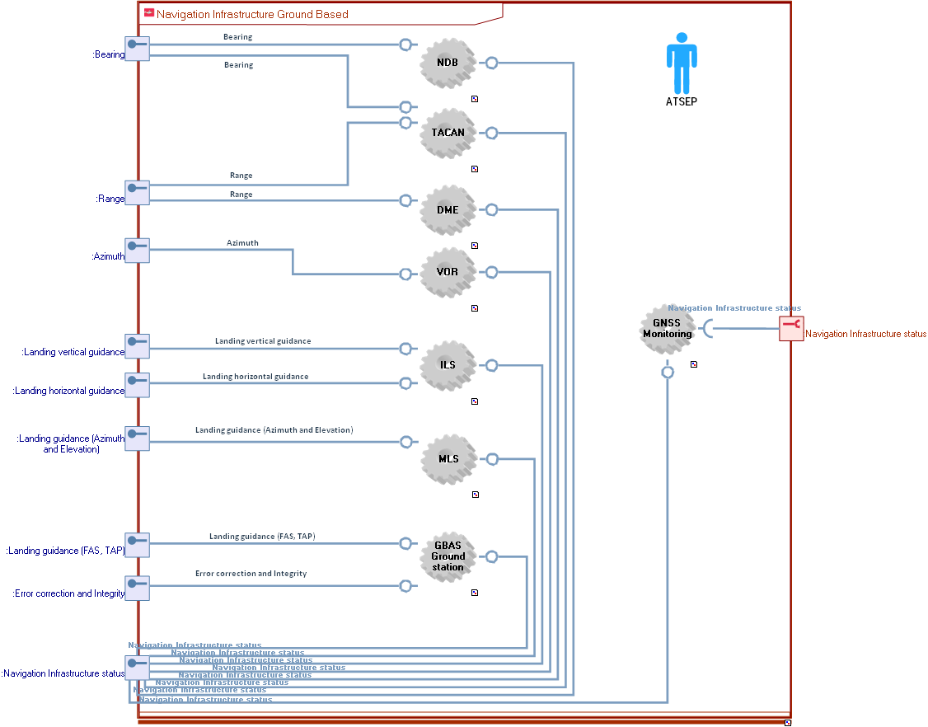
Figure 7 Ground Based Navigation Infrastructure Breakdown
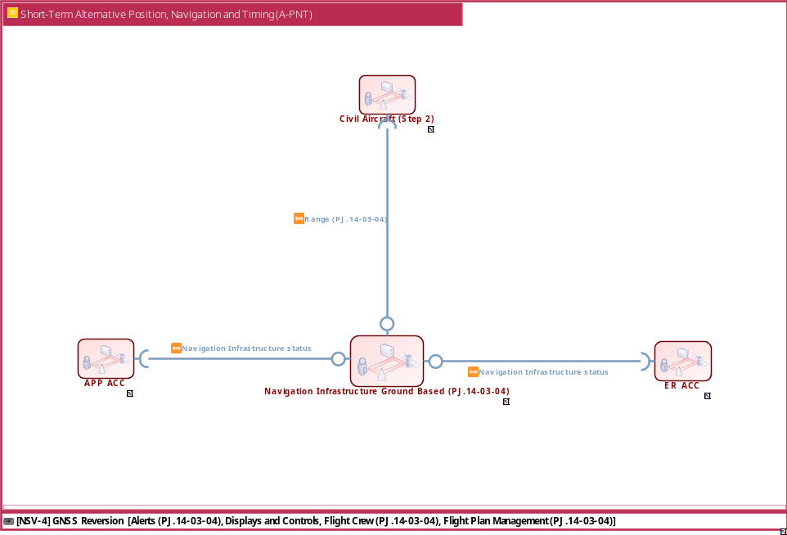
Figure 8 DME Interactions

Resource Orchestration view
Further details on the resources interactions are provided in the following subsections. The description is focused on the defined use case.

[NSV-4] GNSS Reversion
Figure 9 below shows the model created in EATMA for the Short-Term A-PNT use case: [NSV-4] GNSS Reversion.
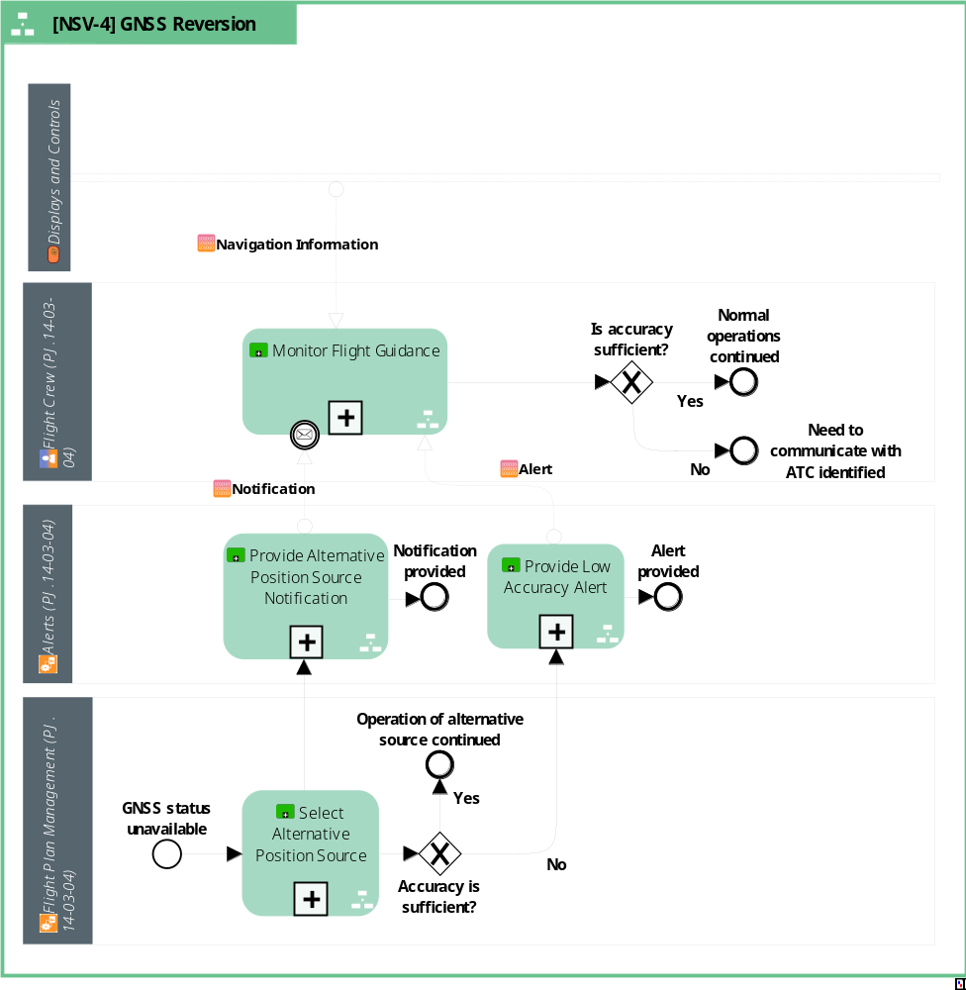
Figure 9 [NSV-4] GNSS Reversion
The use case can be described by the following sequence of events:
- GNSS service becomes unavailable
- GNSS status provided to FMS (Flight Plan Management Functional Block)
- GNSS status alert provided to Flight Crew
- FMS automatically select Alternative Position Source
- Notification regarding the selected Alternative Position Source provided to pilots
- Accuracy of the selected Alternative Position Source is continuously estimated and monitored by FMS
- Alert is provided if accuracy of Alternative Position Source is below required level for intended operation (RNP 1)
- Flight Crew monitors:
  - Alternative Position Source (notification regarding the selected Alternative Position Source (only DME/DME(IRS) accepted)
  - Accuracy of the Alternative Position Source (Low Accuracy Alert)
  - Navigation Information (i.e. Flight Technical Error ) in order to correct any deviation from defined flight path
- If Flight Crew receives alert/notification on Low Accuracy or selection of a different Alternative Position Source (e.g. VOR/DME), contacts ATC to request assistance. Otherwise normal operations are continued.
A brief description of the functions identified in this use case is captured in the table below.
Function | Description
Monitor Flight Guidance | Function allocated to the Flight Crew. The Flight Crew must monitor the following:  Navigation Information (i.e. Flight Technical Error)  Selected Alternative Position Source  Accuracy of the Alternative Position Source  Actions required from Flight Crew:  Maintain Flight Technical Error within required limits, especially during manual flight  Ask ATC assistance if DME/DME service is not available or if the estimated accuracy is below required level.  Special attention should be granted to Alternative Position Source information. In some cockpit architectures, this information is available to the pilot as a notification in the FMS pages but not as an alert. (see Appendix A – Safety Considerations)
Provide GNSS Unavailable Alert | This Function provides an alert to Flight Crew in case GNSS is unusable and triggers selection of alternative position source.
Provide Alternative Position Source Notification | Function allocated to the Flight Plan Management (FMS) and the Alerts Functional Block. This information must be available to the Flight Crew because the DME/DME Alternative Position Source is required in case of GNSS outage for the RNP reversion.
Select Alternative Position Source | Function allocated to the Flight Plan Management (FMS). The multi-sensor FMS automatically selects the position source following a predefined order of priorities as described in 3.1.1.2.3.
Table 7: Description of use case functions
The above use case is based on the assumption that the ground infrastructure provides the required DME/DME positioning service which is described in 4.1.4.

Infrastructure connectivity model
Figure 11

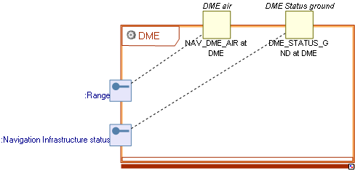
Figure 10 DME ports

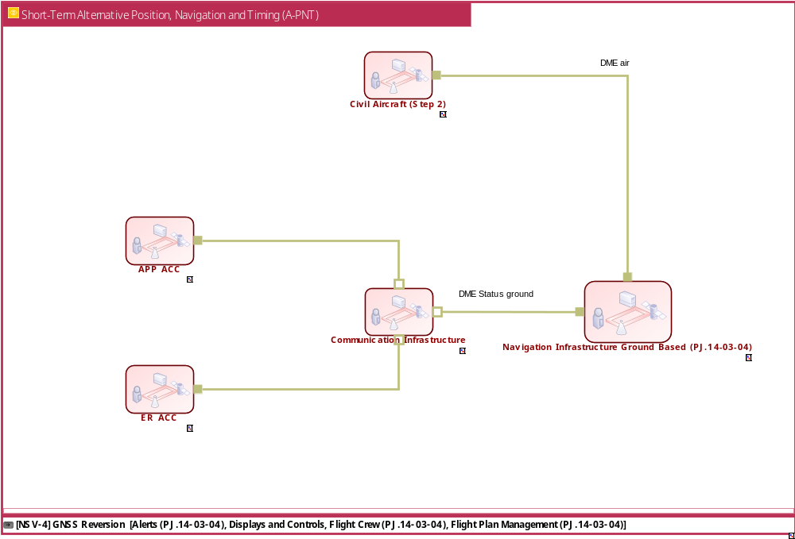
Figure 11 DME connectivity model

Service view

Service description
The Short-Term A-PNT Solution is based on the availability of the positioning service provided by the DME transponder (Technical System component of the Ground Based Navigation Infrastructure).
The service is enabled by the Range information which is derived by the on-board systems, i.e. the DME Interrogator, when receiving replies from the DME Transponders (see technical description in 3.1.1.2.3).
It should be also kept in mind that for calculating a position solution at least two ranges must be available, from two different transponders, and that some restrictions apply to the relative position between the aircraft and the ground stations. The DME/DME position determination can be described as a triangulation method which considers also the previously calculated position in order to use only two ground stations (the solution ambiguity is eliminated based on proximity to previous solution). This solution is computed on board by the RNAV System (e.g. the FMS).
The main parameters used to describe the quality of the service are:
- Accuracy
- Continuity
- Availability
- Integrity
These performance parameters are determined mainly by two factors:
- The quality of the range information provided by individual DME stations
- The number and geometry of the ground stations
The requirements defined in this TS-IRS apply both to the performance of the DME Transponder and to the overall performance of the DME/DME positioning service which takes into account also the second factor.

Service Provisioning
As described above, the service is provided mainly through the “Range” interface implemented between aircraft and the ground DME systems. However the connectivity model shows the existence of a second interface: “DME status ground”. This second interface/interaction send the information regarding the working status of each ground station to the En-route and Terminal ATC. This status information is needed for the awareness of the control centre in charge of a particular airspace, regarding the provision of the DME/DME alternative positioning service in that airspace. The transmission of this status information is needed such that ATC selects the appropriate contingency measures in case of a GNSS outage. For example, if the DME/DME service is not available when the GPS outage occurs (e.g. due to a DME station which is out of service for maintenance or due to a failure), ATC anticipate that all aircraft will need radar vectors.
These two types of interactions of the DME system are summarised in the table below.
Interaction | Consumer CC | Consumer System | Provider CC | Provider System
Range.Civil Aircraft (Step 2)_CC and Navigation Infrastructure Ground Based_CC | Civil Aircraft (Step 2) | Position Determination | Navigation Infrastructure Ground Based (PJ.14-03-04) | DME enhanced (PJ.14-03-04);
Navigation Infrastructure status.ER ACC_CC and Navigation Infrastructure Ground Based_CC | ER ACC | En-Route / Approach ATC; | Navigation Infrastructure Ground Based (PJ.14-03-04) | GNSS Monitoring; DME enhanced (PJ.14-03-04); TACAN; VOR; ILS; MLS; NDB; GBAS Ground station;
Navigation Infrastructure status.APP ACC_CC and Navigation Infrastructure Ground Based_CC | APP ACC | En-Route / Approach ATC; | Navigation Infrastructure Ground Based (PJ.14-03-04) | GNSS Monitoring; DME enhanced (PJ.14-03-04); TACAN; VOR; ILS; MLS; NDB; GBAS Ground station;
Table 8: Service Provisioning Interactions

Service Realization
The technology used to implement the above interactions is provided in the following subsection based on the description of the Interfaces, System Ports, Standards and Protocols which is available in EATMA.
Note that this TS-IRS does not introduce any changes in this respect in comparison with existing DME implementations. Once more, the Short-Term A-PNT Solution foresees changes only in the performance of the DME System (Ground Infrastructure), without introducing any interface or protocol changes.
Note also that the protocol to be used for the implementation of the DME Status ground interface is not specified in the standards, therefore any communications standards can be used.

Interaction Navigation Infrastructure status.APP ACC_CC and Navigation Infrastructure Ground Based_CC

System Port: DME_STATUS_GND at Ground Based Navigation Infrastructure
Protocol Stack | Protocol
DME Status ground
 | IP

Interaction Navigation Infrastructure status.ER ACC_CC and Navigation Infrastructure Ground Based_CC

System Port: DME_STATUS_GND at Ground Based Navigation Infrastructure
Protocol Stack | Protocol
DME Status ground
 | IP

Interaction Range.Civil Aircraft (Step 2)_CC and Navigation Infrastructure Ground Based_CC

System Port: NAV_DME_AIR at Navigation Infrastructure Ground Based_CC
Protocol Stack | Protocol
DME air
 | UHF 960 - 1215 MHz

System Port: DME at Civil Aircraft (Step 2)_CC
Protocol Stack | Protocol
DME air
 | UHF 960 - 1215 MHz

Functional and non-Functional Requirements
The requirements captured in this TS-IRS apply to the Enhanced DME Transponder (CTE-N08c) intended to be used for enabling the RNP 1 reversion.
These requirements are defined in accordance with:
- Initial requirements identified in the FRD
- The concept of RNP Reversion based on DME/DME, which will be fully described in the MASPS produced by EUROCAE WG107
- EUROCAE ED-57A MOPS (update work in progress also in EUROCAE WG107)
The requirements are largely based on the initial conclusions of the SESAR 1 projects, in particular considering the following deliverables:
- Safety Desk Study on A-RNP reversion in case of GPS loss (NAV-SAFREP-2013-0101-IR) [11]
- 15.3.1 Task 12 and the associated deliverable 15.3.1 D12 – Report on RTS (Real Time Simulations) on RNP reversion [12]
- 15.3.2 Task 12 and the associated deliverable 15.3.2 D12 - Analysis of DME Enhancement Needs in Support of Near-term A-PNT [13]
Note that Appendix A, dedicated to safety considerations, captures the relevant outcomes of these documents and includes a copy of the Safety desk study report.
The functional and non-functional requirements retained for the Short-Term A-PNT solution are listed in Appendix C. The following section, 4.2, lists the TS-IRS requirements defined for the sub-solution enabler, i.e. DME enhanced (CTE-N08c), on the basis of the requirements applicable to the Short-Term A-PNT.

Functional and non-Functional for Enhanced DME Transponder Requirements
As described aboce, all the requirements for supporting the Short-Term A-PNT solution, i.e reversion for RNP 1 operations in case of GNSS outages, are allocated to the ground enabler which is the DME Transponder (CTE-N08c).
It is not in the scope of this TS-IRS though to replicate the full DME technical specification as defined by ICAO Annex 10 and the revised EUROCAE specification (ED-57A). This TS-IRS captures instead only the performance requirements which are key for enabling the Short-Term A-PNT Functional and non-Functional Requirements, namely RNP 1 reversion.
Details on the rationale and derivation of for these key requirements are provided in Appendix B.
Note that although the members of PJ14-03-04 are making a major contribution to WG107, EUROCAE fully owns the IPR of its published standards and therefore it is not possible to include in this document full extracts from the MASPS and MOPS documents.
The requirements are summarised in the following tables.

REQ-14.03.04-TS-IRS-0002
Identifier | REQ-14.03.04-TS-IRS-0002
Title | RNP 1 reversion support
Requirement | The Short-Term A-PNT solution shall support RNP 1 reversion based on DME/DME.
Status | Validated
Rationale | Maintain RNP 1 operations in case of GPS outages
Category | Performance

Relationship | Linked Element Type | Identifier
SATISFIES | SESAR Solution | PJ. 14-03-04
SATISFIES | FRD Requirement | REQ-14.03.04-FRD-01.0010
ALLOCATED TO | Enabler | CTE-N08c
ALLOCATED TO | Technical System | DME enhanced

REQ-14.03.04-TS-IRS-0005
Identifier | REQ-14.03.04-TS-IRS-0005
Title | DME range accuracy
Requirement | The Transponder contribution to the overall DME Range accuracy shall be bounded by a normal distribution with a maximum mean of +/-15m and a maximum standard deviation of 53m for sensitivity levels between -10 dBm and -91 dBm
Status | Validated
Rationale | Support the accuracy level required by RNP 1 reversion
Category | Performance

Relationship | Linked Element Type | Identifier
SATISFIES | SESAR Solution | PJ. 14-03-04
SATISFIES | FRD Requirement | REQ-14.03.04-FRD-01.0020
ALLOCATED TO | Enabler | CTE-N08c
ALLOCATED TO | Technical System | DME enhanced

REQ-14.03.04-TS-IRS-0006
Identifier | REQ-14.03.04-TS-IRS-0006
Title | DME service continuity
Requirement | The DME transponder shall ensure a Mean Time Between Outages (MTBO) of at least 10⁴ hours
Status | Validated
Rationale | Support the continuity of service level required by RNP 1 navigation specification
Category | Performance, Safety

Relationship | Linked Element Type | Identifier
SATISFIES | SESAR Solution | PJ. 14-03-04
SATISFIES | FRD Requirement | REQ-14.03.04-FRD-01.0025
ALLOCATED TO | Enabler | CTE-N08c
ALLOCATED TO | Technical System | DME enhanced

REQ-14.03.04-TS-IRS-0007
Identifier | REQ-14.03.04-TS-IRS-0007
Title | DME range integrity
Requirement | The DME transponder shall ensure an integrity level of the Range information of 1-10⁻⁶/h or better
Status | Validated
Rationale | Support the integrity level required by RNP 1 navigation specification
Category | Safety

Relationship | Linked Element Type | Identifier
SATISFIES | SESAR Solution | PJ. 14-03-04
SATISFIES | FRD Requirement | REQ-14.03.04-FRD-01.0010
ALLOCATED TO | Enabler | CTE-N08c
ALLOCATED TO | Technical System | DME enhanced

References and Applicable Documents

Applicable Documents
Content Integration
- B.04.01 D138 EATMA Guidance Material
- EATMA Community pages
- SESAR ATM Lexicon
Content Development
- B4.2 D106 Transition Concept of Operations SESAR 2020
System and Service Development
- B.04.03 D128 ADD SESAR1
System Engineering
- SESAR 2020 Requirements and Validation Guidelines
Safety
- SESAR, Safety Reference Material, Edition 4.0, April 2016
- SESAR, Guidance to Apply the Safety Reference Material, Edition 3.0, April 2016
- SESAR, Final Guidance Material to Execute Proof of Concept, Ed00.04.00, August 2015
- SESAR, Resilience Engineering Guidance, May 2016

Reference Documents
- EUROCONTROL, Safety Desk Study on A-RNP reversion in case of GPS loss (NAV-SAFREP-2013-0101-IR), Ed 0.2, 28 August 2013
- SESAR, 15.3.1 D12 – Report on RTS (Real Time Simulations) on RNP reversion, Edition 00.00.01, 3rd April 2015
- SESAR, 15.03.02 D12-D2.4.A. Analysis of DME Enhancement Needs in Support of Near-term A-PNT, Ed 00.01.00, 13 April 2016
- Commission Implementing Regulation (EU) 716/2014, 27 June 2014
- Commission Implementing Regulation (EU) 2018/1048, 18 July 2018
- ARINC 702A, Advanced Flight Management Computer System, 28 August 2018
- ICAO Annex 10 Aeronautical Telecommunications, Volume I Radio Navigation Aids, Seventh edition July 2018
- RTCA DO-189 MOPS for Airborne Distance Measuring Equipment (DME) Operating within the Radio Frequency Range of 960-1215 Megahertz, September 1985
- FAA TSO C166C: Distance Measuring Equipment (DME) Operating Within The Radio Frequency Range Of 960-1215 Megahertz
- ARINC 709: MARK 5 AIRBORNE DISTANCE MEASURING EQUIPMENT
- EUROCAE ED54 “Minimum Performance Specifications for Distance Measuring Equipment Interrogator (DME/N and DME/P) Operating within the Frequency Range 960 to 1215 MHz (Airborne Equipment), January 1987
- EUROCAE ED57 “Minimum Performance Specifications for Distance Measuring Equipment Interrogator (DME/N and DME/P) (Ground Equipment), December 1986
- RTCA Minimum Aviation Systems Performance Standards: Required Navigation Performance for Area Navigation, June 19, 2013

- Safety Considerations

The safety aspects of the RNP reversion were analysed in SESAR 1 framework through the following tasks and deliverables:
- Safety Desk Study on A-RNP reversion in case of GPS loss (NAV-SAFREP-2013-0101-IR) [11]
- 15.3.1 Task 12 and the associated deliverable 15.3.1 D12 – Report on RTS (Real Time Simulations) on RNP reversion [12]
- 15.3.2 Task 12 and the associated deliverable 15.3.2 D12 - Analysis of DME Enhancement Needs in Support of Near-term A-PNT [13]
The main assumptions and conclusions contained in these documents are highlighted below.

Safety Desk Study on A-RNP reversion in case of GPS loss (NAV-SAFREP-2013-0101-IR)
This study was assuming the wide scale implementation of Advanced RNP (A-RNP) as the nominal PBN application in all phases of flight. A-RNP specification includes a scalable RNP option, which means that different navigation accuracy levels can be selected for different applications. A-RNP specification encompasses most of the other specifications (e.g. RNAV 5, RNAV 1, RNP 1) and includes a number of additional functionalities. In the meantime the SESAR roadmaps and the EC regulations have identified RNP 1 including RF legs as the most stringent PBN application to be supported in Terminal airspace, without requiring the additional functionalities offered by the A-RNP. However, the study considers for Terminal applications an RNP 1 level (1 NM Required Navigation Performance), and only the use of RF legs, without considering other A-RNP functionalities. Therefore the scenario defined in this study is also valid for RNP 1 reversion.
The study has concluded that the risk is considered to be tolerable in the following conditions:
- Controllers must be unambiguously informed about the unexpected GPS outage when it occurs
- Controllers must know which aircraft are impacted by this outage
- There is a limited number of aircraft with FMS/RNAV having only GPS for positioning in the controller’s sector
- Aircraft with FMS/RNAV having DME-DME positioning navigate accurately on A-RNP routes (ATS routes, SIDs, STARs)
- An ATC reversion plan is applied, as soon as the unexpected GPS loss is confirmed, in order to reduce the capacity of the affected sector(s) and if necessary their complexities.
The study identifies as well a good number of mitigation means and actions, at different levels (e.g. ATC level, NM level, Aircraft level, Ground navaid infrastructure level). For the scope of the Short-Term A-PNT solution only the mitigation means and actions related with the navaids infrastructure are relevant. From this perspective it is important to highlight that the risk acceptability conclusion “relies entirely on the ability of FMS/RNAV with DME-DME to navigate accurately on A-RNP routes (ATS routes, SIDs, STARs) by meeting the required navigation accuracy requirement of 1 NM / 95 % of the flight time including during FRT/RF.”
The main actions and mitigation means identified in order to ensure the compliance of the DME infrastructure are:

Action #8: Specific infrastructure quality assurance actions may be necessary.

Mitigation means at the Ground navaid (DME) infrastructure level:
- Good DME coverage / DME accuracy within En-route sector and TMAs
- DME transponder SIS integrity
The requirements defined in this TS-IRS take into consideration the above conclusions and mitigation means.
The safety desk study report is embedded in this appendix for reference.


15.3.1 D12 – Report on RTS (Real Time Simulations) on RNP reversion
The Real Time Simulations on RNP reversion were organized based on the assumptions of the safety desk study with the main objective to validate the conclusions and the recommendations of the study in what regards the impact on ATC operations, limitations and supporting tools.
In these simulations, the desk study assumption that DME/DME equipped aircraft meet the required navigation accuracy requirement of 1 NM / 95 % of the flight time, was modelled in the traffic behaviour. The RTS report does not contain any further recommendations in what regards the navigation systems/infrastructure, however it is relevant to highlight here that one of the main conclusions was:
“Summarising the results on the separation of flights it can be said that no unacceptable degradation of safety in terms of separation performance was identified upon the comparison of the different scenarios. These results are in line with the objective safety perception of the controllers as the majority of controllers said that they did not experience safety hazards during the GPS outage.”
The report includes detailed conclusions and recommendations on ATC procedures, supporting tools and ATCO training, but these are out of the scope of this project.

15.3.2 D12 - Analysis of DME Enhancement Needs in Support of Near-term A-PNT
As stated in this document, its purpose was to assess the ability of current DME to support PBN operations using an RNP navigation specification. This is done with the aim of providing a fully equivalent capability to GNSS such that operations can continue seamlessly in case of a GNSS outage for suitably equipped aircraft in areas where suitable infrastructure is available. Particular emphasis is on determining the accuracy performance level which can be achieved with a GNSS-equivalent level of integrity, in order to prioritize further A-PNT research. While a number of specific improvements are being considered in this document, these remain within the constraints of current equipment, i.e., apart from some minor upgrades, no fundamental equipment changes are proposed. The document achieves a first feasibility demonstration for a significant cross-section of fielded equipment, however, additional work and stakeholder review will be necessary to decide on maturing this capability further towards formal implementation.
The outcome of this task of Project 15.3.2 is the basis for the work carried out in EUROCAE WG 107 which is currently developing the MASPS for the RNP 1 reversion based on DME/DME and updating the MOPS for the DME Transponder.
The study has addresses technical aspects, related with the current DME systems, FMS systems and cockpit integration but also human factors related to the reaction of the pilots in case of a GPS outage. An overview of the main findings is given below.
Cockpit perspective
The main conclusions and recommendations from a cockpit perspective are summarised in Chapter 4.1.6 of 15.3.2 D12: Recommendations for RNP in DME/DME/IRS, taking into account the current state of avionic systems i.e. without envisaging system evolutions. The most relevant outcomes for the scope of the present document are extracted below.
RNP Terminal (RNP 1)
Requirements for RNP Terminal (RNP 1) can be satisfied as long as DME ground stations used in the RNP operation guarantee an integrity rate of 10⁻⁵ per hour.
Crew operating evolutions
Crew reactions and cockpit effects are well adapted to RNP operations in DME/DME/IRS navigation mode: crew reacts to the low accuracy alert and aborts operation if it occurs but they may need to be warned to check the navigation mode, for example in the procedure description or in FCOM.
Following the feedback of operational evaluations with pilots, if an RNP operation is pursued in DME/DME/IRS the crew may have to check the current navigation mode in FMS.
In case of unavailability of the GPS/IRS navigation mode, if the RNP operation flown states that the aircraft could pursue operation in DME/DME/IRS, the crew should be asked to check that it is effectively the current navigation mode used by FMS.
Indeed, the demonstration of compliance to RNP requirements (especially integrity requirement) is performed with GPS/IRS and DME/DME/IRS modes, but not with other modes. In case of RNP operation without GPS, the crew should then periodically check the current navigation mode.
Ground infrastructure perspective
The study has also analysed the performance of some of the most used DME transponders deployed in Europe today. It can be pointed out that according to current manufacturer specifications, all current transponders meet a 10⁻⁶ integrity requirement while the avionics fault analysis only requires an integrity performance of 10⁻⁵. However some old systems for which the integrity level was not demonstrated may still be in operation but not likely for much longer, as they are at the limit of supportability. Consequently, a formal acceptance of the improvement of transponder integrity as a requirement may not be necessary. Rather, it would be better to agree a requirement in line with required PBN performance levels and ensure that currently fielded transponders meet it.

Conclusions
The above studies have concluded that RNP 1 reversion based on DME/DME/(IRS) is possible, with tolerable safety risk, on some conditions imposed on:
- ATC procedures, training and supporting tools
- Pilots procedures and training
- Performance of the ground DME infrastructure
The first two categories are out of the scope of this TS-IRS which is focused on defining the critical requirements for the DME ground infrastructure and the positioning service provided, in terms of:
- Accuracy
- Integrity
- Continuity
The safety aspects related with the implementation of the RNP reversion based on DME/DME are being further analysed in EUROCAE WG 107 and the conclusions and recommendations will be included in the MASPS written by the work group.
- Requirements Derivation

This appendix provides details on the derivation and rationale for the requirements listed in Section 4.
REQ-14.03.04-TS-IRS-0002
The Short-Term A-PNT solution shall support RNP 1 reversion based on DME/DME.
This is the overarching performance requirement derived from the operational environment, the regulatory context and the use case depicted in 3.1.1.2.
RNP enables more advanced PBN airspace concepts compared to RNAV. According to the PBN manual, aircraft who qualify for RNP operations must be equipped with GNSS. The use of DME/DME to support RNP is not excluded in the PBN Manual but only in addition to GNSS.
A large majority of air transport category aircraft are equipped with DME/DME avionics but only some of these aircraft are certified to provide RNP operations based on DME/DME only. In the case of a GNSS outage, many aircraft in a given airspace will revert to DME/DME operations, often supported by INS, even if not certified for RNP based on DME/DME/(INS). In airspaces that take advantage of the greater capabilities of the DME infrastructure to support the continuation of RNP operations such a situation is called RNP reversion.
The target navigation specification for RNP reversion is RNP1.
REQ-14.03.04-TS-IRS-0005
The Transponder contribution to the overall DME Range accuracy shall be bounded by a normal distribution with a maximum mean of +/-15m and a maximum standard deviation of 53m for sensitivity levels between -10 dBm and -91 dBm.
The DME range accuracy plays a key role in the calculation of the DME/DME solution accuracy. The required navigation accuracy for RNP 1 applications is 1NM Total System Error (TSE) for 95% of the flight time. The derivation of TSE for the DME/DME positioning is described in the EUROCONTROL Guidelines for P-RNAV infrastructure Assessment, as follows.
TSE is derived from the Root Sum Square (RSS) of Navigation System Error (NSE) and Flight Technical Error (FTE). NSE incorporates Position Estimation Error (PEE), Path Definition Error (PDE) and display error. For the purposes of the infrastructure assessment, PDE and display error can be assumed to be negligible. PEE is composed of the signal-in-space error and the airborne receiver error.
The first level of accuracy partitioning is between the Flight Technical Error (FTE) and the Navigation System Error (NSE). For P-RNAV, a value of 0.5 NM (95%) is used for FTE. This is consistent with ICAO Doc 8168 (PANSOPS) and Doc 9613, which generally consider being established on a procedure when within half of full scale deflection (full scale in terminal area RNAV mode is ±1NM). While the use of flight director or autopilot is recommended, 0.5NM FTE is achievable in manual flight. As FTE and NSE are treated as independent errors, this FTE allocation provides for a maximum permissible NSE of 0.866NM (95%) using the root sum square formula. These errors are treated as circular errors, and no further allocation into along and cross-track components is done.
The NSE is partitioned into two contributions: one from the airborne equipment (interrogator) and one from the ground equipment (transponder), including signal in space propagation effects. As the minimum requirement for providing RNAV with DME ranges is to have 2 DME’s available with suitable geometry and sufficient range, the following DME RNAV accuracy formula has been agreed (PBN Manual, Vol. II, Part B, Chapter 3.3.3.3.2.g ):
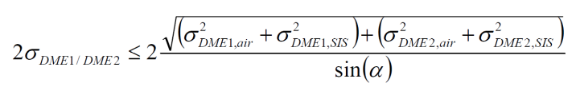
Where: σ_{SIS} = 0.05 NM (or larger value if required),
σ_{air} is MAX {(0.085 NM, (0.125% of distance)},
α = subtended angle (must be within 30º to 150º).
This formula is used to determine if a specific DME pair is able to support the intended procedure. It is assumed that DME positioning is zero-mean, and thus the σ_{DME/DME} result is evaluated against the maximum NSE of 0.866NM derived above.
The Signal-in-Space allocation (0.1NM, 95%) includes an allocation for the ground transponder (0.081 NM according to Annex 10) and the remainder for propagation effects such as multi-path.
The Annex 10 transponder error allocation of 0.081 NM (150m) together with the airborne allocation, and the subtended angle limitations implemented in the FMS (30º to 150º) enables maintaining the NSE lower than the required 0.866NM in most configurations, except for cases where both ground stations are further than 100 NM and the subtended angle is at the limit. Such geometries are unlikely and should not be allowed in TMA’s where DME/DME is used to support RNP 1 reversion. If needed additional ground stations should be deployed to improve the accuracy of the SiS.
However, as shown in [13], the modern transponder provide a much better accuracy as the baseline required by Annex 10. This better accuracy provides a higher margin for the other range error contributions and may cater for cases where the propagation effects (e.g. multipath) introduce transient errors above the allocated limit.
Therefore, in recognitions of the performance demonstrated by modern systems, REQ-14.03.04-TS-IRS-0005 sets a tighter limit for the transponder accuracy. This requirement is also in line with the additional performance data collected by WG 107 and with the accuracy requirement update foreseen in ED-57A.
Note that this requirement allows for a non-zero mean distribution of errors (mean error up to +/- 15m) while Annex 10 considers a zero mean distribution. According to the observed data, the non-zero mean distribution describes more realistically the transponder error. In any case, this non-zero mean distribution is over bounded by a zero mean normal distribution with a standard deviation 54m (0.029NM) i.e. 108m (0.058NM) 95% , therefore the requirement is more stringent that the Annex 10 requirement.
REQ-14.03.04-TS-IRS-0006
The DME transponder shall ensure a Mean Time Between Outages (MTBO) of at least 10⁴ hours
This requirement is a direct consequence of FRD REQ-14.03.04-FRD-01.0025 “The Short-Term A-PNT solution shall be able to provide a continuity of the DME/DME service of 1-10-6/h or better”, which in turn is derrived from the assumption of the safety study that good DME coverage / DME accuracy is available to support the RNP reversion.
The ICAO PBN Manual navigation specifications for RNP specify the continuity risk as “minor” failure condition if the operator can revert to a different navigation system and proceed to a suitable airport. Unlike all the other requirements, no actual numerical interpretation is given. The design requirements resulting from this minor classification apply to the aircraft only, and do not consider infrastructure (space or terrestrial). However, there exists a notion that a State could require increased levels of continuity for a given airspace. This could lead to requiring dual FMS (see continuity requirement for A-RNP in PBN Manual).
This appears to be somewhat in contradiction with the EUROCAE RNP/RNAV MASPS [23], where a containment continuity requirement is set of 10⁻⁴/flight hour. A note states that the infrastructure is assumed to be supporting the operation (which could be interpreted as a continuity requirement of 100%). Appendix B of that document shows an example design analysis which determines, based on a fault tree, whether a dual system is necessary to meet the 10⁻⁴ target. It would therefore not seem logical to require dual systems as a result of an airspace-centric continuity analysis. This may be the reason for the recommendation for States to develop alternative means to mitigate system-wide failures (see PBN Manual, Application of A-RNP).
In ICAO Annex 10 [17], ranges are given for infrastructure continuity (applying to GNSS), depending on airspace complexity. However, no methodologies exist to analyse a given airspace and derive an actual target value. Therefore, it is also impossible to answer the question of how to set continuity requirements for the case of an interruption of the primary navigation infrastructure, i.e., to set DME/DME targets for mitigating GPS outages.
In absence of such guidance, SESAR1 projects on navigation infrastructure rationalization already struggled some years ago with defining such requirements . They were built on a “similar to GNSS” rationale, and set 10⁻⁶ / operating hour as a target. This included a one order of magnitude increase, starting from 10⁻⁵. This appears to be an error since the ED75C requirement is 10⁻⁴.
When revisiting the risk assessment for continuity from basic principles, as described in the ICAO Safety Management Manual, keeping in mind operational background from the Real Time Simulations, a classification of at least minor, to somewhere in the major range seems appropriate (appendix A). It would not really seem worth the effort to build up a DME/DME reversion network if the resulting infrastructure continuity is only “minor”, i.e., there would not be a reasonable level of assurance that the infrastructure is available when needed. This is exacerbated by the possibility of GNSS being used for applications other than PBN, including ADS-B. While the surveillance domain manages GNSS risks independently (using a different set of methodologies, see EUROCAE GEN SUR SPR Volume 2, Annex E) and does not take advantage of DME/DME positioning, it nonetheless makes sense to ensure independence of the navigation function in light of a possible service degradation or contingency situation on the SUR side.
SESAR PJ 14-01-01 makes a first attempt to come up with an integrated CNS concept to set continuity targets. It makes an analogy to aircraft safety certification in accordance with FAA AC.1309 analysis, where an individual system safety target of 10⁻⁷ is set based on an assumption of having about 100 different systems on an aircraft and needing to ensure an overall safety target of 10⁻⁵. In the case of continuity events leading to the need to invoke ATC contingency procedures, these are completely acceptable, provided that they do not occur too frequently. They must be rare enough that the probability to have multiple contingency events at the same time is acceptably small, supporting an assumption of independence. A full analysis of all CNS-related ATC contingency situations has not been completed, nor an analysis of the meaning of “too frequently” in an ATC context. But with ever increasing complexity in CNS, it will become necessary to set a high level target and then provide an allocation among all possible contributors, which is likely to fall somewhere in the 10 to 100 range, and be at a per hour level in terms of exposure time.
Another logic which can be used to set a continuity target is to use a boundary argument. If the requirement for single aircraft continuity is at the 10⁻⁴ level, it is difficult to justify an infrastructure continuity lower than that, even if taking credit for a prior probability (GPS outage event; given the difficulty to quantify the probability of such random events it is better to set the probability to 1). A single DME transponder is designed to support up to 200 aircraft at the same time. However, in a high density airspace there also tend to be more DME, such that the chance of a given DME impacting multiple aircraft is likely to be significantly less than a factor of 200. But justifying a factor of less than 10 for continuity also becomes difficult. This would set the lower boundary at 10⁻⁵. At the upper end of the scale is the relationship between integrity and continuity. Integrity event, bounding the risk of misleading information, are by definition more severe than continuity events, which simply result in loss of function and an invoking of contingency procedures. The PBN TSE integrity requirement is at 10⁻⁵, while a similar single to multiple factor is used for the navigation function relying on GNSS, leading to a 10⁻⁷ requirement. If the continuity target for navigation infrastructure provision (including reversionary infrastructure) is one order of magnitude less, this gives an upper bound of 10⁻⁶.
Considering the above, an infrastructure continuity target in the range of 10⁻⁵ to 10⁻⁶ seems appropriate. For the purpose of the Short-Term A-PNT, and in line with the draft MASPS for RNP reversion based on DME/DME, the continuity risk target for the DME/DME service is set to the upper end of this interval, i.e., 10⁻⁶ per operating hour.
An outage is defined in ED-57 as an unanticipated cessation of signal-in-space. There are several causes that may lead to an interruption of service, these are:
- Shut down due to failure of various modules
- Integrity monitor correctly causing shut down
- Any false alarms leading to shut down
- Outages due to environmental issues (power outage, etc)
- Outages due to planned maintenance action
The last category is generally not counted as an outage because it is not “unanticipated” and normally it is planned during periods that are not operationally relevant: i.e., for RNP procedures supporting a given TMA, this would be during hours of closure of the airport. Alternatively, if a navigation infrastructure provides redundant DME/DME coverage, then there would be no need to coordinate maintenance activities with operations, instead the maintenance activities between different facilities have to be coordinated.
It is also necessary to clarify here the difference between MTBO and MTBF (Mean Time Between Failures). According to ED-57, MTBF is calculated for equipment in single configuration, and therefore is expressing the probability that one single system fails. However, a single system failure doesn’t automatically lead to a cessation of signal-in-space for dual configuration systems. Therefore MTBO takes also into account the system redundancy.
The requirement that MTBO is not less than 10,000 hours is included in the current version of ED-57. In context of WG107 data on achieved systems continuity has been collected in order to assess the feasibility and opportunity of setting more stringent requirements. The conclusion was that:
- The required level of 10,000 hours between outages is exceeded by most facilities
- However, a level of continuity significantly higher (e.g. 100,000 hours) would be difficult to achieve and demonstrate (this would be equivalent with not more than one outage in the equipment life time)
In addition even if an MTBO of 10⁵ hours would be required for the DME transponder, the impact on the infrastructure needed to comply with the DME/DME service continuity requirement of 10⁻⁶/h, would be minimal. This is due to the way of deriving the DME/DME continuity starting from the DME MTBO. The following DME/DME continuity calculation is based on common reliability principles, in line with what is used in ICAO Annex 10 for ILS (Attachment A).
Continuity requirements for avionics are specified on an hourly basis and this convention is maintained for DME infrastructure. Thus the failure probability is a direct inversion of the stated or assumed equipment MTBO, e.g., probability of failure Pf = 1 / MTBO, and continuity Pc = 1 - Pf.
Since for computing a position solution at least one valid DME pair is needed, the DME/DME continuity depends on the number of available pairs. The typical DME/DME redundancy configurations and the corresponding relations for computing the levels of continuity of service are described below.
1. Single Pair (two critical DME) - No redundancy
As both DME need to be working to provide the function, the continuity is the product or AND function of the two individual continuity probabilities:
PP = PDME1 * PDME2 = (1 – 1/MTBO1) * (1 – 1/MTBO2)
2. Two Independent Pairs - Full redundancy-4DME
As either one or the other pair can provide the function, the continuity is an OR function of the respective pairs, designated here pair A and pair B:
P2P = PA + PB – PA*PB
3. Three Pairs formed by 3 DMEs – Full redundancy-3DME
In this case full redundancy is obtained with DMEs. The pairs are not independent but all three possible pairs are valid. If one DME fails there is always the other two forming a valid pair. Therefore any two DMEs have to fail in order to have a loss of continuity event. The combined continuity is given as an OR function of the product (AND function) of the individual continuity probabilities for the 3 possible pairs plus (OR function) when all three DMEs are available.
P3D = PDME1 * PDME2 *(1-PDME3) + PDME1 * PDME3 * (1-PDME2) + PDME2 * PDME3 * (1-PDME1) + PDME1*PDME2*PDME3
4. Two Pairs with One Common DME (one critical DME, or triplet) - Limited Redundancy
In this case the system can be rearranged as an AND sequence, the first part being formed by the two complementary, non-common DME and the second by the critical DME. Thus the combined continuity is given by the product of the critical DME and the non-common DME combined by an OR function, as in the two independent pair case. Here, the critical DME is designated DME C, and the non common DME are designated 1 and 2:
P1C = (P1 + P2 – P1*P2) * PC
5. Three Independent Pairs – Excessive redundancy
At this level is it becoming easier to work with failure probabilities, as they can be multiplied, the pairs being designated A, B and C:
P3P = 1 – [ (1 – PA) * (1 – PB) * (1 – PC) ]
6. One Pair and a Triplet – Excessive redundancy
If one independent pair is combined with a dependent pair, e.g., five DME where one DME is common to two of the pairs, then the above formulas can be recombined as follows:
P5 = 1 – [ (1 – PP) * (1 – P1C) ], where
PP is the result of 1. for the single pair and P1C is the result for the triplet in 3.
The calculation results are summarised in the following table:

Level Of Redundancy | Estimated Failure Rate | Continuity
Excessive Redundancy | At least 10⁻⁸ / Hour | Compliant
Full Redundancy-3DME | Approx. 3*10⁻⁸ / Hour | Compliant
Full Redundancy-4DME | Approx. 4*10⁻⁸ / Hour | Compliant
Limited Redundancy | Approx.10⁻⁴ / Hour | Not Compliant
No Redundancy | Approx. 2*10⁻⁴ / Hour | Not Compliant

From these results it can be observed that in order to meet the required DME/DME continuity of 10⁻⁶/h, at least Full Redundancy is required (at least two valid DME pairs) considering the individual MTBO level of 10⁴h. The required DME/DME redundancy level would not change even if the individual transponder MTBO would be set at 10⁵h.
Consequently in WG107 it was agreed that the transponder MTBO requirement will be kept at the current level of 10⁴ h (10,000 hours between unanticipated cessation of signal-in-space).
REQ-14.03.04-TS-IRS-0007
The DME transponder shall ensure an integrity level of the Range information of 10⁻⁶/h or better
This requirement is derived starting from the conclusions of the cockpit analysis performed by 15.3.2 T12 [13]: Requirements for RNP Terminal (RNP 1) can be satisfied as long as DME ground stations used in the RNP operation guarantee an integrity rate of 10⁻⁵ per hour.
Starting from the required integrity at airspace user level, a required transponder integrity level can be derived based on the same logic used to derive the DME/DME continuity of service requirement (REQ-14.03.04-TS-IRS-0004)
If the requirement for single aircraft integrity is at the 10⁻⁵ level, it is difficult to justify an infrastructure integrity lower than that, even if taking credit for a prior probability (GPS outage event; given the difficulty to quantify the probability of such random events it is better to set the probability to 1). A single DME transponder is designed to support up to 200 aircraft at the same time. However, in a high density airspace there also tend to be more DME, such that the chance of a given DME impacting multiple aircraft is likely to be significantly less than a factor of 200. Moreover, even in high density TMA’s it is unrealistic to assume that at least 100 aircraft are simultaneously performing a SID or a STAR operation, using the same DME ground station (in combination with one of the other stations). Therefore a factor of 10 is more appropriate.
Therefore, starting from the integrity of the signal-in-space required by the on-board systems (10⁻⁵ per hour), and applying a conservative factor of 10, the integrity requirement applicable to the DME transponder becomes 10⁻⁶/h.
According to the results of the ground infrastructure analysis performed by project 15.3.2 [13], the modern transponder already demonstrate this, or better integrity levels. However, one major update planned for ED-57 consists in including a detailed integrity demonstration methodology, such that the results declared by different OEM’s are always reliable and directly comparable.

- Functional and non-Functional Requirements for Short-Term A-PNT

REQ-14.03.04-FRD-01.0010
Identifier | REQ-14.03.04-FRD-01.0010
Title | RNP 1 reversion support
Requirement | The Short-Term A-PNT solution shall support RNP 1 reversion.
Status | In Progress
Rationale | Enable continuity of operations in airspaces where this type of operations are implemented in case of a GNSS outage
Category | Performance

Relationship | Linked Element Type | Identifier
SATISFIES | SESAR Solution | PJ. 14-03-04
ALLOCATED TO | Enabler | CTE-N08c
ALLOCATED TO | Technical System | DME enhanced

REQ-14.03.04-FRD-01.0020
Identifier | REQ-14.03.04-FRD-01.0020
Title | Horizontal Position Accuracy
Requirement | The Short-Term A-PNT solution shall be able to support a positioning accuracy of 1 NM or better (TSE ≤ 1 NM)
Status | In progress
Rationale | Horizontal Position Accuracy required by RNP 1 navigation specification
Category | Performance

Relationship | Linked Element Type | Identifier
SATISFIES | SESAR Solution | PJ. 14-03-04
ALLOCATED TO | Enabler | CTE-N08c
ALLOCATED TO | Technical System | DME enhanced

REQ-14.03.04- FRD-01.0025
Identifier | REQ-14.03.04- FRD-01.0025
Title | DME/DME continuity
Requirement | The Short-Term A-PNT solution shall be able to provide a continuity of the DME/DME service of 1-10⁻⁶/h or better
Status | In progress
Rationale | Maintain continuity of service required by RNP 1 operations
Category | Safety

Relationship | Linked Element Type | Identifier
SATISFIES | SESAR Solution | PJ. 14-03-04
ALLOCATED TO | Enabler | CTE-N08c
ALLOCATED TO | Technical System | DME enhanced

-END OF DOCUMENT-

 |  | 
 |  | 

