
SWIM Governance Structure
Document information
Project Title | Operational Requirements & Demands concerning organisation of the ATM Information Management within the scope of the European ATM Enterprise Architecture
Project Number | 08.01.01
Project Manager | EUROCONTROL
Deliverable Name | SWIM Governance Structure
Deliverable ID | D47
Edition | 00.03.01
Template Version | 03.00.00
Task contributors
DSNA, EUROCONTROL, DFS, AUSTROCONTROL
Abstract
This document will propose the governance arrangements for SWIM in operation. The document concentrates on the SWIM governance needs during the first deployment of SWIM, the establishment of iSWIM via the PCP (Pilot Common Project) regulated by the IR 716/2014.

The deliverable D47 is divided into two parts. Part A (this document) aims in describing the organisational aspects of SWIM governance (groups and processes), whereas part B (IM Functions) is focusing on the activities to be undertaken to keep the SWIM operation and evolution into in a controlled state.

Authoring & Approval
Prepared By - Authors of the document.
Name & Company | Position & Title | Date
Oliver Krueger, DFS | Project Member 8.1.1 | 15/01/2016
Stéphane Dubet, DSNA | Project Member 8.1.1 | 15/01/2016
Roman Nossal, NORACON | Project Member 8.03.10 | 15/01/2016
Sam Van der Stricht, EUROCONTROL | Project Member 8.1.1 | 15/01/2016

Reviewed By - Reviewers internal to the project.
Name & Company | Position & Title | Date
Pedro Cruellas / EUROCONTROL | Project Member | 30/01/2016
Eric Roelants / EUROCONTROL | P08.01.01 Project manager | 30/01/2016
Sam Van der Stricht / EUROCONTROL | Project Member | 30/01/2016
Stéphane Dubet, DSNA | Project Member 8.1.1 | 15/01/2016

Reviewed By - Other SESAR projects, Airspace Users, staff association, military, Industrial Support, other organisations.
Name & Company | Position & Title | Date
Oliver Schrempf / DFS | SEMG Member | 2 Feb 2015
Sujan Perera / NATS | SEMG Member | 2 Feb 2015
Juan Lopez / INDRA | SEMG Member | 2 Feb 2015
Scott Wilson / EUROCONTROL | SEMG Member | 2 Feb 2015
Gianluca Marrazzo / SELEX | SEMG Member | 2 Feb 2015
Tord Pola / Noracon | SEMG Member | 2 Feb 2015
Xavier Jourdain / Thales | SEMG Member | 2 Feb 2015
Hakim Souami / Thales | SEMG Member | 2 Feb 2015
Peder Blomqvist / Noracon | SEMG Member | 2 Feb 2015
Antonio Strano / SELEX | SEMG Member | 2 Feb 2015
Harald Milchrahm / Frequentis | SEMG Member | 2 Feb 2015
Roman Nossal / Austrocontrol | SEMG Member | 2 Feb 2015
Lars Helleblad / Noracon | SEMG Member | 2 Feb 2015
Juliette.Engel / EUROCONTROL | SEMG Member | 2 Feb 2015
Dario Di Crescenzo / SELEX | SEMG Member | 2 Feb 2015
Marc Brochard / EUROCONTROL | SEMG Member | 2 Feb 2015

Approved for submission to the SJU By – Representatives of the company involved in the project.
Name & Company | Position & Title | Date
Oliver Krueger / DFS | Project Member 8.1.1 | 05/02/2016
Stéphane Dubet / DSNA | Project Member 8.1.1 | 05/02/2016
Eric Roelants / EUROCONTROL | P08.01.01 Project manager | 05/02/2016
Sam Van Der Stricht / EUROCONTROL | P08.01 Project manager | 05/02/2016

Rejected By – Representatives of the company involved in the project.
Name & Company | Position & Title | Date

Rational for rejection
None.
Document History
Edition | Date | Status | Author | Justification
00.00.01 |  |  |  | New Document
00.00.13 | 12/01/2015 | Draft | Oliver Kruger | Final Draft for review
00.01.00 | 29/01/2015 | Final | Oliver Kruger | Final (integrating latest comments)
00.01.01 | 31/03/2015 |  | Oliver Krueger | Incorporate findings and comments from the SJU, document version was aligned with the version of the SWIM IM functions document.
00.02.10 | 15/01/2016 | Draft | Oliver Krueger | version send out for review
00.03.00 | 05/02/2016 | Final | Oliver Krueger | Final version delivered to SJU
Intellectual Property Rights (foreground)
This deliverable consists of SJU foreground.

Table of Contents
Executive summary 7
1 Introduction 8
1.1 Purpose of the document 8
1.2 Intended readership 8
1.3 Inputs from other projects 8
1.4 Acronyms and Terminology 9
2 Governance Scope and Principles 10
2.1 What is SWIM Governance? 10
2.2 What are the SWIM objects to be governed? 11
3 SWIM Governance Functions (IM Functions) 13
3.1 Introduction to IM Functions 13
3.1.1 Tailoring the IM Functions for the iSWIM deployment 15
4 SWIM Governance Structure 18
4.1 Introduction 18
4.2 SWIM Governance Structure Overview 18
4.2.1 Traceability between the IM Functions and the SWIM governance bodies 22
5 SWIM Governance Bodies - Terms of Reference 23
5.1 SWIM Steering Group (SSG) 23
5.1.1 Role 23
5.1.2 Tasks 25
5.1.3 Reporting Line 26
5.1.4 Composition 26
5.1.5 Working arrangements 27
5.1.6 Input documentation 27
5.1.7 Output 27
5.2 SWIM Expert Group (SEG) 28
5.2.1 Role 28
5.2.2 Tasks 28
5.2.3 Reporting Line 29
5.2.4 Composition 29
5.2.5 Input documentation 30
5.2.6 Output 30
5.3 SWIM Management Unit (SMU) 31
5.3.1 Role 31
5.3.2 Tasks 31
5.3.3 Reporting Line 32
5.3.4 Composition 32
5.3.5 Input documentation 32
5.3.6 Output 32
5.4 Relationships between SWIM Governance Bodies 33
5.4.1 Relationships between SSG and SEG 33
5.4.2 Relationships between SSG and SMU 33
5.4.3 Relationships between SEG and SMU 33
6 SWIM Providers (SSP/SCSP) 33
6.1 SWIM Service Providers (SSP) Tasks 34
6.2 SWIM Common Infrastructure Service Provider (SCSP) Tasks 34
6.2.1 Reporting Line 34
6.2.2 Composition 34
6.2.3 Input documentation 35
6.2.4 Output 35
7 SWIM Consumers 36
8 Considerations on Working Arrangements 37
8.1 Team Composition Proposal for the initial Deployment 38
8.1.1 Criteria 38
8.1.2 Team Composition for the SWIM Steering Group (SSG) 39
8.1.3 Team Composition for the SWIM Management Unit (SMU) 39
8.1.4 Team Composition for the SWIM Expert Group (SEG) 39
9 Transition to an independent SWIM Governance 41
9.1 SWIM Governance Prerequisites 42
9.1.1 Sponsoring of SWIM Governance 42
9.1.2 Compliance Testing or SWIM Reference Infrastructure 42
9.1.3 SWIM Foundation 42
9.1.4 SWIM Service Portfolio Management 42
9.1.5 Validation of the Governance Structure 42
9.1.5.1 Experiences gained during the runtime of the SEMG 43
9.1.6 SWIM Governance Policies 45
9.1.7 SWIM Governance Processes 46
9.1.7.1 Change Management Process (example) 46
9.1.7.2 SWIM Service Lifecycle Process 47
9.1.8 Service Level Agreements (SLAs) 49
9.2 Transfer of Responsibility 49
10 International aspects 51
10.1 ICAO Information Management Panel 51
10.1.1 Background 51
10.1.2 Terms of Reference 51
10.1.3 Link with SESAR SWIM Governance 52
10.2 EASA RMT on SWIM 53
10.2.1 Link with SESAR SWIM Governance 53
10.3 EUROCAE work on SWIM 53
10.3.1 Link with SESAR SWIM Governance 54
11 References 55
Appendix A Options on working arrangements for the SWIM Governance bodies 56
Federated Teams 57
When to choose a federated approach? 57
Designated Teams 57
When to choose a designated approach? 58
Appendix B A6 Governance Proposal 59
Appendix C SEMG Terms of Reference 2

List of tables
Table 1: Mapping IM Functions and Governance Bodies 22

List of figures
Figure 1: SWIM Foundation “landscape” 11
Figure 2 – IM Functions 14
Figure 3: Dependency between IM Function governance bodies and governance processes 18
Figure 4: SWIM Governance Structure 19
Figure 5: Example Process for Change Management 46
Figure 6: SWIM Service Lifecycle 47

Executive summary
This document proposes the governance arrangements for SWIM in operation. The document concentrates on the SWIM governance needs during the initial deployment of SWIM, i.e. the establishment of iSWIM via the PCP (Pilot Common Project) regulated by the IR 716/2014.

Even though initially the number of information services is limited and SWIM does not yet provide its full benefits, appropriate and comprehensive governance mechanisms have to be established. This is necessary right from the beginning to manage the implementation of new services and SWIM Common Infrastructure Services [1] in a collaborative and transparent way.
It is to be noted that this document does not describe the end-state of the implementation of the governance structure. To that ultimate goal a concrete implementation plan of iSWIM needs to be available and agreed upon.
However, this document provides guidance and pre-conditions which should be considered when establishing iSWIM Governance. It is expected that with the experience gathered throughout the initial deployment period, additional inputs and details will emerge. Consequently, future governance activities will have to build upon these first experiences to further shape it as required.

Introduction

Purpose of the document
The document at hand is part A of the 08.01.01 deliverable D47 and closely related to part B, which is the SWIM IM Functions document.
SWIM governance is needed to ensure a controlled operation and evolution of SWIM. This document is aiming in providing a complete picture of the SWIM governance by defining what the objects of governance are and which governance functions need to be established, how the organisational structures need to be implemented and provide consideration on how the transition from the SESAR SWIM governance to an independent arrangement of governance bodies can be organised.
The cornerstone for the definition of governance structures is building on the ‘IM functions (governance specifications)’ [2] document provided by the SESAR Project 8.1.1 and the governance proposals which were handed over to that project by the A6 Group.

This document also includes practical experiences gained during the execution of the SEMG (SWIM Evolution Management Group) within SESAR 1.

Intended readership
As this document addresses future arrangements on the Governance of SWIM during the PCP deployment phase, every stakeholder who will be involved in the iSWIM deployment or has a certain interest in the proper management and governance of iSWIM should read this document.
In particular, the following stakeholders need to notice this document:
- PCP Deployment Manager
- SWIM Service Providers
- SWIM Common Infrastructure Service Providers
- Organisations which plan to contribute to the SWIM Governance
- SESAR SJU
- SWIM Service Consumers

Inputs from other projects
- 08.01.01 D42 – SWIM ConOps [1]
- 08.01.01 D23 – IM Functions [2]
- 08.01.01 D43 – SWIM Compliance Framework Principles [3]
- 08.01.01. D45 – SWIM Compliance Criteria [4]

Acronyms and Terminology

Term | Definition
ATM | Air Traffic Management
E-ATMS | European Air Traffic Management System
IM Functions | Information Management Functions
iSWIM | initial SWIM
SCSP | SWIM Common Infrastructure Service Provider
SEMG | SWIM Evolution Management Group
SESAR | Single European Sky ATM Research Programme
SJU | SESAR Joint Undertaking (Agency of the European Commission)
SJU Work Programme | The programme which addresses all activities of the SESAR Joint Undertaking Agency.
SESAR Programme | The programme which defines the Research and Development activities and Projects for the SJU.
SSP | SWIM Service Provider
SWIM Services | SWIM Services are comprised of SWIM Common Infrastructure Services and SWIM Information Services.
SWIM Providers | Are providers of any SWIM capability (e.g. common infrastructure components, information service instances, …) The SWIM Providers is an umbrella term for the ‘SWIM Service Providers’ (SSP) and ‘SWIM Common Infrastructure Service Providers’ (SCSP).
SWIM TI | SWIM Technical Infrastructure

Governance Scope and Principles

What is SWIM Governance?
SWIM Governance is about establishing policies and continuous monitoring their proper implementation to ensure a stable operation and controlled evolution of SWIM.
SWIM Governance means all the processes that coordinate and control all resources and actions of a pan-European SWIM implementation. It is established to align the SWIM strategy with the ATM strategy and implementing good ways to measure its performance. It makes sure that all stakeholders’ interests are taken into account and that processes provide measurable results.
The governance of SWIM should aim at steering topics such as listed hereafter:
- Strategic alignment: Bringing the evolution of the aviation business and implementation of SWIM together into consistent evolution plans based on stakeholder needs.
- Resource management: Ensuring the necessary resourcing to operate SWIM.
- Charging and funding: Agreeing on charging and funding.
- Quality assurance: Establishing service level agreements (SLAs) and policies to assure the quality of service and build trust between SWIM users.
It should be noted that this document is not comprehensive on all aspects of SWIM governance. However this document provides inputs on those aspects of iSWIM governance, which are deemed necessary at this stage such as governance policies, rulebooks, SLAs, guidelines, etc.

To get a full picture on SWIM Governance, this document should be read in conjunction with other documents, namely:

- SWIM Conops [1]
- IM Functions [2]
- SWIM Compliance Framework Principles [3]
- SWIM Compliance Framework Criteria [4]

During iSWIM the governance will likely be under the control of the SESAR deployment manager. During this period the governance bodies will mostly be problem/solution driven within the context of the PCP. Thereafter, agility will be needed since it may be required to adapt to possible changes of the governance structures, processes and functions of iSWIM.

Following the initial period, it is expected that a steady state will be reached. At this point in time it is not needed to keep the close link to the PCP anymore and the SWIM Governance bodies will continue to work independently. Then the work arrangements and team composition may need to be revisited in order to settle in. Consequently further consideration will have to envisage this situation and provide some guidance on how to rearrange the governance teams. This is not in scope of the document at hand.

This document only addresses this first phase of the SWIM deployment as described in the Implementing Rule (IR) 716/2014 “Pilot Common Projects”.

What are the SWIM objects to be governed?
The SWIM governance is implemented to encourage the trust of the SWIM stakeholders in the quality of provided services.
The proposed SWIM governance is an evolution of the SESAR 1 SWIM governance groups (e.g. the SCG – Service Coordination Group). Governance processes are established which take over the roles and responsibilities of SESAR 1 governance groups to ensure the continuation of a coherent and consistent operation and evolution of SWIM.
The SWIM governance establishes rules, specifications and guidelines to manage certain types of SWIM elements, which are the objects to be governed. Those elements can be grouped into three categories as depicted in Figure 1 below:

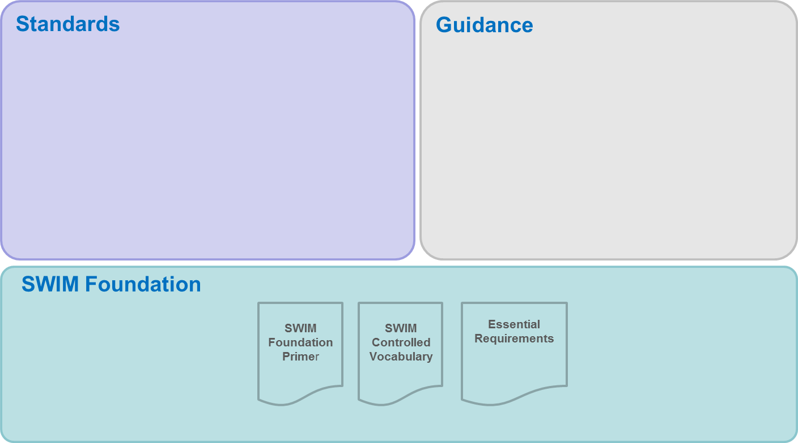
Figure 1: SWIM Foundation “landscape”

- The SWIM Foundation provides a coherent set of foundational principles, rules and recommendations for establishing SWIM standards related to information, information services, technical infrastructure and governance.
The SWIM Foundation is owned by the “SWIM Authority”, meaning that it sits within the remit of the SWIM Steering Group (SSG). For a full list of artefacts refer to the SWIM Foundation Primer [11].
- SWIM Guidance Material is typically developed to accompany SWIM elements to assist the application of the SWIM Foundation and the Standards used by SWIM and to help illustrate the meaning of technical specifications and requirements.
The SWIM Guidance Material is owned by the “SWIM Authority”, meaning that it sits within the remit of the SWIM Steering Group (SSG). For a full list of artefacts refer to the SWIM Foundation Primer [11].
- A SWIM Standard is a specification, endorsed by a recognised standardisation body or community of interest for repeated or continuous application in the context of SWIM. This means that a SWIM Standard is a standard which is provided, used and governed by SWIM stakeholders.
This group needs is split, as some components are ownership of the “SWIM Authority”, whereas others are to be coordinated with other governance authorities:
  - SWIM Governing Standards
The SWIM Governing Standards are owned by the “SWIM Authority”, meaning that they are within the remit of the SWIM Steering Group (SSG). For a full list of elements refer to the SWIM Foundation Primer [11]Error! Reference source not found..
  - SWIM Community of Interest Standards
These standards are not owned by the “SWIM Authority” but there are close relations with the SWIM governance. Therefore a collaboration and coordination with the governing bodies has to be established. For a full list of artefacts refer to the SWIM Foundation Primer [11].
SWIM Compliance Reference Platform (tentative)
If a validation respectively reference platform for SWIM compliance would be established (see chapter 9.1.2) additional related artefacts would also be objects under governance e.g. predefined test procedures, test reports, etc. In Addition the governance would advert to the provider management for the infrastructure itself (e.g. establishing and monitoring the SLA).

SWIM Governance Functions (IM Functions)

Introduction to IM Functions
The reference document for the IM Functions is the “IM Functions (governance specifications)” [2]. This chapter will provide only a brief outline of those governance functions to ease the understanding of the governance structure.

The IM Functions represent ‘what’ are the appropriate activities required to operate SWIM services in the “steady-state” configuration, i.e. when SWIM Operational Capabilities have been implemented, the related Governance has been established and SWIM is used in ATM operations, whereas the document at hand aims in describing ‘who’ will perform the IM Functions and on a high level, ‘how’ this will be done.

Finally the governance policies and additional documents will define ‘how’ governance has to be executed in detail during the day to day business. This is not in scope of this document and needs to be tackled by subsequent activities.

Within SESAR, SWIM was defined as “standards, infrastructure and governance enabling the management of ATM information and its exchange between qualified parties via interoperable services”. Governance is thus a major concept component of which the Information Management (IM) Functions are an integral part.

IM Functions are defined as those needed for the operation and evolution of SWIM. They are the functions for the provision, distribution, sharing and use of Information provided by the European ATM Information Services. They should be applicable to all SWIM participants to ensure the interoperability that leads to the effective exchange of information.

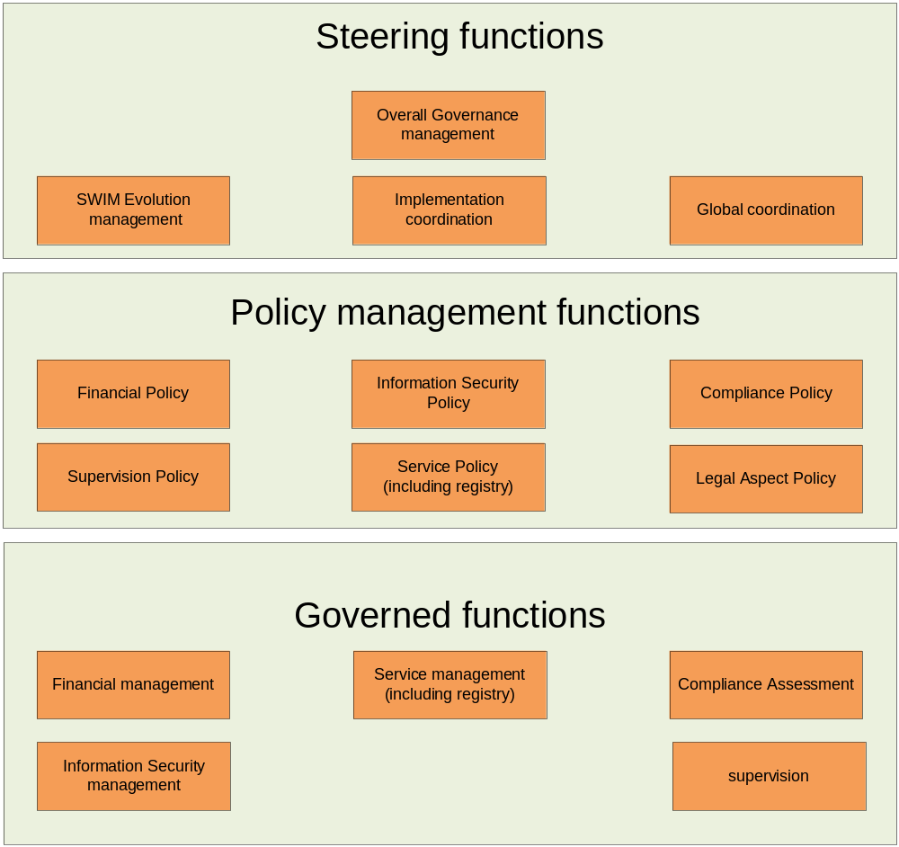
Figure 2 – IM Functions

The IM Functions are grouped as ‘steering’, ‘policy management’ or ‘governed’ functions:

- The ‘steering’ IM Functions are the functions that guide and steer the SWIM evolution. They also cover the actual overall SWIM governance process. The ‘steering’ IM Functions have a direct influence on the ‘policy management’ and ‘governed’ IM Functions.
- The ‘policy management’ functions create and maintain the policies for the areas covered by SWIM services (financial, compliance, supervision, etc.).
- The ‘governed’ IM Functions are classified as such because their scope is defined / delimited by the ‘steering’ and ‘policy management’ functions.

It is assumed that service providers will implement their own ‘IM Functions’ (i.e. governance) related to the services (and information) they provide. Therefore, it is expected that they will put in place appropriate Change, Fault, Performance and Security management mechanisms etc. In the SWIM context, the IM Functions classified as ‘governed functions’ represent just the IM functions that are ‘driven’ (or impacted) by the ‘steering’ and ‘policy management’ functions.

Tailoring the IM Functions for the iSWIM deployment
As mentioned within the document ‘IM Functions (governance specifications)’ [2] not all governance functions deemed to be needed for the iSWIM deployment within the PCP (Implementing Rule (IR) 716/2014).
The following table lists the proposed functions for PCP/iSWIM.

Functions | Description
Steering functions
Overall Governance | This is a transversal function affecting all other IM Functions. It is the root of all IM functions, it defines who (entity, group) is responsible to execute the other IM functions if not already defined in an agreed SWIM Governance structure. Its purpose is to ensure that SWIM Governance is fulfilled properly, i.e. it does what it is supposed to be doing, detects shortcomings and defines corrective actions that need to be implemented. It also steers SWIM Governance overall to adapt to changing conditions.
SWIM Evolution Management | This function will provide the overall control board for SWIM standards, SWIM Foundation and ‘SWIM common components’. It evaluates, approves or rejects change request. It ensures that decisions on change requests, submitted by e.g. the Global Co-ordination or the Service Lifecycle Management (described subsequently), are based on the best available expertise and supported by appropriate rationale.
Implementation coordination | This function will perform impact analyses of change requests that can impact the current operations requiring overall co-ordination for their implementation (e.g. putting in operation a new service instance, changes to operational service instance(s), changes to the SWIM infrastructure). The function will define appropriate transition plans and co-ordinate the execution of such plans.
Policy Management Functions
The SWIM governance process will be steered using SWIM Policies. A policy is a principle to guide decisions and achieve rational outcomes. The content of a policy comprises amongst others instructions how to conduct a process, which guidance and rules are to be used to create artefacts, how to assess the compliance of an outcome according to given quality criteria.

Information Security Policy | The function provides (defines and updates) the information security policy applicable to SWIM. The information security policy provisions shall be proportional to security requirements.
Service Policy | This function manages (defines and updates) the Service Lifecycle policy, including the Registry policy. The service lifecycle comprises several steps that a service needs to traverse from its inception to its deprecation. It defines all artefacts required to be produced during a service’s lifecycle and provides appropriate guidelines and rules to be applied (e.g. foundation material, templates).
Compliance Policy | The function manages (defines and updates) the SWIM Compliance Principles and Criteria. This Compliance policy may cover items (objects under assessment) such as service definitions; service Instances, SWIM infrastructure (e.g. SWIM nodes) etc.
Governed functions
Compliance Assessment | This function assigns the performance of compliance assessments as defined by the Compliance Policy Management function to service providers. These compliance assessments may mean executing tests available from third parties and furnishing such test reports as proof of compliance. They may alternatively mean that a formalized certification process needs to be undertaken by the service provider.
Service Management | In the scope of this function the activities in conjunction with the Service Lifecycle Policy as well as the Compliance Policy concerning the infrastructure and services provided by service providers are performed. For example in case a service provider would like to implement a new service instance, the aforementioned policies will indicate what actions and artefacts need to be performed/created to put the new service in operation at any given compliance level.

Not in scope of PCP/iSWIM governance

Functions | Why is the function not needed?
Steering functions
Global Coordination | The proposal considers that this IM Function is addressed by ad-hoc / current arrangements e.g. ICAO consultation arrangements, EUROCONTROL/FAA co-ordination group, EUROCONTROL AAB and sub-structure (Global Coordination is not specific to SWIM). The current working arrangements will need to be updated following the evolving requirements for coordination.  Considered the existing arrangements, it is not needed for the PCP / iSWIM deployment.
Policy Management Functions
Financial Policy | The proposal considers that the only Financial Policy available will be the one set by the European Commission in its regulations for the funding of the SESAR Deployment. It is assumed that the funding arrangements of the PCP/iSWIM cover the financial aspects for the iSWIM deployment and no specific financial policy for SWIM is needed. It is assumed that the operational running of the iSWIM services after the initial deployment is covered by the service provider.
Supervision Policy | The proposal considers that there will be no need in the context of the PCP to have Supervision implemented at a level higher than the local one. Therefore, no Supervision Policy will be needed, so this IM Function will not be needed.
Legal Aspects Policy | The proposal considers that no additional specific arrangements will be necessary for the PCP / iSWIM in addition to the existing national and European arrangements. Therefore, this IM Function will not be needed.
Governed functions
Financial Management | It is assumed that a Financial Policy will be available as defined by the EC for the SESAR Deployment. No specific for iSWIM Financial Policy will be required. Therefore, this proposal considers that this IM Function is not needed.
Information Security Management | The proposal assumes that even if a security policy is put in place, it will not impose to the service providers additional requirements specific to SWIM, other than what they are already supporting / implementing. Therefore, it is assumed that this IM function will not be needed
Supervision | The proposal assumes that there will no requirements on Supervision at level higher than the local one. Therefore, such IM Function will not be needed (see footnotes in section 3.3.4)

SWIM Governance Structure

Introduction
This chapter provides the actual governance bodies required to operate SWIM services in the “steady-state” configuration, i.e. when SWIM operational capabilities have been implemented and SWIM is used in ATM operations. High level information is provided concerning how this will be done in terms of roles, responsibilities, Interfaces to other bodies, the artefacts which are produced by the governance group as well as those which are needed as input material, etc

The governance bodies are the organisational instances composed of people from different organisations working together either temporarily or permanently. The governance bodies can be implemented either in a matrix organisation or in a line organisation, location spanning or residing at a specific location.

The governance bodies carry out the IM Functions attributed to them and introduced in chapter 3. For a better understanding, the following figure is provided to principally illustrate how the different IM Functions respectively the included activities are assigned to the governance bodies and reflected within the ToRs (terms of reference). Eventually governance processes are needed to be described. Those processes arrange governance activities in a timely order (see chapter 9.2.7).

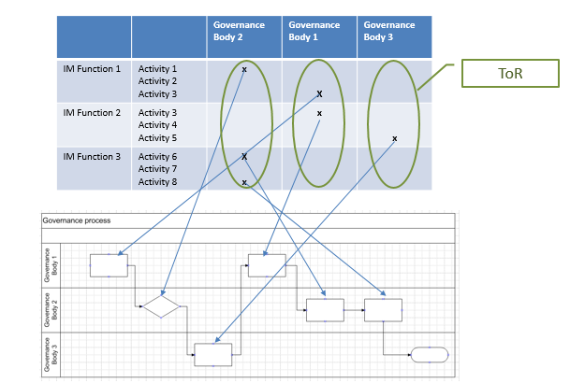
Figure 3: Dependency between IM Function governance bodies and governance processes

An overview of the SWIM Governance bodies and their relationships will be given as well as initial contents of Terms of Reference for each of the governance-bodies.

SWIM Governance Structure Overview
The picture below depicts the proposal of the governance bodies (called groups) to be created for the governance of SWIM. The governance structure proposed is modelled with the successful PENS governance approach as a role model. The first proposal of a governance structure for SWIM is exposed in appendix B of this document. This organisational structure was approved as fit for purpose by the A6 Steering Board in Q4/2014.
Nonetheless, the work on the governance structure has been going through several iterations and the concepts have been improved. The following figure represents the current proposal on how to shape the SWIM governance structure.
Therefore the new version of the governance structure was introduced on the level of the AIM/SWIM team and again discussed on the level of the A6 group in autumn 2015. It was approved by A6 and is now envisaged as appropriate to be the final aim for a SWIM governance structure.
The A6 board recommended that for the instantiation of this structure it needs to be linked to the decision and steering bodies, which are planned to be established for the NewPENS and Datalink governance.

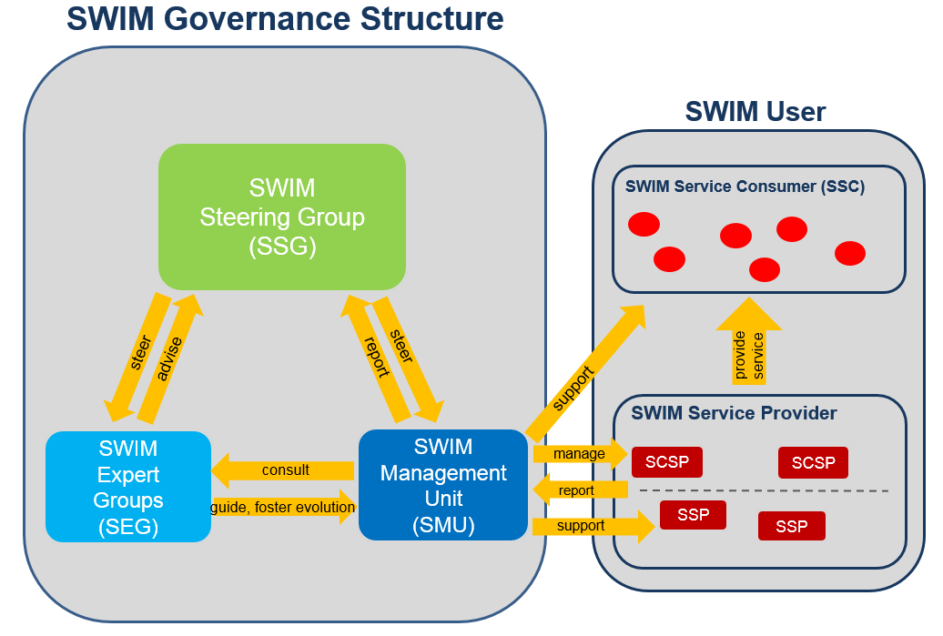
Figure 4: SWIM Governance Structure

This SWIM governance structure does address the SESAR PCP deployment as regulated in the EC Implementing Rule (IR) 716/2014.

SWIM governance shall be similar to that of PENS being undertaken by three groups representing the interests of the SWIM User:

- SWIM Steering Group (SSG)

The SWIM Steering Group (SSG) has to represent the interests of all SWIM stakeholders and shall oversee the operational and strategic development of SWIM. It shall steer the other governance bodies. In this regard it provides direction to the SMU for the collaboration with the SWIM Users and to the SEG for their technical advice provision.

The SSG is the decision making body for general topics which have a broad technical, strategic, political, financial or/and organisational impact. It serves as the final escalation body for disagreements on changes, problems or improvement suggestions.

In addition it has to ensure the coordination with the outside world on a global and European level, e.g. Deployment Manager, SESAR 2020, ICAO, EUROCAE, etc.

- SWIM Expert Group (SEG)

The SWIM Expert Group (SEG) has to provide technical and financial advice to the SSG.

The internal setup of the SEG will specifically address in a well-managed way the SWIM elements related to information (AIRM), or related to SWIM services, or related to the SWIM registry.

The SEG shall report to the SSG on assigned SWIM elements addressing current and future operations and requirements of SWIM, including the provision and maintenance of those SWIM elements (e.g. SWIM Policies, SWIM Foundation elements, guidance material).

The SEG conducts the SWIM change management activities.

The SEG provides technical solutions on delegated problems (e.g. as reported by the SMU).

- SWIM Management Unit (SMU)

The SWIM Management Unit (SMU) has to ensure the effective and efficient implementation of changes, problem solutions and requirements concerning SWIM Services and SWIM Technical Infrastructures.

The SMU shall carry out the day to day management of SWIM, including implementation planning and service monitoring for safety and time critical information services and common infrastructure services.

The SMU supports (e.g. by taking care of reported problems) the SWIM Service Consumers (SSC) and manages the SWIM Common Infrastructure Service Providers (SCSP). Thereto the SMU ensures the provision of common infrastructure services (e.g. the SWIM Registry).

The SMU supports stakeholders with conformance reporting according to the SWIM Compliance Framework. Thereto the SMU supports the SWIM Service Providers (SSP) by supplying needed materials and assistance to enable compliant service provisioning in accordance with the effective rules and policies.

- SWIM Users

The SWIM Users are not part of the SWIM Governance structure but are representing the main SWIM stakeholders. SWIM Users comprise SWIM Providers and SWIM Service Consumers (SSC). They are not represented by a single group, but are independent actors, whereby both the SSC and the SWIM Providers have common interests. The notion of SWIM Providers is an umbrella term for the SWIM Service Providers (SSP) and SWIM Common Infrastructure Service Providers (SCSP).

The SWIM Governance is established to act in the interest of the SWIM Users and has to ensure that the consumer/provider relationship is shaped according to the SWIM policies and rules.

The SWIM Common Infrastructure Providers (SCSP) supply common functionalities needed by providers and consumers of information services to technically establish a secure usage of SWIM services.

More details on the various governance bodies are provided in Chapter 5, introducing the terms of reference for the governance bodies.

Traceability between the IM Functions and the SWIM governance bodies
According to the proposal explored in the IM Functions (governance specifications) document [2] the IM Functions are tailored for the beginning of the PCP deployment. The following table provides an overview on the IM Functions to be established for this early phase and the assignment of those functions to the appropriate governance bodies.

Table 1: Mapping IM Functions and Governance Bodies

Governance Body | IM Function
SSG | Overall Governance Management
SMU | Compliance Assessment
SMU | Implementation Coordination
SEG | SWIM Evolution Management
SEG | Information Security Policy Management
SEG | Service Policy Management
SEG | Compliance Policy Management
SSP / SCSP | Service Management
SSP / SCSP | Compliance Assessment

SWIM Governance Bodies - Terms of Reference
The Terms of Reference (TOR) of the SWIM governance bodies define the roles, tasks and relationships between the governance bodies as well as a description of in- and outputs. References to the engineering artefacts of the IM Functions, i.e. the IM Functions requirements, listed in Part B of this deliverable are made in brackets.
It is anticipated that there will also be relationships to SESAR 2020 and the PCP deployment management. At the time of writing it is not possible to indicate how those relationships will be shaped. Hence they are not mentioned within the TORs. This is set aside, and if appropriate reassessed.
The requirements mentioned within this chapter are references to the 08.01.01 D47 IM Functions document (appendix C) [2].

SWIM Steering Group (SSG)

Role
The SWIM Steering Group (SSG) shall be the core European SWIM governance structure and govern the following SWIM elements:
- The SWIM Foundation, which provides a coherent set of principles, rules and recommendations for establishing SWIM standards related to information, information services, technical infrastructure and governance.
- The SWIM Standards, which are specifications provided to SWIM stakeholders to implement SWIM enabled applications.
- SWIM Guidance Material, developed in order to provide additional explanation to assist the application of the SWIM Foundation and the Standards used by SWIM.
The SSG is responsible for the steering of the overall governance [REQ-08.01.01-CONOPS-OGMa.0010] and will provide general decisions on the evolution of SWIM [REQ-08.01.01-CONOPS-OGMa.0020, REQ-08.01.01-CONOPS-SWEM.0010]. It is the SWIM authority that defines the roles and responsibilities of all other SWIM governance bodies. In this respect the group identifies and establishes the relevant decision bodies to perform change management on the various elements that build the SWIM Foundation, standards & guidelines [REQ-08.01.01-CONOPS-ImCo.0010]. It has to ensure transparency on the decision making process.
The SSG needs to ensure that the various initiatives, carried out by the other governance groups, pertaining to the evolution of SWIM artefacts are aiming at the same direction [REQ-08.01.01-CONOPS-OGMa.0020].
Its purpose is to ensure that the SWIM Governance is fulfilled properly, i.e. it does what it is supposed to be doing, detects shortcomings and defines corrective actions that need to be implemented [REQ-08.01.01-CONOPS-OGMa.0030].
It is currently not foreseeable if within the context of existing arrangements, the SSG will directly participate in global coordination activities, such as through the current ICAO consultation arrangements. Nevertheless it is crucial to ensure the influence of the European SIWM community on international SWIM matters.
For established coordination groups (e.g. ICAO consultation arrangements, EUROCONTROL/FAA co-ordination group, EUROCONTROL AAB and sub- structure, …) or groups that do not allow for direct participation of an SSG, european delegates of those groups could be nominated as associated partners of the European SWIM Governance and take an additional role to represent the European SWIM community. A briefing of those persons upfront the relevant international meetings to provide directives and also a de-briefing after the meetings to gain awareness on actual developments could be one means to achieve a two-way interaction based on well-established liaisons with external boards [REQ-08.01.01-CONOPS-GloC.0010].
If new groups for international coordination are formed, the European SWIM Governance should strive a representative of the SSG as such participate.
Outward facing (e.g. to external boards) it ensures that SWIM developments are not contradicting the principles of the European SWIM governance [REQ-08.01.01-CONOPS-GloC.0020]. Thereto it asserts to the SWIM community with the necessary influence.
Inward facing the SSG has to react to external developments in due time and needs to coordinate with the SWIM Stakeholders the implementation of envisaged changes triggered by external boards.
The SSG has to ensure that relevant information on the evolution of SWIM respectively the evolution of SWIM services is published in an appropriate way to enable the SWIM stakeholders to retrieve it.

Tasks
In SWIM decision making:
- Act as the final escalation body in case of disagreements concerning the implementation of changes to SWIM Capabilities.
- Make decisions on issues escalated to the group.
- Represent the highest escalation level in case of issues (e.g. compliance disputes) [REQ-08.01.01-CONOPS-OGMa.0050].

In SWIM coordination and collaboration:
- Coordinate with appropriate European organizations to perform the ‘Global Co-ordination’ IM function [2] for the SWIM Foundation, standards & guidelines. In particular, liaise with the current CPs and the ICAO IM Panel to either incorporate their input or provide contributions.
- Coordinate with appropriate European standardisation organisations on the SWIM Foundation and SWIM Standards [REQ-08.01.01-CONOPS-GloC.0030].
- Liaise with international organisations like the ICAO IM Panel and provide inputs linked to global coordination to the other governance bodies [REQ-08.01.01-CONOPS-GloC.0030, REQ-08.01.01-CONOPS-GloC.0040].
In SWIM evolution management:
- Provide directives for the SWIM Foundation evolution and endorse the publication of new versions of the SWIM Foundation under the form of a roadmap.
- Ensure a consistent and coherent evolution of SWIM Foundation, standards and guidelines.
- Endorse or initiate proposals for the evolution of the SWIM common infrastructure components and make decisions about their updates and upgrades [REQ-08.01.01-CONOPS-SWEM.0030].
- Initiate changes to SWIM Policies and SWIM Standards [REQ-08.01.01-CONOPS-SWEM.0030] and endorse them.
- Ensure that the SWIM Foundation, standards & guidelines are grouped together, referenced and put under configuration management.
- Provide change requests or input to change requests concerning issues originated by global coordination or issues which have transversal and /or strategic aspects. This concerns the SWIM Foundation, SWIM Standards as well as SWIM Common Infrastructure Components.
- Endorse the SWIM Foundation Evolution Plan, SWIM Standards Evolution Plan.
- The SSG will establish internal Change Control Boards for the following SWIM Standards [REQ-08.01.01-CONOPS-SWEM.0020, REQ-08.01.01-CONOPS-SWEM.0030, REQ-08.01.01-CONOPS-SWEM.0050]:
ATM Information Reference Model (AIRM)
The AIRM CCB is expected to:
- take into account the directions provided by the SSG
- inform on disagreements in changes to the AIRM
- inform on gaps not addressed by any of the existing processes.
- support the SSG in matters related to, or concerning the AIRM
- provide feedback on the SWIM Foundation Evolution plan
Information Service Reference Model (ISRM)
The ISRM Foundation CCB is expected to:
- take into account the directions provided by the SSG
- inform on disagreements in changes to the ISRM Foundation
- inform on gaps not addressed by any of the existing processes
- support the SSG in matters related to, or concerning the ISRM Foundation
- provide feedback on the SWIM Foundation Evolution plan
SWIM Technical Infrastructure and Profiles
The TI CCB is expected to:
- take into account the directions provided by the SSG
- inform on disagreements in changes to the “technical profiles and TI”
- inform on gaps not addressed by any of the existing processes
- support the SSG in matters related to, or concerning the “technical profiles and TI”
- provide feedback on the SWIM Foundation Evolution plan
SWIM Registry
The SWIM Registry CCB is expected to:
- take into account the directions provided by the SSG
- inform on disagreements in changes to the “SWIM Registry”
- inform on gaps not addressed by any of the existing processe
- support the SSG in matters related to, or concerning the “SWIM Registry”
- provide feedback on the SWIM Foundation Evolution plan

Reporting Line
The reporting lines of the SSG still need to be defined. It is envisaged, that existing governance arrangements for NewPENS and Data Link will be adapted to also provide the overall decision making for SWIM.

Composition

Chair
The Chairperson of the SSG shall be recommended by the SSG members and shall preferably be a stakeholder representative. The term of office for the chairperson will be for two years, renewable for one term.

Secretariat
The Secretariat of the Group will produce minutes of meetings and keep track of all discussion items, issues, decisions and resolutions and ensuring proper communication of the SSG work progress to all affected stakeholders.

Representatives
The composition of the SWIM Steering Group shall include a wide stakeholder representation within the context of the iSWIM deployment. It will include representation of the following stakeholders:
- ANSPs
- EUROCONTROL
- Airports
- Airspace Users
- ATM Industry
- Military Organisations
- Regulation and Standardisation Organisations

Working arrangements
The working arrangements will be based on meetings and work by correspondence.
The decisions by the SWIM Steering Group shall be taken by consensus. If consensus cannot be achieved, the disagreement will be documented and escalated to the appropriate body to seek to unblock the situation.

Input documentation
The SWIM deliverables from SESAR 1 will be used as the starting point for the work to be done by the SSG. Changes to the SESAR SWIM deliverables shall be part of a formal change management process, carried out by the respective SWIM Expert Groups.
The minimum inputs that should be considered are:
- SWIM ConOps ([1])
- IM functions ([2])
- Compliance framework ([3] and [4])
- Deployment schedules
- The ATM Masterplan
- SWIM Foundation Evolution Plan
- SWIM Standards Evolution Plan
The group will take into account the lessons learned from various SESAR activities, e.g. SWIM Masterclass, Validation Exercises, Compliance assessment reports, etc.

Output
- Recommendations / Action list for the other governance bodies
- Recommendations on SWIM standardisation
- ToRs for governance bodies
- Clearances for governance artefacts
- Signed final contract documents (e.g. service level agreements for common infrastructure services)

SWIM Expert Group (SEG)

Role
The SWIM Expert Group is tasked by the SSG to ensure that any decisions on SWIM are backed by adequate technical and architectural competence.
The SWIM Expert Group is mandated by the SSG to
- Run change control activities to manage the evolution of those SWIM elements that are specific to the European SWIM deployment, i.e. execute the SWIM Evolution Management function on these elements [REQ-08.01.01-CONOPS-SWEM.0030]
  - It is anticipated that there may be multiple Change Control Boards because (for example) changes to compliance rules and Technical Infrastructure components may have different stakeholder groups
- Represent the collective interests of the European SWIM stakeholders in the governance of standards that are used but not solely owned by European SWIM stakeholders (e.g. FIXM CCB). This representation may be ensured either through a coordination of the positions of the European members involved in these communities or through a direct representation of the SEG.
- The group is responsible for the creation and maintenance of the SWIM Policies [REQ-08.01.01-CONOPS-FiPo.0010, REQ-08.01.01-CONOPS-FiPo.0020, REQ-08.01.01-CONOPS-ISPo.0010, REQ-08.01.01-CONOPS-ISPo.0020, REQ-08.01.01-CONOPS-SePo.0010, REQ-08.01.01-CONOPS-SePo.0020, REQ-08.01.01-CONOPS-CoPo.0010, REQ-08.01.01-CONOPS-CoPo.0020, REQ-08.01.01-CONOPS-SuPo.0010, REQ-08.01.01-CONOPS-SuPo.0020, REQ-08.01.01-CONOPS-LAPo.0010, REQ-08.01.01-CONOPS-LAPo.0020].

Tasks
In SWIM compliance management
- Analyse compliance assessment reports (also for self-assessment reports) from a technical point of view, identify consequences and recommend technical actions.
In SWIM operations management
- Determine technical solutions to SWIM user problem reports on request of the SMU.
- Make technical proposals and recommendations on SWIM matters on request of the SMU, the SSG, or on its own initiative.
In SWIM change management (planning phase)
- Provide overall directions to the CCBs
- Manage the evolution of SWIM artefacts and SWIM common Infrastructures [REQ-08.01.01-CONOPS-SWEM.0030, REQ-08.01.01-CONOPS-SWEM.0050], i.e.
  - Receive Change Requests from the SMU.
  - Evaluate change requests and allocate to the appropriate internal or external CCB or CCBs.
  - Escalate to the SSG change requests and Ad-hoc reports on open issues which don’t fall within the remit of the SEG.
  - Establish and maintain a dialogue on long-term evolution and innovation with the technical experts of the SWIM User community.
  - For “internal” CCBS
    - Run the CCBs.
    - Coordinate and communicate between CCBs and act as the escalation body in case of disagreements.
    - Analyse change requests and technical change proposals from SWIM users and provide recommendations to the relevant CCBs.
    - Review and approve the ToRs and procedures of the CCBs.
  - For “External” CCBs
    - Elaborate appropriate Change Requests on behalf of the SSG.
    - Organize the contributions to the external SSG, either through liaison with the European participants, or through actual SEG participation and direct contribution.
    - Gather inputs from the CCBs meetings, analyse any decisions and evolutions affecting the European SWIM deployment, and report to the SSG.
In SWIM Change management (Implementation Phase)
- Review and approve, from a technical point of view, the integration plans, the integration documentation and eventually other implementation related documents (e.g. test reports).
In SWIM Governance internal tasks
- Ensure proper maintenance of the SWIM Registry and SWIM TI by co-ordinating with the recognized SCSP.
  - Set the priorities for the development of the SWIM Registry and SWIM TI.
- Define and maintain the SWIM Policies (Information Security Policy, Service Policy and Compliance Policy), SWIM Governance process descriptions and SWIM Governance templates [REQ-08.01.01-CONOPS-ISPo.0010, REQ-08.01.01-CONOPS-ISPo.0020, REQ-08.01.01-CONOPS-SePo.0010, REQ-08.01.01-CONOPS-SePo.0020, REQ-08.01.01-CONOPS-CoPo.0010, REQ-08.01.01-CONOPS-CoPo.0020].
  - Provide concrete directions to the SMU through the provisioning of the SWIM Foundation.
- Maintain the SWIM Foundation.
  - Provide and maintain a SWIM Foundation Evolution Plan and SWIM Standards Evolution Plan.

Reporting Line
The SEG reports on all relevant matters to the SSG.

Composition

Chair
The Chairperson of the Group will be nominated by the appropriate body (e.g. deployment manager, SSG) based on a recommendation/nomination of the Group members.

Representatives
The SEG provides the technical SWIM expertise (including financial advice when needed) and needs therefore to consist of experts for Service and Data Modelling, SWIM TI profiles, compliance, testing, procurement, infrastructures and SWIM Policies.
The “internal” Change Control Boards (i.e those responsible for artefacts under the auspices of SWIM Governance) are seen as extensions organised, steered or coordinated by the SEG. The composition of the CCBs needs to follow the particular specific competences needed.
These CCBS will be open to all interested members of the SWIM community. In order to avoid deadlock situations jeopardizing the SWIM deployment, their ToRs will be such that the SEG on behalf of the SSG can decide a solution. The SSG will be the ultimate escalation instance for these CCBs.

Input documentation
- Change Requests
- Technical User problem reports delegated by the SMU.
- Policy-applicable regulations from ICAO, EU and other organizations
- Standards of EUROCAE and EASA
- Existing Foundation Material
- Updated external reference material, and information on the planned evolution of such material.
- Proposed decisions of SMU, relevant to technical and compliance matters.
  - SWIM compliance assessment reports for technical review
- Requests for support in execution of SWIM compliance assessments

Output

- Updated means of compliance, where maintained by the SEG itself
  - e.g. ISRM models
  - e.g. SWIM TI specifications
- Sign-off on proposed decisions of the SMU on technical and compliance matters.
- Updated Foundation documents
- SWIM Foundation Evolution Plan
- SWIM Standards Evolution Plan
- Decisions on “internal” CR approvals and reports on the progress of “external” CRs
- Service Policy document (Service Policy, Information Security Policy and Compliance Policies)
- Updated Compliance Framework
- Compliance Assessment Reports

SWIM Management Unit (SMU)

Role
The SMU is the single point of contact for collaboration with the SWIM Users (e.g. escalation of problems).
The SMU acts as the coordinator when overall co-ordination for maintenance or implementation is required [REQ-08.01.01-CONOPS-ImCo.0010]. This coordination may relate to SWIM TI, SWIM Common Infrastructure Components, SWIM Service Descriptions and Instances, change requests that can influence the current operations putting in operation a new service instance or changes to operational service instances [REQ-08.01.01-CONOPS-ImCo.0020].
The SMU acts as the coordinator of compliance assessments [REQ-08.01.01-CONOPS-CpAs.0010, REQ-08.01.01-CONOPS-CpAs.0020].
The SMU acts as an escalation body for conflicts between SWIM Service Providers and consumers and will support the SWIM Service Consumer.

Tasks
In SWIM compliance management:
- Manage the implementation of the policies and standards provided by the SEG.
- Mandate the SEG or external assessors to perform compliance assessments, when applicable as defined by the compliance policy
- Coordinate between the SWIM providers and the mandated assessor, when applicable as defined by the compliance policy
In SWIM operations management:
- Analyse compliance assessment reports (also for self-assessment reports) from a formal point of view and request a technical review from the SEG. Based on the outcome recommend actions to be undertaken by the SWIM providers to fulfil compliance criteria.
- Produce and manage the contracts with the SCSPs and ensure that the expected service quality is met.
- Process problems reported by the SWIM Service Consumers or SWIM Providers and consult the SEG in technical and compliance matters.
- Escalate non-solvable or controversial issues to the SSG
In SWIM change management (planning phase):
- Draft change requests on behalf of the service providers and service consumers
- Receive and process change requests against any part of the European SWIM, i.e.
  - Conduct an impact analysis of Change Requests related to planning and project management matters, notably identifying planning dependencies [REQ-08.01.01-CONOPS-ImCo.0020]
  - Forward Change Requests to the SEG for discussion and decision via the relevant CCB or CCBs.
  - Identify and recommend SWIM user specific actions required to implement approved change requests.
  - Decide on the need for further over-all coordination and coordinate from the approval of a change request until the final implementation.
In SWIM Change management (Implementation Phase):
- Analyse and formally approve integration plans, integration documentation or test reports
  - Obtain a complementary review/approval from the SEG from the technical point of view
- Monitor the SWIM service management between providers and consumers, i.e. monitor version change, deprecation, cutover dates etc.
  - Define transition plans and co-ordinate the execution of such plans [REQ-08.01.01-CONOPS-ImCo.0030].
  - Obtain advice from the SEG on technical issues and dependencies.
- Maintain a record of the SWIM modification activities.

Reporting Line
The SMU shall regularly provide progress and critical problem reports to the SSG

Composition

Chair
The Chairperson of the Group will be nominated by the appropriate body (e.g. deployment manager, SSG) based on a recommendation/nomination of the Group members.

Representatives
The members of the group need to have skills in organising IT related projects and not necessarily need to have a technical background.

Input documentation
- Change requests for submission to the SEG (provided by SWIM Users) or requests to create such
- Change requests approved by CCBs, via SEG
- In case coordination is required: Maintenance Plans submitted by SWIM providers
- Compliance assessment reports transmitted by SWIM providers
- Integration plans and integration documentation
- Problem reports
Tentative:
- Test reports transmitted by SWIM providers
- Additional service lifecycle information from service providers

Output
- Impact Analyses reports
- In case coordination is required: Project Management outcome (e.g. Schedules, meeting minutes, …)
- Service Contract Definitions (e.g. SLAs)
- Problem Reports
- Transition plans
Tentative
- Schedules for a service deployment

Relationships between SWIM Governance Bodies

Relationships between SSG and SEG
The SSG will provide overall directions to the SEG concerning the execution of the change management process. The SEG will advise the SSG on controversial technical matters and crucial problems which have a high impact on several SWIM stakeholders and therefore need to take the positions of a broader audience into account. The SSG will initiate “top-down” change requests on those matters with the SMU and inform the SEG about the need to develop a change proposal.
The SEG will inform the SSG on gaps not addressed by any of the existing processes to initiate discussions and changes on the SWIM Governance functions. The SEG will also regularly keep the SSG informed on open and resolved problems and change requests.
The SEG has to align the maintenance and evolution of the SWIM Foundation Evolution Plan and the SWIM Standards Evolution Plan with the directives provided by the SSG.
The SSG will endorse the policies prepared and maintained by the SEG.

Relationships between SSG and SMU
The SSG will provide overall directives concerning the processing of change implementations and compliance assessments to the SMU. In return the SMU provides ad-hoc reports concerning disagreements on the implementation of changes or compliance assessments to the SCG. In addition the SMU will regularly report on the progress of change implementations.
When an SSG change request (with SEG change proposal) has been approved, the SMU will initiate an implementation planning process or immediately assign a SWIM Provider to implement the according change or problem solution.

Relationships between SEG and SMU
For change requests raised by the SSG, the SEG will provide detailed and mature change proposals and technical problem solutions to the SMU.
The SMU will request the SEG to conduct the technical review of SWIM compliance assessments / reports put forward by SWIM users.
The SMU will request the SEG to conduct the technical review of integration plans, integration documentation and test reports, and indicate approval or need for change.
The SMU can delegate the SEG with the execution of compliance assessments of SWIM Providers. In addition the SMU delegates problem reports to the SEG for further evaluations as well as feedback on the SWIM Foundation Evolution Plan and the SWIM Standards Evolution plan.

SWIM Providers (SSP/SCSP)
The notion of SWIM Providers is an umbrella term for the SWIM Service Providers (SSP) and SWIM Common Infrastructure Service Providers (SCSP).

The SWIM Providers perform the IM Functions “Service Management” and “”Compliance Assessment” as described in the “IM-Functions (governance specifications)” document [2].
The SWIM Providers are not a part of the SWIM Governance structure as such but are the governed parties, i.e. those parties to which the SWIM governance applies.

The SWIM Providers ensure stakeholder satisfaction by providing services according to the service quality defined in service contracts under the form of Service Level Agreements. These are normally handled in a direct provider to consumer relationship and follow the recommended principles of the SWIM Governance. In case of the common infrastructure components and safety or time critical services the SWIM Governance (namely the SMU) will act on behalf of the SWIM stakeholders. Furthermore, as a prerequisite for offering SWIM Services, the SWIM Service Providers have to be qualified as SWIM Providers.

The SWIM Providers report to the consumers on planned changes and known problems, coordinating change implementations and maintenance activities with them. In return the SWIM Service Consumers should communicate problems and suggestions for improvement.
SWIM policies govern the functions performed by the SWIM Providers.

SWIM Service Providers (SSP) Tasks
- Offer SWIM Information Services following the rules and guidelines provided by the SWIM Service Policy and further applicable documents.
- Accomplish compliance assessments according to the provider compliance policy.
- Perform the service lifecycle in accordance with the SWIM Service policy, if needed define an integration and transition plan to put a service into operations. It shall also define provisions addressing the potential interdependencies with other services.
This includes organizing and documenting a collaborative lifecycle process with the service consumers as described above, and reporting lifecycle related activities to the SMU.
- Maintaining all information related to services in the Registry including Service Definitions, when updates or new service definitions are required, and Service Instances. Depending on the type (Service Definition vs. Instance) different attributes (to be defined in the Service Lifecycle Policy) will have to be maintained.
- Provide final integration documentations and test-reports.

SWIM Common Infrastructure Service Provider (SCSP) Tasks
- Offer SWIM Common Infrastructure Components following the rules and guidelines provided by the SWIM Service Policy and further applicable documents.
- In case of compliance assessments being performed by a SCSP:
  - Accomplish compliance assessments according to the compliance policy.
- In case the Registry service is performed by a SCSP:
  - Handle registration requests, definitions in the registry, allocation of appropriate access rights, etc.
  - Other administration tasks concerning the information stored in the Registry. Such tasks could be cleaning up, triggering appropriate actions at the appropriate time (e.g. when the validation period of a compliance allocation expires, etc.).
  - Technical maintenance of the registry infrastructure such as the implementation of upgrades or changes mandated by the SMU.
  - Provide final integration documentations and test-reports.

Reporting Line
It is assumed that the SWIM Providers have established internal reporting mechanisms to ensure the availability of their services. Towards the SMU they have to report on compliance assessments, the progress of problem reports (in case of overall impacts) and the implementation of change requests.

Composition
The SWIM Providers are self-organised organisational separated independent actors, therefore statements concerning their composition can’t be made.

Input documentation
- Service Lifecycle Policy
- Compliance Policy
- Change Requests
- Problem Solutions
- Problem Reports (from the SWIM Service Consumer)

Output
- Compliance assessment report
- (Self)declarations of compliance
- Service definitions
- Service Instances
- Service Models
- Registry entries
- Service change-and decommissioning report
- Reports on Implementations of CRs and problem solutions
- Integration plans and integration documentation
- Test-reports

SWIM Consumers
The SWIM Consumers are not a part of the SWIM Governance structure but are governed parties, i.e. those parties to which the governance applies. The SWIM Consumers are stakeholders of the SWIM governance since they benefit from the standardisation of SWIM but also could be affected by change.
Typically, the deployment of a SWIM service requires compliant technical implementations on the side of both the provider and the consumer. Therefore consumers are also subject to certain implementation level aspects of SWIM compliance (e.g. it must be ascertained that no security breach occurs in the consumer side implementation).
All governed functions apply to SWIM Consumers, so their view is relevant in the corresponding change process.
SWIM consumer tasks therefore include:
- Consume SWIM Information Services, follow the rules and guidelines provided by the SWIM Service Policy and further applicable documents.
- Accomplish compliance assessments according to the consumer compliance policy.
- Provide final integration documentations and possibly other documentation, e.g. test-reports.

Considerations on Working Arrangements

The IM functions and the governance structure set the framework for managing SWIM in operation. Still a lot of options how to shape the concrete staffing and working arrangements remain.

This chapter provides considerations for the initial phase of SWIM deployment (iSWIM) on the composition of the governance bodies using certain criteria. Details on those criteria are exposed in appendix A.

The deployment of iSWIM takes the form of a Deployment Programme under the management of the SESAR Deployment Alliance.
Having this in mind it is assumed that the SWIM governance establishment will likely be sub-divided into two phases.
In the beginning it is crucial that a governance structure for the first years of the deployment phase has the ability to act rapidly and in a flexible way. Effective problem handling experience will have to build up first. (Note: the initial phase is the scope of this document.)
After this first phase the iSWIM governance arrangements should be reassessed and arising new conditions should be taken into account. This is required to maintain and improve where needed the cost efficiency and agility levels when moving to the subsequent SWIM governance.
In this second phase, which is out of scope of the document at hand, the governance processes should focus on stability and reproducibility as most of the problems are known and experience is available. At this point it is assumed that SWIM will be up and running in a relative steady state whereby the required governance arrangements evolved progressively into an effective and appropriate set-up.
The immutability of the governance structure is another pre-condition. Regardless how many information service instances will be implemented, consumed and maintained, the governance bodies will remain the same, instantiated for only one service or for a number of services. Consequently, it does not make sense to implement a governance body like the SWIM Steering Group (SSG) which is the judicative of the governance framework without instantiating in addition at least a minimum set of those governance functions which implement the executive authority represented by the SMU and SEG. This was proved by the experiences gained by the execution of the SEMG within the framework of SESAR 1 (please refer to chapter 9.1.5).
Corroborative the non-optional SWIM IM Functions are so much interrelated that their establishment as a whole needs to be ensured, otherwise significant functional gaps could appear, and would lead to inconsistencies and dead locks.

Team Composition Proposal for the initial Deployment
The following is a first proposal on how the working arrangements of the governance bodies could be shaped using certain criteria. It is needed to be noted that final governance arrangements can’t be stated at this stage. For the first realistic setup of a governance structure for the deployment phase with an intention on resources and costs, a first implementation of iSWIM needs to be fixed and agreed related to the locations, contents and the time. This forms the basis for cost/benefit-analyses which rely on stable and realistic parameters.
Following the considerations exposed in appendix “A” there are two valid group arranging options:
- Federated Teams

The term federated means that the organisational structure is made of a number of individuals / representatives from stakeholders that will dedicate part of their own work to the task set by the steering management. In other words, individuals / representatives from stakeholders selected by the steering management to be part of the team constitute a group of individuals from various companies which collectively proposes decision and provide direction in the domain they have been mandated for. The participants will work together temporarily within a matrix-structure on a decentralised basis.

- Designated Teams

Such a team is set under the control of a central and single authority, but disregards the location where the members reside. This approach seems to be appropriate having a pan-European governance concept in mind.

The term designated means that the organisational structure is set by the steering management to work on its behalf with a given mandate and timeframe. Individuals proposed to be part of the team work (full time) for this structure and might not represent anymore their own initial company. In other words, the individuals / representatives from stakeholders selected by the steering management to be part of the team constitute a single entity that makes decision and provides direction in the domain they have been mandated for.

A special case of a designated team is represented by a centralised team. Such teams are mandated by a single authority as a permanent instance residing (residential or temporary) at one location under the disciplinary control of one single authority.

Criteria
This sections provides an excerpt of the criteria to take into account for the choosing of a group arrangement. The main criteria to support the first deployment phase are:
- project-characteristic
- Need to act rapidly and flexible
- High problem intensity with broad variations
- Workload has peak characteristic

Team Composition for the SWIM Steering Group (SSG)
The SWIM Steering Group is acting on behalf of the SWIM Stakeholders. Therefore all SWIM Stakeholders need to have the chance to nominate participants into the group.
To fulfil the main purpose of steering the evolution of the SWIM Foundation and SWIM Standards the SSG as a decision making body has to handle technical, political, strategic, financial, and standardisation/regulation influences. The composition of the group related to expertise needs to take this broad variance of impacts into account.
It seems appropriate that in the beginning of the SWIM deployment, the group consists of nominated members in a federated team which concentrate on the start-up of SWIM. However, in the course of time a transition to a more and more federated team approach should occur. The workload when starting the group is rather high but will be handled by a lot of members, what implies a high fluctuation. As there should be some stability, this might be another argument for having some designated members in the beginning.

Team Composition for the SWIM Management Unit (SMU)
The SMU is the executive body of the SWIM governance and will have a constantly high workload in the beginning. The group has to react very quickly. Therefore it is considered to be constituted by designated members during the first period of the SWIM deployment complemented by “federated” team members on a needed basis. It seems also feasible to merge designated teams of the SSG and the SMU.
Eventually the SMU could be considered to be location-oriented to a certain extend in the beginning as the members need a continuous communication and the ability to meet very often without having the time to plan their resources and availabilities.
The expertise of the team members is not intended to be technical oriented, for technical problems the SMU should consult the SEG. As the SMU has to organise and manage the implementation of change requests and problem solutions it seems appropriate to have experts in project management in the team. Nevertheless a technical expertise can be very helpful.

Team Composition for the SWIM Expert Group (SEG)
The setup of the SWIM Expert Group should be established as a federated team but consist of nominated members in the beginning. The workload and the time criticality in this phase are estimated to be very high. During this phase this body should work constantly and be staffed with additional people depending on the issue to be solved.
In the course of time it is foreseen, that the workload on conceptual issues (in particular the evolution of policies and guidance) will decrease. In respect thereof the SEG will continue work solely using a topic-driven approach. These issues are typically not very time critical, so that the team can be formed ad-hoc.
On the other hand, the need to back up the SMU on technical issues will not disappear as the need for technical review and approval as well as for solution of technical problems is a constant of IT system evolution. It is important to notice that these activities are also time critical, i.e. availability of technical competence must not be allowed to become a bottleneck of SWIM governance.
The constitution of the SEG is not depending on a location as most of the solutions and concepts the group provides will not be prepared within the team but by single experts.
The bandwidth of themes the group has to handle is very broad, but will most of the time have a technical scope. Therefore a technical expertise is highly recommended. But also financial, and methodological experts as well as experts on standards and organisation will be needed.
A plausible team setup for the SEG is a small federated “standing committee” of technical experts (virtually) convening regularly and available on relatively short noticed but not working fulltime for the SEG. The SMU and SSG would communicate with this group. It would be itself backed up by a network of technical domain experts that accept delegations of review work or are consulted on specific matters in within the SEG.

Transition to an independent SWIM Governance
This chapter introduces considerations concerning the transition from SESAR 1 SWIM governance arrangements to governance arrangements needed for the iSWIM deployment within the PCP.

The governance structure to be brought into life will be a replacement of governance tasks established within the SESAR1 work packages 8 and 14.

The main drivers for a transition to a SESAR- independent SWIM governance are

- the ending of SESAR 1
- the deployment of iSWIM within the PCP
- foreseen new requirements on SWIM provided by SESAR 2020
- foreseen new requirements provided by independent initiatives initiated by e.g. SWIM Users

SWIM and its governance should be grown organically within an open and transparent framework, most importantly, in response to user needs.

SWIM Governance Prerequisites
Some aspects on prerequisites and pre-conditions for the establishment of SWIM Governance are highlighted within this chapter. However, this is not representing a full list. It is assumed that subsequent activities concerning the concrete planning and implementation of the governance structures and processes are addressing all aspects of SWIM governance in a profound way.

Sponsoring of SWIM Governance
At the moment of writing it is anticipated that the first implementation of a governance structure for iSWIM will be done under the remit of the SESAR deployment manager. A first INEA Call has been issued to initiate this iSWIM governance.

It is needed to be mentioned that the deployment manager would only be mandated to take care of the requests stipulated by the Implementing Rule (IR) 716/2014 concerning the Pilot Common Project (PCP). But in addition to what IR 716/2014 is regulating, new requirements will arise generated by SESAR 2020 or other activities undertaken outside SESAR. SWIM is evolving beyond what is mandated by the PCP. Those developments also need to be governed and the deployment manager is not mandated to handle this.

Compliance Testing or SWIM Reference Infrastructure
SWIM compliance has three main focusses, the compliance of service instance to a service technical design, the compliance of the logical service design with the according business needs and the compliance to a certain TI profile.
For the industrialisation of SWIM services it is crucial to establish a testing infrastructure to assess service instances in a real world reference environment.
Especially the assessment of service implementations under certain TI profile conditions before offering them to customers deems highly recommended to ensure the provision of the services according to the promised service quality.
This technical reference infrastructure should be separated from the real world SWIM infrastructures to enable predefined and standardised test cases with e.g. traffic simulations without having interferences of stochastic real world effects.

SWIM Foundation
Before starting to operate SWIM, a coherent baseline of the SWIM Foundation is needed, which is SESAR agnostic.

SWIM Service Portfolio Management
The service portfolio management of SESAR 1 was aiming in the management of the implementation and evolution of logical service models.
The continuous operative usage of service instances by service consumers was not in scope of SESAR 1. Therefore concepts for the establishment of a service portfolio management including service instances deem necessary.
For the operational usage of services some regulations need to be defined including e.g. considerations about what would happen to already implemented service instances if there is a change to the according logical service description.

Validation of the Governance Structure
To validate the governance structure and principles within SESAR 1 it didn’t seem to be appropriate to rearrange the already established working arrangements of the SESAR1 WPs 8 and 14.
A restructuring would have jeopardised the validation of SWIM services for the SESAR releases 4 and 5 which was considered as an important prerequisite for the start of the PCP.
Instead it was decided to just implement one IM function (SWIM Evolution Management) within a group called the SWIM Evolution Management Group (SEMG), which would work as a decision and coordination board in cooperation with the existing teams and bodies of SESAR 1.

Experiences gained during the runtime of the SEMG
The idea of setting up a pilot SWIM governance group, also known as SWIM Evolution Management Group (SEMG), was initiated at the Project 08.01.01 Gate meeting in June 2014. The Project team proposed then to define an additional task (SWIM Evolution Management implementation and Operation) whose output would be used as an input to the document at hand and IM functions documents [2]. The SEMG was then kicked off at the end of 2014 as the result of the SJU request to project 08.01.01.

The main goal for the establishment of the SEMG was to implement and gain experience with the SWIM Evolution Management IM function and to update the ‘IM Functions’ deliverable. Furthermore, the group was also set to ensure that the various initiatives, carried out by specialist groups, pertaining to the evolution of SWIM artefacts elements are heading to the same direction and are carried out in a consistent way. The Terms of Reference of the SEMG, reflecting this framework and main objectives, are provided in Appendix C.

The SEMG held 8 meetings in one year. The main points discussed during these meetings are listed below:
- SWIM governance structure
- SWIM foundation, essential requirements, standards and guidance material
- SWIM standardization roadmap, processes and priorities, list of applicable standards
- SWIM registry
- SWIM compliance
- Information : AIRM and exchange models, controlled vocabulary
- Services : ISRM, SDCM (the SESAR/NEXTGEN common Service Metamodel), STDD (technical design document of a service), taxonomy of services
- International developments
As can be seen with the above list, the main challenges faced by the SEMG are the wide variety of topics linked (more or less directly) with governance on the one hand, and the technical nature of many topics. The former one led to a difficulty to address all the current topics of interest in a limited (meeting) time, the latter one highlighted the difficult balance between remaining a « high-level, decision-oriented » forum and a technical expert group.

A clear benefit from the SEMG includes the opportunity to tackle some transverse topics (e.g. the service description model thread) together with all affected stakeholders and to be able to converge to common positions and consensual propositions (e.g. SDCM). Another positive feedback is the establishment of key SWIM elements supporting the whole notion of SWIM governance: foundation, essential requirements, list of standards and guidance material.

Sharing information on international developments is also deemed as beneficial so that all stakeholders get the right level of awareness about ongoing discussions related to SWIM governance at various levels (regulation, standardization, ICAO).

As the SEMG was mandated to be a decision body, it deemed necessary to establish in addition temporarily operating task forces to further evaluate on technical aspects or refine governance related artefacts. Those task forces represented and acted similar to what within the envisaged future governance arrangements would be the so called expert groups (SEG). They have been staffed with SWIM experts taken from the SESAR 1 workpackages 8 and 14.

The outcomes of the task forces had a great impact on the day to day business within these SESAR workpackages. For example, the STDD was used to document the technical service designs and to show evidence that the validation exercises (e.g.VP-679 on runway management) have built their prototype services in compliance with the logical service designs derived from the SESAR OSED requirements.

The exchange of service metadata between the registries of NEXTGEN and SESAR was made possible by the alignment of the registry entries via the SDCM, which is another good example for the achievements of the tested organisational structure.

The existing working arrangements of the SESAR/SWIM thread implemented what the task forces stipulated. In this respect they represented the third pillar of the foreseen governance structure, the SWIM Management Unit (SMU).

The envisaged partitioning of SWIM governance into the three pillars, decision making, expert judgement and implementation management was demonstrated to be a realistic approach as almost naturally after establishing the SEMG the work breakdown was structured in a similar way.

The drawback of the SEMG includes the trend to commit in the technical details rather than stay at the decision-making level, thus slowing down the whole process. Another experienced difficulty is linked to the tendency to assign to the SEMG agenda all topics deemed as non-consensual but requiring consensus, thus making the agendas of SEMG meetings overloaded with not necessarily priority topics.

The difficulty of making decisions on some non-consensual topics without management commitment can also be noted as a point to be improved.
The lessons learned from a one-year experience with SEMG shows clear benefits with actual progress made on the creation of SWIM governance artefacts (SWIM foundation, contribution to SWIM standardization artefacts), the refinement of common components (registry), the exchange of information on international developments, the progress of the work on information (controlled vocabulary) and services (work on SDCM, propositions for the future of ISRM).
An additional recommendation given the SEMG experience would be to clearly engage the stakeholder management in the SWIM governance groups so that decisions can be made, including on topics for which full consensus cannot be achieved.

SWIM Governance Policies
A SWIM Governance Policy groups a coherent set of rules and principles on certain cases of governance to steer decisions and achieve rational outcome. Thus it makes the operation of the SWIM Governance deterministic. A SWIM Policy is the framework, in which the SWIM Governance Processes are defined.
The SWIM governance policies will rely on and adapt rules and guidelines achieved by SESAR 1.
Envisaged content of the policies:
- Scope
- Applicability
- Liability
- Roles and responsibilities
- Governance processes
- Charging
- Intellectual property rights
An exemplary policy on compliance will be provided with the IM Functions [2] document.

SWIM Governance Processes
As a part of the SWIM Policies, SWIM Governance Processes can be defined to better illustrate the timely order in which the activities are executed and describe the collaboration and transition of responsibility between the different governance bodies.
Examples of processes could be
- Change Management
- Problem Management
- Portfolio Management
- Standards Management
- Foundation Management
- Compliance Assessment
- Service Activation
- Service Decommissioning
- Service Monitoring

Change Management Process (example)
To illustrate how such a process is supposed to look like one example diagram is provided within this section:
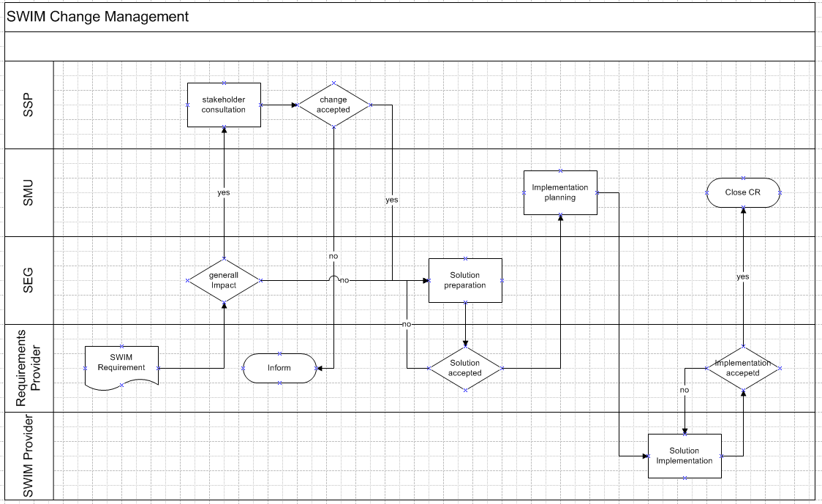
Figure 5: Example Process for Change Management
Such a Change Management process could be provided more than once:
- For several policies
- For one policy but addressing different objects (e.g. the service instance and the Registry which are both addressed by the service policy).

SWIM Service Lifecycle Process
This is another example on a higher level which could be a part of the service policy. The following figure describes a process for the lifecycle of a SWIM Information Service.
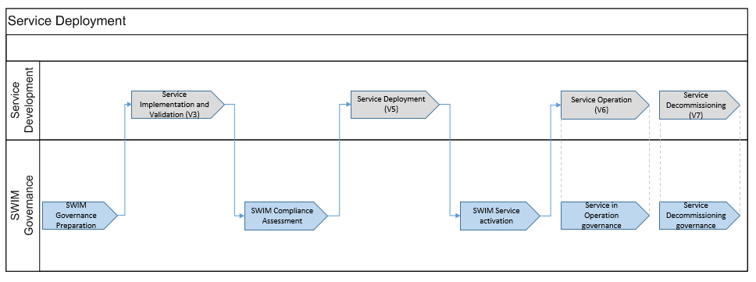
Figure 6: SWIM Service Lifecycle

SWIM Governance Preparation
During this phase all the prerequisites and preconditions to start the deployment of the first SWIM services need to be established, like the SWIM policies, the SWIM Registry, SLA Management, Service Portfolio Management, governance process descriptions, templates, etc. It is assumed that at this point in time an appropriate governance structure is set up and running to accomplish the preparation and subsequent governance tasks. More on that is explained within chapter 9.2.
SWIM Compliance Assessment
The SWIM Compliance assessment is using the SWIM compliance policy and associated artefacts like SWIM Rulebooks, compliance report templates etc. The inputs for that phase are standardised comprehensive descriptions of the service designs ware foreseen to be implemented by the service providers and an integration planning for the service instance.

The output is the approval of SWIM compliancy, eventually complemented by an implantation plan and the clearance for the service deployment. The compliance assessment can be a provider self-assessment, in this case the provider delivers a compliance assessment report which will be approved by the governance authorities or the governance authorities will assess the service and generate the report. More information on that is given in [2].

To use software in operational scenarios certain software assurance levels need to provided, depending on the safety-criticality of the operational process which is supported by the information service. An evidence that the service design was accomplished respecting the appropriate software-assurance level might be given by the service provider.

SWIM Service Activation

During the service deployment the providers will install, integrate, validate and test the service instances. This also includes the operational testing according to regulated testing-procedures if indicated.

Appropriate test-reports need to be provided before the service can be activated.
The service activation is the step which makes the service available for the service consumer. It has a number of prerequisites which are exemplarily mentioned here.

For the service activation the service provider has to ensure and provide:
- proper registry entries (service logical design, service technical design and service instance metadata)
- testing- reports
- service integration documentation (systems, software.. )
- SLAs
- ..

Governance of services in operation

Also during service operation it is crucial to have governance mechanisms in place. During the operational phase the main governance tasks are the change management, problem management and service monitoring (ensuring that the service is provided according to the promised quality levels).

Appropriate governance processes have to be established and the involvement of the SWIM stakeholders has to be assured.

Service Decommissioning

The service decommissioning concerns the service instances as well as the service design descriptions. It has to be ensure that a substitute for a deprecated service is available, that service consumers are informed in time, that service providers implement instances on the basis of new logical descriptions that plans for decommissioning are available, etc.

Service Level Agreements (SLAs)
A SLA is a contract between a provider and a consumer. Regarding SWIM there are the following types of providers:
- SWIM Service Provider
- SWIM Common Infrastructure Provider
- SWIM Network Provider
During the starting phase of the iSWIM deployment the first contracts with providers need to be established. As a prerequisite it is needed to standardise the integral parts of the contract.
The contracts have to be established between
- SWIM Service Provider SWIM Service Consumers or SSG as the representation of the SWIM Service Consumer
- SWIM Common Infrastructure Service Provider SSG as the representation of all SWIM Users
- Network Provider SSG as the representation of all SWIM Stakeholders
Likely it will not be required to establish a single contract with every service provider as most of the conditions are equal for all providers. Therefore it could be feasible to establish a single standardised contract for all service providers (eventually grouped by SWIM profile) and extend this contract with additional conditions if needed.
Bilateral contracts between a service provider and service consumer should follow SLA specific guidelines and standards stipulated by the SWIM Governance framework e.g. by providing a SLA template.

Transfer of Responsibility
In 2016, when SESAR1 will have been ended also the SWIM governance activities undertaken within SESAR1 will come to end. It deems not appropriate to halt the SWIM Governance as the deployment manager (DM) will need support SWIM governance right from the beginning.
A continuing of SWIM Governance should be provided right from the beginning of the iSWIM deployment. This first activity should have a scope as described hereafter.
- The SWIM Governance & Coordination would further build on the experience of the SEMG (SWIM Evolution Management Group). The content of the work can be based on the TOR of that group and will support the Deployment Manager by coordinating between SESAR deployment projects and R&I programs. It has both, a management body (e.g. SEMG), but also technical experts would be needed to update e.g. the ISRM for the projects, guidelines, compliance criteria, etc.

Under the guidance of the DM the task aims in developing and proposing the governance structures and processes for SWIM, re-using the work done in SESAR1. It will provide a fine-tuning of the SESAR1 work and preparation for implementation.

The main participants to this task are probably in the area of the ANSPs, supported by industry for the technical parts.

- The SWIM Compliance support consists of assistance that is given to the SESAR deployment projects to adhere to SWIM. The SESAR deployment projects should reach a SWIM maturity (compliance) level, complete the compliance report and provide the evidence.
Assistance on this topic is important as the SESAR deployment projects might not (yet) have the experts that are able to deliver the compliance evidence, etc.

The second part of the compliance support relates to tools for SWIM compliance. Within the technical area, a number of tools have being developed to test the compliance of the services. More work is required to have a compliance toolset. The main participants to this part will be the industry partners.

- The Transition Support is providing the assessment of the current legacy infrastructure, and would deliver a plan for an optimised and timely transition of this equipment towards SWIM on request of the organisation which is planning to provide or consume a service.
Each ANSP will have a need for such a support. This support will be provided ‘independently’ per DM project.

- The Registry in support to governance, co-ordination and compliance will publish the SWIM reference material, provide the inventory and status of the services, collect compliance evidences, etc.

- The legal and financial aspects of a SWIM in operation need to be addressed, as SESAR 1 focused on R& D and did not face such issues.
These first activities resolve concrete problems occurring during the first phase of the iSWIM deployment and create the basis for the establishment of the permanent SWIM Governance structure.
When the permanent structure is established and validated, the DM support task will end.

International aspects

ICAO Information Management Panel

Background
In November 2012, the ICAO 12th Air Navigation Conference, while considering agenda item 3 – Interoperability and data, through globally interoperable SWIM, recommended ICAO to update the information management / system wide information management (IM/SWIM) working arrangements and to develop the related specifications pertaining to the technical performance, security requirements, bandwidth requirements of a global framework supporting a global SWIM concept for air traffic management operations.
On 28 November 2013, ICAO Air Navigation Commission agreed to establish an expert group to progress the work associated with global information management: the Information Management Panel (IMP). The IMP objective is to elaborate on the necessary concepts, and to investigate and develop a global interoperability framework comprising information models, service models, architecture, governance functions, and service requirements to maintain information security, integrity, confidentiality and availability. This Panel will also develop the Standards and Recommended Practices (SARPs) necessary for harmonized global implementation.
Taking into account the nature of the task to be performed by the panel, the Air Navigation Commission invited membership from the following States and international organizations: Australia, Brazil, China, France, Germany, India, Japan, Russian Federation, Singapore, South Africa, Turkey, United Arab Emirates, United States, the Agency for Air Navigation Safety in Africa and Madagascar (ASECNA), Civil Air Navigation Services Organisation (CANSO), European Organisation for the Safety of Air Navigation (EUROCONTROL), International Air Transport Association (IATA) and the International Coordinating Council of Aerospace Industries Associations (ICCAIA).
The first meeting of the IMP is planned for 26 to 30 January 2015.

Terms of Reference
The Terms of Reference of the Information Management Panel are the following
a) Background
The Information Management Panel (IMP) is to be established to develop a global and harmonized interoperable approach and elaborate on necessary concepts in order to ensure effective management of information, including identifying the need for new information exchange formats, on a system-wide basis within the air navigation system.
A global approach on information management (IM) is essential to ensure global interoperability and standardization across all data domains and to support activities such as flight and flow - information for a collaborative environment (FF-ICE), the evolution of meteorological services towards digital information exchange and a NOTAM system review.
b) Scope
The Information Management Panel (IMP) will investigate and develop solutions supporting the planning framework on information management contained in the global air navigation plan (GANP), including further development of system-wide information management (SWIM) using as a basis the SWIM concept as elaborated by the Air Traffic Management Requirements and Performance Panel (ATMRPP).
The IMP will develop a global interoperability framework for international air navigation. Its components (for example, technical resources such as information models and associated exchange formats, service models, governance functions and structure) will be worked upon as they are identified and agreed during the course of the IMP proceedings.
c) Required expertise
The panel shall be preferably composed of experts involved in:
    - cross data domain information management processes in the field of air traffic management (ATM);
    - the transition of State data domain specific systems (flight operations, meteorological services, airport services or aeronautical information service (AIS)) to a cross data domain IM system; and
    - the operational use of information supplied.
d) Objectives
1. Define the Global Interoperability Framework (including a minimum set of global use cases, models, processes and requirements) describing the functions, architectures and system design requirements which should include the items further described hereafter.
2. Define and elaborate on the ATM information management concepts, functions and processes required, including a business model to provide accredited, quality-assured and timely information required by actors within the air navigation system and used to support operations (including full FF-ICE, digital MET information exchange and NOTAM system review) on a system-wide basis, including avionics.
3. Identify the quality of service requirements necessary to maintain ATM information security, integrity, confidentiality and availability, and to mitigate the risks of intentional disruption and/or changes to safety-critical ATM information.
4. Develop an ATM information service architecture.
5. Identify the requirements for SARPs and changes to existing SARPs that will provide an interoperable environment to support the information requirements of all air navigation services (ANS) stakeholders in accordance with the blocks and operational improvements outlined in the Global Air Navigation Plan and:
    - develop those SARPs necessary to enable SWIM in accordance with the roadmap outlined in the Global Air Navigation Plan;
    - provide suitable objectives and requirements to serve as the basis for SARP development by other groups where appropriate; and
    - update and maintain the information management roadmap.
6. Develop transition strategies and guidance necessary for the implementation of global SWIM and new information exchange formats, including future avionic requirements.
7. Identify and plan for anticipated data and information flows in relation to future ATM requirements and capabilities and assess the capacity of appropriate facilities to support them.
e) Working arrangements
It is anticipated that the panel will be supported by working groups, each dealing with a specific area. Precise details and meeting frequency/locations will be provided once the group has been established and determines its tasks. It is expected that data domain specific elements would be handled in coordination with domain specific expert groups, for example, an envisaged future MET Panel.
For AIS to AIM, the existing Aeronautical Information Services-Aeronautical Information Management Study Group (AIS-AIMSG) will be maintained until completion of current work on the amendment of Annex 15 — Aeronautical Information Services and PANS-AIM. The further evolution and work on AIM towards cross domain information management will then fall under the remit of the IMP.

Link with SESAR SWIM Governance
SWIM being a global concept, the SESAR SWIM governance has to fully take into account the IMP work.
Firstly, the SESAR SWIM governance bodies should act first as sources of inputs for submission of the governance principles developed within SESAR and presented in this deliverable for consideration at the global ICAO level.
The governance bodies will also be a good means to communicate the output of the IMP work, so as to allow identification of the potential required evolutions in the governance concepts within SESAR that need consequential amendments or supplements.
The SESAR governance should facilitate an optimum coordination of propositions made from SESAR to the IMP and, the other way around, effective dissemination of the IMP outputs to all affected stakeholders. This can be further facilitated by several SESAR memberships in the IMP.

EASA RMT on SWIM
The EASA rule-making programme for 2014-2017 includes a Rule-Making Task (RMT) on SWIM to support the SESAR PCP.
This RMT will develop provisions (rules, acceptable means of compliance, guidance material) for organisational requirements with respect to the introduction of SWIM. It is anticipated that the RMT will focus on rights and obligations for SWIM stakeholders to provide a legal framework for service provision.
The RMT should be set-up in 2015 for a period of two years.
(TBC when more information from EASA is available)

Link with SESAR SWIM Governance
The EASA RMT will formalize into a European Rule those elements of SWIM governance deemed necessary in order to ensure a harmonized implementation of SWIM within Europe. As such, much of the SWIM governance developed during the SESAR programme will serve as input to the RMT. The RMT feedback will become de-facto governance rules to be enforced in Europe.

EUROCAE work on SWIM
In May 2012, EUROCAE established a strategic line on the subject of SWIM that subsequently led to the set-up of a EUROCAE SWIM Task-Force (TF). This TF aims at reviewing the existing activities on SWIIM in Europe in various for a (SESAR, EASA, EUROCONTROL, etc.) and proposing standardization activities to be initiated at EUROCAE level.
The TF anticipates that an overarching EUROCAE SWIM group could oversee, coordinate and harmonise the different transversal SWIM standardization aspects across the existing EUROCAE Working Groups. This overarching group would need participants from different ATM data domains who are operationally as well as technically skilled. These working arrangements would facilitate EUROCAE being the natural candidate to elaborate technical CS as and when required.
It should be noted that as the US NextGen programme identifies SWIM as a pillar of its concept, it would be appropriate that this WG works jointly with an equivalent RTCA counterpart.
Besides this suggestion for a coordination working group, there are already a number of EUROCAE working groups that deal with topics that are now part of SWIM (WG44, WG59, WG69 and WG76). Typically, WG44 has engaged as a forerunner on writing SWIM related provisions for Aerodrome Mapping data and information services. However, when the EUROCAE WGs were created SWIM did not exist and thus the WG activities range from data and format definition to technical infrastructure (e.g. WG59). SWIM clearly makes the distinction between the information and the infrastructure and for the latter the intent is to limit the number of technologies. It would then seem more appropriate to reorganise the EUROCAE activities around those principles and have on one hand groups dealing with information through identified communities of interest (when inherited from the past or not adequately covered by ICAO activities) and on the other hand at least one working group for the technology/profiles, the maximum being one per profile type. The table below shows how this could be organized.

Data domain | Aeronautical | Flight | Surveillance | Weather | Airport | ATFCM
Information standardisation activities | ICAO | ICAO/WG59 | EUROCONTROL/WG51 | ICAO/  WMO | WG44/69 | ICAO
Supporting Technology/profile | Between one and three WGs depending on the decision

Link with SESAR SWIM Governance
As in other ATM domains, EUROCAE provides a proven framework to develop industry standards supporting a global system. For SWIM, some of the governance principles will rely on the availability of such supporting standards, so a review of the work being set at EUROCAE level is deemed required.

References
- 08.01.01 D42 – SWIM ConOps
https://extranet.sesarju.eu/WP_08/Project_08.01.01/Project%20Plan/DEL08.01.01-D42-SWIM%20conops.doc
- 08.01.01 D47 Part B – IM Functions
https://extranet.sesarju.eu/WP_08/Project_08.01.01/Project%20Plan/D47%20SWIM%20Governance%20Structure%20and%20IM%20Functions/DEL08%2001%2001-D47-SWIM%20IM%20Functions.doc
- 08.01.01 D48 – SWIM Compliance Framework Principles https://extranet.sesarju.eu/WP_08/Project_08.01.01/Project%20Plan/D48%20SWIM%20Compliance/08%2001%2001-D48-SWIM%20Compliance%20Framework%20Criteria.docx
- 08.01.01 D45 – SWIM Compliance Framework Criteria for R4 V&V exercises https://extranet.sesarju.eu/intraprogman/Assessment%20Library/08%2001%2001-D45-SWIM%20Compliance%20Framework%20Criteria%20for%20R4%20V-V%20exercises.doc
- 08.01.03 D14-001 – ATM Information Reference Model https://extranet.sesarju.eu/intraprogman/Assessment%20Library/8.1.3.D14_Intermediate_Release_for_v3.doc
- 08.01.03 D46 – AIRM Foundation: Rulebook
https://extranet.sesarju.eu/WP_08/Project_08.01.03/Project%20Plan/Archived_Deliverables/8.1.3.D46_AIRM_Foundation_Rulebook%20v4.0.0.doc
- 08.03.10 – DEL 8.3.10.D64 ISRM-Model
https://extranet.sesarju.eu/WP_08/Project_08.03.10/Project%20Plan/ISRM%201.4/DEL_08.03.10_D64_ISRM1.4.1-model.zip
- 08.03.10 – D44 ISRM Foundation Rulebook
https://extranet.sesarju.eu/WP_08/Project_08.03.10/Project%20Plan/ISRM%20Foundation%2000.07.00/ISRM_Foundation_Rulebook.docx
- 14.1.3 – D38 SWIM Profiles for Step 2 - Iteration 3.1
https://extranet.sesarju.eu/WP_14/Project_14.01.03/Project%20Plan/P14.1.3-D38%20SPD%20v3.1.doc
- COMMISSION IMPLEMENTING REGULATION (EU) No 716/2014 on the establishment of the Pilot Common Project supporting the implementation of the European Air Traffic Management Master Plan
- 08.01.01 D51 SWIM Foundation Primer
https://extranet.sesarju.eu/WP_08/Project_08.01.01/Project%20Plan/D51%20SWIM%20Foundation/DEL08%2001%2001-D51-SWIMFoundationPrimer.docx

- Options on working arrangements for the SWIM Governance bodies
Despite the fact, that there are a lot of similarities compared with governance teams implemented by a single organisation or company, a team building for a Pan-European governance structure entails additional political and cultural aspects which needs to be reflected when setup teams.
An analogy with the IT business (source Gartner), there are four predominant business and IT global governance orientations, each with distinctive characteristics.

- Centralized businesses strive to provide consistent product and customer experiences globally, and seek to maximize synergies by centralizing assets and capabilities.

- Federated businesses aim for global efficiency as well as flexibility to adapt products and services locally, where possible. They maximize synergies relating to their competitive strategy, centralizing strategic assets and decentralizing the others.

- Parent-led businesses seek to adapt parent business policies and practices across the local businesses when they can achieve specific synergies for certain products, processes or customers. Most assets are decentralized though.

- Multi-local businesses build strong local bases and emphasize local self-sufficiency.

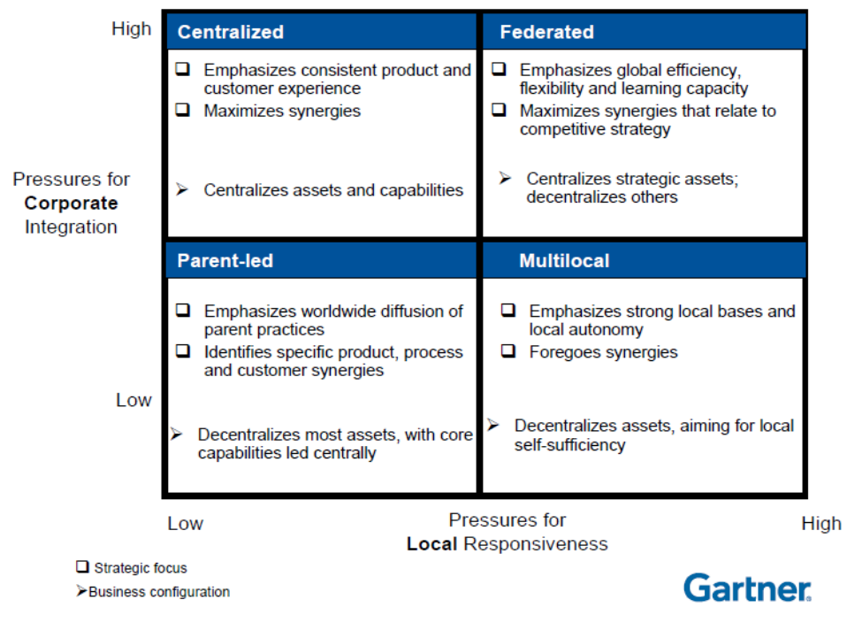

The Parent-led as well as the multi-local concept doesn’t seem to work in a multinational and cross-organisational context as there is not placed enough emphasis on governance. They suggest a more locally organised governance on a volunteer basis.

As a consequence for SWIM the centralised (within this document called “designated”) and federated concepts seem appropriate alternatives for consideration. Within the following sections the two concepts will be explained in some more detail and briefly analysed in terms of their advantages/disadvantages. It should be noted that for all mentioned disadvantages there might be mitigating actions. But this is not the scope of this document. The disadvantages are solely mentioned to get a clue on which concept to use for which situation and governance body.

Federated Teams
The term federated team means that the organisational structure is made of a number of individuals / representatives from stakeholders that will dedicate part of their own work to the task set by the steering management. In other words, individuals / representatives from stakeholders selected by the steering management to be part of the team constitute a group of individuals from various companies which collectively proposes decision and provide direction in the domain they have been mandated for. The participants will work together temporarily within a matrix-structure on a decentralised basis.

Advantages
- Flexibility: Federated teams work problem driven and utilise differing individuals which leads to a variety of expertise and knowledge for working on various topics. A broad-based alternating team helps to handle various types of contexts and situations.
- Costs: A federated team will be constituted only when needed and therefore only be paid for the time they are concentrating on a topic.
- Codetermination: Decision making on a federated basis offer the possibility to let all interested organisations have their influences on the achievements.

Disadvantages

- Availability: It can be difficult to get the right people together in a sufficient time frame
- Fluctuation: As the participants only work together in a temporarily manner, it is likely that there is a high fluctuation, which hinders the team building process and leads to time consuming learning processes.
- Efficiency: As different organisations are having different agendas or strategies according to SWIM, a federated approach, where team members also have to take the strategy of their company into account, might be less performant.

When to choose a federated approach?
As this approach is the one with the better performance in terms of costs, it should always be considered in the first run. But there is a break-even point. When the same group constitutes very often in short time periods and the work gets more and more permanently, the cost for travelling, communication, work preparation, etc. might outrun the savings. In this case a dedicated approach should be taken into account.
Generally a federated approach should be chosen when:
- the governance is in the status of transition or needed within a project structure
- deep and specific expertise on various topics are needed
- work is to be done occasionally

Generally a federated approach should not be chosen when:
- the group needs to setup very often on a short term basis

Designated Teams

A designated team disregards the location where the members reside. Anyway, the team is set under the control of a central and single authority. This approach seems to be appropriate having a pan-European governance concept in mind.

The term designated means that the organisational structure is set by the steering management to work on its behalf with a given mandate and timeframe. Individuals proposed to be part of the team work (full time) for this structure and might not represent anymore their own initial company. In other words, the individuals / representatives from stakeholders selected by the steering management to be part of the team constitute a single entity that makes decision and provides direction in the domain they have been mandated for.

A special case of a designated team is represented by a centralised team. Such teams are mandated by a single authority as a permanent instance residing at one location under the disciplinary control of one single authority.

Advantages
- Efficiency: A designated team can be very efficient regarding decision-making. It has a clear and consistent view of its mission and of the objectives and underlying vision of its subject.
- Responsibility: The members of a designated team have potentially a high identification with and knowledge of the themes they are mandated for.

Disadvantages
- Costs: A designated team will probably be more costly than a federated team
- Flexibility: As the designated team consists of permanent members, issues which need a specific expertise can’t be resolved in short term as additional expertise needs to be gained.
- Persuasibility (independency): In the case that the organisational body performing a governance task is under the control of a single organisation the priorities might be set not according to the European interests but to the strategic views of that single entity.

When to choose a designated approach?
Generally a designated team should be chosen when
- the workload for the team is constantly high
- the team needs to work very tightly together and needs to often find quick solutions
- the scope of the group is to steer and organise rather than to solve technical problems
- the bandwidth of themes is clearly defined and rather narrow with not a lot of exceptions

- A6 Governance Proposal
The governance proposals made in the document at hand are relying on a preceding evaluation on governance structures prepared by the A6 Group as Input to SESAR Project 08.01.01. As PENS governance is scoping on network infrastructures, further investigations and discussions on the topic of SWIM governance have shown that a slight deviation from the primary approaches was needed to satisfy best the needs of governing the overlying levels starting from technical infrastructures (e.g. middleware functionality) up to Software implementations,
SWIM Governance Proposal
The picture below depicts a proposal of the groups/bodies to be created for the governance of SWIM. The proposal is modelled with the successful PENS governance approach as a role model.
This first proposal was introduced on the level of the A6 group in 2014.

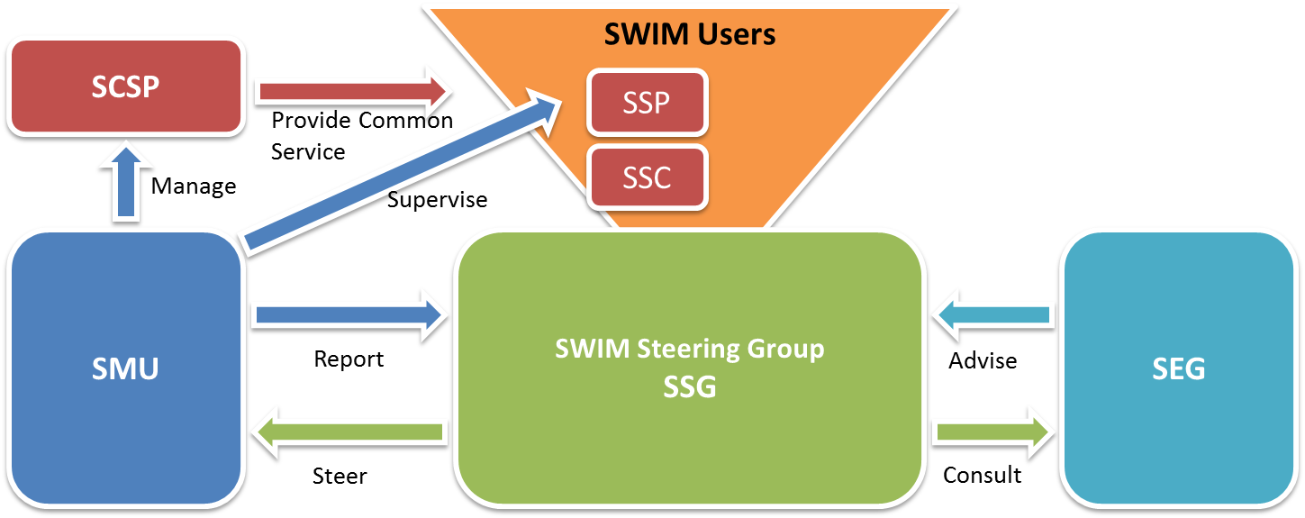

SWIM governance shall be similar to that of PENS being undertaken by two groups representing the interests of its users: a SWIM Steering Group (SSG), supported, where needed, by a SWIM Expert Group (SEG)
In Europe, SWIM users comprise SWIM Service Consumers (SSC) and SWIM Service Providers (SSP) The SWIM Common Service Provider (SCSP) that provides SWIM Common Services will be managed by a SWIM Management Unit. The SWIM Common Services support the operation of SWIM.

So, SWIM Users will authorize, through their representation on the SWIM Steering Group, the SWIM Management Unit (SMU) to ensure the provision, monitoring, and supervision of the SWIM Common Services on their behalf in order to meet their SWIM performance needs. While the authority to demand and authorize the provision of a SWIM Common Service formally resides with the SWIM Users, this right is exercised by the SWIM Steering Group, the actual decision making body. Daily management of the SCSP is delegated to the SMU as the operating body. As the SCSP works, in effect, for the SWIM Users, it is not represented by the SSG

Responsibilities
- The SWIM Steering Group (SSG) shall oversee the operation and strategic development of the SWIM. It shall provide direction to the SMU for the management of SWIM common components and to the SEG for their technical, financial and administrative advice provision.
The main functions of the SSG are the Overall Governance Management and the Global Co-ordination.
- The SWIM Management Unit (SMU) shall carry out the day to day management of SWIM, including planning, monitoring the service and liaising with the SWIM Service Providers and SWIM Service Consumers. It will carry out the IM functions of SWIM Evolution Management, Implementation co-ordination and Common component supplier management.
- SWIM Expert Group (SEG) shall provide technical and financial advice to the SSG. The SEG shall report to the SSG on matters relating to the current and future operations and requirements of SWIM. The SEG deals with the policies required for SWIM Governance, i.e. Financial Policy Management, Service Lifecycle Policy Management, Compliance Policy Management and the optional Supervision Policy management.
- The SWIM Common Service Provider (SCSP) shall provide SWIM common components according to the management of SWIM Management Unit.
- The SWIM users comprise SWIM Service Consumers (SSC) and SWIM Service Providers (SSP) that use the SWIM Common Components infrastructure to consume or provide SWIM services. The SWIM Users are represented in the SSG.

Mapping IM Functions to SWIM Governance Groups
IM Function | Governance Body carrying out
Overall Governance Management | SSG
Global Coordination | SSG
SWIM Evolution Management | SMU
Implementation Coordination | SMU
SWIM Common Component Supplier Management | SMU
Financial Policy Management | SEG
Information Security Policy Management | SEG
Service Lifecycle Policy Management | SEG
Compliance Policy Management | SEG
Supervision Policy Management | SEG
Service Management | SSP / SCSP
Financial Management | SSP / SCSP
Compliance Assessment | SSP / SCSP
Supervision (optional) | SSP / SCSP
Information Security Management (optional) | SSP / SCSP / SSU

Mapping to ITIL Processes
The IT Infrastructure Library (ITIL) for IT Service Management describes a number of processes that cover the entire lifecycle of a service provision. As ITIL in its current version 3 is a well-established de-facto standard that is widely applied, the project team undertook to cross-check the IM Functions described in this document with the ITIL processes for 2 purposes:
- To underpin the necessity of the IM Functions
- To ensure that none of tasks of the ITIL processes is left out by mistake (deliberate exclusion of certain tasks and processes is of course possible)
The cross-check was done using a so-called RACI matrix that describes the roles for each ITIL process. RACI stands for Responsible, Accountable, Consulted and Informed with the following meanings:
- Responsible: Those who do the work to achieve the task. There is at least one role with a participation type of responsible, although others can be delegated to assist in the work
- Accountable (also approver or final approving authority): The one ultimately answerable for the correct and thorough completion of the deliverable or task, and the one who delegates the work to those responsible. In other words, an accountable must sign off (approve) on work that responsible provides. There must be only one accountable specified for each task or deliverable.
- Consulted: Those whose opinions are sought, typically subject matter experts; and with whom there is two-way communication.
- Informed: Those who are kept up-to-date on progress, often only on completion of the task or deliverable; and with whom there is just one-way communication.
SWIM will see a split responsibility between IM Functions that provide a central steering and Functions that are carried out by a local service provider. In some cases a global accountability, responsibility or consultancy is complemented by a local one that fulfils the IM Function on a local level. In these cases the local role is denoted by a lower-case letter.

The following depicts the RACI Matrix mapping IM Functions to ITIL processes
 | IM Function Group | Steering functions |  |  |  |  | Policy Management Functions |  |  |  |  | Governed service provider functions
 | ITIL Process/IM Function | Overall Governance Management | Global Co-ordination | SWIM Evolution Management | Implementation co-ordination | Common component supplier management | Financial Policy Management | Information Security Policy Management | Service Lifecycle Policy Management | Compliance Policy Management | Supervision Policy management (optional) | Service Lifecycle Management | Financial Managment | Compliance Assessment | Supervision (optional) | Information Security Management (optional)
Service Strategy | Portfolio Management | A | C | R |  |  | C
Service Strategy | Demand Management | A |  |  |  |  |  |  | R |  |  | a/r
Service Strategy | Financial Management | A |  |  |  |  | R |  |  |  |  |  | a/r
Service Design | Service Level Management | A |  |  |  |  |  |  | R |  |  | a/r
Service Design | Service Catalogue Management | A |  |  |  |  |  |  | R |  |  | a/r | c
Service Design | Capacity Management |  |  |  |  |  |  |  |  |  |  | A/R
Service Design | Availability Management |  |  |  |  |  |  |  |  |  |  | A/R
Service Design | Continuity Management |  |  |  |  |  |  |  |  |  |  | A/R
Service Design | Information Security Management | A |  |  |  |  |  | R |  |  |  | c |  |  |  | a/r
Service Design | Supplier Management | A |  | C | C | R
Service Transition | Change Management |  |  | A | R |  |  |  | C |  |  | a/r
Service Transition | Configuration Management |  |  |  |  |  |  |  |  |  |  | A/R
Service Transition | Release Management |  | C | A | R |  |  |  |  |  |  | a/r
Service Operations | Incident Management |  |  |  |  |  |  |  |  |  |  |  |  |  | A/R
Service Operations | Event Management |  |  |  |  |  |  |  |  |  |  |  |  |  | A/R
Service Operations | Request Fulfilment
Service Operations | Problem Management |  |  |  |  |  |  |  |  |  |  | A/R
Service Operations | Access Management |  |  |  |  |  |  |  |  |  |  |  |  |  |  | A/R
Continual Service Improvement | Continuous Service Improvement | A |  | R |  |  |  |  |  |  |  | a/r |  |  | c

The above mapping is the basis for the descriptions of the IM Functions in this document. Wherever the table denotes an A, R or I, the functions description will list more details on this IM Functions’ task,
Note that in cases where the IM Function is not mapped to any ITIL process, this does not automatically imply that the function is obsolete. This solely means that this Function is not covered in the ITIL framework. Nevertheless the function Security Policy Management is considered to be not needed.

- SEMG Terms of Reference
The SJU requested project 08.01.01to instantiate the IM Function “SWIM Evolution Management”.
There are three main reasons for the establishment of the SEMG:
- Practically implementing and gaining experience with the SWIM Evolution Management IM function as described in the ‘IM Functions’ deliverable and provide feedback to P08.01.01 to update the ‘IM Functions’ deliverable.
- Ensuring that the various initiatives, carried out by specialist groups, pertaining to the evolution of SWIM elements are aiming at the same direction and are carried out in a consistent way.
- Gathering and processing the requests for evolution of SWIM, expressed by stakeholders e.g. when defining and implementing new SWIM Foundation guidelines or rule sets.
It is acknowledged that SWIM Evolution Management is already addressed by a number of existing bodies and projects. It is not anticipated that the SEMG will take over existing activities; rather the SEMG will liaise with them to ensure the required consistency.

The SWIM Evolution Management Group is a group established within the framework of SESAR 1. The group does not address SWIM deployment considerations.
Role
The SWIM Evolution Management Group is established and mandated by the SESAR Joint Undertaking (SJU) as:
- the group to perform “SWIM evolution management” as described in the “IM-Functions (governance specifications)” document [2].
- the decision making body for the definition and evolution of the SWIM Foundation, standards & guidelines and other SWIM elements such as the SWIM common infrastructure components within SESAR 1.
- responsible for ensuring that the SWIM Foundation, standards & guidelines are grouped together, referenced and put under configuration management.
The group will ensure transparency of the decision making process about defining and setting the SWIM Foundation, standards & guidelines.

Tasks
In order to fulfil its role the SWIM Evolution Management Group will:
- Define the SWIM Foundation, standards & guidelines and the relationships with and among SWIM elements.
- Ensure a consistent and coherent evolution of the SWIM Foundation, standards & guidelines.
- Align the priorities for the development of the different elements that build the SWIM Foundation, standards & guidelines and identify the impacts on the dependant SWIM elements (e.g. logical models, service models, adopted standards).
- Provide inputs for the evolution of the SWIM standards in coordination with WP C03.
- Define the SWIM Foundation, standards & guidelines evolution plan.
- Schedule the publication of new versions of the SWIM Foundation, standards & guidelines under the form of a roadmap.
- Evaluate proposals for evolution of the defined elements that build the SWIM Foundation, standards & guidelines and make decisions about their updates and upgrades.
- Coordinate with appropriate European organizations to perform the ‘Global Co-ordination’ IM function [2] for the SWIM Foundation, standards & guidelines. In particular, liaise with the current CPs and the ICAO IM Panel to either incorporate their input or provide contributions. Note that the SJU and its members will ensure that proper liaison is established with international SWIM activities (including, but not limited to those bodies listed in the ‘Global Co-ordination’ IM function).
- Identify or establish the relevant decision bodies to perform change management on the various elements that build the SWIM Foundation, standards & guidelines.
- Contribute to the update the IM functions deliverable.
- Validate the IM function ‘SWIM Evolution Management’ within the SESAR 1 programme.
Reporting Line
The SWIM Evolution Management Group is established, mandated and governed by the SJU. It reports to the SJU on all its tasks.
Relations with other projects and groups.
The SEMG is part of the SESAR working arrangements for SWIM. It will coordinate as necessary with other SESAR projects and groups dealing with SWIM such as:
ATM Information Reference Model (AIRM) Change Control Board (CCB)
The SWIM Evolution Management Group will:
- provide overall direction for the SWIM related aspects of the AIRM development through the declaration of SWIM Foundation, standards & guidelines, its Evolution Plan and the SWIM elements over time
- provide inputs linked to global coordination, e.g. feedback from the ICAO IM Panel
- act as the escalation body in case of disagreements within the AIRM CCB
The AIRM CCB is expected to:
- take into account the directions provided by the SEMG
- inform on disagreements in changes to the AIRM
- inform on gaps not addressed by any of the existing processes
- support the SEMG in matters related to, or concerning the AIRM
- provide feedback on the SWIM Foundation Evolution plan
Information Service Reference Model (ISRM) Foundation Change Control Board (CCB)
The SWIM Evolution Management Group will:
- provide overall direction for the SWIM related aspects of the ISRM Foundation development through the declaration of SWIM Foundation, standards & guidelines, its Evolution Plan and the SWIM elements over time
- provide inputs linked to global coordination, e.g. feedback from the ICAO IM Panel
- act as the escalation body in case of disagreements within the ISRM Foundation CCB
The ISRM Foundation CCB is expected to:
- take into account the directions provided by the SEMG
- inform on disagreements in changes to the ISRM Foundation
- inform on gaps not addressed by any of the existing processes
- support the SEMG in matters related to, or concerning the ISRM Foundation
- provide feedback on the SWIM Foundation Evolution plan
Service Coordination Group (SCG)
The SWIM Evolution Management Group will:
- provide overall direction for the SWIM related aspects through the declaration of SWIM Foundation, standards & guidelines, its Evolution Plan and the SWIM elements over time
- provide inputs linked to global coordination, e.g. feedback from the ICAO IM Panel
- Provide comments on the Service Roadmap
The SCG is expected to:
- take into account the overall directions provided by the SEMG
- inform on gaps not addressed by any of the existing processes
- provide feedback on the SWIM Foundation Evolution plan
- Provide the Service Roadmap to the SEMG
P14.1.3 / P14.1.4: SWIM Technical Infrastructure and Profiles
The change and configuration management activity concerning the SWIM Technical Infrastructure has been organised between projects 14.01.03 and 14.01.04.
The SWIM Evolution Management Group will:
- provide overall direction for the SWIM related aspects of the “technical profile and TI” through the declaration of SWIM Foundation, standards & guidelines, its Evolution Plan and the SWIM elements over time
- provide inputs linked to global coordination, e.g. feedback from the ICAO IM Panel
- act as the escalation body in case of disagreements on change and configuration management within 14.01.03 and 14.01.04

Projects 14.01.03 and 14.01.04 are expected to:
- take into account the directions provided by the SEMG
- inform on disagreements in changes to the “technical profiles and TI”
- inform on gaps not addressed by any of the existing processes
- support the SEMG in matters related to, or concerning the “technical profiles and TI”
- provide feedback on the SWIM Foundation Evolution plan
P08.01.01: Registry
It is assumed that a change and configuration management activity concerning the “SWIM Registry” will be performed in project 08.01.01.
The SWIM Evolution Management Group will:
- provide overall direction for the SWIM related aspects of the “SWIM Registry” through the declaration of SWIM Foundation, standards & guidelines, its Evolution Plan and the SWIM elements over time
- provide inputs linked to global coordination, e.g. feedback from the ICAO IM Panel
- act as the escalation body in case of disagreements concerning SWIM Registry changes
The “SWIM Registry” change and configuration activity in 08.01.01 is expected to:
- take into account the directions provided by the SEMG
- inform on disagreements in changes to the “SWIM Registry”
- inform on gaps not addressed by any of the existing processes
- support the SEMG in matters related to, or concerning the “SWIM Registry”
- provide feedback on the SWIM Foundation Evolution plan
WP C: standardisation
SEMG will liaise with WP C for aspects related to the regulation of the SWIM foundation, standards & guidelines. The SEMG will then provide a common view on SWIM standardisation.
The SEMG will not be involved in the production of the regulation nor in the production of standardisation material (as a group) but will point out to WPC, the SESAR SWIM related material that is ready to be an input for standardization processes.
Composition
Chair
The Chairperson of the Group will be nominated by the SJU based on a recommendation/nomination of the Group members.
Secretariat
The Secretariat of the Group will:
- Produce minutes of ‘evolution management’ meetings
- Keep a log of all discussion items, issues, decisions & resolutions and this under the form of a simple list.
Representatives
The aim of the SWIM Evolution Management Group is a wide stakeholder representation based on the anticipated interest in this activity from (types of) organisations that will be involved in SWIM developments outside the specific SESAR R&D programme in order to manage the evolution of SWIM Foundation, standards & guidelines and SWIM elements within the context of SESAR 1 and, subsequently, its deployment. For that purpose, it shall be composed of representatives of SESAR members covering the Information, Services and Infrastructure domains. It will include representation of the following stakeholders: the SESAR Joint Undertaking, EUROCONTROL, ANSPs, airlines and the manufacturing industry.
In addition to the representatives, experts from the regulation and standard organizations may be invited to the meetings when actual regulation or standardization actions are to be discussed.
Working arrangements
The SEMG will be setup and arranged in the context of P08.01.01. The P08.01.01 project will take benefit of this first instantiation of the SWIM Evolution Management IM function to further refine the IM Functions document accordingly.
The working arrangements will be based on meetings and work by correspondence. The frequency of meetings within SESAR 1 will be set by the chairman (Webex by default, face-to-face meetings to be organized only when required).
The decisions by the SWIM Evolution Management Group shall be taken by consensus. If consensus cannot be achieved, the disagreement will be documented and escalated to the SJU decision-making level.
Subgroups may be established to focus on one or several of the tasks of the group.
Communication
The group will ensure communication of its main output through co-ordination with WP 14.04.
The reports, minutes and other material will be distributed to the members participating to the SEMG meetings as well as the WP Management of WP14, WP8, WPB43. A formal SESAR distribution list will be established with all the implied actors. From time to time a report to WP Leaders and the SCG can be performed (including a kind of awareness for the system and ops projects).
Input documentation and deliverables
The minimum inputs that should be considered towards establishing the SWIM Foundation are:
- SWIM ConOps ([1])
- IM functions ([2])
- Compliance framework ([3] and [4])
- AIRM and Foundation documents ([5] and [6])
- ISRM and Foundation documents ([7] and [8])
- SWIM profiles ([9])
- Project schedules
- The ATM Masterplan
- Service roadmap
- V&V roadmap
The group will take into account the lessons learned from various SESAR activities, e.g. SWIM Masterclass, Validation Exercises, Compliance assessment reports, SCG, etc.
Output
- Definition of the SWIM foundation, standards and guidance material
- Recommendation / Action list for the projects and working arrangements
- Provide feedback to P08.01.01 to update the IM function deliverable, when applicable
- Providing a common view on SWIM standardisation
- SWIM Foundation, standards and guidance material evolution Plan under the form of a roadmap.
- Contributions for communication to WP 14.04.

-END OF DOCUMENT-

This is envisaged to be done by a planned INEA Project for iSWIM governance.
As it has already been stated previously, this does preclude every service provider to implement their ‘local’ Supervision processes according to their ‘local’ practices and applicable regulations.
In the case that assessments are needed and are accomplished by an external authority, the SMU coordinates or exercises them.
This concerns self-assessments and collaboration during external assessments.
The CPs ensure the coordination of specific SWIM related themes between the European SWIM Authorities and the FAA/ NEXTGEN SWIM Authorities
Some of the objects under governance are under full control of the SWIM governance and therefore an internal CCB will be established to control their evolution. An internal CCB is an integral part of the SWIM governance organisation. Other standards are “external”, managed outside of the SWIM governance structure, but having a major impact on SWIM. There is a need to coordinate their evolution with external CCBs.
It is envisaged, that the CCBs will be executed under the control of the SEG.
It is currently still under discussion, if the AIRM CCB will be an external or internal board.
It should be noted that in general, most service implementations and updates will be co-ordinated between the service providers and their consumers.
For more details see appendix A.
For more details on criteria see appendix A.
For more information on policies refer to [2]
Note that to a large extent there is no difference between the provision of a SWIM Service and a SWIM Common Service. Both types of service providers are governed by the same rules, have the same responsibilities etc. The major difference between a SWIM Service Provider and a SWIM Common Service Provider lies with the form of oversight. SWIM Service Providers are subject to the supervision of the SWIM Management Unit, which ensures that the rules of properly accessing and using the infrastructure are observed. Whereas the SWIM Common Services Provider is managed under contract by the SMU to ensure that prescribed performance and QoS requirements are met.
Where needed as described in the IM Functions Specification
The SWIM common infrastructure components are SWIM technical infrastructure elements implementing a shared capability. These include the registry and Public Key Infrastructure (PKI) [10] (This definition comes from the SWIM ConOps document (see ref [1]). As it is indicated in such document, the ‘common components’ term has been replaced in the latest WP14 documents by ‘common functional blocks’. It was decided not to change the term in the SWIM ConOps and keep the former one. The same decision has been made in this ToR to easier its readability).
The SEMG has no direct co-ordination with CPs and the liaison is ensured by SJU.
The potential role of this Group within the context of the PCP will have to be further discussed with the Deployment Manager when nominated.
At the time the ToR is being produced, it is not defined if the full ISRM or just the ISRM Foundation will be part of the SEMG scope.

