
SWIM Registry Concept of Operations V2
Document information
Project Title | Operational ATM Requirements and Demands concerning ATM Information Catalogue & Registry Services
Project Number | 08.01.01
Project Manager | EUROCONTROL
Deliverable Name | SWIM Registry Concept of Operations V2
Deliverable ID | D53
Edition | 00.02.03
Template Version | 03.00.00
Task contributors
EUROCONTROL, DSNA, DFS
Abstract
This document provides a detailed view of the SWIM Registry. It describes what it is (i.e. what kind of data is stored and which services are provided), who is involved (i.e. roles and responsibilities), why it should be implemented (i.e. benefits and implications), the business processes it supports including use cases and other additional considerations important for its implementation (i.e. security, safety, supervision and topology).

Authoring & Approval
Prepared By - Authors of the document.
Name & Company | Position & Title | Date
Pedro Fernandez Sancho | 8.1.1 Team member | 20/11/2016

Reviewed By - Reviewers internal to the project.
Name & Company | Position & Title | Date
Stephane Dubet | 8.1.1 Team member | 25/11/2015
Oliver Krueger | 8.1.1 Team member | 01/12/2015
Sam Van Der Stricht | WP8 Deputy Project Leader | 30/11/2015
Eric Roelants | 8.1.1 Project Manager | 11/01/2016
Pedro Fernandez Sancho | 8.1.1 Team member | 20/11/2016

Reviewed By – Other SESAR projects, Airspace Users, staff association, military, Industrial Support, other organisations.
Name & Company | Position & Title | Date
Hakim Souami | WP14 Team member | 07/01/2016
Juliette Engel | B.4.3 Team member | 04/01/2016
Scott Wilson | WP8 Team member | 04/12/2015
SEMG members | SEMG | 15/01/2016

Approved for submission to the SJU By - Representatives of the company involved in the project.
Name & Company | Position & Title | Date
Stephane Dubet | 8.1.1 Team member | 25/11/2015
Oliver Krueger | 8.1.1 Team member | 01/12/2015
Sam Van Der Stricht | WP8 Deputy Project Leader | 30/11/2015
Eric Roelants | 8.1.1 Project Manager | 11/01/2016
Pedro Fernandez Sancho | 8.1.1 Team member | 20/11/2016

Rejected By - Representatives of the company involved in the project.
Name & Company | Position & Title | Date

Rational for rejection
None.

Document History
Edition | Date | Status | Author | Justification
00.00.01 | 26/10/2010 | Draft | Pedro Fernandez | New document including structure skeleton
00.00.02 | 29/10/2010 | Draft | Pedro Fernandez | Document structure skeleton update based on team review
00.00.03 | 9/11/2010 | Draft | Pedro Fernandez | Added content to “Registry Content and Structure” section
00.00.04 | 10/11/2010 | Draft | Pedro Fernandez | Added team review comments to “Registry Content and Structure” section
00.00.05 | 15/12/2010 | Draft | Pedro Fernandez | Added sections 3,5,6,7 and changes to section 4.
00.00.06 | 17/12/2010 | Draft | Pedro Fernandez | Added Eric’s comments.
00.00.07 | 26/01/2010 | Draft | Pedro Fernandez | Added Georg’s comments.
00.01.00 | 31/01/2010 | Draft | Pedro Fernandez | Removed comments and tracked changes from previous versions for handover to SJU.
00.01.01 | 04/03/2011 | Draft | Pedro Fernandez | Included topology section plus clarification on design vs run-time usage of the registry.
00.01.02 | 20/04/2011 | Draft | Pedro Fernandez | Updated DSNA disclaimer
00.01.03 | 05/05/2011 | Draft | Pedro Fernandez | Added security section
00.01.04 | 16/06/2011 | Final | Pedro Fernandez | Removed safety, supervision and performance sections to a separated document.  Removed the split between SWIM generic and business area specific as interviews in different domains (e.g. meteo, flight planning) hasn’t reveal any specific requirements for the registry.  Added management summary.
00.01.05 | 24/06/2011 | Final | Eric Roelants  Georg Trausmuth | Comments from Georg.  Executive summary, version update for SJU handover  Update of SJU template
00.02.00 | 23/11/2015 | Draft | Pedro Fernandez | Major update to reflect the experience gained in SESAR. It aligns to the latest view on SWIM as reflected in recent deliverables. It reflects discussions (at SEMG) with a large group of SWIM partners. The document is also simplified to avoid redundancy with the requirements document.
00.02.01 | 19/01/2016 | Draft | Pedro Fernandez | Updated draft based on comments from partners.
00.02.02 | 29/01/2016 | Final | Eric Roelants | Final version. Accepted all changes and update reviewer and approver table.
00.02.03 | 14/03/2016 | Final | FJ Crabiffosse | Update to address SJU comments.
Intellectual Property Rights (foreground)
This deliverable consists of SJU foreground.
Table of Contents
Executive summary 7
1 Introduction 8
1.1 Purpose of the document 8
1.2 Approach and Assumptions 8
1.3 Intended readership 8
1.4 Acronyms and Terminology 8
2 Registry Overview, Benefits, Implications and Limitations 10
2.1 Registry Overview 10
2.2 Benefits 10
2.3 Implications 11
2.3.1 Limitations 11
3 Content and Structure 12
3.1 Overview 12
3.2 Service Implementations 12
3.3 Standards 13
3.4 Policies 14
3.5 Organizations 15
3.6 Users 15
4 Functionality 16
4.1 Overview 16
4.2 Discovery Functionality 16
4.3 Registration Functionality 16
4.4 Security Functionality 16
4.5 System Interface Functionality 17
5 Registry Roles 18
5.1 Overview 18
5.2 Organizational Roles 18
5.3 User Roles 19
6 Use Cases and Processes 20
6.1 Overview 20
6.2 Service Implementation Registration 21
6.3 Service Implementation Compliance Assessment 21
6.4 Service Implementation Compliance Declaration 21
6.5 Service Implementation Discovery 22
6.6 SWIM Reference Registration 22
6.7 SWIM Reference Discovery 23
7 Security Requirements 24
7.1 Confidentiality 24
7.2 Integrity 24
7.3 Availability 24
7.4 Authenticity and Non-Repudiation 25
8 Topology Requirements 26
9 References 27

List of tables
No table of figures entries found.
List of figures
Figure 1: Interaction between the different stakeholders of the registry 7
Figure 2: Registry Overview 10
Figure 3 Registry Service Description Model 13

Executive summary
The SWIM registry aims at improving the visibility and accessibility of ATM information and services available through SWIM. It enables service providers, consumers, and the swim governance to share a common view on SWIM.

The SWIM registry provides consolidated information on services that have been implemented based on SWIM standards. It stores structured descriptions that facilitate the discovery and comparability of services. The registry also provides a consolidated list of standards and policies required for the implementation of SWIM compliant services.

The SWIM registry enables direct ATM business benefits to its stakeholders by:

- Allowing providers (mainly those sharing information over SWIM) to increase visibility (and consequent adoption) of their services. It will also support them in discovering and managing their dependencies with other services, standards and policies.
- Improving the efficiency of consumers (mainly those getting information from other stakeholders over SWIM) in identifying the most appropriated service and its provider.
- Enables the communication and ultimately adoption of standards and policies. It also supports SWIM governance by providing a consolidated view on the adoption of these.

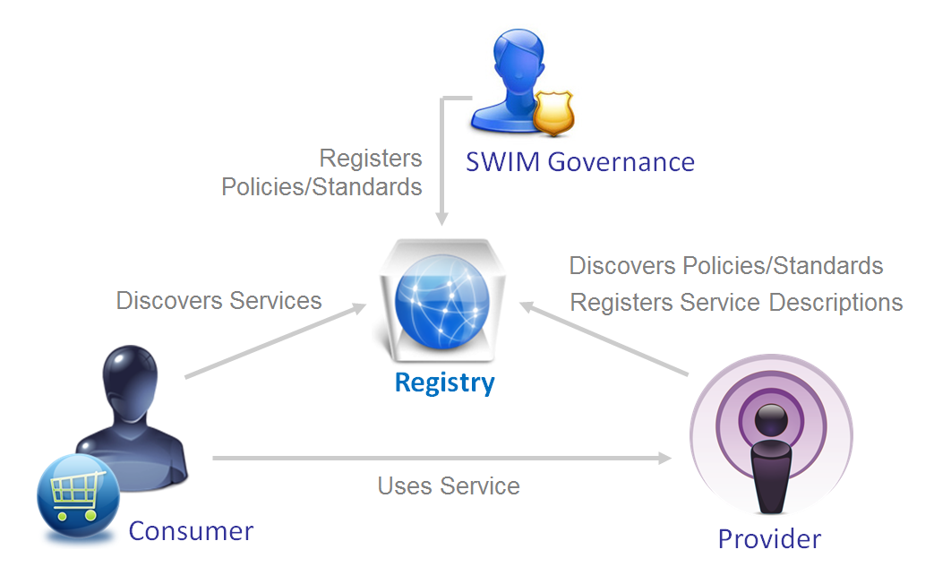
Figure 1: Interaction between the different stakeholders of the registry

As depicted above, the registry enables the “provider” to “publish” information related to its services so that the “consumer” is able to “discover” them and obtain what is required (e.g. interface information, access request procedure) to “use” those services. The “SWIM Governance” uses the registry to influence the implementation of services in SWIM with the publication of policies and standards.

Introduction

Purpose of the document
This document provides a detailed view of the SWIM Registry. It describes what it is (i.e. what kind of data is stored and which services are provided), who is involved (i.e. roles and responsibilities), why it should be implemented (i.e. benefits and implications), the business processes it supports (i.e. use cases) and other additional considerations important for its implementation (i.e. security and topology). This document builds upon a previous document that introduces the concept of registries (See registry concepts reference document).

Approach and Assumptions
This document describes the SWIM Registry in its largest scope covering both the runtime and design time registry declinations. However, considering the main focus and expertise of SESAR Project 8.1.1 and the experience obtained by a prototype implemented to support the development of services in SESAR (SWIM Masterclass and validation exercises), the main focus of this document is on the design time registry. The difference between both types of registry is:

- A design time registry supports 1) the implementation of services by providing service design guidance (standards and policies), 2) the discovery of planed/implemented services and 3) the implementation of consuming systems providing information on how to interface with a registered service. The registry contains design information that is rather static and target those persons involved in the implementation of services/interfaces.
- A run time registry supports the discovery of live services and information that represents the running status of the service (e.g. currently active end point). This implies an interface between the runtime infrastructure and the registry to maintain dynamic service information. Systems are typical consumers of the runtime registry for late binding or runtime policy enforcement purposes.

Intended readership
The registry enables service providers, consumers, and the swim governance to share a common view on SWIM. It is expected that any of these stakeholders could be interested in a high level but comprehensive view of the registry as provided in this document.

Acronyms and Terminology
Term | Definition
ATM | Air Traffic Management
E-ATMS | European Air Traffic Management System
SESAR | Single European Sky ATM Research Programme
SJU | SESAR Joint Undertaking (Agency of the European Commission)
SJU Work Programme | The programme which addresses all activities of the SESAR Joint Undertaking Agency.
SESAR Programme | The programme which defines the Research and Development activities and Projects for the SJU.
SWIM Services | SWIM Services are comprised of SWIM Common Infrastructure Services and SWIM Information Services. They can also be referred simply as services when SWIM can be understood by the context.
SWIM Providers | Are providers of any SWIM capability (e.g. common infrastructure components, information service instances, …)
SWIM TI | SWIM Technical Infrastructure
SWIM Reference | Any descriptive artefact (e.g. specifications document) that is proposed by the SWIM governance to be used as a guiding reference in the implementation of SWIM.

Registry Overview, Benefits, Implications and Limitations

Registry Overview
The SWIM Registry is a directory of information that supports the discovery and implementation of services. The Registry uses a formal registration process to store, catalogue and manage metadata describing service implementations, and the related governance standards and policies.
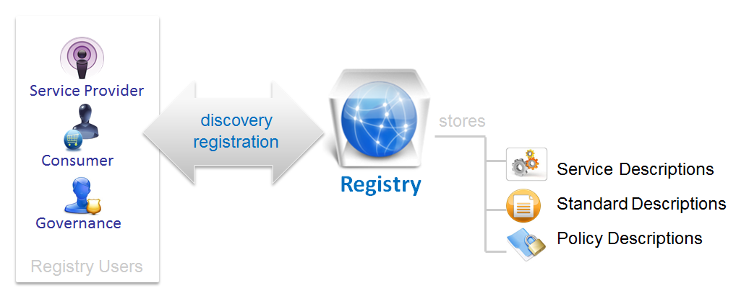
Figure 2: Registry Overview

The registry stores service related information that becomes available to the registry users based on the discovery capabilities of the registry. The information is stored in the registry based on a controlled registration process. Both discovery and registration are functions provided by the registry via its interface, allowing the storage and retrieval of service related information. The main users of the registry are the 1) service providers that discover the standards and policies required for the implementation of services and register their service implementations, the 2) SWIM governance that steers service implementation with standards and policies that are made available in the registry, and the 3) service consumers that identify suitable services for consumption in the registry.

Benefits
SESAR follows a service oriented approach as stated in the master plan, and the registry is a consequence of that. The registry will be an enabler for the deployment of SWIM that will enable to achieve a number of benefits:

- Reduced System Implementation Effort
The registry provides a consolidated point of access to service information. This improves the efficiency to discover ATM services and implementation reference resources.
- Enhanced collaboration based on visibility and trust
The registry improves visibility and quality of service resources based on its controlled registration process. This increases trust and facilitates the creation of new collaborations among SWIM stakeholders (that exchange information via services).
- Efficient and coordinated evolution
The registry facilitates managing the lifecycle of services, standards and policies supporting versioning and the management of dependencies. This facilitates the coordinated evolution of systems and standards.
- Oversight (Support to governance)
The registry enables to maintain a consolidated view of services and their conformance to standards, and policies.
- Flexibility
The registry promotes SOA making service descriptions discoverable regardless of the identity of the service consumer (and the service provider) contributing to the implementation of loose coupling systems between service provider and service consumer.

Implications
In order to achieve the stated benefits of the registry, there are a number of requirements or implications that must be met by the participants of SWIM. This is expected to be enforced by SWIM Governance.
Mandatory requirements
These requirements must be met in order to achieve the main benefits of the registry. If these are not implemented the registry will not succeed to deliver its core value.
Responsible | Requirement
Service Providers | SWIM service implementations must be described in the registry. These will include the dependencies with implemented governance standards and policies.
SWIM Governance | SWIM standards and policies related to services must be described in the registry.
The main objective of the mandatory requirements is to ensure that the registry becomes a complete, trusted and consolidated source of reference for service related information in order to improve the visibility, adoption and evolution of services in SWIM. The registry is positioned by these requirements as a key enabler during the design-time phase of the service lifecycle.
Optional requirements
Optional requirements enable to achieve further benefits with the registry; however these have not been validated sufficiently in SESAR and cannot be made recommended for deployment.
Responsible | Requirement
Service Consumer | Service consumers should be aware, promote and use when applicable the registry based late binding pattern. (i.e. Before invoking a service, the consuming systems looks up the registry to identify the most suitable service to consume and automatically binds to it).

The main objective of the optional requirements is to decouple communications between service consumers and providers to improve the flexibility of the service network. These requirements imply that the registry is used within a run-time context.

Limitations
At the time of this writing, no limitations have been identified so far.

Content and Structure

Overview
The Registry supports the discovery of service implementation resources in SWIM. It stores information that describes service implementations and 2) reference resources provided by the SWIM governance to steer the deployment of services (i.e. Standards, Policies). The information stored in the registry is structured according to the registry information model. The primary information elements described in the registry are:
- Service Implementations. These are services implemented by service providers in SWIM including: service functionality, ATM Context, implementation maturity, interoperability requirements, service qualities, available support, constraints and accessibility requirements.
- Standards. These guide the implementation of SWIM (e.g. Service Logical Models, Infrastructure Profiles). The description of standards includes: scope of applicability, publishing organization and source. Specific descriptions might be required for SESAR produced standards e.g. ISRM, TI Specifications and AIRM.
- Service Implementation Policies. These are policies applicable to SWIM service implementations.

The registry stores additional supporting information elements that are required to facilitate the discovery, consistency and accessibility of the main elements described above:
- Registry Users. These are users that have a personal account in the registry. This enables the implementation of access controls, personalization, and the traceability of actions to individual persons.
- Organizations. These are organizations that have users or specific content in the registry (e.g. Service Providers). It enables to reflect the ownership and responsibility of a specific information element to a legal entity. It enables to group content by organization facilitating its discovery and keeping its consistency of data in the registry, as well as to enable the efficient implementation of access controls based on organization privileges.

In addition to the information elements described above there is relational information that describes the dependencies between these elements:
- Service Provision. It is described the relationship between an organization (service provider) and the service implementations it provides.
- Service Standardization. It is described the relationship between a service and the standards it implements.
- Service Regulation. It is described the relationship between a service and the policies it conforms with.
- Service Dependency. It is described the relationship between services.
- Registry Taxonomy. It is described the relationship between a registered item in the registry and a category of information.

The registry does not intend to duplicate information available in other systems, its objective is only to store the minimum information required to facilitate discovery, identification and comparison between resources. When it comes to documents, the registry prefers linking to external content if available.

Service Implementations
The registry stores information that describes service implementations.

As defined in the SWIM Foundation Controlled Vocabulary, a service is the contractual provision of something (a non-physical object), by one, for the use of one or more others. Services involve interactions between providers and consumers, which may be performed in a digital form (data exchanges) or through voice communication or written processes and procedures.

The registry stores information that describes service implementations in alignment with the Service Description Conceptual Model (SDCM), including:

Property | Description
Service Capability | It describes what the service does or is capable of, including the function(s) and the service effects of invoking the function. It also describes the service qualities and policies that refine the capabilities of the service.
Service Provision | It describes the provider of the service as well as the location at which the service is available (i.e. endpoints).
Service Model | It describes semantic and operational interoperability elements of the service including Interfaces, operations, messages and information elements.
Service Technology | It describes technology Interoperability elements including protocols and physical information structures.
Service Compliance | It describes the level of alignment of a service implementation to SWIM compliance criteria.

The figure below provides an overview of a service description.

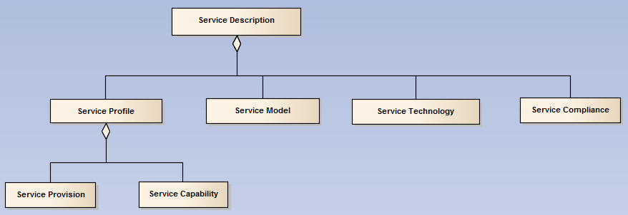
Figure 3 Registry Service Description Model

Standards
The registry stores information that describes standards.
As defined in the SWIM Foundation Controlled Vocabulary, standards are specifications, endorsed by a recognised standardisation body or community of interest for repeated or continuous application. Standardization typically aims at improving compatibility, interoperability, independence of single suppliers, safety, repeatability, or quality. The process of identification and development of standards is managed by the SWIM governance.
The registry stores information that describes standards, including:
Property | Description
Name | Name of the standard
Scope of applicability | Description of the applicability of the standard.
Objective | Description of the objective of implementing the standard.
Specifications | This is the actual content that is standardized. The description in the registry will refer to the location where this information is published.

The following list provides an overview to the standards that will be registered:
- Service Logical Models accepted by SWIM governance as common reference for implementation will be described in the registry with a sufficient level of detail that enables good understanding of its integrating elements (e.g. Service, Interface, Operation, Message, and Payload). The registry will support the process of submitting service logical models to the verification process and managing the corresponding feedback. The registry will provide and import interface that enables to store the structured description of service logical models into the data structures of the registry.
- AIRM will have a basic description in the registry that enables to identify its various versions and refer to the source where is published.
- TI Profile Specifications will be described in the registry with a sufficient level of detail that enables good understanding of its integrating elements (e.g. TI Profiles, Bindings, Exchange Patterns)
- Exchange Formats accepted by SWIM governance as reference for implementation will have a basic description in the registry that enables to identify their various versions and refer to the source where they are published.
- Technical Designs (i.e. STDD) accepted by SWIM governance as common reference for implementation will be described in the registry with a sufficient level of detail that enables good understanding of its integrating elements (e.g. Service, Interface, Operation, Message, Payload)
- Other reference material provided by SWIM governance as a common reference for implementation (e.g. SWIM Foundation, Compliance Criteria) will be also registered and have a basic description in the registry.
Standards are registered in SESAR facilitating its discovery by the European SWIM community. It is acknowledged that other organizations (e.g. FAA, ICAO) may do different as they operate in a different context.

Policies
The registry stores information that describes service implementation policies.
Policies are a set of requirements formulated and prescribed by the SWIM governance, to direct and limit actions in pursuit of long-term goals.
Policies prescribe the conditions and constraints for interacting with a service. A policy can be of different types (e.g. security, commercial conditions, and applicable laws). These will be classified according to a common taxonomy.
The registry stores information that describes policies, including:

Property | Description
Name | Name of the policy
Scope of applicability | Description of the applicability of the policy.
Objective | Description of the objective of implementing the policy.
Specifications | Specifications for using the policy.

Organizations
The registry stores information that describes organizations. Organizations are legal entities with the capacity to enter into agreements or contracts.
Organizations are stored in the registry in order to facilitate the discovery and consistency of other stored information including:
- service implementations are associated to a provider (i.e. organization)
- standards are associated to a publishing organization
- registry users are associated with legal entities (i.e. organizations)

The registry stores information that describes organizations, including:
Property | Description
Name | Name of the organization
Description | Description of the organization.
Website | Website of the organization

Users
The registry stores information that describes its users. Registry users are persons with an account in the registry that allows them to view or change content in the registry.
Registry user information is stored in the registry in order to enable the management of access control, editing traceability and personalization.
The registry stores information that describes users, including:
Property | Description
Name | Name of the user
Title | Description of the user.
email | Email of the user
Phone | Phone of the user

Functionality

Overview
As described in the SWIM Governance CONOPS, the registry is a common component that provides functionality that can be grouped in the following categories:
- Discovery (e.g. search, subscriptions, highlight reporting)
- Registration (e.g. workflow, information forms, categorization)
- Security (e.g. access control, organizational ownership, authentication/authorization, audit trail)
- System Interface (e.g. Inter Registry Synchronization, System Queries)

Discovery Functionality
Discovery functionality enables to identify registered resources, obtain their descriptions, identify related resources and follow up their evolution. It includes:
- Search functionality enables to look for resource descriptions that match specific criteria that can be formulated based on 1) Resource Properties and 2) Resource Categorization
- Subscription functionality enable users to follow up content changes in the registry that receive notifications when there are changes related to 1) a particular resource, 2) a category of resource (e.g. Flight related) 3) a type of resource (e.g. standard).
- Highlight reporting functionality enables users to get a quick view to registry information and its evolution based on graphical representations that summarize registry content (e.g. chart on most popular/recent content, number of resources per ATM domain)

Registration Functionality
Registration functionality enables the controlled and structured registration of resources in the registry. It includes:
- Registration workflows enable to define steps in the registration of resources allowing validation and approvals by a governance actor.
- Information forms enable to capture structured description of resources.
- Categorization enables to classify resources based on a common registry taxonomy that facilitates the discovery and comparability of resources.

Security Functionality
Security functionality enables to ensure that only authorized users are able to view or edit certain information in the registry. It includes:
- Authentication enables to identify users so that actions can be traced to individuals.
- Registry public area enables users to access certain information in the registry without the need to authenticate. It enables to communicate with a larger community of users (e.g. news, communications, sharing partial views of content).
- Registry restricted area; it enables to enforce access controls to information.
- Dual zone access enables information owners (e.g. service provider) to make a partial description of their registered resources available in the public area of the registry keeping certain information available only for authenticated users.
- Organization based ownership enables to define access control at an organization level for all the resources own by the organization. This enables to apply an efficient and consistent access control
- Audit trail provides a history of access to registry resources.

System Interface Functionality
System interface functionality enables the registry to exchange information with other systems. It includes:
- Inter registry synchronization enables the exchange of information with other registries. This would enable e.g. information registered in the SESAR registry implementation to become discoverable from the NEXTGEN registry implementation.
Other potential registry functionality to be exchanged with other systems, for which further research is still required:
- System queries enable other systems (non-registries) to connect and consume information from the registry.
- Runtime information farming enables the registry to stay up to date on the current state of service implementations by exchanging information with the infrastructure.
- Runtime policy information exchange enables policy enforcement agents to modify their behaviour according to information defined in the registry. The registry gets statics from policy enforcement point on service utilization.

Registry Roles

Overview
From an identity point of view there are two types of entities that need to be described in relation to registry:
 | User  This is either a person or system that interacts directly with the registry. Users have an account in the registry that uniquely identifies them and distinguishes them from other users.
 | Organization  This is the legal entity that groups users. All authenticated accesses to the system are done by users that belong to a SWIM stakeholder organization. Users participate in the registry as representatives of that organization.

Organizational Roles
Organizations have different interests in the registry, resulting in different roles and responsibilities.
Registry Usage Roles
In terms of the usage organizations make of the registry (requiring different functionality/access rights) the following roles can be distinguished:
- SWIM Stakeholder: It is an organization with an interest in SWIM and the registry information in general. SWIM Stakeholder organizations are registered in order to enable their users to get authenticated access to the SWIM Registry.
- Service Provider: It is a SWIM stakeholder interested in sharing information on its service implementations with other SWIM stakeholders. It is particularly interested in registry information containing guidelines and reference material for the implementation of services based on SWIM standards and policies.
As explained in the content chapter, organizations are described in the registry as supporting information of the primary assets of the registry. Organizations with any of the above two roles will be described in the registry.
Registry Governance Roles
The following roles can be distinguished, attending to the responsibilities of organizations in the governance of the registry:
- Registry Specifications Manager: The SWIM Governance is responsible for managing the standards and reference specifications for the implementation of SWIM. Organizations in this role are responsible for specifying the registry in terms of functional and non-functional requirements as well as the processes the registry needs to implement and support.
- Registry Operations Manager; Organizations in this role are responsible for operating the registry service including:
  - Implementation of the Registry according to the specifications.
  - Ensure that registry implementation evolves in line with the specifications and changes are implemented in a controlled and transparent manner (i.e. release management)
  - Ensuring that registry implementation changes are properly assessed to minimize the impact of change related incidents on service quality (i.e. change management)
  - Supporting users to get access and use the registry, restoring normal service operation in case of incidents (i.e. help desk, incident management, access management)

User Roles
Users of the registry will have different interests and responsibilities (requiring different functionality/access rights) that can be grouped into the following roles:
- Registry Member: It is a role associated to a person member of a SWIM Stakeholder with interest in registry information in general.
- Service Provider Administrator: It is a role associated to a person member of a service provider that has the responsibility to register services for his organization.
- Reference Administrator: It is a role associated to a person member of the registry operations manager that on behalf of the SWIM Governance registers the reference material in the registry (e.g. Service Models, SWIM Compliance Requirements).
- Service Registration Administrator: It is a role associated to a person member of the registry operations manager that on behalf of the SWIM Governance validates the registrations of service implementations.
- Service Compliance Administrator: It is a role associated to a person member of the registry operations manager that on behalf of the SWIM Governance registers the results of a service compliance assessment.
- Registry Support Administrator: It is a role associated to a person member of the registry operations manager that acts as the point of contact to support registry users. It manages access control lists as well as registry related communications.

Use Cases and Processes

Overview
The added value of the registry is directly linked to the different business processes that supports. In this section it is provided a description of the main use cases, related processes and optionality of implementation of these.
Use Case | Description | Process Required | Optionality
Service Implementation Registration | The service provider registers a description of a service implementation | Yes | Mandatory
Service Implementation Compliance Assessment | The service compliance administrator registers the compliance level of a service implementation | Yes | Mandatory
Service Implementation Compliance Declaration | The service provider registers compliance evidences of a service implementation | Yes | Optional
Service Implementation Discovery | The registry members browse information in the registry concerning service implementations | No | Mandatory
SWIM Reference Registration | The SWIM reference administrator registers reference material (standards, policies) | Yes | Mandatory
SWIM Reference Discovery | The registry members browse information in the registry concerning the SWIM reference | No | Mandatory
Service Run-time Information Farming | The registry gets runtime information from the infrastructure concerning service implementations. | N.S. | Optional
Service Run-time Information Discovery | Systems get runtime information from the registry concerning service implementations | N.S. | Optional
Runtime Policy Enforcement Discovery | Policy enforcement points in the infrastructure based their behaviour on registered policies | N.S. | Optional
Use cases with processes identified refer to either 1) SWIM processes that exist independent of the registry or 2) registry processes that are specific to the registry.
Use cases described as mandatory are highly recommended to be implemented as they provide substantial benefits with no (or minor) challenges associated. Optional use cases still bring benefits but have associated challenges. For optional use cases, the need for processes is Not Specified (N.S.).
With the exception of the last three, the rest of use cases belong to the so called design time registry scope.

Service Implementation Registration
It enables the service provider to register a description of a service implementation.
Actors | Service Provider, Service Registration Administrator
Trigger | A service provider creates a new entry in the registry for a service implementation.
Pre-Conditions | - The service provider organization is registered  - The registry member that triggers the action is member of the service provider
Post-Conditions | The registry is updated with a new service implementation description.  The service implementation description gets status updated based on the Service Implementation Registration Process
Process | Service Implementation Registration Process is a registry specific process that has the following steps:  - Draft: Gets in this state with use case trigger  - Registration Validation: The service provider sends description for validation.  - Registered: The Service Registration Administrator validates the registration.

Service Implementation Compliance Assessment
It enables the service compliance administrator to register the compliance level of a service implementation.
Actors | Service Compliance Administrator
Trigger | A Service Compliance Administrator updates the compliance information level for a registered service implementation.
Pre-Conditions | The service implementation is registered by the service provider
Post-Conditions | The registry is updated with a modified service implementation description.  The service provider is notified via the service point of contact.
Process | The service implementation compliance assessment use case has no registry specific process associated, however it is triggered as a result of the SWIM Compliance Assessment Process that is external to the registry.

Service Implementation Compliance Declaration
It enables the service provider to register compliance evidences for a service implementation.
Actors | Service Provider
Trigger | A service provider updates the compliance information level for a registered service implementation.
Pre-Conditions | - The service provider organization is registered  - The registry member that triggers the action is member of the service provider  - The service implementation is registered
Post-Conditions | The registry is updated with a modified service implementation description.
Process | The service implementation compliance declaration use case has no registry specific process associated, however it is related to the SWIM Compliance Assessment Process

Service Implementation Discovery
It enables the registry members to browse information in the registry concerning service implementations
Actors | SWIM Member
Trigger | A SWIM Member queries the registry for service implementation information.
Pre-Conditions | N/A
Post-Conditions | N/A
Process | The SWIM Reference Registration use case has no registry specific process associated or refers to any external SWIM process.

SWIM Reference Registration
It enables the reference administrator to register reference material (standards, policies).
Actors | Reference Administrator
Trigger | A SWIM Reference Administrator updates the registry with a new SWIM Reference entry.
Pre-Conditions | N/A
Post-Conditions | The registry is updated with a new SWIM Reference.
Process | The SWIM Reference Registration use case has no registry specific process associated, however it is triggered as a result of the SWIM Standards Management process that is external to the registry.
Reference material (including standards and policies) are deemed valuable to be registered in SESAR, however this still under discussion for SWIM governance at the global level.

SWIM Reference Discovery
It enables the registry members to browse information in the registry concerning the SWIM reference
Actors | SWIM Member
Trigger | A SWIM Member queries the registry for SWIM Reference information.
Pre-Conditions | N/A
Post-Conditions | N/A
Process | The SWIM Reference Registration use case has no registry specific process associated or refers to any external SWIM process.

Security Requirements
The security measures required to protect the registry will have to be aligned with the criticality of the registry as stated in this section. This will be described in terms of confidentiality, integrity, availability, authenticity and non-repudiation requirements.

Confidentiality
Confidentiality deals with the risk of disclosing information to unauthorized individuals or systems. The registry is built to increase visibility of service information raising the level of SWIM implementation awareness. This translates into a low requirement for confidentiality; however there is certain information for which their owners might prefer that this remains accessible only to the SWIM stakeholders and not to everyone in the internet:
- Certain standards and specifications developed by the SWIM Governance with specific IPR requirements.
- SWIM Governance specifications and policies addressing security.
- Sensitive service implementation information: access points, security specifications, compliance information.

Integrity
Integrity deals with the risk of data being modified undetectably. The registry supports two different types of use cases that have substantially different requirements concerning integrity.
- The registration of service information that is discovered by users in a design time context. In this case, an undetected alteration of data is not expected to have major consequences, however the following aspects need to be considered:
  - Alteration of service implementation information (e.g. connectivity requirements) might lead consumers to establish exchanges of information with rogue implementations.
  - Alteration of registry information to introduce viruses.
- The use of registry information by a system to take run-time decisions. In this case, an undetected alteration of data could have a high impact preventing the communication between operational systems. It should be noted that even if the registry is not looked up in run-time (due to caching), altered data has an impact on the run-time as it propagates (sooner or later) to the run-time environment.

Availability
Availability deals with the risk of data not being available when needed. The registry distinguishes two different types of use cases that have substantial different requirements for availability.
- The registration of service information that is discovered by users in a design time context. In this case, a brief (i.e. several hours) unavailability of the registry will not be catastrophic but could still have an impact on the productivity of those users impacted.
- The usage of the registry information by a system to make run-time decisions. In this case, the temporary unavailability of the registry will not have any impact on the operational systems as the information from the registry must never be consulted at run-time and should always be replicated locally (caching) by the consuming system. However if the downtime of the registry is sustained for a longer period of time (caching mechanisms might need a refresh at a certain time), the availability of the registry will become critical.

Authenticity and Non-Repudiation
Based on the need to preserve the confidentiality and integrity of information in the registry, it is important to validate the authenticity of users that access the registry (validate they are who they claim they are). Additionally, the registry shall ensure that the actions done on the registry data can be traced to an identity, so that the origin of data is always known and the originator can not repudiate these actions.

Topology Requirements
If the global perspective is considered, it is clear that multiple SWIM registries will coexist. Registries will be implemented in support to service governance that is expected to have different approaches in in different regions.
In the absence of a common approach, it is expected a proliferation of registries that will manage service information relevant for their own community/region. This will be to the detriment of global service users that will pay for the inefficiencies of scattered service information over multiple silo repositories using different terminologies, and difficult to compare information. This is a global problem that will require a global solution currently under discussion at ICAO level.
CP2.1 has assessed this registry interoperability problem between SESAR and NextGen and has made the following recommendations:
- Registry implementations should be able to exchange service information with each other by implementing a common exchange interface. This will create a federated network of affiliated registries where users have access to all service information independently of where it was registered.
- The exchange interface should be common to all implementations and establish a 1) common information exchange model addressing semantic and syntactic interoperability and a 2) common exchange protocol for enabling technical interoperability between interconnected registry systems.
- The exchange of information between registries should consider organizational (e.g. registration processes) and legal issues (e.g. privacy).
- A federated approach to exchange service information does not preclude the future deployment of a centralized registry for the management of common standards and policies.

References
- P08.01.01; Registry as-is situation and concepts document. (2011) https://extranet.sesarju.eu/WP_08/Project_08.03.02/Project%20Plan/DEL08.03.02%20T002%20Registry%20Concepts.doc
- P08.03.10-D11; Service Description Conceptual Model https://extranet.sesarju.eu/intraprogman/Assessment%20Library/DEL%2008.03.10.D11_Service%20Description_Conceptual_Model.docx
- P08.01.01 D42; SWIM conops
https://extranet.sesarju.eu/WP_08/Project_08.01.01/Project%20Plan/DEL08.01.01-D42-SWIM%20conops.doc
- P08.01.01 D47; SWIM Governance Structure, edition 00.03.00, 05/02/2016
- P08.01.01 D47; SWIM IM Functions, edition 00.03.00, 05/02/2016

-END OF DOCUMENT-

Requirements expressed in conformance with IETF RFC 2119.
The optionality refers to the implementation of the Use Case by a SWIM Registry provider. A SWIM Registry user has freedom to use each of the Use Cases at his discretion according to their needs.

